Supplementary Materials
Supplementary Table S1. Baseline characteristics for propensity score matching
 | Global study population  (n=8,241) | Global population |  | p-value |  | Matched population |  | p-value
 |  | SGLT2i  (n=202) | No SGLT2i  (n=8,039) |  |  | SGLT2i  (n=152) | No SGLT2i  (n=152)
Age (years) | 67 (57–76) | 63 (53–72) | 68 (57–76) | <0.001 |  | 66 (55–74) | 66 (57–74) | 0.600
Male sex | 4,865 (59.0%) | 144 (71.3%) | 4,721 (58.7%) | <0.001 |  | 104 (68.4%) | 95 (62.5%) | 0.335
Hypertension | 3,392 (41.2%) | 99 (49.0%) | 3,293 (41.0%) | 0.025 |  | 69 (45.4%) | 79 (52.0%) | 0.302
Dyslipidemia | 2,154 (26.1%) | 81 (40.1%) | 2,073 (25.8%) | <0.001 |  | 49 (32.2%) | 52 (34.2%) | 0.808
Coronary artery disease | 3,181 (38.6%) | 76 (37.6%) | 3,105 (38.6%) | 0.826 |  | 57 (37.5%) | 54 (35.5%) | 0.812
Chronic kidney disease | 701 (8.5%) | 20 (9.9%) | 681 (8.5%) | 0.444 |  | 17 (11.2%) | 19 (12.5%) | 0.859
Heart failure | 714 (8.7%) | 74 (36.6%) | 640 (8.0%) | <0.001 |  | 74 (48.7%) | 72 (47.4%) | 0.909
Atrial fibrillation | 1,487 (18.0%) | 48 (23.8%) | 1,439 (17.9%) | 0.041 |  | 47 (30.9%) | 48 (31.6%) | 1.000
Follow-up interval (months) | 14 (11–19) | 15 (8–21) | 14 (11–19) | <0.001 |  | 13 (8–20) | 12 (8–19) | 0.647
The propensity score matching with 1:1 ratio was performed for the patient’s age, sex, hypertension, dyslipidemia, coronary artery disease, heart failure, chronic kidney disease, atrial fibrillation, and interval of echocardiogram, between the eligible patients with SGLT2i treatment (n = 202) and those without SGLT2i treatment (n = 8.039).
Abbreviations: SGLT2i, sodium-glucose cotransporter 2 inhibitor.

Supplementary Table S2. Detailed information on the use of SGLT2i and cardioprotective medications
 | Total study population  (n=304) | Group 1  No HF, no SGLT2i  (n=76) | Group 2  No HF, SGLT2i (+)  (n=78) | p-value  (groups 1 vs. 2) | Group 3  HF (+), no SGLT2i  (n=76) | Group 4  HF (+), SGLT2i (+)  (n=74) | p-value  (groups 3 vs. 4)
Use of SGLT2i
Dapagliflozin | 69 (22.7%) | 0 (0.0%) | 39 (50.0%) | N/A | 0 (0.0%) | 29 (39.2%) | N/A
- Dapagliflozin 5 mg/day |  |  | 1 (1.3%) |  |  | 0 (0.0%)
- Dapagliflozin 10 mg/day |  |  | 38 (48.7%) |  |  | 29 (39.2%)
Empagliflozin | 83 (27.3%) | 0 (0.0%) | 39 (50.0%) | N/A | 0 (0.0%) | 45 (60.8%) | N/A
- Empagliflozin 10 to 12.5 mg/day |  |  | 33 (42.3%) |  |  | 39 (52.7%)
- Empagliflozin 25 mg/day |  |  | 6 (7.7%) |  |  | 6 (8.1%)
Increased dose during follow-up |  |  | 4 (5.1%) |  |  | 5 (6.8%)
RAS inhibitors | 268 (88.2%) | 61 (80.3%) | 64 (82.1%) | 0.777 | 71 (93.4%) | 72 (97.3%) | 0.442
ACEi | 107 (35.2%) | 20 (26.3%) | 26 (33.3%) | 0.341 | 29 (38.2%) | 32 (43.2%) | 0.526
Types of ACEi |  |  |  | 0.786 |  |  | 0.414
- Captopril | 21 (6.9%) | 3 (3.9%) | 5 (6.4%) |  | 4 (5.3%) | 9 (12.2%)
- Ramipril | 48 (15.8%) | 6 (7.9%) | 8 (10.3%) |  | 17 (22.4%) | 17 (23.0%)
- Perindopril | 36 (11.8%) | 11 (14.5%) | 12 (15.4%) |  | 7 (9.2%) | 6 (8.1%)
- Enalapril | 2 (0.7%) | 0 (0.0%) | 1 (1.3%) |  | 1 (1.3%) | 0 (0.0%)
Standard dose for HF* | 27 (8.9%) | 4 (5.3%) | 5 (6.4%) | 0.948 | 9 (11.8%) | 9 (12.2%) | 0.804
Change in ACEi dose |  |  |  | 0.447 |  |  | 0.991
- Decreased | 7 (2.3%) | 0 (0.0%) | 1 (1.3%) |  | 3 (3.9%) | 3 (4.1%)
- No change | 67 (22.0%) | 16 (21.1%) | 17 (21.8%) |  | 16 (21.1%) | 18 (24.3%)
- Increased | 33 (10.9%) | 4 (5.3%) | 8 (10.3%) |  | 10 (13.2%) | 11 (14.9%)
ARB | 161 (53.0%) | 41 (53.9%) | 38 (48.7%) | 0.516 | 42 (55.3%) | 40 (54.1%) | 0.882
Types of ARB |  |  |  | 0.414 |  |  | 0.940
- Losartan | 34 (11.2%) | 7 (9.2%) | 10 (12.8%) |  | 8 (10.5%) | 9 (12.2%)
- Candesartan | 39 (12.8%) | 11 (14.5%) | 8 (10.3%) |  | 9 (11.8%) | 11 (14.9%)
- Valsartan | 39 (12.8%) | 6 (7.9%) | 7 (9.0%) |  | 13 (17.1%) | 13 (17.6%)
- Telmisartan | 19 (6.3%) | 5 (6.6%) | 5 (6.4%) |  | 5 (6.6%) | 4 (5.4%)
- Irbesartan | 8 (2.6%) | 5 (6.6%) | 0 (0.0%) |  | 2 (2.6%) | 1 (1.4%)
- Olmesartan | 7 (2.3%) | 3 (3.9%) | 3 (3.8%) |  | 1 (1.3%) | 0 (0.0%)
- Fimasartan | 12 (3.9%) | 4 (5.3%) | 5 (6.4%) |  | 2 (2.6%) | 1 (1.4%)
- Azilsartan | 3 (1.0%) | 0 (0.0%) | 0 (0.0%) |  | 2 (2.6%) | 1 (1.4%)
Standard dose for HF* | 39 (12.8%) | 6 (7.9%) | 5 (6.4%) | 0.850 | 16 (21.1%) | 12 (16.2%) | 0.440
Change in ARB dose |  |  |  | 0.973 |  |  | 0.999
- Decreased | 13 (4.3%) | 6 (7.9%) | 5 (6.4%) |  | 1 (1.3%) | 1 (1.4%)
- No change | 99 (32.6%) | 27 (35.5%) | 25 (32.1%) |  | 24 (31.6%) | 23 (31.1%)
- Increased | 49 (16.1%) | 8 (10.5%) | 8 (10.3%) |  | 17 (22.4%) | 16 (21.6%)
Beta-blockers | 255 (83.9%) | 58 (76.3%) | 61 (78.2%) | 0.780 | 67 (88.2%) | 69 (93.2%) | 0.284
Types of beta-blockers |  |  |  | 0.754 |  |  | 0.381
- Carvedilol | 131 (43.1%) | 25 (32.9%) | 25 (32.1%) |  | 38 (50.0%) | 43 (58.1%)
- Bisoprolol | 89 (29.3%) | 25 (32.9%) | 24 (30.8%) |  | 19 (25.0%) | 21 (30.8%)
- Nebivolol | 29 (9.5%) | 7 (9.2%) | 9 (11.5%) |  | 8 (10.5%) | 5 (6.8%)
- Others | 6 (2.0%) | 1 (1.3%) | 3 (3.8%) |  | 2 (2.6%) | 0 (0.0%)
Standard dose for HF* | 30 (9.9%) | 2 (2.6%) | 4 (5.1%) | 0.680 | 11 (14.5%) | 13 (17.6%) | 0.711
Change in beta-blockers dose |  |  |  | 0.424 |  |  | 0.273
- Decreased | 23 (7.6%) | 4 (5.3%) | 8 (10.3%) |  | 4 (5.3%) | 7 (9.5%)
- No change | 126 (41.4%) | 34 (44.7%) | 30 (38.5%) |  | 35 (46.1%) | 27 (36.5%)
- Increased | 106 (34.9%) | 20 (26.3%) | 23 (29.5%) |  | 28 (36.8%) | 35 (47.3%)
MRA | 103 (33.9%) | 9 (11.8%) | 9 (11.5%) | 0.953 | 40 (52.6%) | 45 (60.8%) | 0.312
Standard dose for HF* | 68 (22.4%) | 2 (2.6%) | 4 (5.1%) | 0.620 | 30 (39.5%) | 32 (43.2%) | 0.687
Change in MRA dose |  |  |  | 0.681 |  |  | 0.603
- Decreased | 28 (9.2%) | 4 (5.3%) | 4 (5.1%) |  | 8 (10.5%) | 12 (16.2%)
- No change | 63 (20.7%) | 5 (6.6%) | 5 (6.4%) |  | 25 (32.9%) | 28 (37.8%)
- Increased | 12 (3.9%) | 0 (0.0%) | 0 (0.0%) |  | 7 (9.2%) | 5 (6.8%)
* Standard doses of ACEi, ARB, beta-blockers, and MRA for HF were determined according to the 2016 ESC Guidelines for the diagnosis and treatment of acute and chronic heart failure.
Abbreviations: HF, heart failure; SGLT2i, sodium-glucose cotransporter 2 inhibitor; RAS, renin-angiotensin system; ACEi, angiotensin converting enzyme inhibitors; ARB, angiotensin receptor blocker; BB, beta-blocker; MRA, mineralocorticoid antagonists.

Supplementary Table S3. Univariable analysis for the improvement in LV-EF
 | +5% improvement in LV-EF |  |  |  | +10% improvement in LV-EF
 | Unadjusted OR | 95% CI | p-value |  | Unadjusted OR | 95% CI | p-value
Age (per +1 year) | 0.986 | 0.966 – 1.005 | 0.152 |  | 0.976 | 0.952 – 1.001 | 0.056
Male sex | 1.040 | 0.633 – 1.710 | 0.877 |  | 0.633 | 0.346 – 1.158 | 0.138
Hypertension | 0.605 | 0.375 – 0.975 | 0.039 |  | 0.641 | 0.350 – 1.172 | 0.148
Dyslipidemia | 0.615 | 0.366 – 1.033 | 0.066 |  | 0.602 | 0.306 – 1.185 | 0.142
Coronary artery disease | 0.957 | 0.586 – 1.563 | 0.860 |  | 0.507 | 0.258 – 0.997 | 0.049
Chronic kidney disease | 0.689 | 0.319 – 1.490 | 0.344 |  | 0.940 | 0.371 – 2.387 | 0.897
Atrial fibrillation | 1.212 | 0.732 – 2.006 | 0.456 |  | 0.941 | 0.494 – 1.793 | 0.854
HF | 2.290 | 1.413 – 3.711 | 0.001 |  | 2.452 | 1.318 – 4.562 | 0.005
Types of HF*
No HF | Reference |  |  |  | Reference
HFpEF (LV-EF ≥40%) | 0.727 | 0.359 – 1.472 | 0.376 |  | 0.659 | 0.234 – 1.858 | 0.431
HFrEF (LV-EF <40%) | 4.946 | 2.789 – 8.774 | <0.001 |  | 4.487 | 2.307 – 8.729 | <0.001
Medications
SGLT2i | 1.905 | 1.179 – 3.077 | 0.008 |  | 2.017 | 1.092 – 3.726 | 0.025
- High dose of SGLT2i* | 0.956 | 0.502 – 1.820 | 0.890 |  | 0.713 | 0.331 – 1.536 | 0.388
- Increased dose of SGLT2i during follow-up | 0.672 | 0.162 – 2.795 | 0.585 |  | 0.417 | 0.050 – 3.454 | 0.417
Statin | 0.629 | 0.339 – 1.165 | 0.140 |  | 0.466 | 0.230 – 0.944 | 0.034
Metformin | 0.923 | 0.503 – 1.696 | 0.797 |  | 1.097 | 0.500 – 2.405 | 0.817
Sulfonylurea | 0.577 | 0.357 – 0.932 | 0.025 |  | 0.429 | 0.235 – 0.782 | 0.006
DPP-4 inhibitors | 1.210 | 0.722 – 2.029 | 0.470 |  | 0.690 | 0.372 – 1.280 | 0.239
ACEi | 1.262 | 0.773 – 2.059 | 0.353 |  | 0.845 | 0.449 – 1.589 | 0.601
- Standard dose of ACEi for HF | 1.859 | 0.908 – 3.807 | 0.090 |  | 0.841 | 0.314 – 2.252 | 0.730
- Increased dose of ACEi during follow-up | 2.325 | 1.160 – 4.660 | 0.017 |  | 0.888 | 0.348 – 2.268 | 0.805
ARB | 0.786 | 0.490 – 1.261 | 0.319 |  | 1.441 | 0.788 – 2.635 | 0.235
- Standard dose of ARB for HF | 0.677 | 0.342 – 1.339 | 0.262 |  | 0.545 | 0.225 – 1.320 | 0.178
- Increased dose of ARB during follow-up | 1.210 | 0.653 – 2.242 | 0.545 |  | 1.425 | 0.690 – 2.944 | 0.339
RAS inhibitors | 0.940 | 0.455 – 1.942 | 0.868 |  | 1.790 | 0.605 – 5.295 | 0.293
- Standard dose of RAS inhibitors for HF | 1.652 | 0.973 – 2.084 | 0.063 |  | 0.733 | 0.352 – 1.525 | 0.406
- Increased dose of RAS inhibitors during follow-up | 1.244 | 0.712 – 2.174 | 0.442 |  | 1.406 | 0.740 – 2.672 | 0.298
Beta blockers | 1.590 | 0.803 – 3.149 | 0.184 |  | 2.676 | 0.919 – 7.794 | 0.071
- Standard dose of beta blockers for HF | 1.617 | 0.750 – 3.485 | 0.220 |  | 2.849 | 1.254 – 6.471 | 0.012
- Increased dose of beta blockers during follow-up | 1.597 | 1.051 – 2.429 | 0.028 |  | 1.989 | 1.158 – 3.416 | 0.013
MRA | 1.896 | 1.159 – 3.102 | 0.011 |  | 2.391 | 1.310 – 4.366 | 0.005
- Standard dose of MRA for HF | 0.995 | 0.439 – 2.256 | 0.990 |  | 0.671 | 0.271 – 1.663 | 0.389
- Increased dose of MRA during follow-up | 1.150 | 0.604 – 2.190 | 0.670 |  | 1.354 | 0.651 – 2.815 | 0.417
Diuretics | 2.499 | 1.501 – 4.161 | <0.001 |  | 3.636 | 1.750 – 7.557 | 0.001
Laboratory findings at baseline
Hemoglobin (per +1 g/dL) | 0.994 | 0.885 – 1.115 | 0.917 |  | 1.037 | 0.895 – 1.202 | 0.625
Serum creatinine (per +1 mg/dL) | 0.712 | 0.386 – 1.311 | 0.275 |  | 0.684 | 0.303 – 1.543 | 0.360
Fasting glucose (per +1 mg/dL) | 1.000 | 0.995 – 1.006 | 0.888 |  | 1.000 | 0.993 – 1.007 | 0.952
Total cholesterol (per +1 mg/dL) | 1.005 | 0.999 – 1.010 | 0.120 |  | 1.008 | 1.001 – 1.014 | 0.032
HbA1c (per +1%) | 0.958 | 0.816 – 1.126 | 0.605 |  | 0.970 | 0.792 – 1.189 | 0.772
Echocardiographic findings at baseline
LV-EDD (per +1mm) | 1.052 | 1.022 – 1.082 | <0.001 |  | 1.059 | 1.024 – 1.096 | 0.001
LV-ESD (per +1mm) | 1.050 | 1.027 – 1.074 | <0.001 |  | 1.058 | 1.030 – 1.086 | <0.001
LV-EDV (per +1mL) | 1.011 | 1.006 – 1.016 | <0.001 |  | 1.012 | 1.006 – 1.018 | <0.001
LV-ESV (per +1mL) | 1.015 | 1.009 – 1.021 | <0.001 |  | 1.015 | 1.009 – 1.021 | <0.001
LV-EF (per +1%) | 0.944 | 0.928 – 0.960 | <0.001 |  | 0.936 | 0.916 – 0.956 | <0.001
LV-MI (per +1g/m²) | 1.011 | 1.003 – 1.018 | 0.005 |  | 1.015 | 1.006 – 1.024 | 0.001
LAVI (per +1mL/m²) | 1.011 | 1.001 – 1.021 | 0.032 |  | 1.010 | 0.999 – 1.021 | 0.065
PASP (per +1 mmHg) | 1.034 | 1.013 – 1.055 | 0.001 |  | 1.023 | 1.001 – 1.045 | 0.040
E velocity (per +1 m/sec) | 2.404 | .0988 – 5.850 | 0.053 |  | 2.168 | 0.763 – 6.155 | 0.146
Mitral annular e’ velocity (per +1 cm/sec) | 0.988 | 0.876 – 1.113 | 0.840 |  | 0.910 | 0.780 – 1.061 | 0.229
Mitral annular s’ velocity (per +1 cm/sec) | 0.971 | 0.902 – 1.046 | 0.440 |  | 0.778 | 0.653 – 0.927 | 0.005
Mitral E/e’ ratio | 1.015 | 0.988 – 1.043 | 0.273 |  | 1.025 | 0.993 – 1.058 | 0.126
LV-GLS (per +1%) | 0.878 | 0.826 – 0.934 | <0.001 |  | 0.856 | 0.792 – 0.924 | <0.001
Univariable logistic regression analyses were performed for the +5% improvement of LV-EF (left column) and for the +10% improvement of LV-EF (right column) on the follow-up echocardiogram.
* Analysis for the types of HF was performed using the patients without HF as a reference.
Abbreviations: OR, odds ratio; CI, confidence interval; HF, heart failure; HFpEF, heart failure with preserved ejection fraction; HFrEF, heart failure with reduced ejection fraction; SGLT2i, sodium-glucose cotransporter 2 inhibitor; DPP-4, dipeptidylpeptidase-4; RAS, renin-angiotensin system; MRA, mineralocorticoid antagonist; LV, left ventricular; EDV, end-diastolic volume; ESV, end-systolic volume; EDD, end-diastolic dimension; ESD, end-systolic dimension; EF, ejection fraction; MI, mass index; LAVI, left atrial volume index; PASP, pulmonary artery systolic pressure; GLS, global longitudinal strain.

Supplementary Figure S1. Changes in LV geometry and systolic function
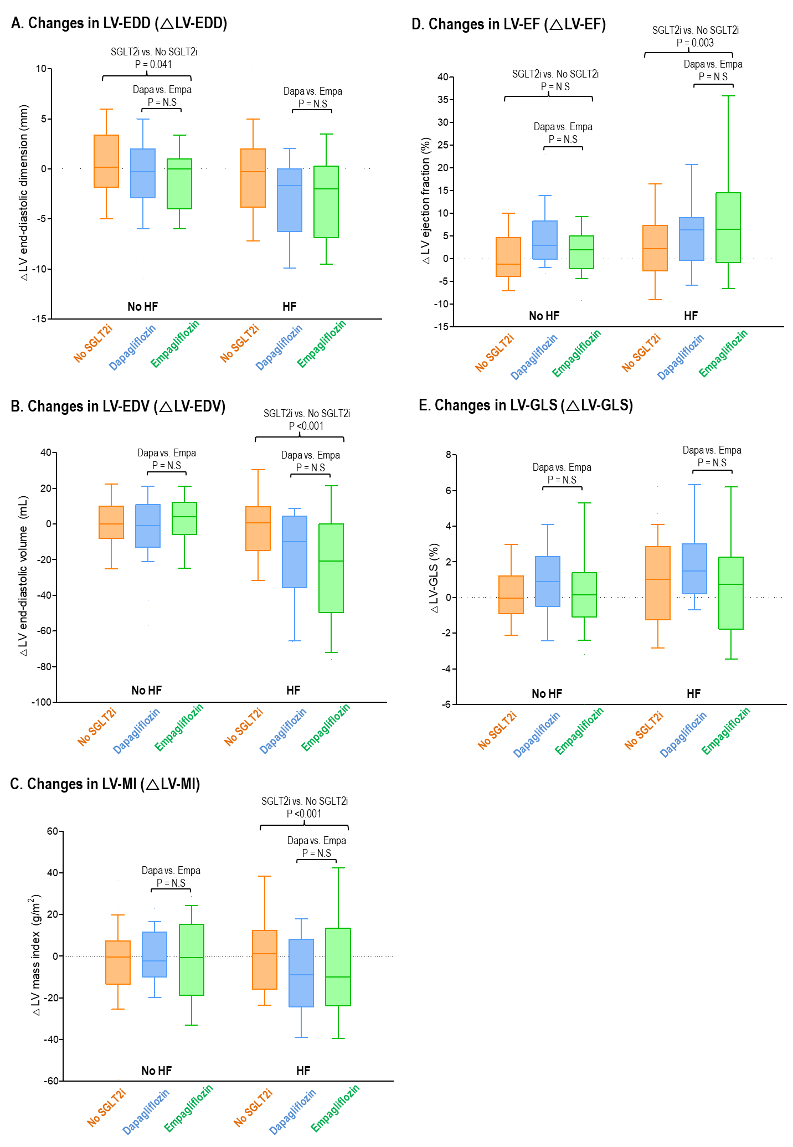
Changes in LV-EDD, LV-EDV, LV-MI, LV-EF, and LV-GLS are compared between the patients without SGLT2i (orange), those on dapagliflozin (blue), and those on empagliflozin (green), according to the presence of HF.
Supplementary Figure S2. Changes in LV diastolic function
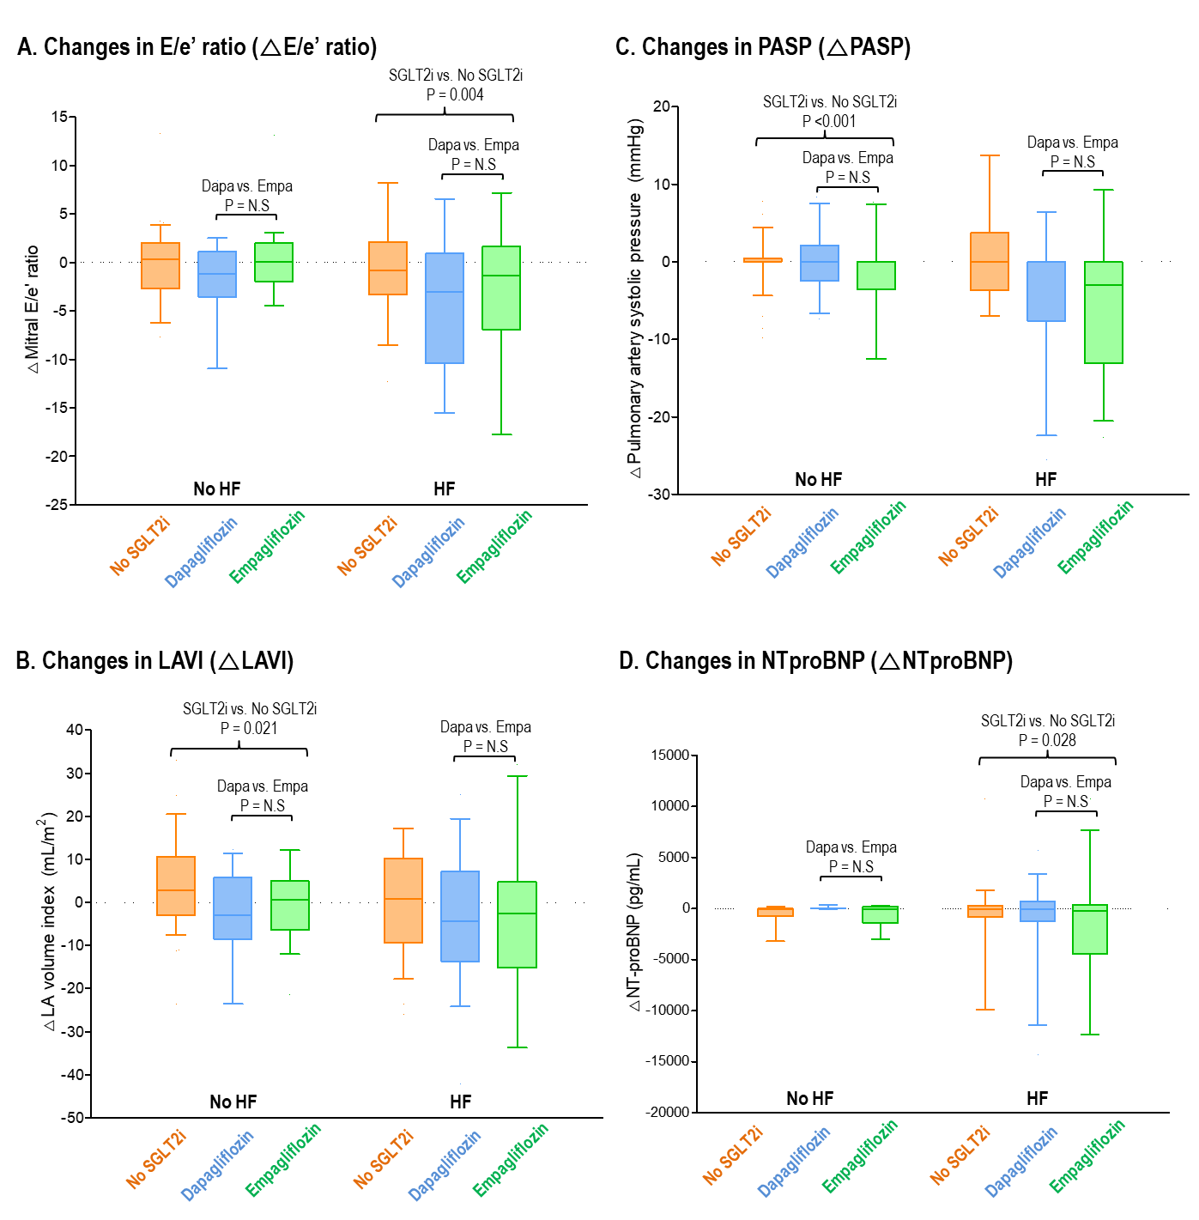
Changes in mitral E/e’ ratio, LAVI, PASP, and NT-proBNP are compared between the patients without SGLT2i (orange), those on dapagliflozin (blue), and those on empagliflozin (green), according to the presence of HF.

