Morau & Piepho: Interactions between abiotic factors and the bioactivity of biodynamic horn manure on the growth of garden cress (Lepidium sativum L.) in a bioassay

Additional file

Contents

1- Description of supplemental statistical analyses 1
1.1 Model 2: Integrating the factor day 2
1.2 Model 3: Integrating the factor position 3
1.3 Model 4: Analysis of one hanger 3
1.4 More liberal comparison method for Model 1 4

2. Additional Tables S1-S7 5

3. Additional Figures S1-S3 11

1- Description of supplemental statistical analyses

1.1. Model 2: Integrating the factor day

In Model (1), the traits at different days are analysed individually. An overall analysis of the growth was performed by integrating the factor day as follows (Model 2):
Y _{mijkl} = µ + b_{i} + f_{j} + bf_{ij} + d_{m} + db_{mi} + df_{mj} + dbf_{mij} + t_{k} + dt_{mk} + dft_{mjk} + dftw_{mjkl} + e_{mijkl}
Where:
- µ, b_{i}, f_{j}, bf_{ij,} and t_{k} as defined for Model (1)
- d_{m} is the fixed effect of the m-th day
- db_{mi} is the fixed effect of the i-th level of the dose factor at m-th day
- df_{mj} is the fixed effect of the j-th level of the test factor at m-th day
- dbf_{mij} is the fixed effect of the interaction between the i-th level of the dose factor and the j-th level of the test factor at m-th day
- dt_{mk} is the random effect of the k-th trial at m-th day
- dft_{mjk} is the random effect of the jk-th hanger at m-th day
- dftw_{mjkl} is the random effect of the l-th block in the jk-th hanger at m-th day
- e_{mijkl} is the random effect of the ijkl-th bag at m-th day
- Y_{mijkl} is the mean of root or hypocotyl length in the ijkl-th bag at m-th day
In case of variance heterogeneity for day, a log-transformation was performed. For each series, p-values (Wald F-test) of Model (2) are presented in Table 2.
For the individual analysis for each trait, Model (1) was preferred because of the possibility to fit specific variances for the test factors and the avoidance of a logarithmic transformation.

1.2 Model 3: Integrating the factor position
To analyse the influence of the seedling position in the bag, it was required to define one observation as one seedling instead of as one bag in Model 1. This analyse was performed separately for each factor level of each Series with the following Model (3):
Y_{ijkl} = µ + b_{i} + p_{j} + pb_{ij} + t_{k} + bt_{ik} + tw_{kl} + btw_{ikl} + e_{ijkl} (3)
Where:
- µ, b_{i}, and t_{k} as defined for Model (1)
- p_{j} is the fixed effect of the jth-position (j = 1-16)
- pb_{ij} the fixed effect of the interaction between the j-th position and the i-th treatment
- bt_{ik} is the random effect of the interaction between the i-th dose treatment and the k-th trial
- tw_{kl} the random effect of the l-th block of the k-th trial
- btw_{ikl} the random effect of the ikl-th bag
- e_{ijkl} the error effect of the ijkl-th seedling
- Y_{ijkl} the length of the ijkl-th seedling

The results are documented in the Supplemental Figures S1, S2 and S3.

1.3 Model 4: Analysis of one hanger
To evaluate the reproducibility of the bioassay, each replication (i.e. one single hanger) was independently analysed according to a randomized complete block design (n = 20). The analysis was performed for root length at day 7 (Series W and G) and day 8 (Series L) with the following linear mixed Model (4):
Y_{ijk} = µ + b_{i} + w_{j} + bw_{ij} + e_{ijk} (4)
Where:
- µ the overall effect
- b_{i} the fixed effect of the i-th treatment (Series W and G: i=1-3; series L: i=1-2)
- w_{j} the random effect of the j-th block (j=1-20)
- bw_{ij} the random effect of the ij-th bag
- e_{ijk} the random effect of the k-th seedling (k=1-16) in the ij-th bag
- Y_{ijk} the root or hypocotyl length of the k-th seedling in the ij-th bag

The results are documented in the Supplemental Table S5.

1.4 More liberal comparison method for Model 1
In the comparison approach performed for Model (1) in the main text, the treatment means were compared with the LSMEANS statement, using the Tukey-Kramer-test to control the family-wise Type I error rate. This approach is conservative because it also accounts for comparisons of treatments differing in both dose and volume.
Another, more liberal comparison approach, which compares doses only at the same level of volume, and vice versa, can be conducted as follows. The dose treatment means at the same volume level were compared with the SLICE statement. The volume treatment means at the same dose control (Variant: Control) were compared the same way. To control the family-wise Type I error rate, these comparisons were adjusted with the Tukey-Kramer procedure. Furthermore the significance level α was adjusted to 0.05 / a, with a the number of slices. This corresponds to a Bonferroni correction.
The results of this alternative approach, which produced a few more significant results than the conservative approach, are documented in the Supplemental Tables S1, S2 and S3.

2. Additional Tables and Figures

Table S1. Average lengths (mm) for all growth traits in series W. Means (mm) and standard error (s.e; by variance heterogeneity: minimum and maximum) are detailed. The pairwise comparisons were conducted with the alternative, more liberal method described in Section 1.4. At a time point (in column), dose treatments by the same volume level with no lowercase in common differ significantly (in bold, p < 0.0167, Tukey-Kramer-test by the same volume level); volume treatments by the dose level ‘Control’ with no uppercase in common differ significantly (p < 0.0167, Tukey-Kramer-test by the same dose level).

Volume | Dose | Hypocotyl length (mm) |  |  |  |  | Root length (mm)
 |  | day 3 | day 4 | day 5 | day 6 |  | day 2 | day 3 | day 4 | day 5 | day 6 | day 7
4 ml | D_{0.1µl} | 17.48 | 35.93 | 49.67 | 59.86 |  | 14.77 | 39.28 | 67.35 | 83.40 | 91.93 | (91.93) ¹
 | D_{1µl} | 17.45 | 35.91 | 49.90 | 60.30 |  | 14.77 | 39.21 | 67.48 | 83.97 | 92.80 | (92.80) ¹
 | C | 17.30 B | 35.84 | 49.60 B | 59.83 C |  | 14.66 | 38.90 A | 67.88 A | 84.96 A | 93.52 A | (93.52 A) ¹
5 ml | D_{0.1µl} | 17.49 | 35.62 | 50.70 | 61.96 |  | 14.02 | 35.86 | 58.07 | 70.13 | 79.02 | 84.83 a
 | D_{1µl} | 17.30 | 35.80 | 51.07 | 62.44 |  | 13.92 | 35.34 | 57.06 | 69.26 | 78.92 | 85.04 a
 | C | 17.34 B | 35.77 | 50.88 B | 62.02 B |  | 13.93 | 36.00 B | 58.43 B | 69.87 B | 76.84 B | 81.34 B b
6 ml | D_{0.1µl} | 17.83 ab | 36.17 ab | 52.22 ab | 63.96 |  | 14.05 | 34.57 | 52.49 | 63.48 | 71.78 | 77.69
 | D_{1µl} | 17.68 b | 35.72 b | 51.85 b | 63.79 |  | 14.04 | 34.34 | 51.82 | 63.13 | 72.67 | 79.84
 | C | 18.20 A a | 36.81 a | 52.74 A a | 64.35 A |  | 14.22 | 35.04 B | 53.59 B | 63.96 B | 70.92 B | 76.37 B
s.e. |  | 0.45 | 1.33 | 1.23 | 1.20 |  | 0.54 | 1.62 | 2.18 | 2.60-2.67 | 2.81-2.94 | 2.79-2.95

¹ For variant 4ml, root length at day 7 was not measured. Root length at day 6 was used to perform the final statistical analysis at the end of experiment.

Table S2. Average lengths (mm) for all growth traits in series G. Means (mm) and standard error (s.e.) are detailed. The pairwise comparisons were conducted with the alternative, more liberal method described in Section 1.4. At a time point (in column), dose treatments by the same laying time level with no lowercase in common differ significantly (in bold, p < 0.0125, Tukey-Kramer-test by the same laying time level); laying time treatments by the dose level ‘Control’ with no uppercase in common differ significantly (p < 0.0167, Tukey-Kramer-test by the same dose level).

Laying  time | Dose | Hypocotyl length (mm) |  |  |  |  | Root length (mm)
 |  | day 3 | day 4 | day 5 | day 6 |  | day 2 | day 3 | day 4 | day 5 | day 6 | day 7
0min | D_{0.1µl} | 17.37 | 34.72 | 51.38 | 62.69 |  | 14.58 | 35.62 b | 57.25 | 69.72 | 78.02 | 84.75
 | D_{1µl} | 17.54 | 34.99 | 51.80 | 63.04 |  | 14.63 | 35.81 ab | 57.38 | 69.80 | 77.91 | 84.86
 | C | 17.69 AB | 35.30 AB | 51.90 AB | 63.10 B |  | 14.79 | 36.52 A a | 59.10 A | 72.12 A | 80.12 A | 86.53 A
20min | D_{0.1µl} | 19.22 | 37.89 | 54.48 | 65.34 |  | 15.06 | 32.81 | 47.77 | 58.03 | 66.29 | 73.29
 | D_{1µl} | 19.10 | 37.66 | 54.31 | 65.16 |  | 15.07 | 32.59 | 47.25 | 57.48 | 65.88 | 73.44
 | C | 19.33 A | 38.08 A | 54.68 A | 65.41 A |  | 15.06 | 32.99 AB | 48.24 B | 58.31 B | 65.71 B | 71.73 B
40min | D_{0.1µl} | 16.14 | 33.97 | 51.57 | 63.31 |  | 14.18 | 29.08 | 45.79 | 58.30 | 67.77 a | 74.94 a
 | D_{1µl} | 16.10 | 33.84 | 51.42 | 63.32 |  | 14.22 | 28.88 | 45.07 | 57.67 | 67.87 a | 75.87 a
 | C | 15.99 B | 33.50 B | 50.96 B | 62.89 B |  | 14.23 | 28.67 C | 44.62 B | 55.65 B | 63.58 B b | 69.32 B b
60min | D_{0.1µl} | 16.56 | 34.22 | 51.21 | 62.39 |  | 14.48 | 29.61 | 45.12 | 56.98 | 65.95 | 72.80
 | D_{1µl} | 16.40 | 34.10 | 51.42 | 62.85 |  | 14.43 | 29.08 | 44.20 | 55.99 | 65.86 | 74.26
 | C | 16.62 B | 34.41 B | 51.63 B | 62.90 B |  | 14.41 | 29.37 BC | 44.92 B | 56.39 B | 64.42 B | 70.25 B
s.e. |  | 0.71 | 1.07 | 0.78 | 0.58 |  | 0.28 | 1.21 | 1.75 | 1.92 | 1.87 | 1.80

Table S3. Average lengths (mm) for all growth traits in series L. Means (mm) and standard error (s.e.) are detailed. The pairwise comparisons were conducted with the alternative, more liberal method described in Section 1.4. At a time point (in column), dose treatments by the same light level with no lowercase in common differ significantly (in bold, p < 0.01, Tukey-Kramer-test by the same light level); light treatments by the dose level ‘Control’ with no uppercase in common differ significantly (p < 0.025, Tukey-Kramer-test by the same dose level).

Light | Dose | Hypocotyl length (mm) |  |  |  |  | Root length (mm)
 |  | day 3 | day 4 | day 5 | day 6 |  | day 2 | day 3 | day 4 | day 5 | day 6 | day 7 | day 8
FL 100 | D_{1µl} | 17.11 | 34.11 | 51.94 | 63.16 |  | 13.48 | 30.91 | 47.13 | 59.38 | 68.37 | 75.59 | 80.51
 | C | 17.12 A | 33.96 AB | 51.73 | 63.06 |  | 13.56 | 31.12 A | 46.78 A | 57.66 A | 64.90 A | 70.96 A | 75.03 A
FL 500 | D_{1µl} | 16.52 | 33.75 | 51.31 | 62.88 |  | 13.39 | 30.11 | 45.21 | 56.68 | 65.20 | 71.73 | 76.24
 | C | 16.74 AB | 33.98 AB | 51.34 | 62.61 |  | 13.59 | 30.67 AB | 46.02 AB | 56.17 AB | 62.84 AB | 67.98 AB | 71.67 AB
FL 1000 | D_{1µl} | 16.19 | 33.84 | 51.24 | 62.29 |  | 13.41 | 30.29 | 46.93 | 59.52 a | 68.48 a | 74.77 a | 78.82 a
 | C | 16.22 AB | 33.72 AB | 51.17 | 62.23 |  | 13.36 | 30.14 AB | 45.80 AB | 55.95 AB b | 62.20 AB b | 66.97 AB b | 70.19 AB b
FL 1500 | D_{1µl} | 16.13 | 33.34 | 51.35 | 62.50 |  | 13.20 | 30.39 | 47.02 | 60.18 a | 69.33 a | 75.56 a | 79.72 a
 | C | 16.15 B | 33.09 B | 51.00 | 62.14 |  | 13.26 | 30.48 AB | 46.15 AB | 56.81 A b | 63.64 AB b | 68.41 AB b | 71.62 AB b
NL | D_{1µl} | 17.17 | 35.08 | 52.17 | 62.83 |  | 13.34 | 29.46 | 43.29 | 52.74 | 59.66 | 66.03 | 70.55
 | C | 17.11 AB | 35.00 A | 52.16 | 63.12 |  | 13.24 | 29.49 B | 43.47 B | 52.43 B | 58.67 B | 64.01 B | 67.79 B
s.e. |  | 0.39 | 0.89 | 1.40 | 1.53 |  | 0.46 | 0.32 | 0.85 | 1.60 | 2.14 | 2.29 | 2.26

Table S4. Estimated covariance parameter from Model 1 in Series W, G and L. The values shown represent the estimated variance parameters for the random factors in Model 1. Trait is the root length at day 7 (Series W and G) or at day 8 (Series L).

Factor | Series W | Series G | Series L
Trial | 11.2 | 1.9 | 5.9
Trial × Dose | 0 | 1.3 | 11.2
Trial × Test factor¹ | 19.0 | 15.2 | 8.6
Trial × Test factor × Block | 2.3 | 6.4 | 5.7
Residual | 4ml: 17.8 ²  5 ml: 55.8  6 ml: 88.5 | 140.4 | 91.9
¹ Series W: water volume; Series G: laying time; Series L: light
² Variance heterogeneity for the factor volume was considered in Model 1.

Table S5. Statistical evaluation of individual hanger in series W, G and L. The values shown represent the p-values for the factor dose of the individual analyses (Wald F-test of Model 4 described in Section 1.3). Significant results are shown in bold (p < 0.05). Trait is the root length at day 7 (Series W and G) or at day 8 (Series L).
Series | Factor |  |  |  | Trial
 |  | 1 | 2 | 3 | 4 | 5 | 6 | 7 | 8
W | 4 ml ¹ | 0.94 | 0.51 | 0.29 | 0.20
 | 5 ml | 0.55 | 0.03 (+)ª | 0.003 (+)^{a b} | 0.95
 | 6 ml | 0.001 (+)ª | 0.21 | 0.03 | 0.91
G | 1 min | 0.004 (-)ª | 0.76 | 0.82 | 0.15 | 0.76 | 0.26 | 0.07 | 0.69
 | 20 min | 0.005 (+)ª | 0.007 (+)^{b} | 0.28 | 0.64 | 0.45 | 0.83 | 0.51 | 0.69
 | 40 min | 0.08 | <0.001 (+)ª ^{b} | 0.27 | 0.76 | 0.03 (+)ª | 0.02 (+)ª | 0.20 | 0.52
 | 60 min | 0.38 | 0.08 | 0.46 | 0.61 | 0.01 (+)ª ^{b} | 0.66 | 0.66 | 0.007 (+)ª ^{b}
L | NL | 0.37 | 0.62 | 0.01 (+)ª | 0.53 | 0.03 (+)ª | 0.19
 | FL 100 | 0.11 | 0.04 (+)ª | 0.005 (+)ª | 0.06 | 0.03 (+)ª | 0.22
 | FL 500 | 0.11 | 0.81 | 0.10 | < 0.001 (+)ª | 0.38 | 0.66
 | FL 1000 | < 0.001 (+)ª | 0.06 | 0.001 (+)ª | 0.003 (+)ª | 0.004 (+)ª | 0.09
 | FL 1500 | < 0.001 (+)ª | 0.14 | 0.90 | 0.001 (+)ª | < 0.001 (+)ª | 0.005 (+)ª
¹ Trait is the root length at day 6.
(+) [(-)]: significant increasing [reducing] effect compared to Control (Tukey-Kramer test, p < 0.05, n = 20).
ª [^{b}]: D_{1µl} [D_{0.1µ}] differs significantly to Control

Table S6. Number of discarded bags and seeds.

Series | Treatment | Discarded bags | Discarded seeds
W | D_{0.1µl} | 0 (0%) | 294 (7.7%)
 | D_{1µl} | 1 (0.4%) | 330 (8.6%)
 | C | 0 (0%) | 305 (7.9%)
G | D_{0.1µl} | 1 (0.2%) | 695 (6.8%)
 | D_{1µl} | 1 (0.2%) | 748 (7.3%)
 | C | 1 (0.2%) | 722 (7.1%)
L | D_{1µl} | 0 (0%) | 1,109 (11.6%)
 | C | 0 (0%) | 1,107 (11.5%)

Table S7. P-values of the fixed effects with number of excluded seedlings as trait.

Series | W | G | L
Dose | 0.28 | 0.28 | 0.93
Test factor¹ | 0.34 | 0.003 | 0.76
Dose x Test factor | 0.88 | 0.80 | 0.50
¹ Series W: volume, Series G: laying time, Series L: light

3. Additional Figures

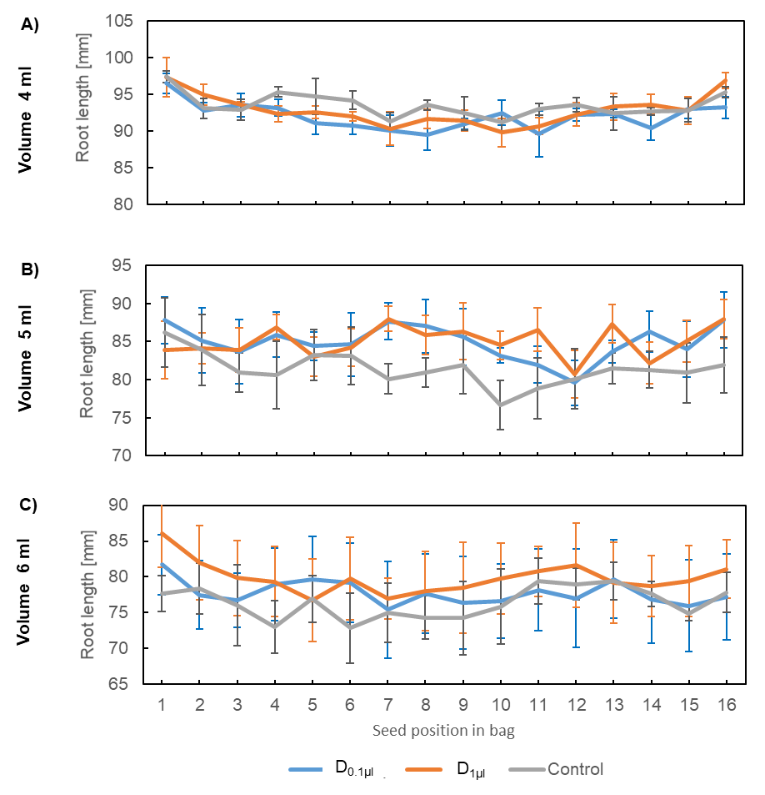
Figure S1. Root length of cress seedlings in Series W in dependence with the seedling position in bag and the dose factor by volume levels 4 ml (A), 5 ml (B), and 6 ml (C). Root length at day 6 for (A) and at day 7 for (B) and (C). One point represents the average root length (in mm) based on 73 ± 2 seedlings. Error bars represent ± standard error (n = 4). No significant difference between the dose treatments by the same seedling position was detected (Modell 2; p < 0.05, Tukey-Kramer-test).

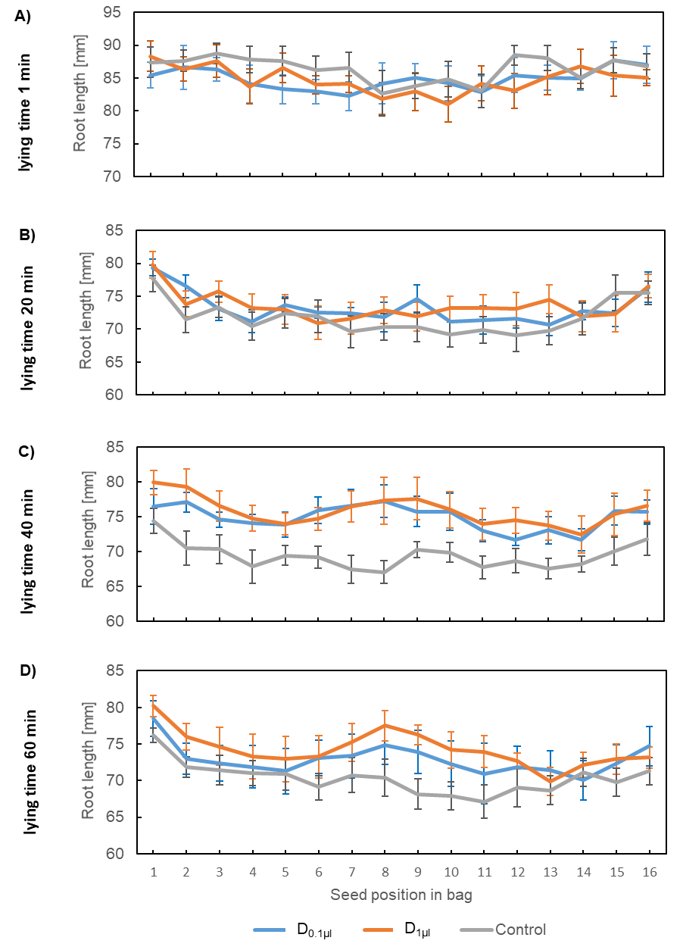
Figure S2. Root length of cress seedlings in Series G in dependence with the seedling position in bag and the dose factor by laying time levels 1 min (A), 20 min (B), 40 min (C), and 60 min (D). One point represents the average root length (in mm) based on 148 ± 4 seedlings. Error bars represent ± standard error (n = 8). No significant difference between the dose treatments by the same seedling position was detected (Modell 2; p < 0.05, Tukey-Kramer-test).

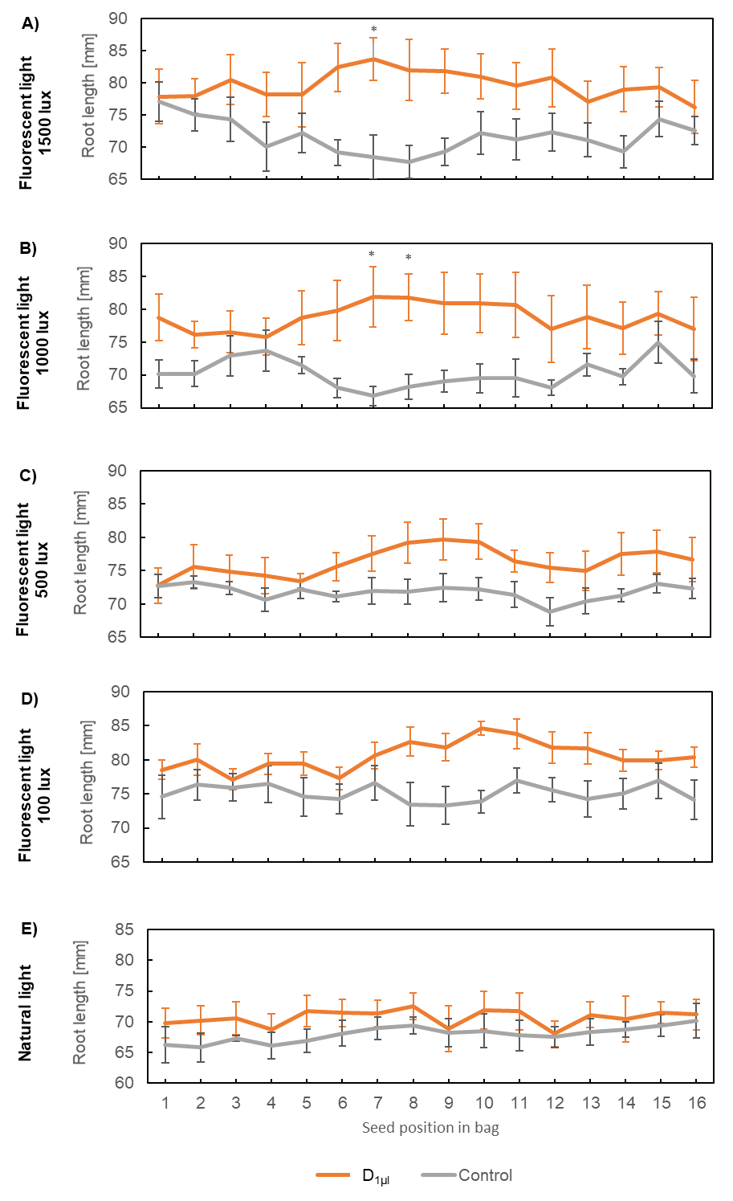
Figure S3. Root length of cress seedlings in Series L in dependence with the seedling position in bag and the dose factor by light levels FL 100 Lux (A), FL 500 Lux (B), FL 1000 Lux (C), FL 1500 Lux (D), and Natural light (E). One point represents the average root length (in mm) based on 106 ± 3 seedlings. Error bars represent ± standard error (n = 6). Asterisks indicate significant differences between D_{1µl} and Control by the same seedling position (Modell 2; p < 0.05, Tukey-Kramer-test).

