Table of Contents
Page Content
- ……………………………………………………………………………………….……..Table of Contents
- ………………………………………………………………………………………………. Legends
- ………………………………………………………………………………………………. PHF21A
- ………………………………………………………………………………………………. KCNQ3
- ………………………………………………………………………………………………. GPC5
- ………………………………………………………………………………………………. RANBP17
- ………………………………………………………………………………………………. ELP4
- ………………………………………………………………………………………………. CNKSR2
- ………………………………………………………………………………………………. NAV2
- ………………………………………………………………………………………………. GDI2
- ………………………………………………………………………………………………. EIF2B3
- ………………………………………………………………………………………………. ATP6VE1
- ………………………………………………………………………………………………. PGAM1
- ………………………………………………………………………………………………. CCK
- ………………………………………………………………………………………………. ATP6V1D
- ………………………………………………………………………………………………. RSRC2
- ………………………………………………………………………………………………. SAP18
- ………………………………………………………………………………………………. GFAP
- ………………………………………………………………………………………………. ARPP19
- ………………………………………………………………………………………………. EIF1B
- ………………………………………………………………………………………………. PLP1
- ………………………………………………………………………………………………. PCP4
- ………………………………………………………………………………………………. GRID2
- ………………………………………………………………………………………………. PCDH7
- ………………………………………………………………………………………………. SLC2A13
- ………………………………………………………………………………………………. RASGEF1B
- ………………………………………………………………………………………………. LRP1B
- ………………………………………………………………………………………………. CCSER1
- ………………………………………………………………………………………………. SLC26A3

Coronal Slices
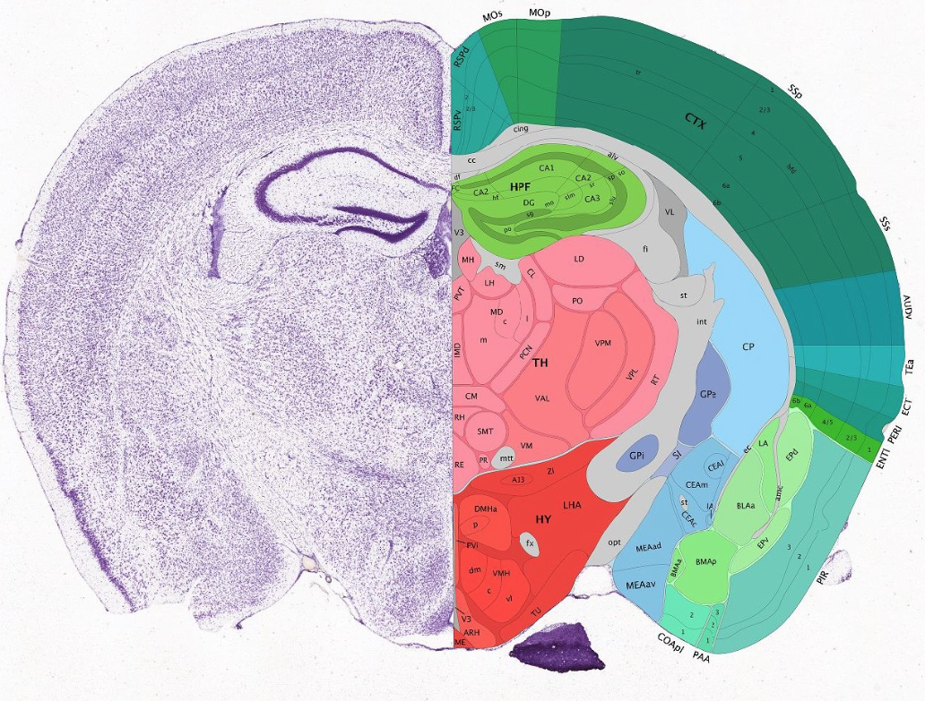
Sagittal Slices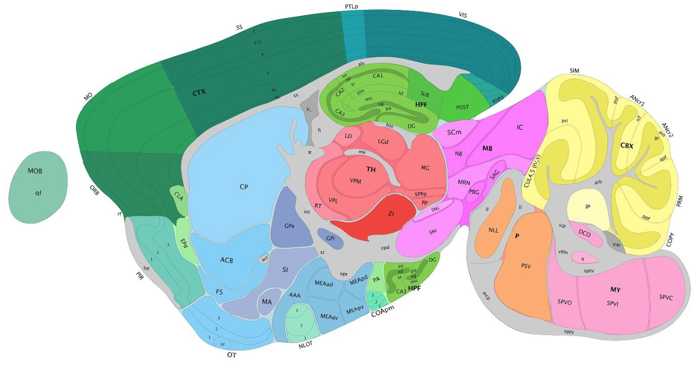

PHF21A
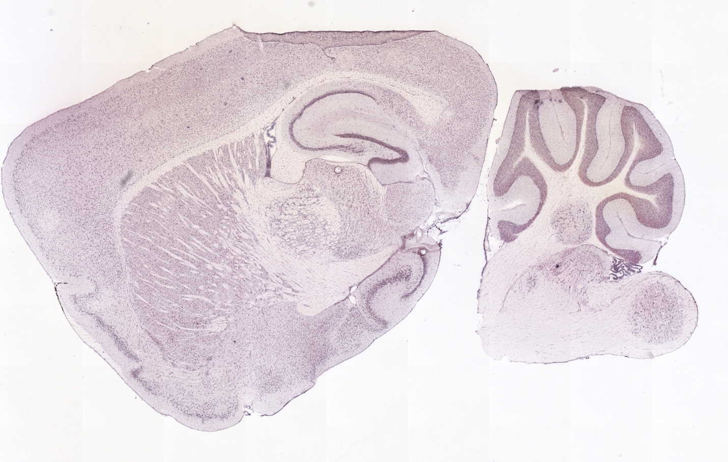
Click Here to Return to Table of Contents

KCNQ3
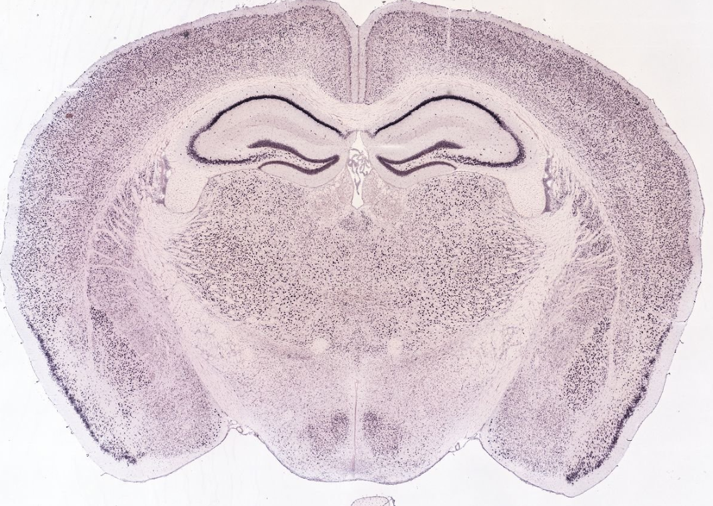
Click Here to Return to Table of Contents

GPC5
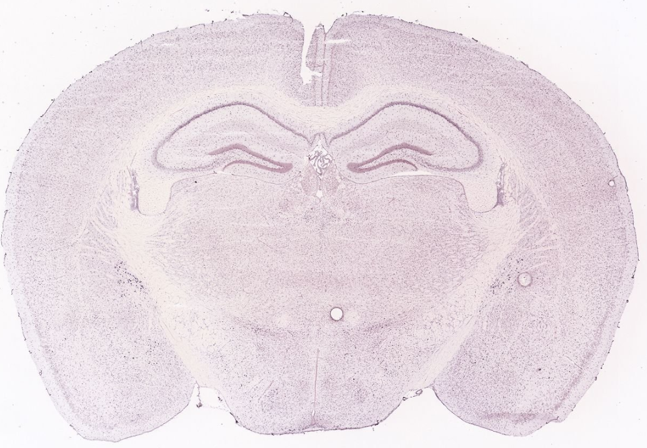
Click Here to Return to Table of Contents

RANBP17
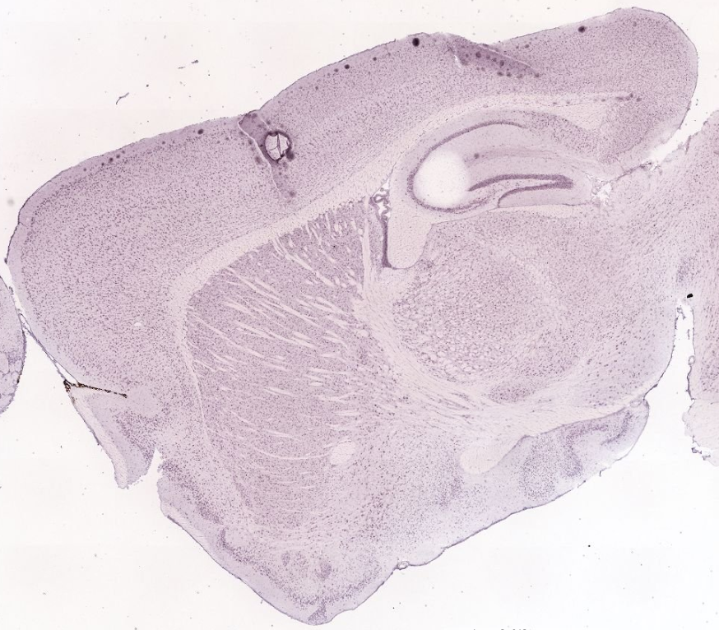
Click Here to Return to Table of Contents

ELP4
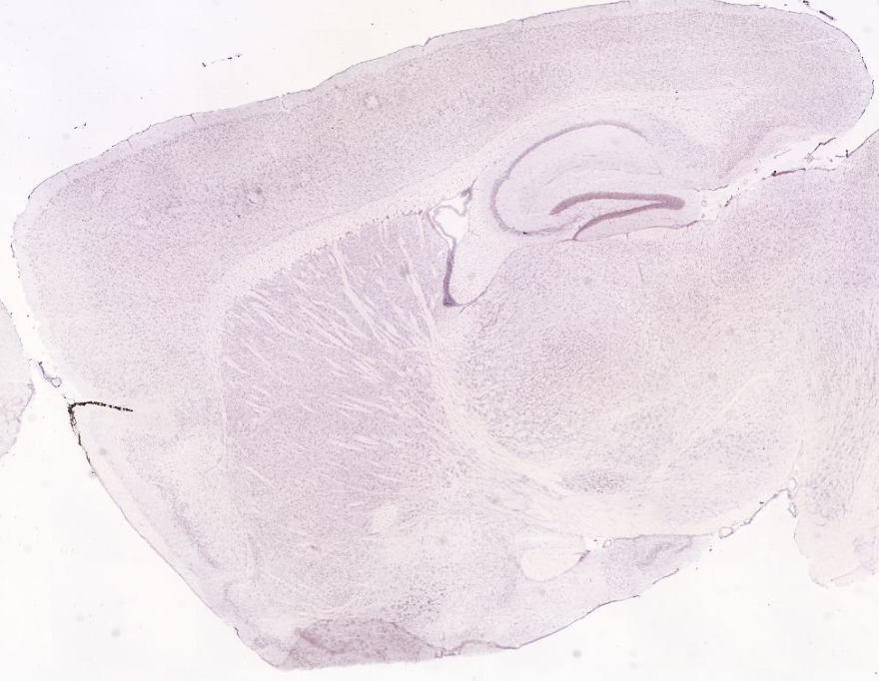
Click Here to Return to Table of Contents

CNKSR2
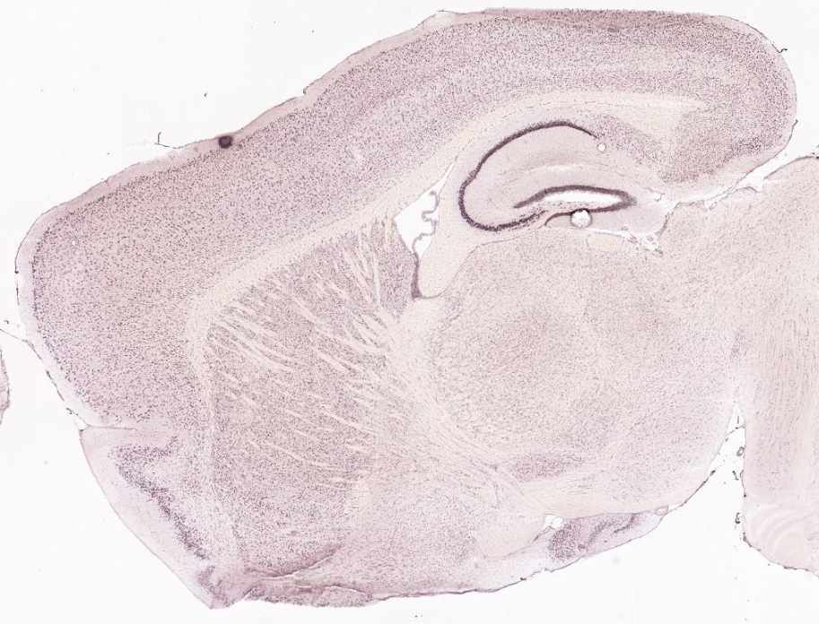
Click Here to Return to Table of Contents

NAV2
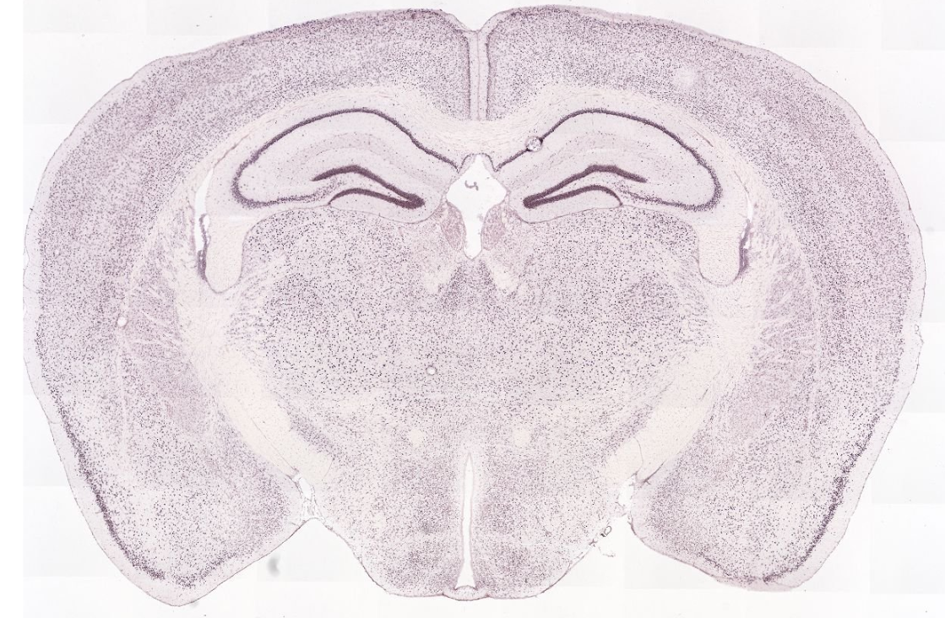
Click Here to Return to Table of Contents

GDI2
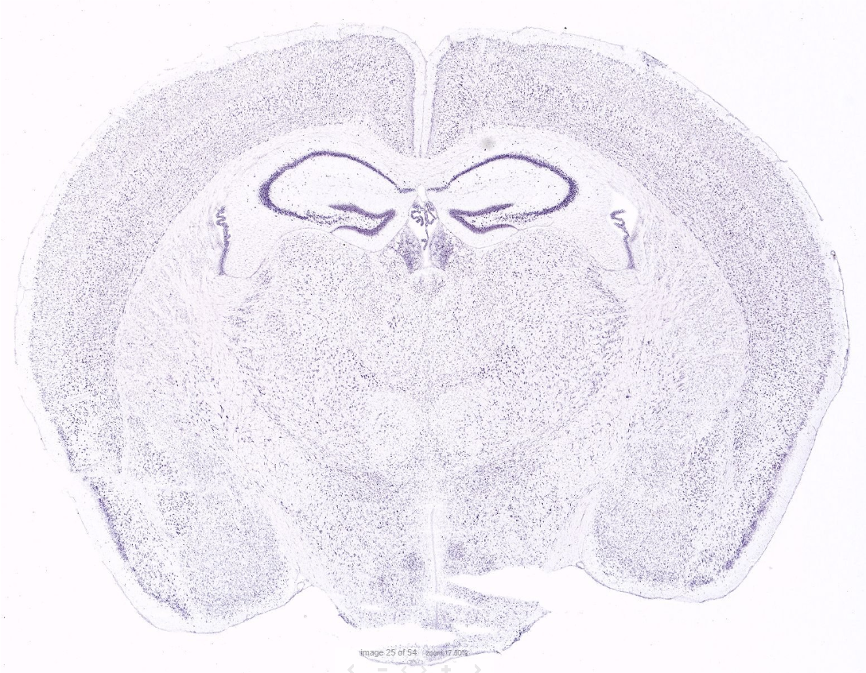
Click Here to Return to Table of Contents

EIF2B3
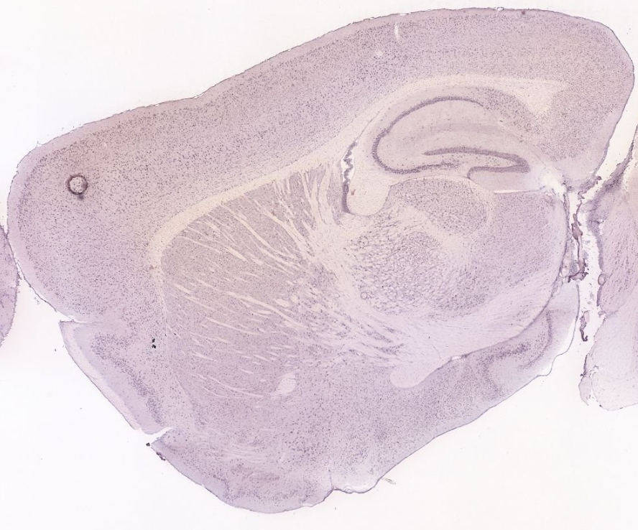
Click Here to Return to Table of Contents

ATP6V1E1
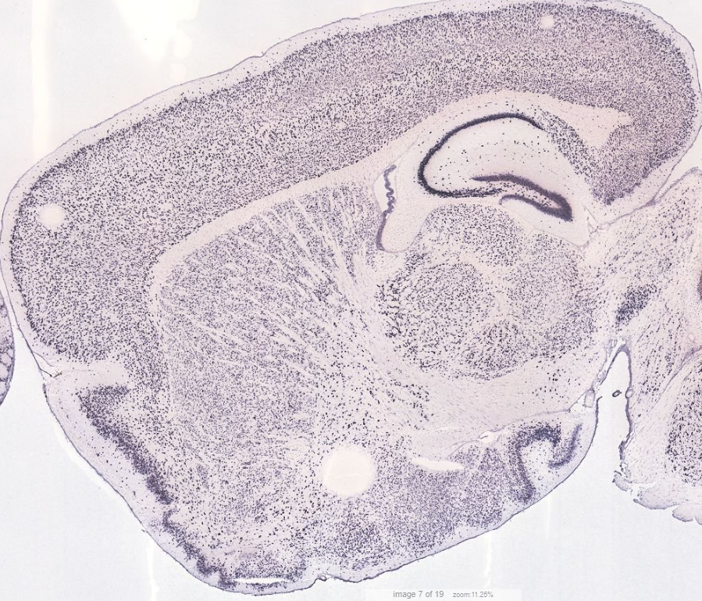
Click Here to Return to Table of Contents

PGAM 1
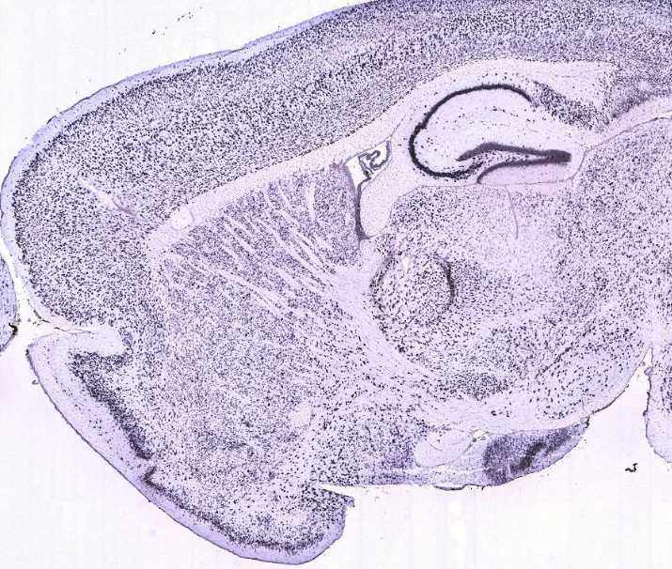
Click Here to Return to Table of Contents

CCK
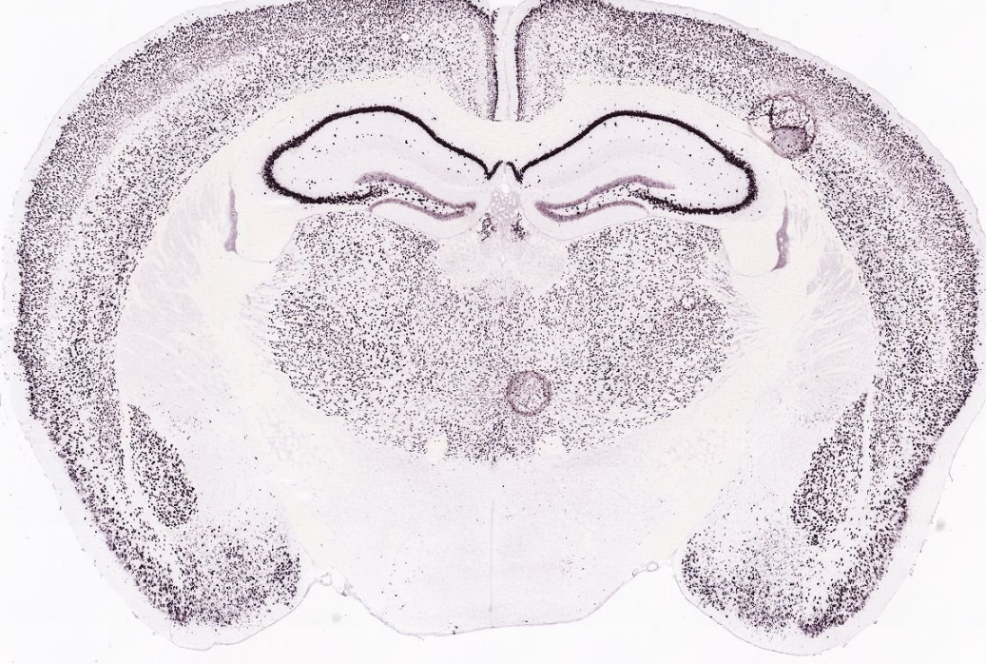
Click Here to Return to Table of Contents

ATP6V1D
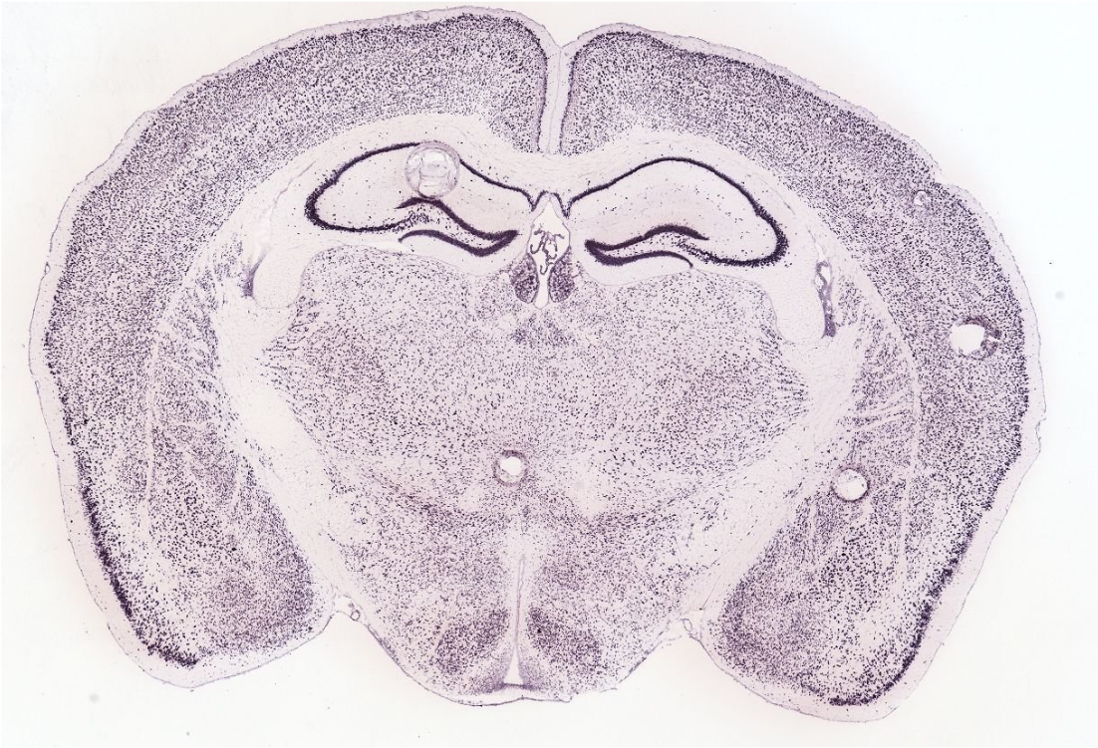
Click Here to Return to Table of Contents

RSRC2
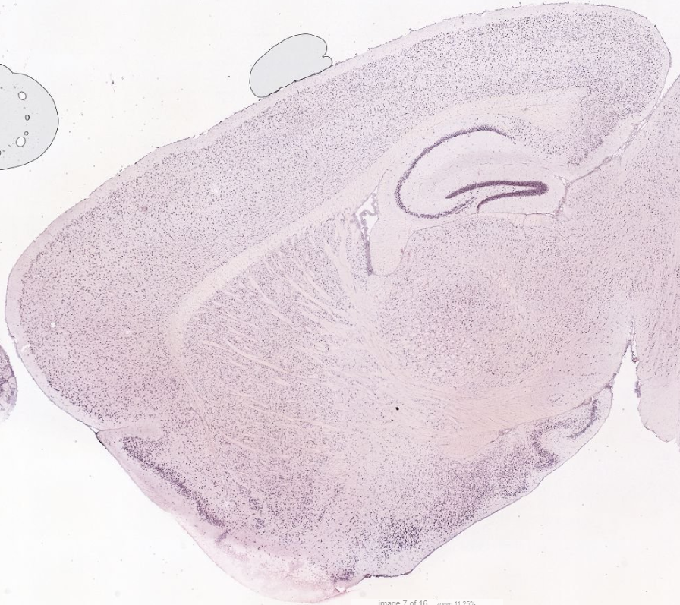
Click Here to Return to Table of Contents

SAP18
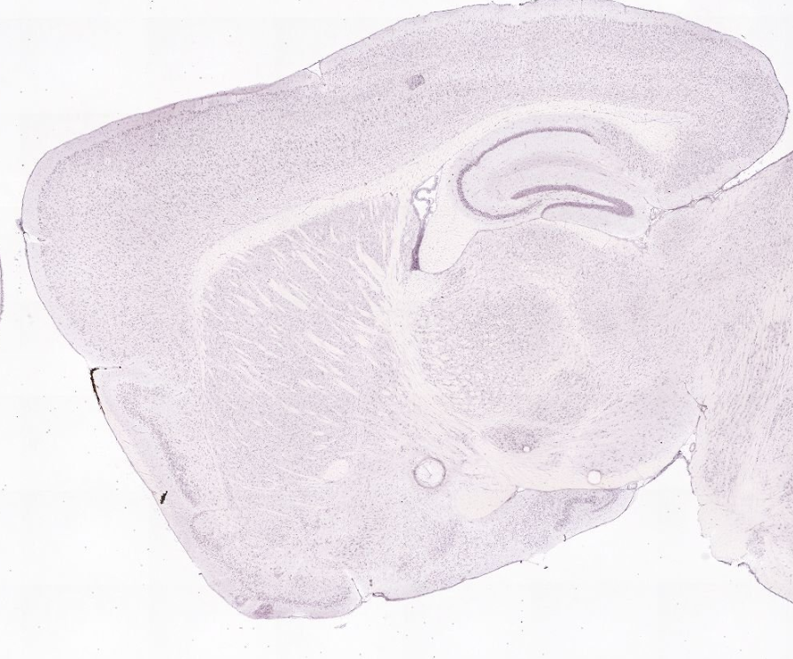
Click Here to Return to Table of Contents

GFAP
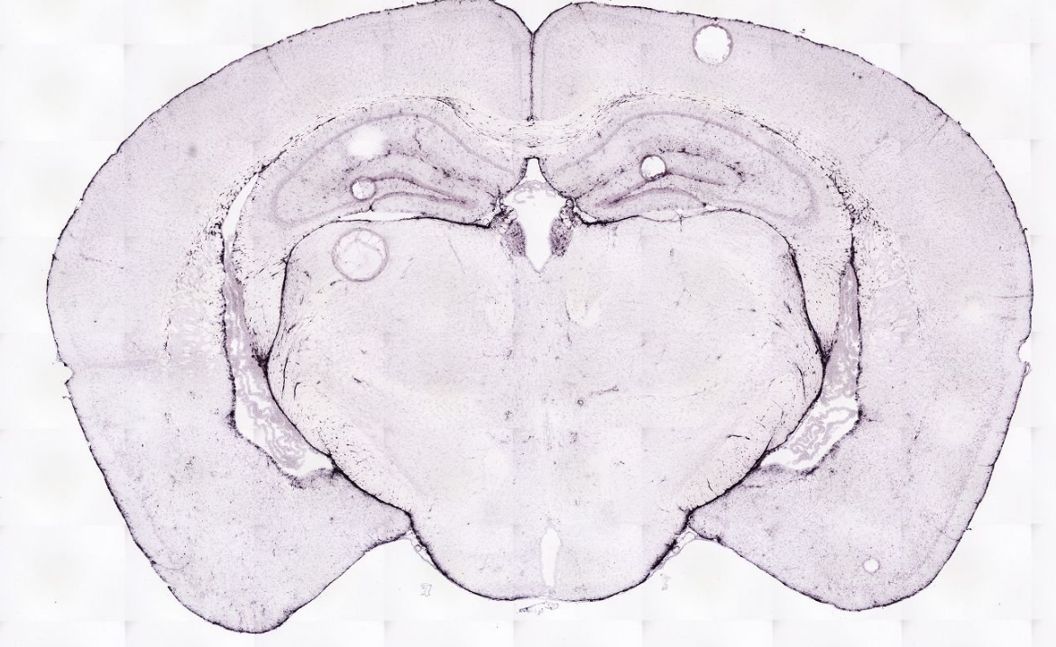
Click Here to Return to Table of Contents

ARRP19
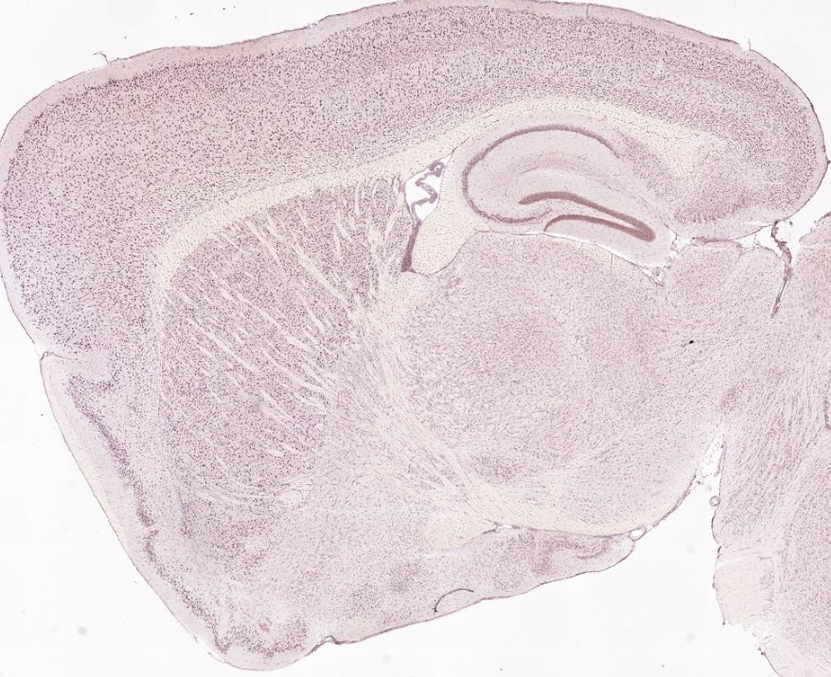
Click Here to Return to Table of Contents

EIF1B
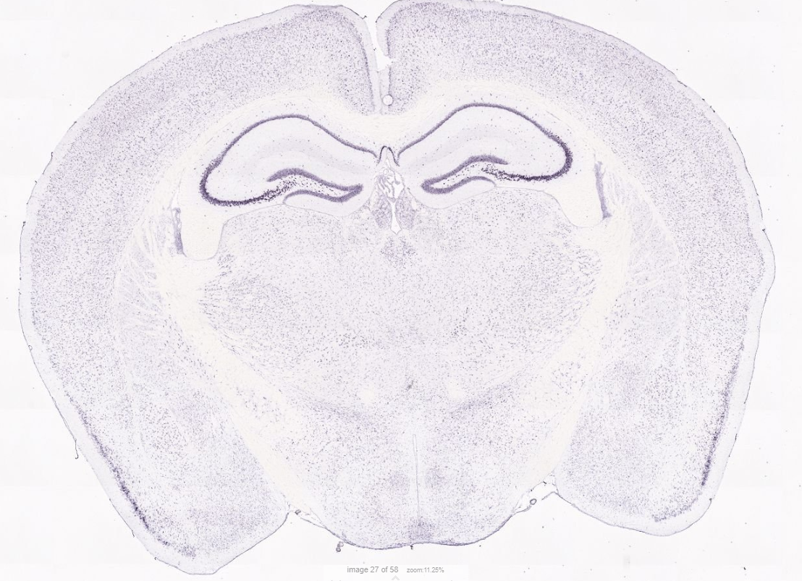
Click Here to Return to Table of Contents

PLP1
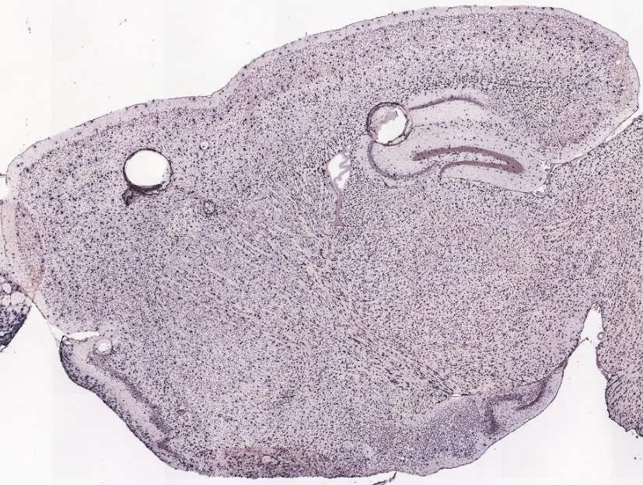
Click Here to Return to Table of Contents

PCP4
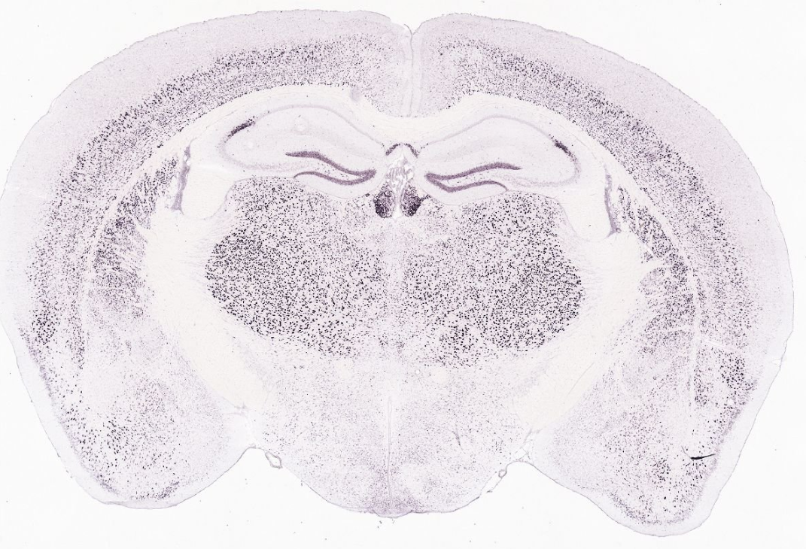
Click Here to Return to Table of Contents

GRID2
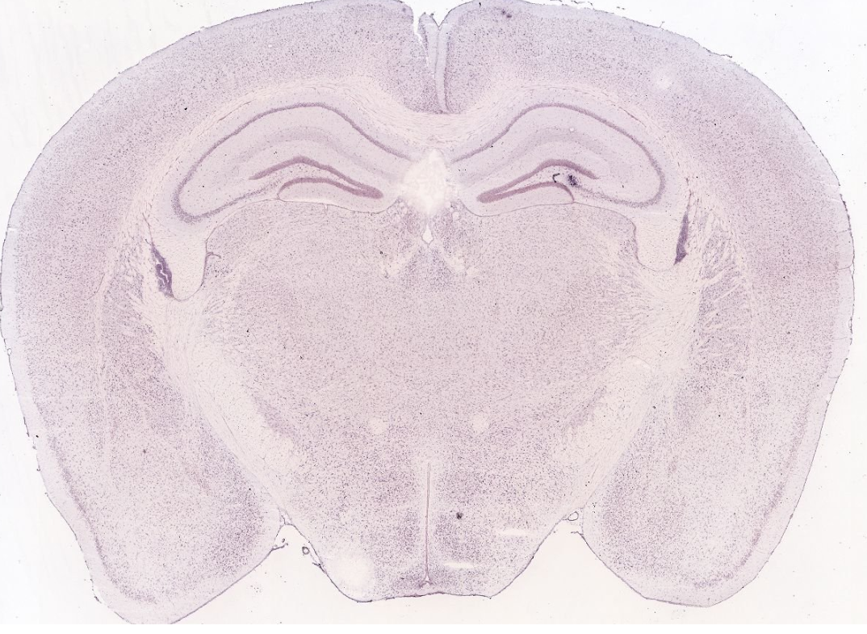
Click Here to Return to Table of Contents

PCDH7
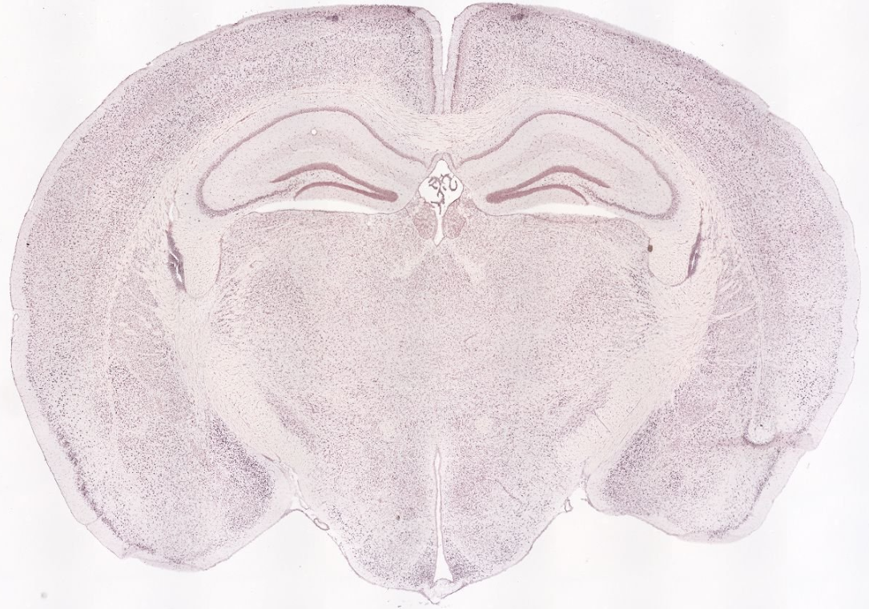
Click Here to Return to Table of Contents

SLC2A13
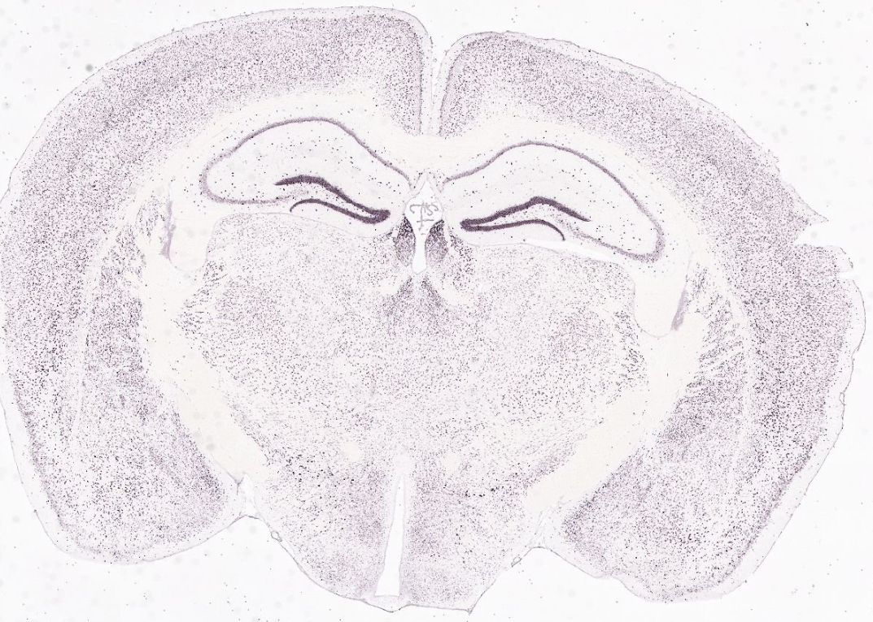
Click Here to Return to Table of Contents

RASGEF1B
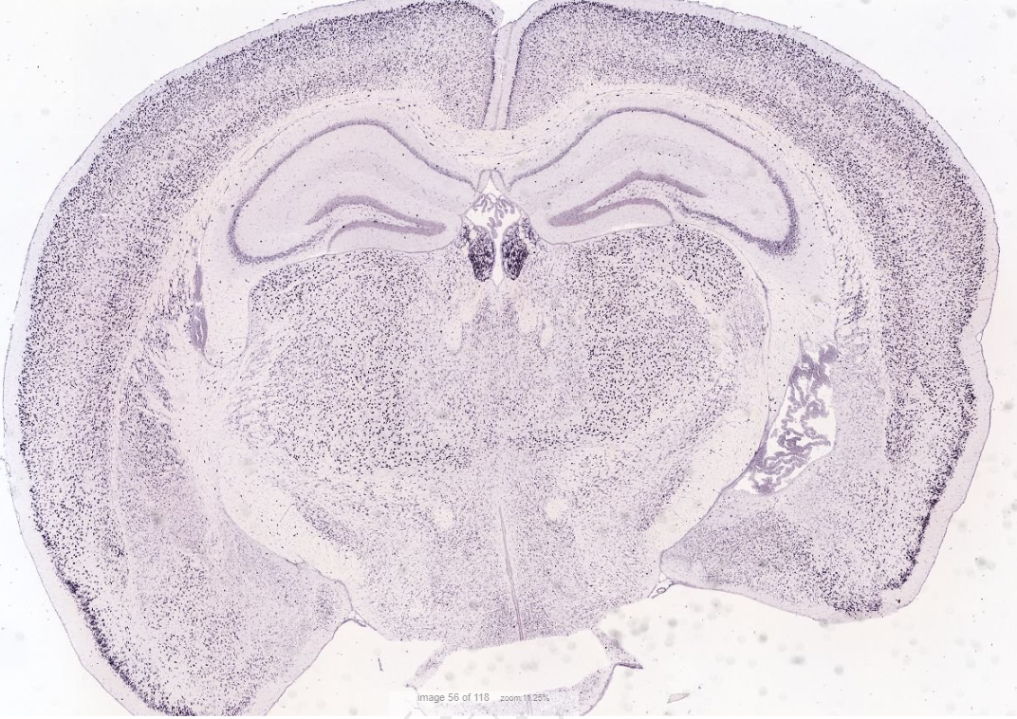
Click Here to Return to Table of Contents

LRP1B
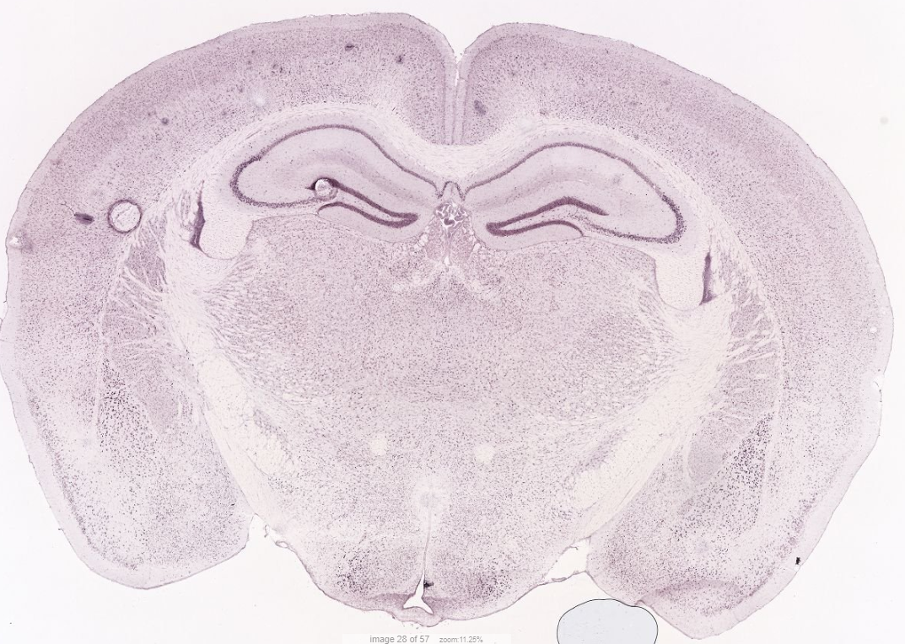
Click Here to Return to Table of Contents

CCSER1
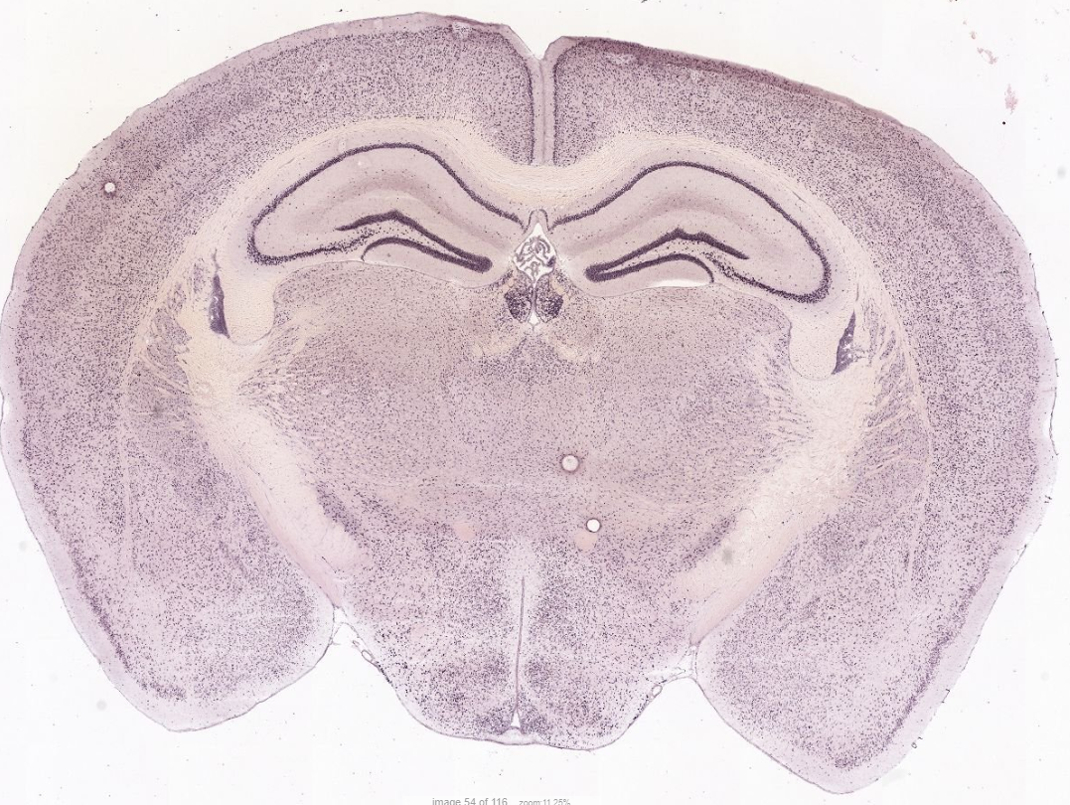
Click Here to Return to Table of Contents

SLC26A3
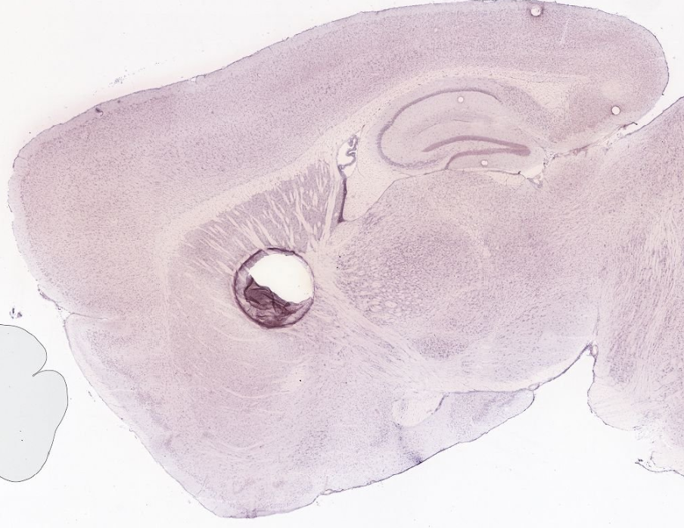
Click Here to Return to Table of Contents

