Gene | ALLEN DEVELOPING MOUSE BRAIN DATA
ALDH5A1 | HEAT MAP |  |  | 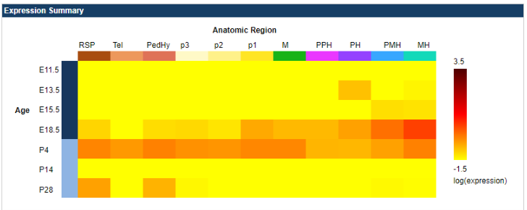
 | IN SITUS | E11.5 |  | No Expression | 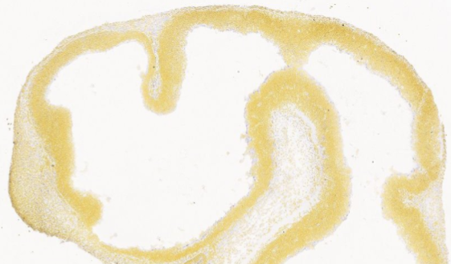
 |  | E13.5 |  | No Expression | 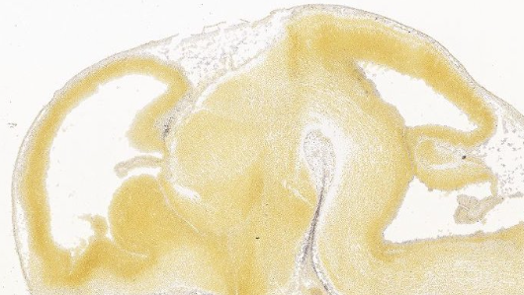
 |  | E15.5 |  | No Expression | 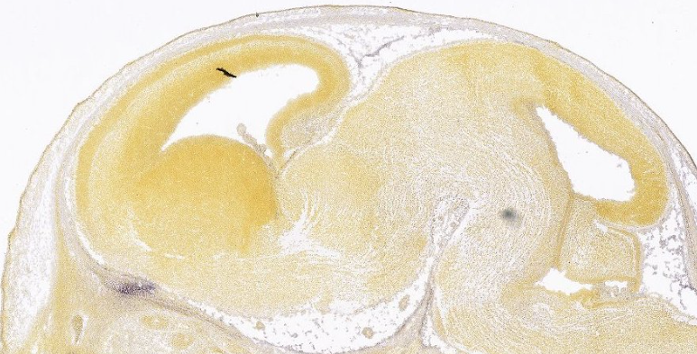
 |  | E18.5 |  | No Expression | 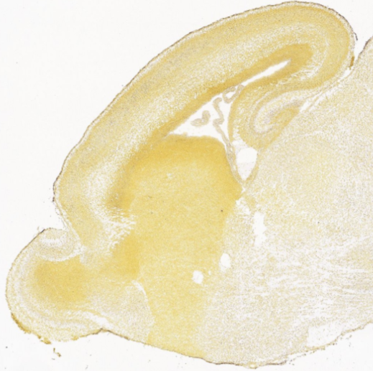
 |  | P4 |  | Low Expresion | 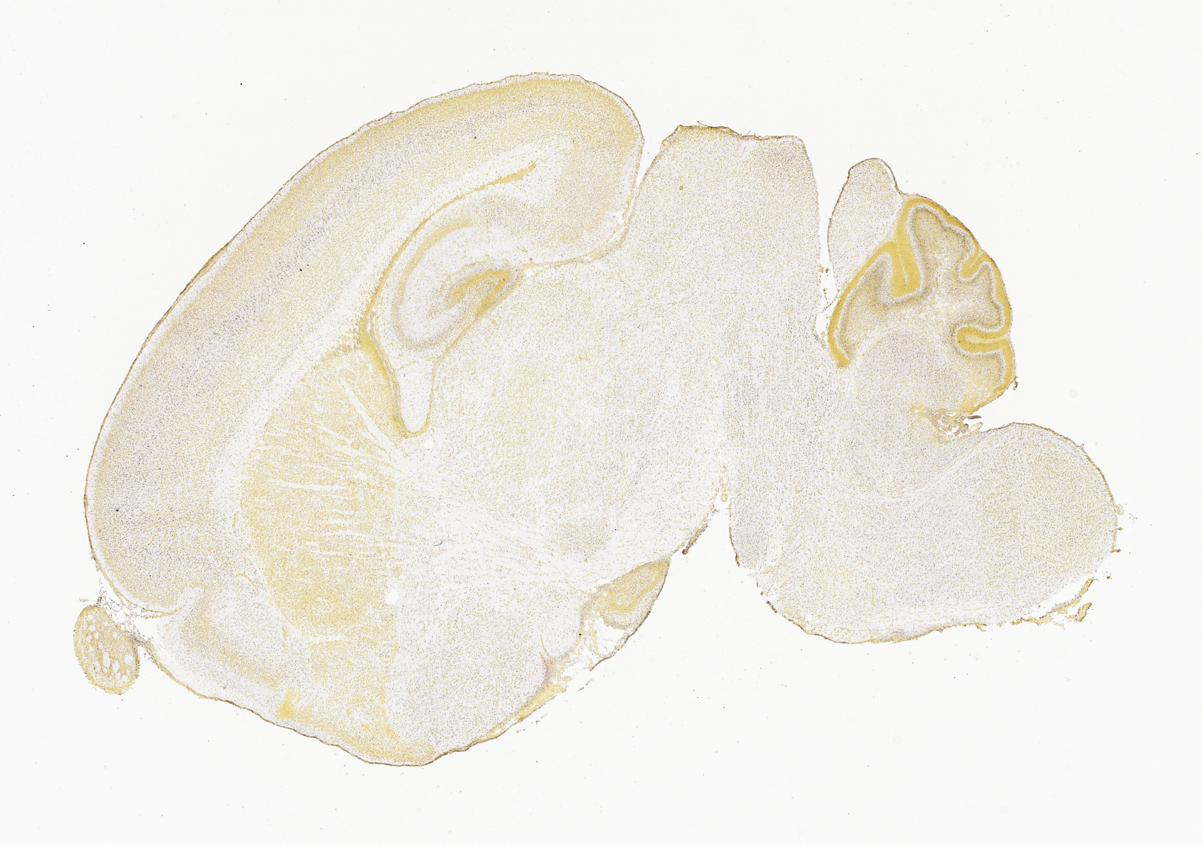
KCNQ3 | HEAT MAP |  |  | 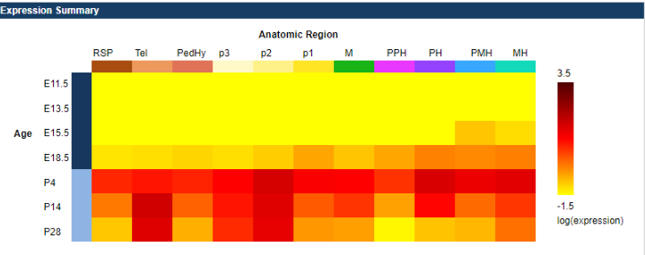
 | IN SITUS |  | E11.5 | No Expression | 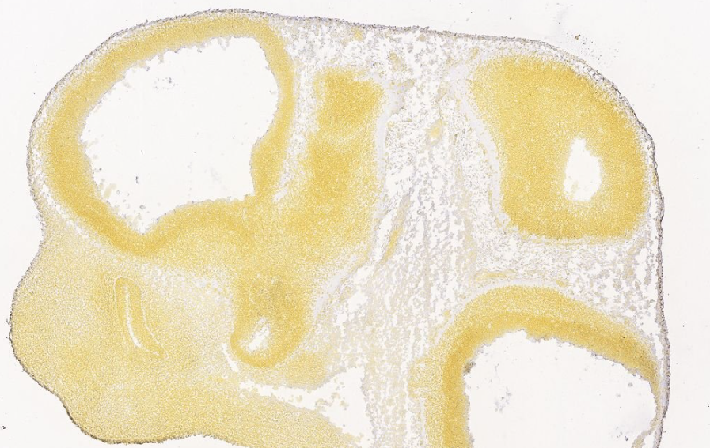
 |  |  | E13.5 | No Expression | 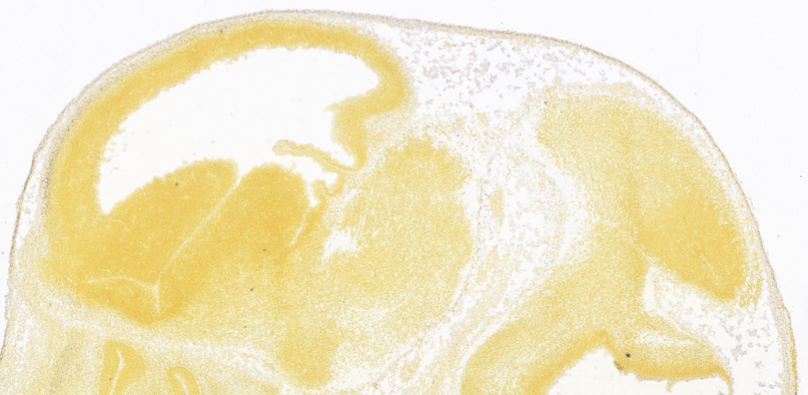
 |  |  | E15.5 | No Expression | 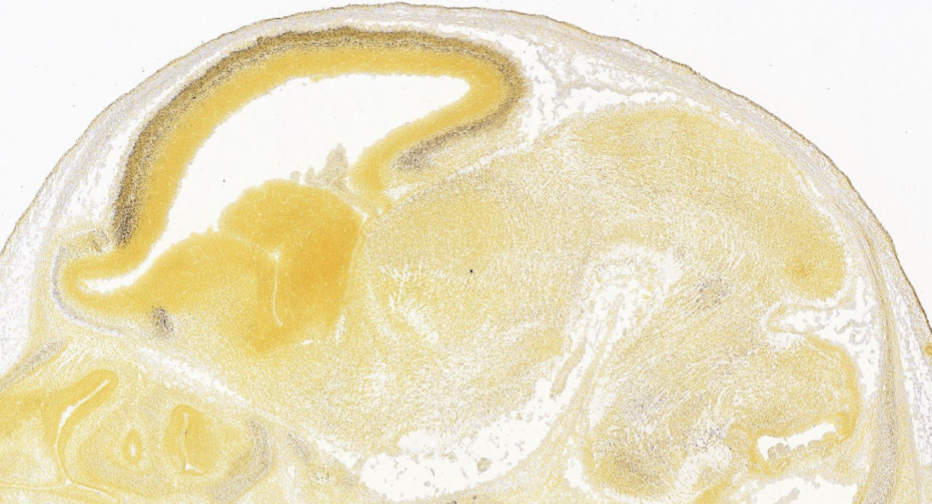
 |  |  | E18.5 | No Expression | 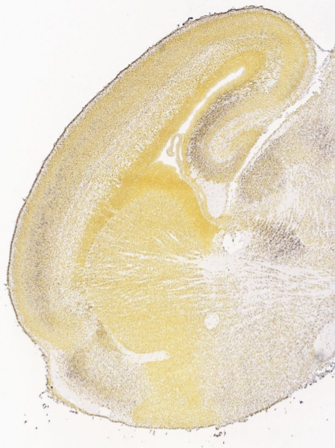
 |  |  | P4 | High Expression | 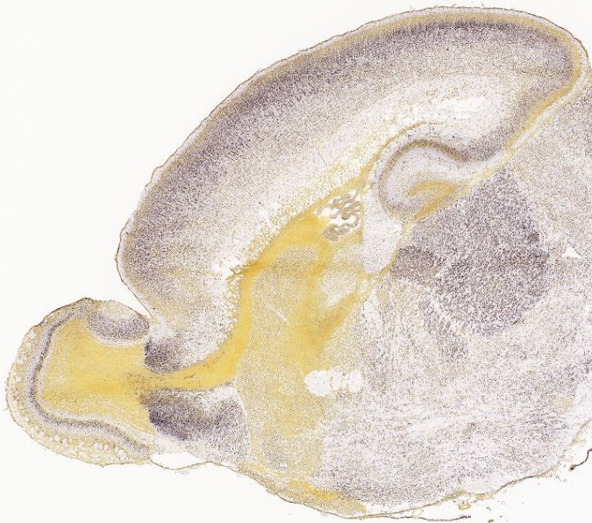
GFAP | HEAT MAP |  |  | 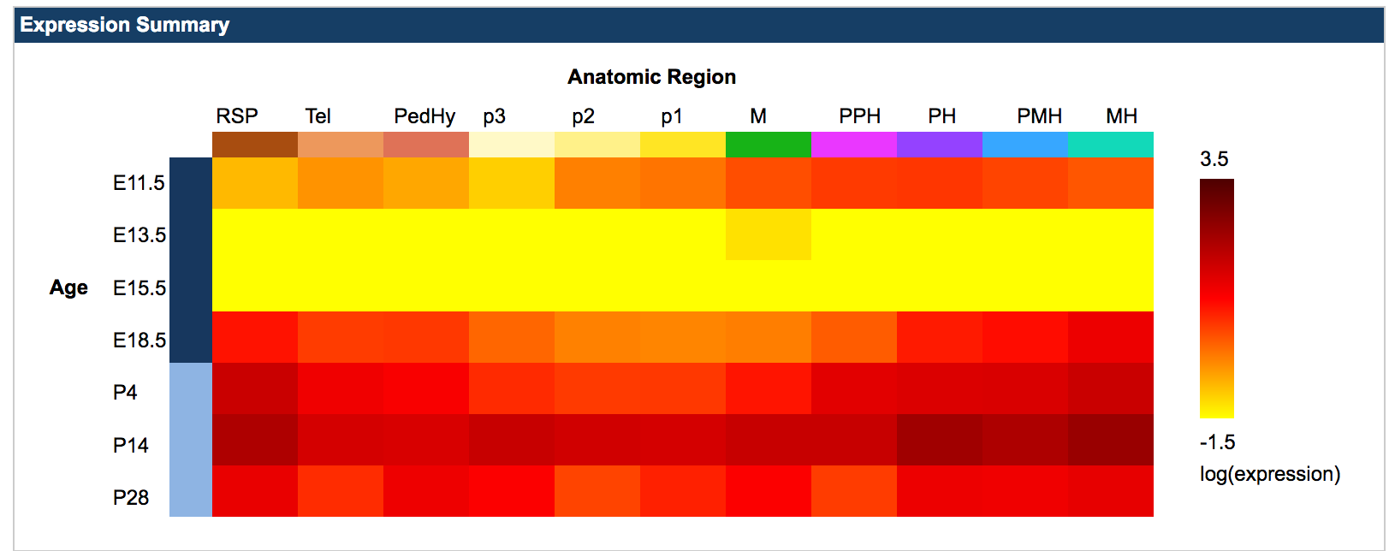
 | IN SITUS |  | E11.5 | Low Expression
 |  |  | E13.5 | No  Expression
 |  |  | E15.5 | No  Expression
 |  |  | E18.5 | High Expression
 |  |  | P4 | High  Expression | 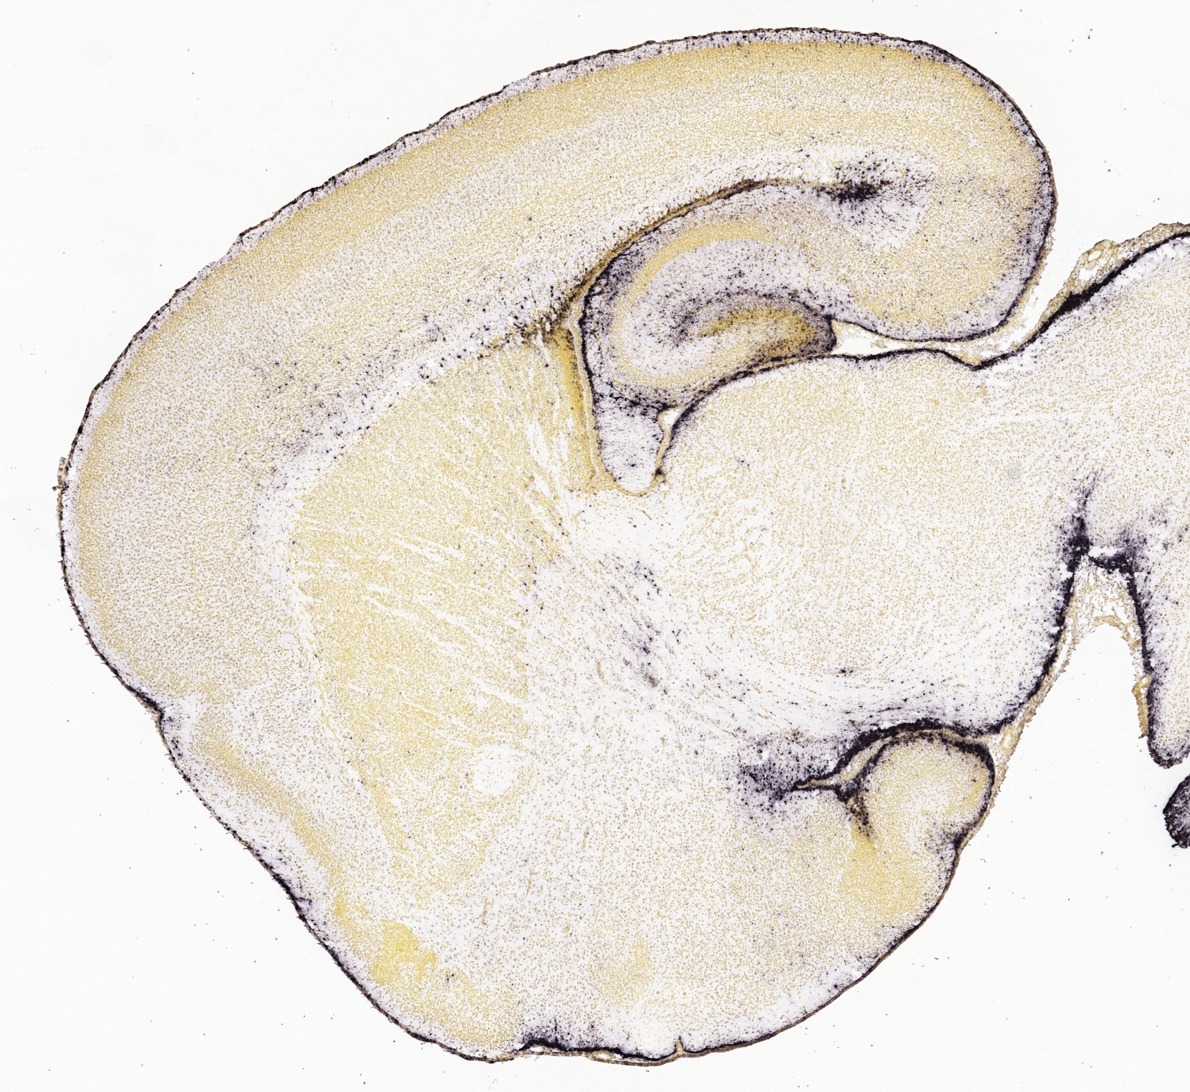
RELN | HEAT MAP |  |  | 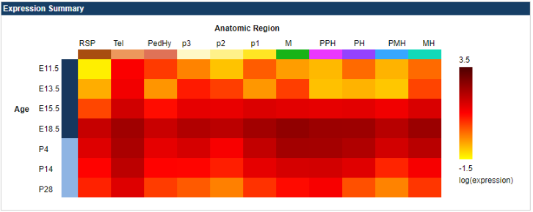
 | IN SITUS |  | E11.5 | Low  Expression | 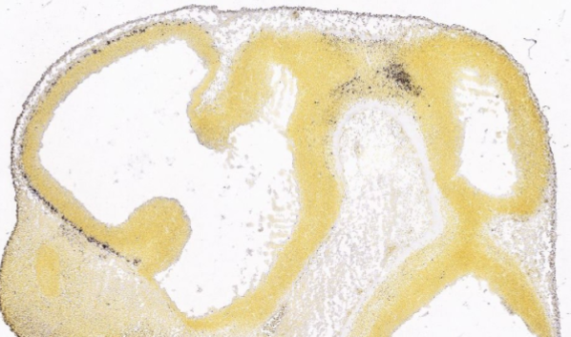
 |  |  | E13.5 | High  Expression | 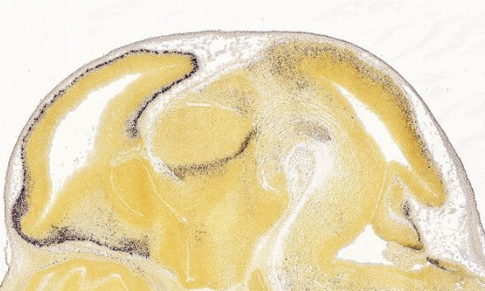
 |  |  | E15.5 | High  Expression | 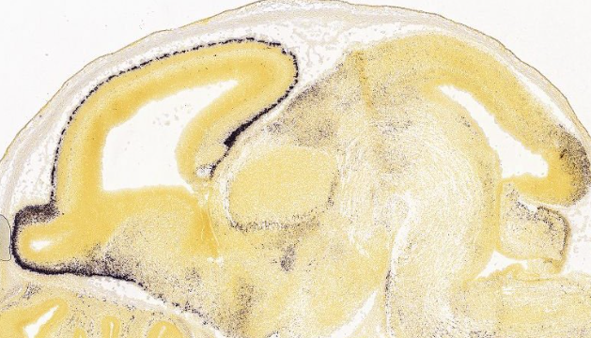
 |  |  | E18.5 | High Expression | 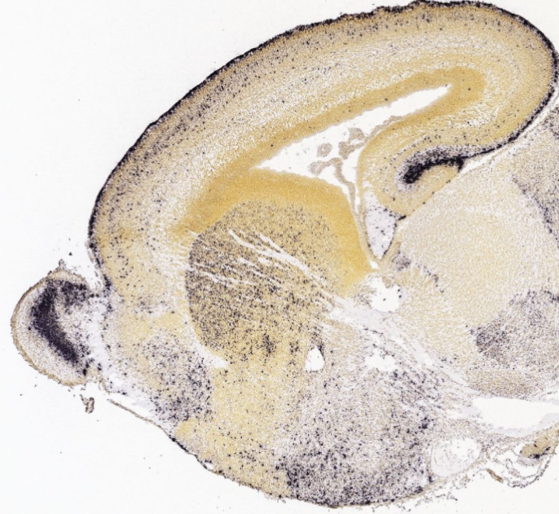
 |  |  | P4 | High  Expression | 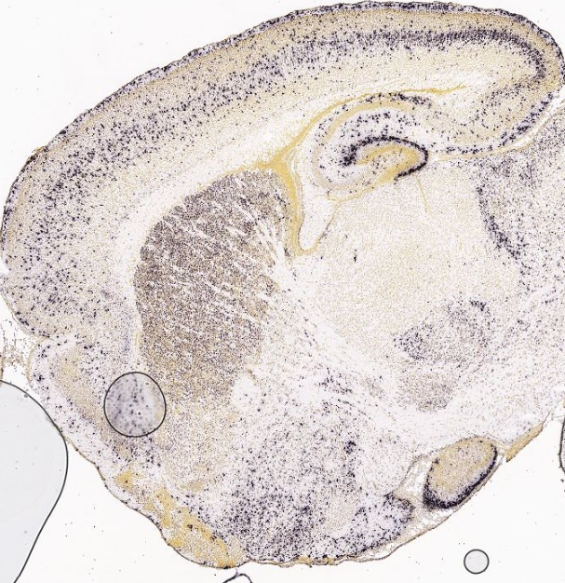
NRXN1 | HEAT MAP |  |  | 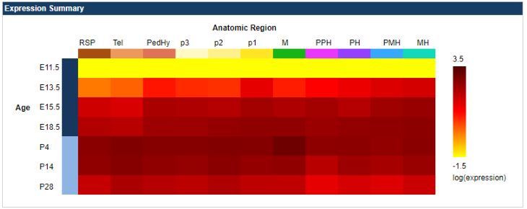
 | IN SITUS |  | E11.5 | No Expression | 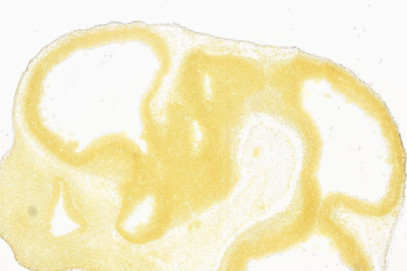
 |  |  | E13.5 | LowExpression | 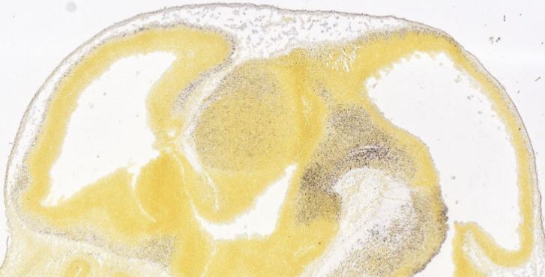
 |  |  | E15.5 | High  Expression | 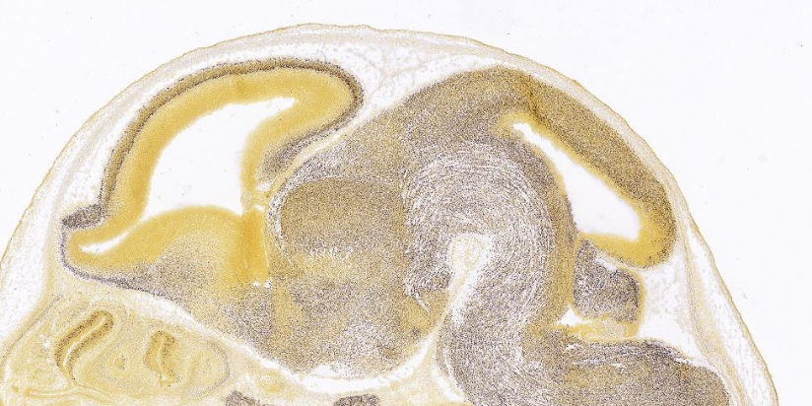
 |  |  | E18.5 | High Expression | 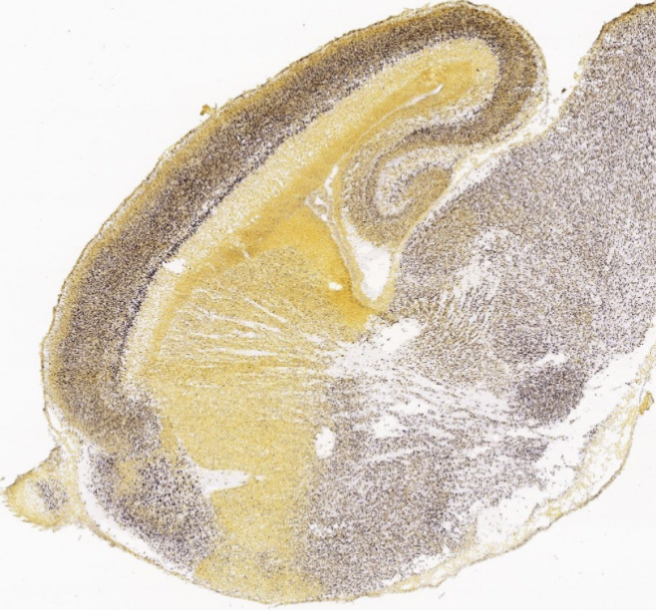
 |  |  | P4 | High  Expression | 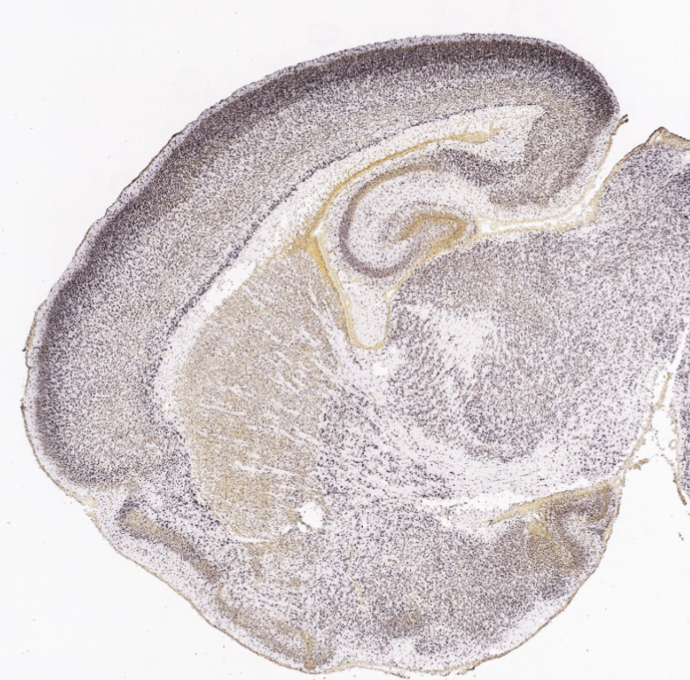
GRIN2B | HEAT MAP |  |  | 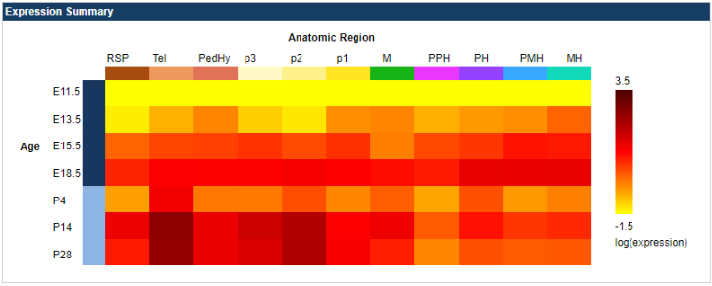
 | IN SITUS |  | E11.5 | No Expression | 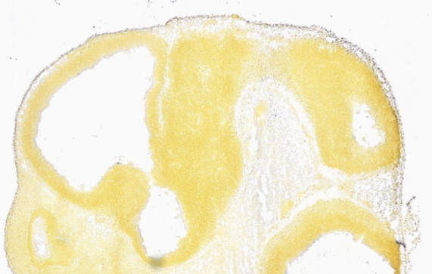
 |  |  | E13.5 | Low  Expression | 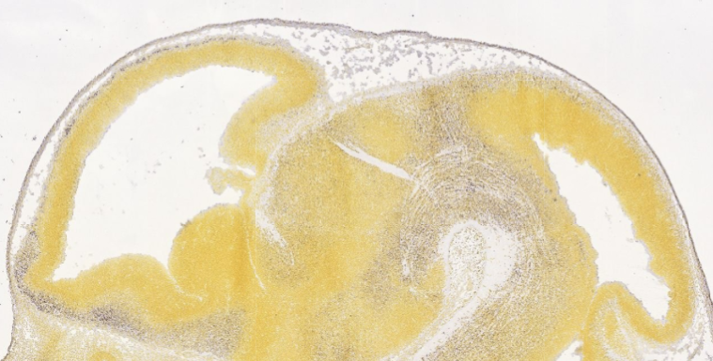
 |  |  | E15.5 | Low  Expression | 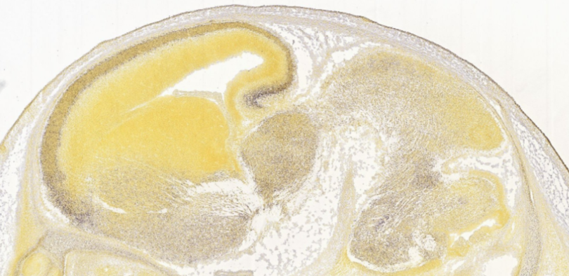
 |  |  | E18.5 | High  Expression | 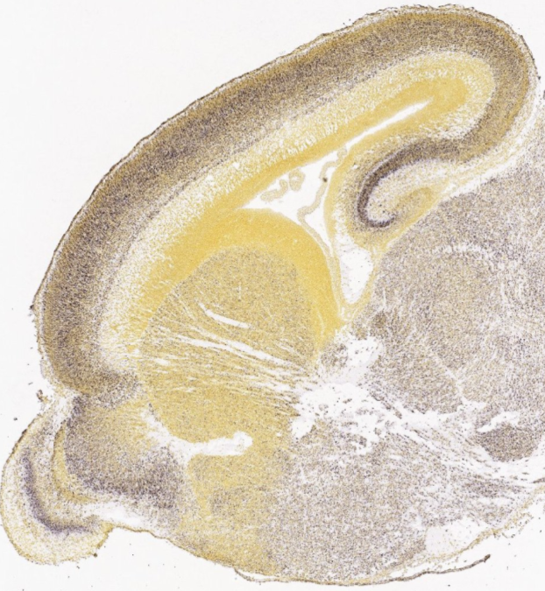
 |  |  | P4 | High  Expression | 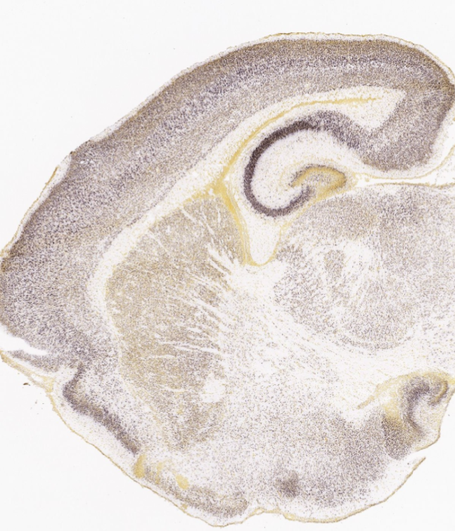
GRIN1 | HEAT MAP |  |  | 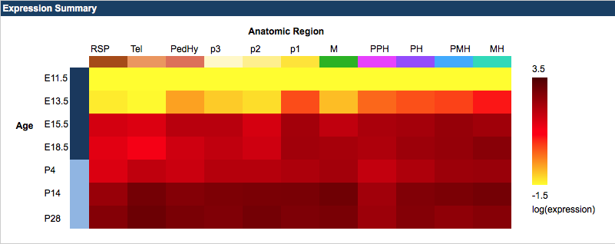
 | IN SITUS |  | E11.5 | No Expression | 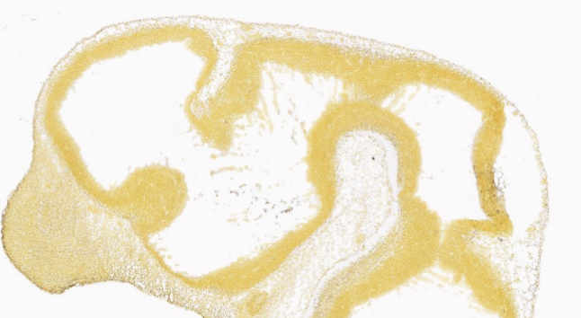
 |  |  | E13.5 | Low  Expression | 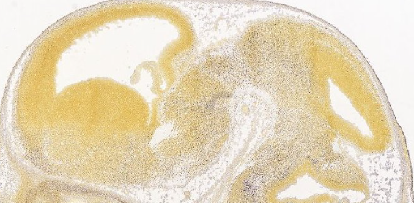
 |  |  | E15.5 | High Expression | 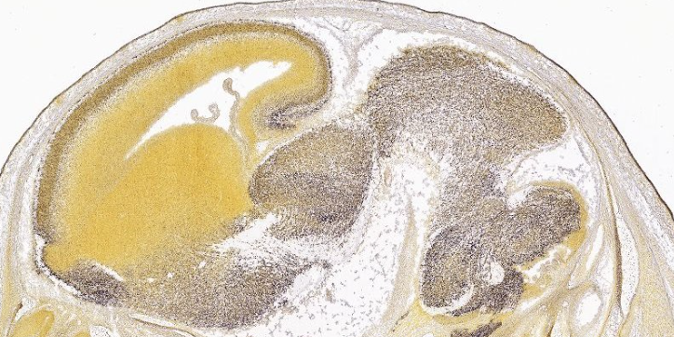
 |  |  | E18.5 | High Expression | 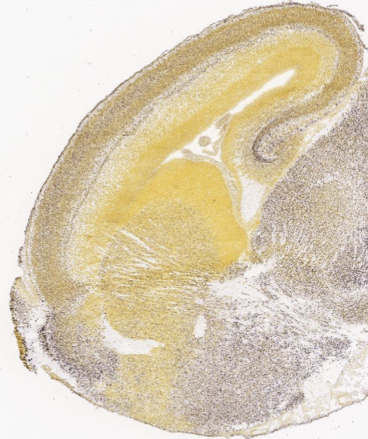
 |  |  | P4 | High Expression | 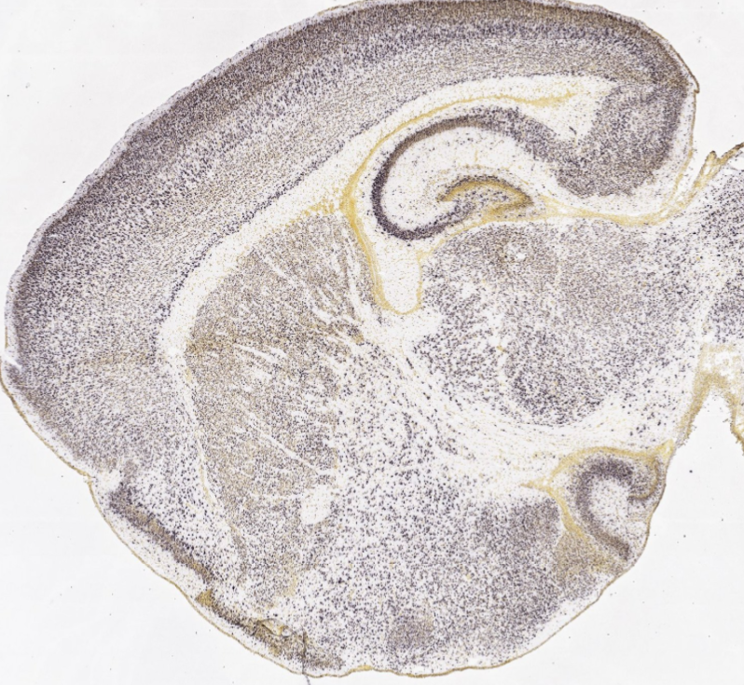
ACHE | HEAT MAP |  |  | 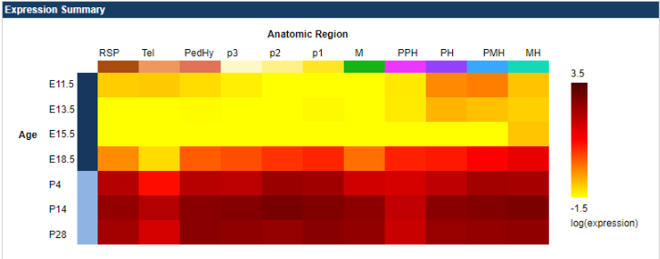
 | IN SITUS |  | E11.5 | No Expression | 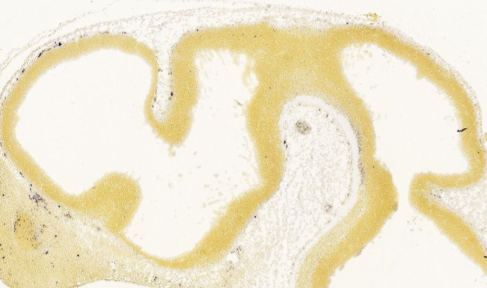
 |  |  | E13.5 | Low  Expression | 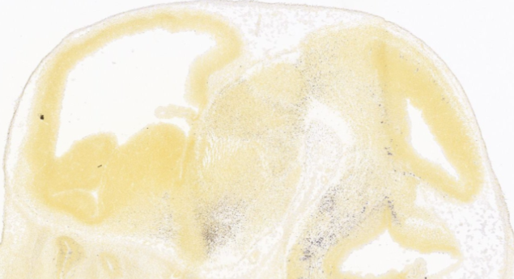
 |  |  | E15.5 | No Expression | 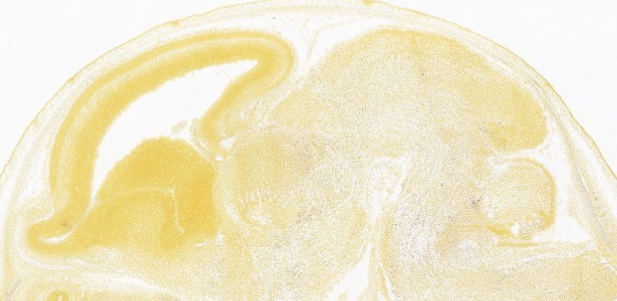
 |  |  | E18.5 | Low  Expression | 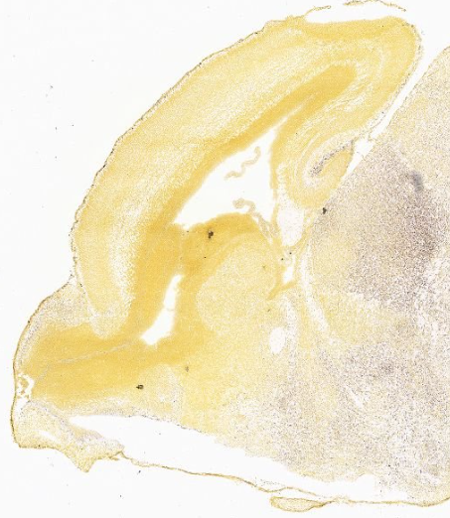
 |  |  | P4 | High  Expression | 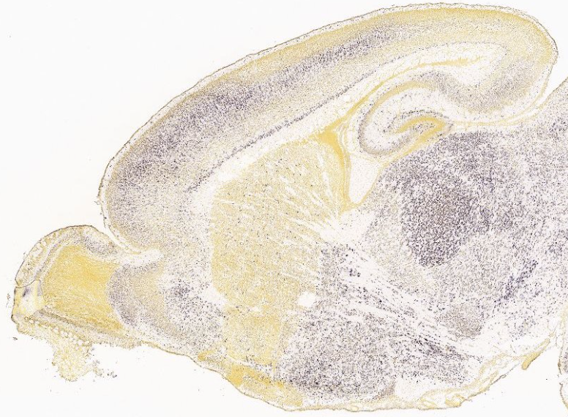
MYT1L | HEAT MAP |  |  | 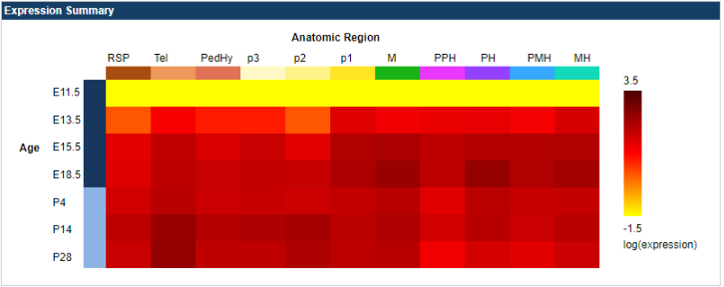
 | IN SITUS |  | E11.5 | Low  Expression | 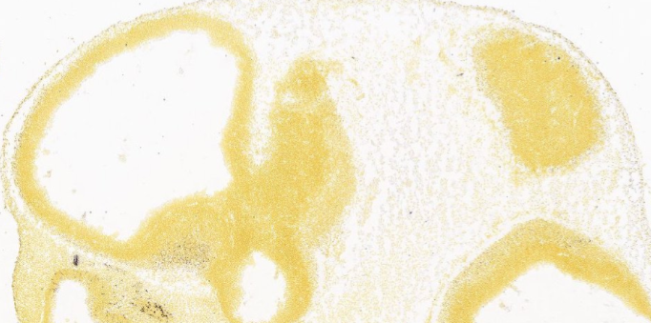
 |  |  | E13.5 | High Expression | 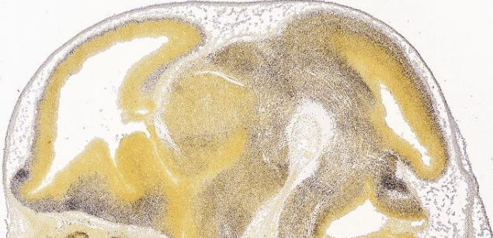
 |  |  | E15.5 | High Expression | 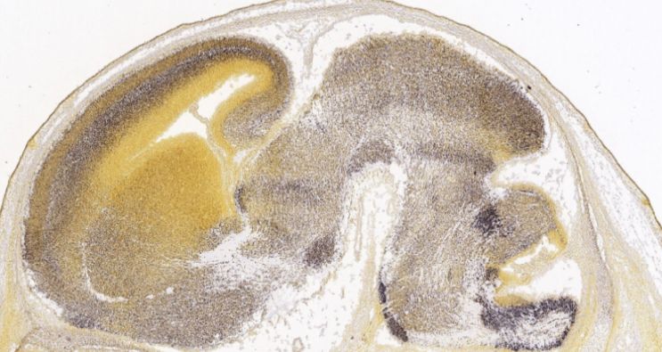
 |  |  | E18.5 | High Expression | 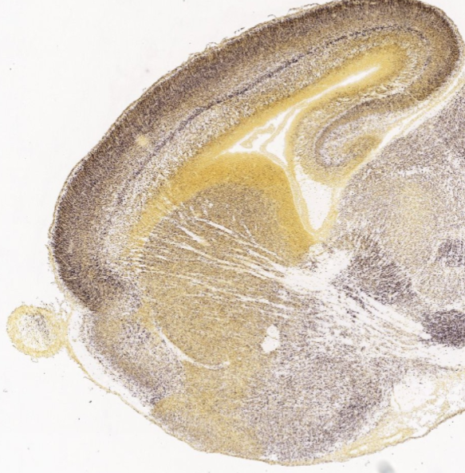
 |  |  | P4 | High Expression | 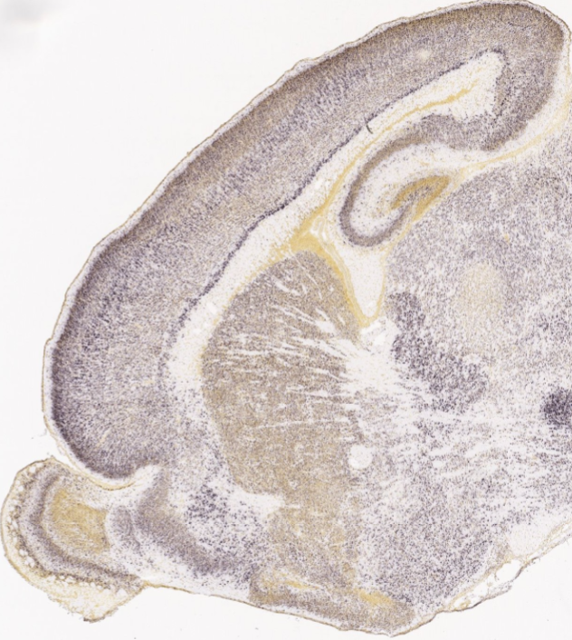
PTEN | HEAT MAP |  |  | 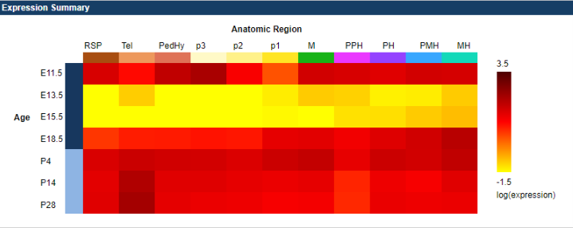
 | IN SITUS |  | E11.5 | High Expression | 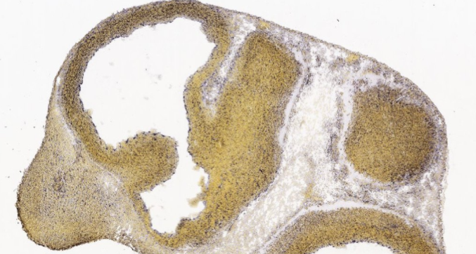
 |  |  | E13.5 | No Expression | 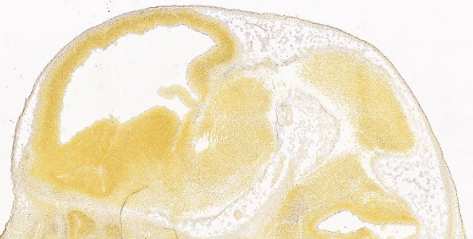
 |  |  | E15.5 | No Expression | 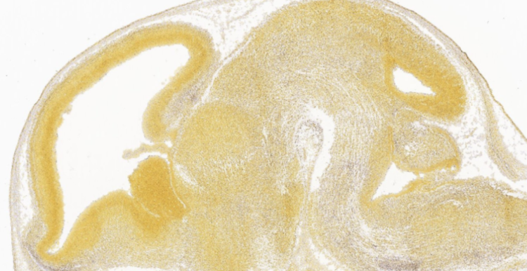
 |  |  | E18.5 | Low  Expression | 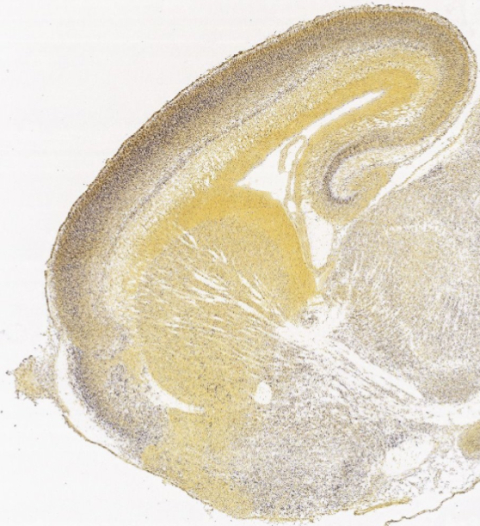
 |  |  | P4 | High  Expression | 