Additional file
Table S1. Food security of access by period and by province (% of site)
 |  | Food secure | Mildly food insecure | Moderately food insecure | Severely food insecure
lean period | Seno | 1.5 | 2 | 13 | 83.5
 | Yatenga | 10.5 | 17 | 41 | 31.5
Flush period | Seno | 22 | 11 | 18 | 49
 | Yatenga | 14.5 | 45 | 24 | 16.5

Table S2. Intensification practices adopted in Seno for the 2015 cropping period (% of households)
 | Adopted | Not adopted
Improved livestock breeds | 1 | 99
Value additionª | 76 | 24
Irrigate cash crops | 6 | 94
Fertiliser | 20.5 | 79.5
Improved seed | 31.5 | 68.5
a value addition of crops such as dehusking, hulling, polishing, milling ect.

Table S3. Intensification practices adopted in Yatenga for the 2015 cropping period (% of households)
 | Adopted | Not adopted
Improved livestock breeds | 0.5 | 99.5
Value addition | 87.5 | 12.5
Irrigate cash crops | 27.5 | 72.5
Fertiliser | 39.5 | 60.5
Improved seed | 62 | 38

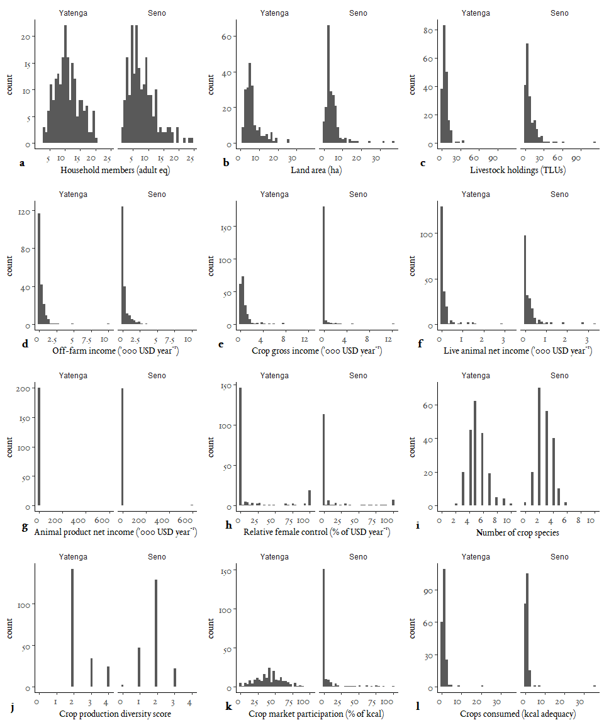
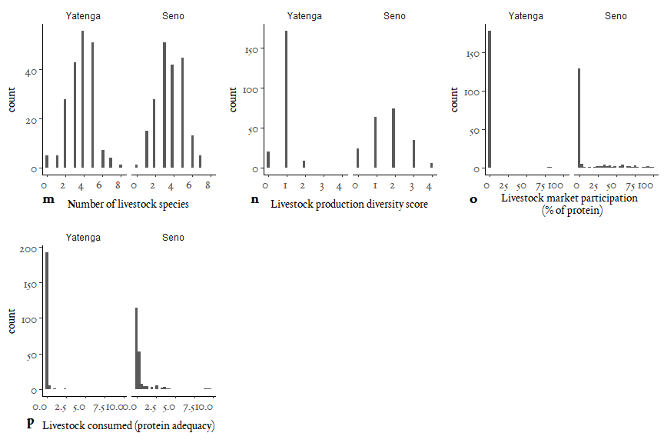
Fig S1. Summary of resources and farm characteristics of households by province
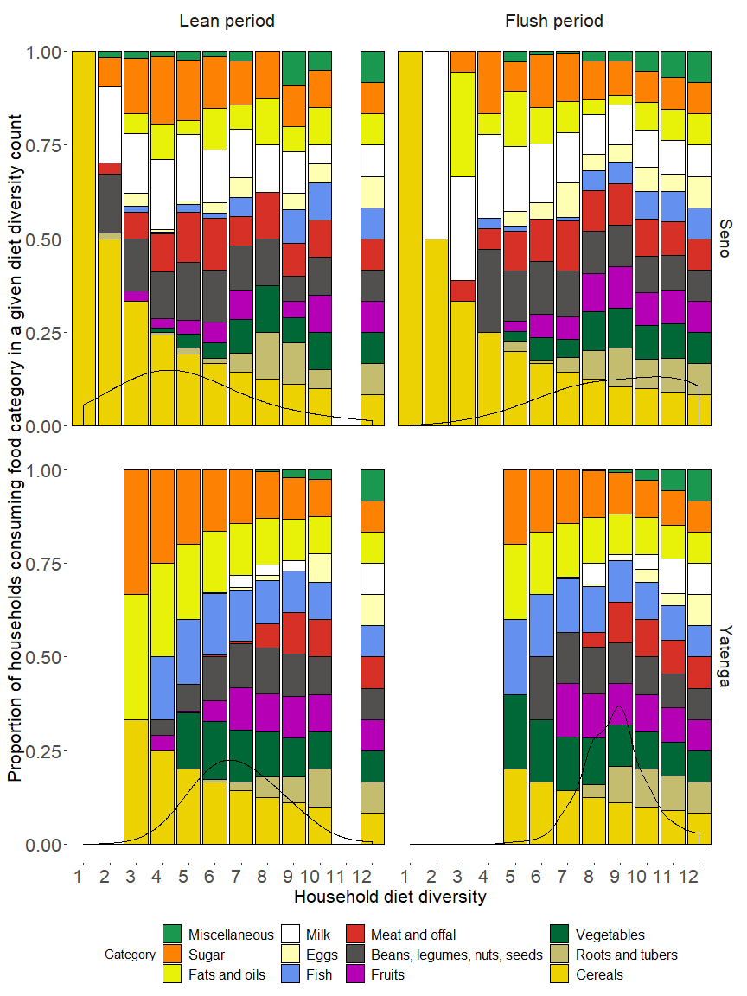
SI Fig. 2. Diet diversity: density and proportion of sampled households (n=400) consuming specific food categories by province and food security period. The distribution (probability density function) of diet diversity for each province and period is represented as a black line on the lower half of each figure facet. Food categories are represented by different colours, showing the proportion of households consuming each category at specific diet diversity levels

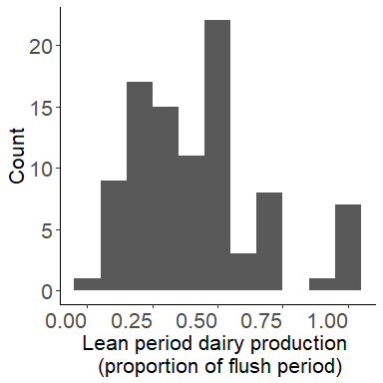
SI Fig. 3. Histogram of the production volume of milk in the lean period relative to the flush period. Frequency capped at 1

