APPENDICES

Monitoring activity of Hip Injury Patients (MoHIP): An sub-study of the World Hip Trauma Evaluation Observational Cohort Study

Laura C Armitage, Yuan Chi, Mauro Santos, Beth K Lawson, Carlos Areia, Carmelo Velardo, Peter J Watkinson, Lionel Tarassenko, Matthew L Costa, Andrew J Farmer.

Appendix 1

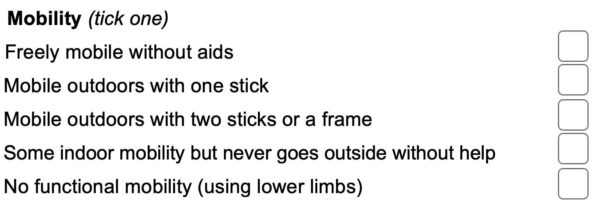

Appendix 2

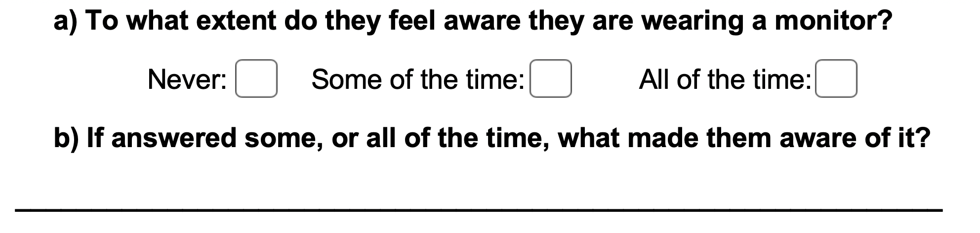

Appendix 3

