**Phenylethanol glycosides from the seeds of *Aesculus chinensis* var.** ***chekiangensis***

Nan Zhang#a,b, Di Liu#a,b, Shuxiang Weia,b, Shijie Caoa,b, Xinchi Fenga, Kai Wanga, Liqin Dingb,*, Feng Qiua,b,*

*a* *School of Chinese Materia Medica, Tianjin University of Traditional Chinese Medicine, Tianjin, China*

*b Tianjin Key Laboratory of TCM Chemistry and Analysis, Institute of Traditional Chinese Medicine, Tianjin University of Traditional Chinese Medicine, Tianjin, China*

* Corresponding authors. School of Chinese Materia Medica, Tianjin University of Traditional Chinese Medicine, No. 10 Poyanghu Road, West Area,Tuanbo New Town,Jinghai Dist, Tianjin 301617, People’s Republic of China. Phone: +86-22-59596223 E-mail: fengqiu20070118@163.com (F. Qiu), ruby70303@163.com (L.D.).

# These authors contributed equally to this work.

**Supporting Information List of Contents**

|  |  |  |
| --- | --- | --- |
| No. | Content | Page |
| 1 | **Figure S1.** The HR-ESI-MS Spectrum of Compound **1** | 3 |
| 2 | **Figure S2.** The 1H-NMR Spectrum of Compound **1** | 3 |
| 3 | **Figure S3.** The 13C-NMR Spectrum of Compound **1** | 4 |
| 4 | **Figure S4.** The HSQC Spectrum of Compound **1** | 4 |
| 5 | **Figure S5.** The HMBC Spectrum of Compound **1** | 5 |
| 6 | **Figure S6.** The HR-ESI-MS Spectrum of Compound **2** | 5 |
| 7 | **Figure S7.** The 1H-NMR Spectrum of Compound **2** | 6 |
| 8 | **Figure S8.** The 13C-NMR Spectrum of Compound **2** | 6 |
| 9 | **Figure S9.** The HSQC Spectrum of Compound **2** | 7 |
| 10 | **Figure S10.** The HMBC Spectrum of Compound **2** | 7 |
| 11 | **Figure S11.** The HR-ESI-MS Spectrum of Compound **3** | 8 |
| 12 | **Figure S12.** The 1H-NMR Spectrum of Compound **3** | 8 |
| 13 | **Figure S13.** The 13C-NMR Spectrum of Compound **3** | 9 |
| 14 | **Figure S14.** The HSQC Spectrum of Compound **3** | 9 |
| 15 | **Figure S15.** The HMBC Spectrum of Compound **3** | 10 |
| 16 | **Figure S16.** Cytotoxic activities of compounds 1-4 on PC12 cells at 10 μM | 10 |

**Figure S1.** The HR-ESI-MS Spectrum of Compound **1**

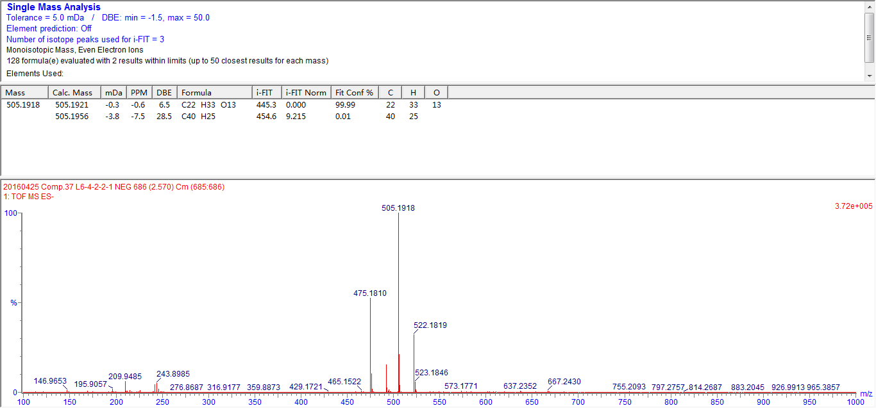

**Figure S2.** The 1H-NMR Spectrum of Compound **1**

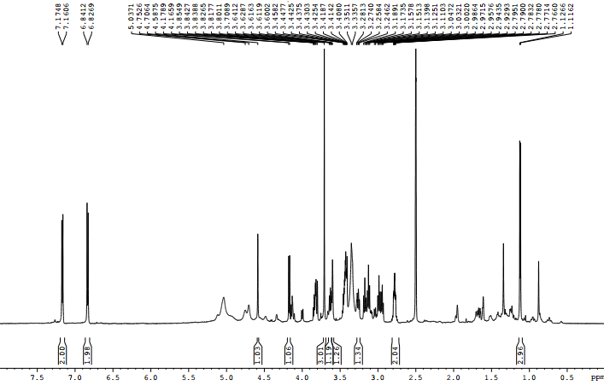

**Figure S3.** The 13C-NMR Spectrum of Compound **1**

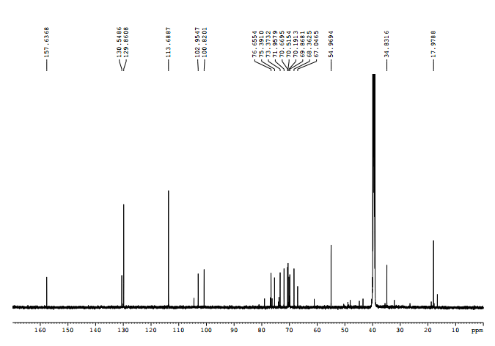

**Figure S4.** The HSQC Spectrum of Compound **1**

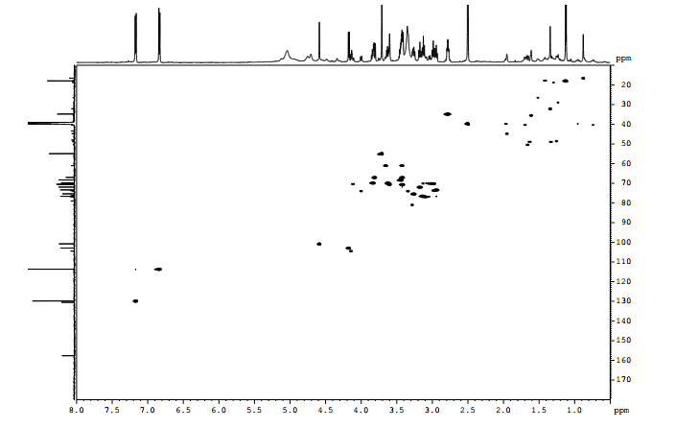

**Figure S5.** The HMBC Spectrum of Compound **1**

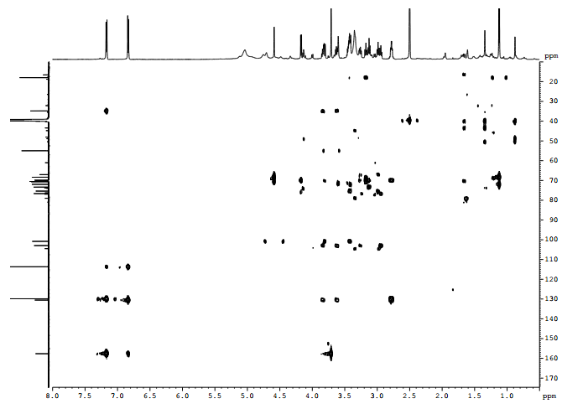

**Figure S6.** The HR-ESI-MS Spectrum of Compound **2**

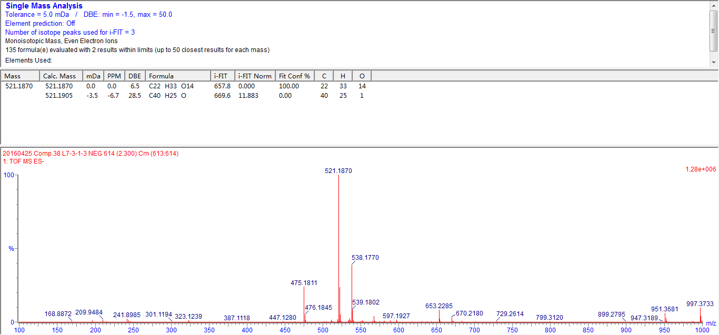

**Figure S7.** The 1H-NMR Spectrum of Compound **2**

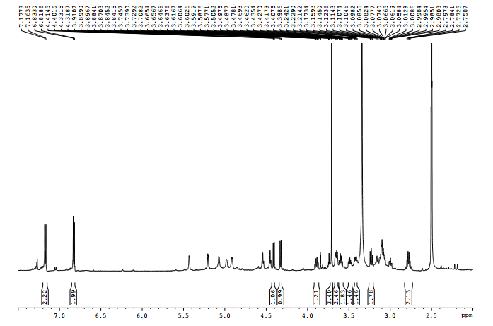

**Figure S8.** The 13C-NMR Spectrum of Compound **2**

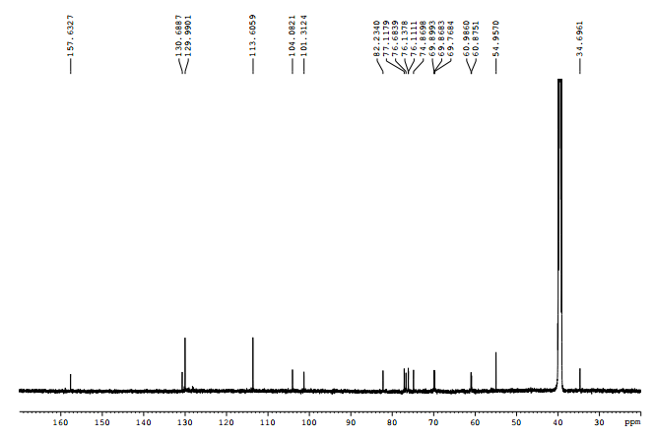

**Figure S9.** The HSQC Spectrum of Compound **2**

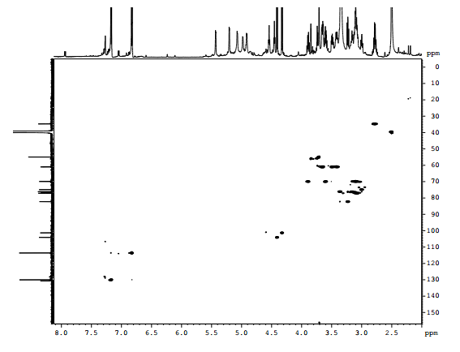

**Figure S10.** The HMBC Spectrum of Compound **2**

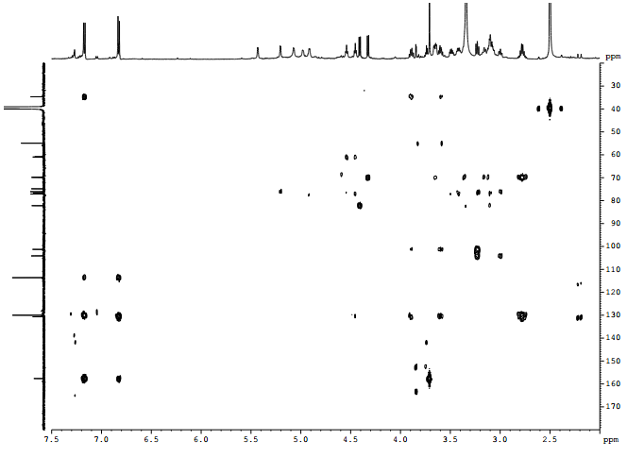

**Figure S11.** The HR-ESI-MS Spectrum of Compound **3**

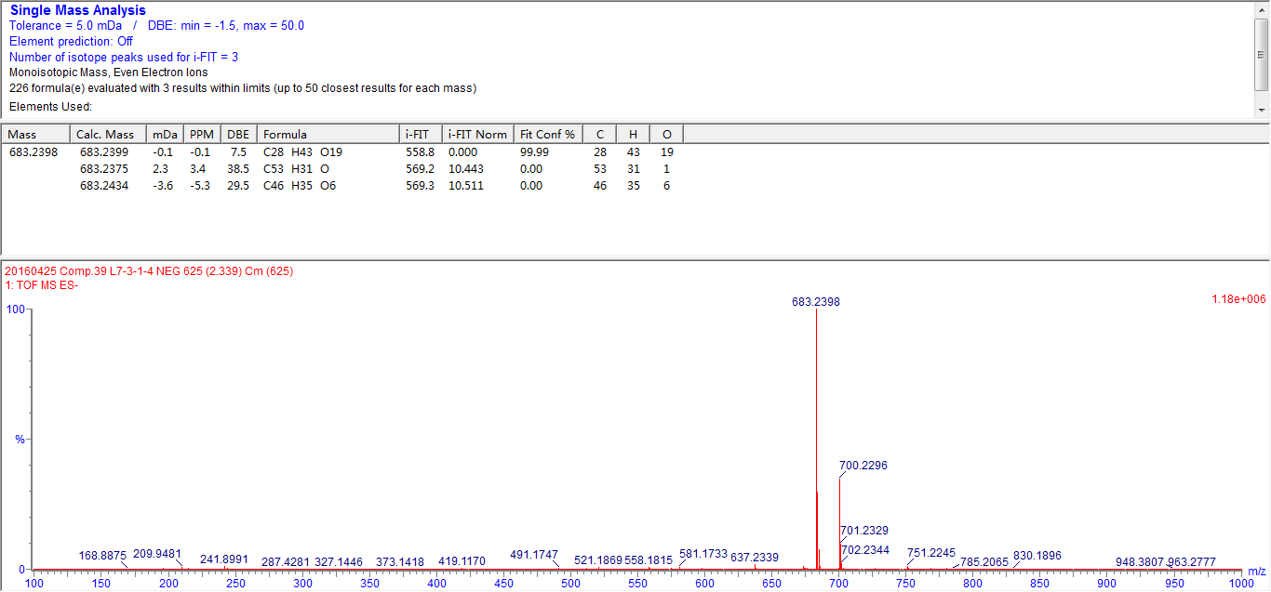

**Figure S12.** The 1H-NMR Spectrum of Compound **3**

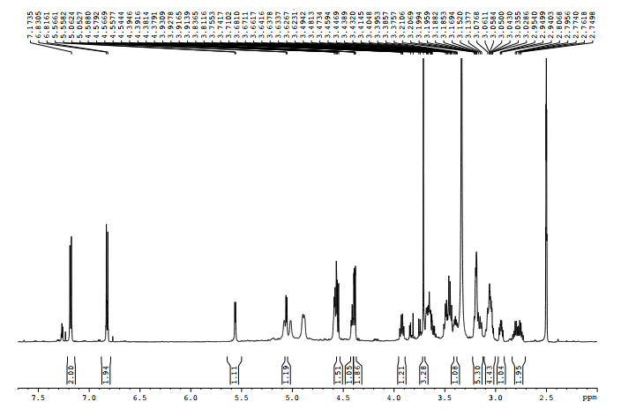

**Figure S13.** The 13C-NMR Spectrum of Compound **3**

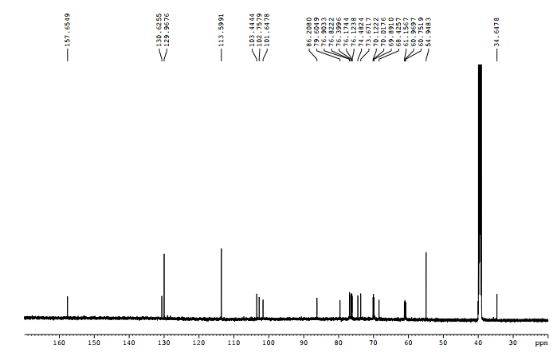

**Figure S14.** The HSQC Spectrum of Compound **3**

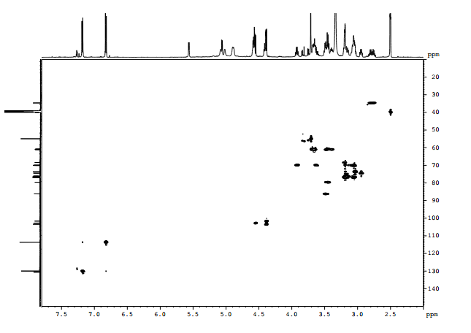

**Figure S15.** The HMBC Spectrum of Compound **3**

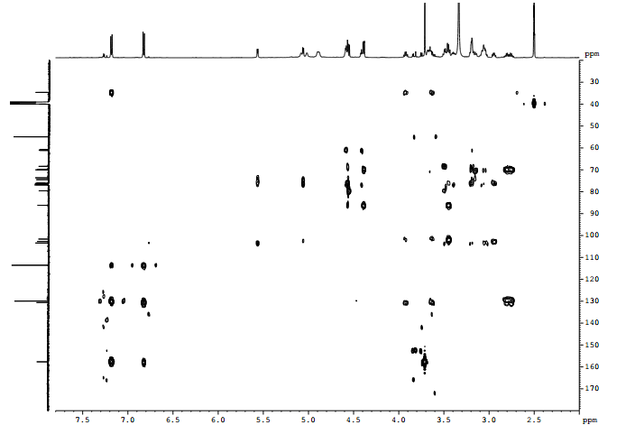

**Figure S16.** Cytotoxic activities of compounds **1-4** on PC12 cells at 10 μM

