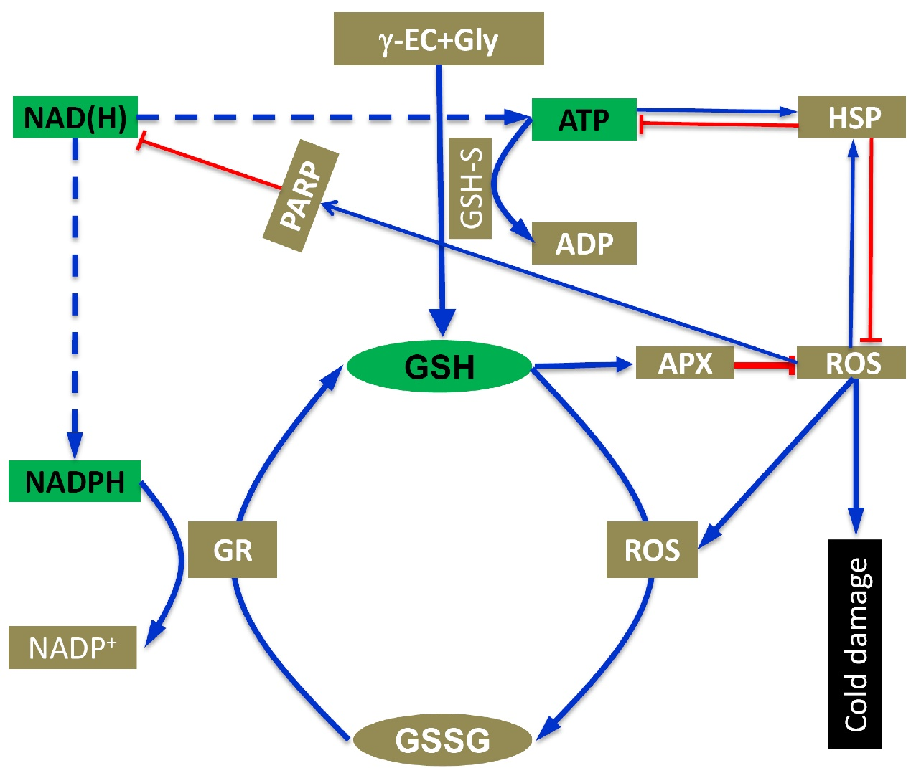
Fig.S1 Descriptive model of relationships between GSH accumulation, heat shock protein and energy homeostasis in plants under cold stress. The GSH plays a key role in reducing ROS by regulating the APX activity in plants, which could alleviate cold damage. During this process, the accumulation of GSH is determined by GSH-S and GR, the former consumes ATP, while the latter consumes NADPH. The heat shock protein could be induced by ROS, which in turn could reduce excess ROS in plants. Indeed, the accumulation of heat shock protein is a process of high energy consumption via consuming ATP. Thus, PARP can be activated by ROS which could inhibit the accumulation of heat shock proteins because it can consume NAD⁺ and thereby reduce ATP under cold stress. γ-EC, γ-glutamylcysteine; Gly, Glycine; GSH, Glutathione; 3-ab, 3-aminobenzamide; GSH, Glutathione; PARP, Poly(ADP-ribose) polymerase.

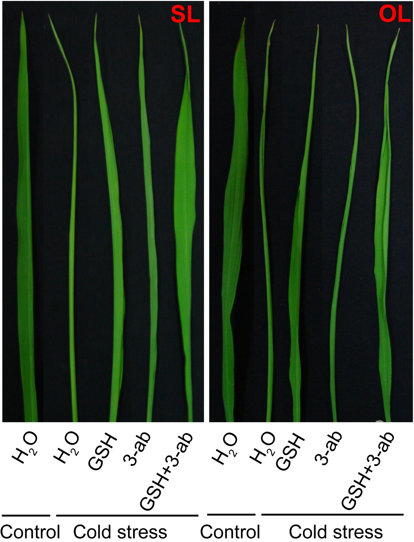
Fig. S2 The morphology of the second and old leaves in RIL82 plants under cold stress. SL, Second leaf; OL, Old leaf.

Table S1. Primer sequences used in quantitative Real-Time reverse transcription PCR.
Locus ID, gene name | Forward (5’-3’) | Reverse (5’-3’)
LOC_Os05g45420, SnRK1A | ACAACCAGTGGCTACCTTGG | CGATGATCAGTGGCTGAGTT
LOC_Os07g09610, SnRK1B | ATATCAGGCGCCGAATACTG | TGTGCCTGAAGAACTTGCTG
LOC_Os05g14550, TOR | GCTGAACGCTGCAATGACTA | ACCGAACAAGTACTGGAGCA
LOC_Os03g16860, HSP71.1 | CTACGAGGGCATCGACTTCT | CGGTGCTCTTGTCCATCTTG
LOC_Os02g52150, HSP24.1 | TGAGCCTCATGGACGACCT | CCCTTGATCACGAGGCTGTT
LOC_Os07g27790, GSH1 | TTCCTGAGGTCAGGCTGAAG | TGGCAAAGCACACAATCTCC
LOC_Os05g03820, GSH2 | GGAGATTGTGTGCTTTGCCA | GGAAGGGTGTCTTCAAACCG
NC_001320.1, ATPase | TCGGTGGAGCTACTCTTGGA | CGGGCGCGGATCTATGAATA
LOC_Os01g22490 ,UBQ | GACTACAACATCCAGAAGGAGTC | TCATCTAATAACCAGTTCGATTTC

