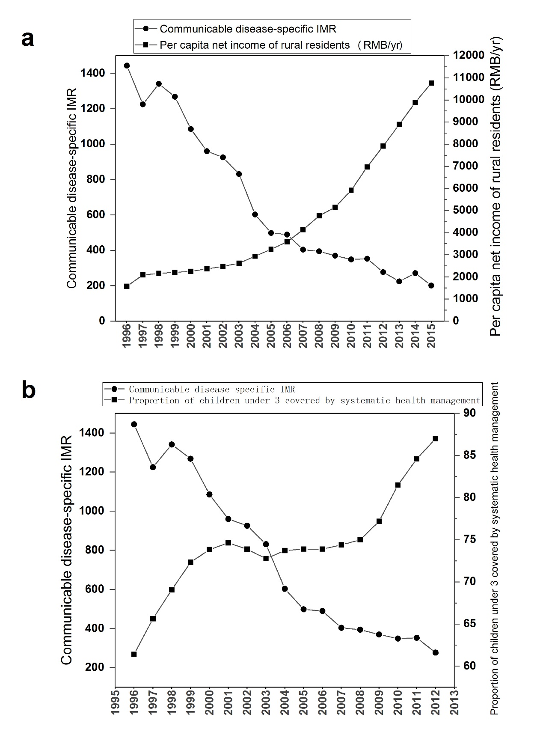
Figure S1. (a) Per capita net income of rural residents (RMB/yr) and ARI-specific infant mortality rate, (b) Proportion of children under 3 covered by systematic health management and ARI-specific infant mortality rate.

