## Additional file 1

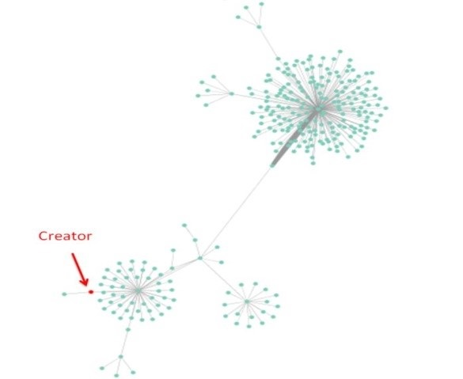

**Figure S1. Degree of a fake news creator.** A typical example of a fake news network whose creator does not have the maximal degree.

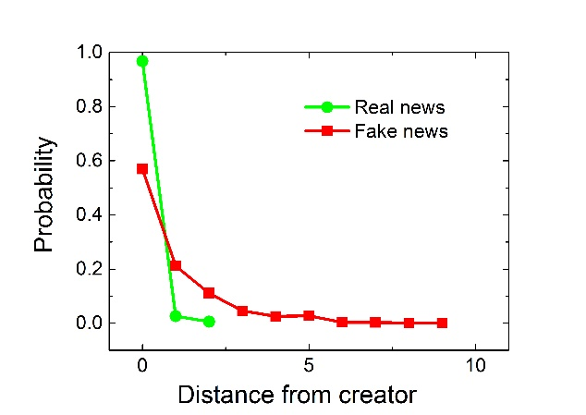

**Figure S2. The distribution of the distance between the creator node and the node with the maximal degree in Weibo.** The x axis is the distance between creator nodes and nodes with the maximal degree. If the x value is zero, the creator is exactly the node that has the maximal degree. For real news, about 97% of the creators have the maximal degree, while 57% of the creators of fake news networks have the maximal degree.

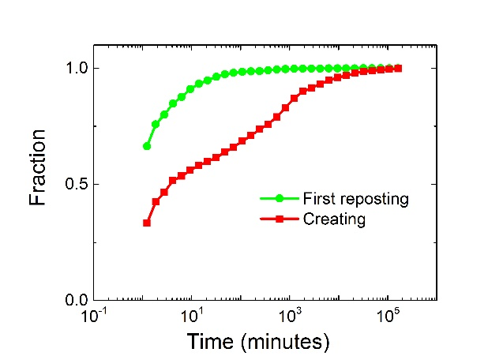

**Figure S3. The fraction of Weibo propagation network that can be analyzed for different starting time.** Our methods in this paper are based on the re-postings. The y axis is the fraction of the Weibo propagation networks that has new re-postings till specific time x. Different colors stand for different starting instants. For example, if we study the temporal networks five hours from the first reposting time (green curve), the fraction y is about 0.99, which means we could analyze 99% of Weibo propagation networks. Since the reposting fraction of using first re-posting time as starting time is much larger than that of creating time, we choose first re-posting time as the starting time.

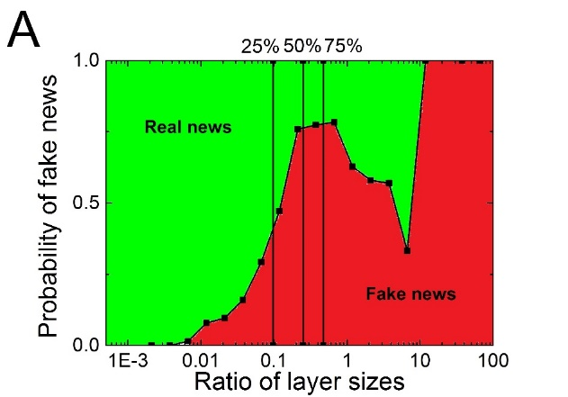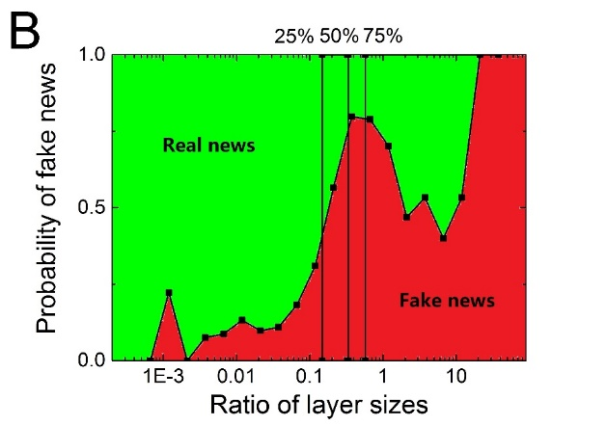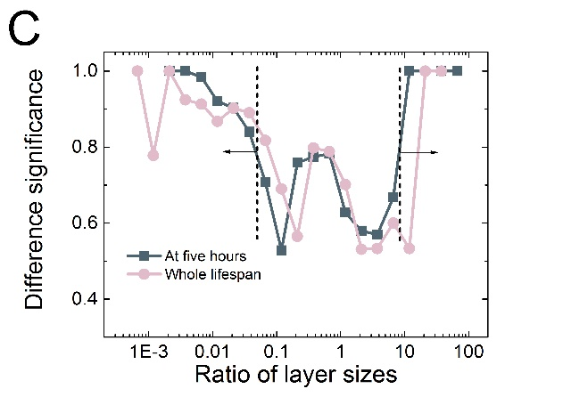 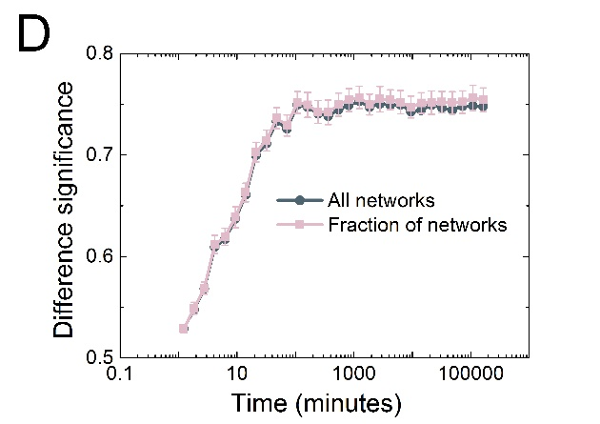

**Figure S4. Probability for fake news with the ratio of layer sizes.** (A) Probability of being fake news at five hours. The three vertical lines divide the figure into 4 parts with equal number of networks. (B) Probability of being fake news for the whole lifespan. (C) The difference significance between two types of news at five hours and the whole lifespan. (D) The difference significance as a function of time. And the difference significance in the early stage (for example, five hours) is similar to that of the whole lifespan. The dark green curve considering all 1701 Weibo propagation networks of fake news and all 492 Weibo propagation networks of real news. For the node that stands for five hours in this curve, we consider 1578 fake news networks and 448 real news networks (more details are given in Table 1). However, the pink curve is the average of 100 iterations of measuring the difference significance of 850 randomly chosen fake news networks and 246 randomly chosen real news networks.

**Supplementary table: Number of users and networks of another Weibo dataset**

|  |  |
| --- | --- |
|  | **Real news** |
| Weibo users in the whole dataset | 1,632,026 |
| Number of Weibo propagation networks  (larger than 200 re-postings) | 2000 |
| Number of Weibo propagation networks  (from non-official users) | 2000 |

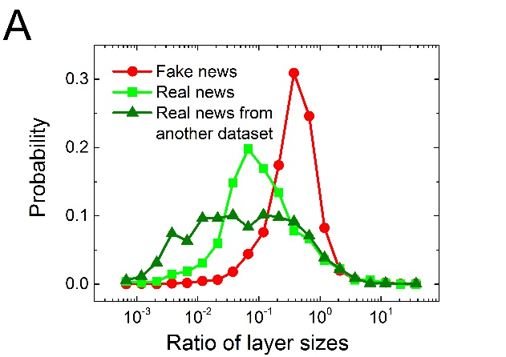 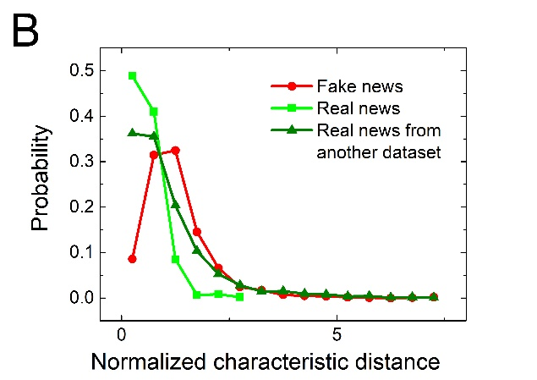

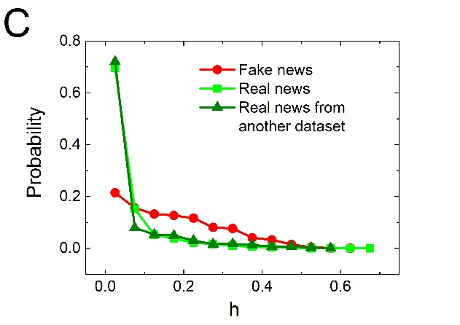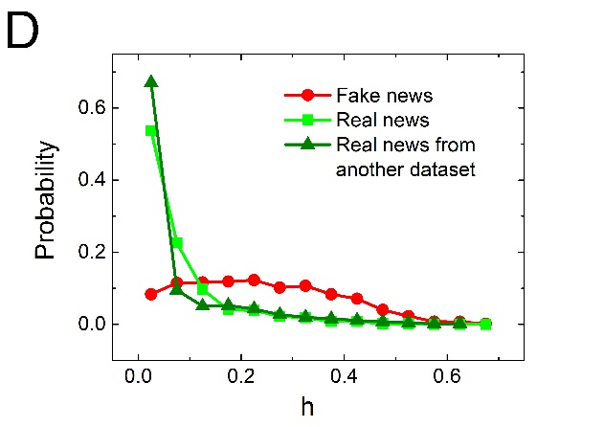

**Figure S5. Validation from different datasets.** (A) Distribution of the ratio of layer sizes of all re-postings. The *p*-value between fake news and real news from another dataset is below 0.01. Here we consider all available Weibo propagation networks (1701 fake news, 492 real news and 2000 real news from another dataset). (B) The PDF of the normalized characteristic distances for fake news, real news and real news from another dataset. The normalized characteristic distance is the characteristic distance divided by the logarithm value of size N. The *p*-value between fake news and real news from another dataset is below 0.01. (C) Distribution of *h* at five hours from the first re-posting of the Weibo propagation networks. The *p*-value here is below 0.01. (D) Distribution of *h* of all re-postings for the whole lifespan in Weibo. The *p*-value is below 0.01.

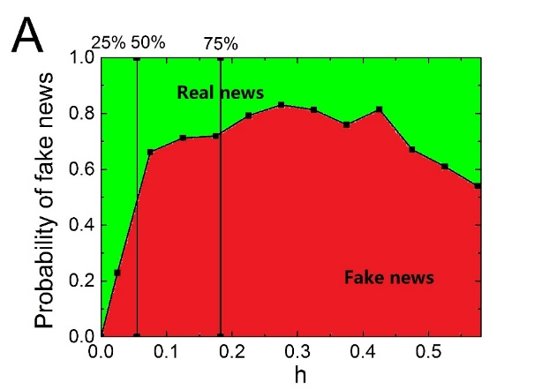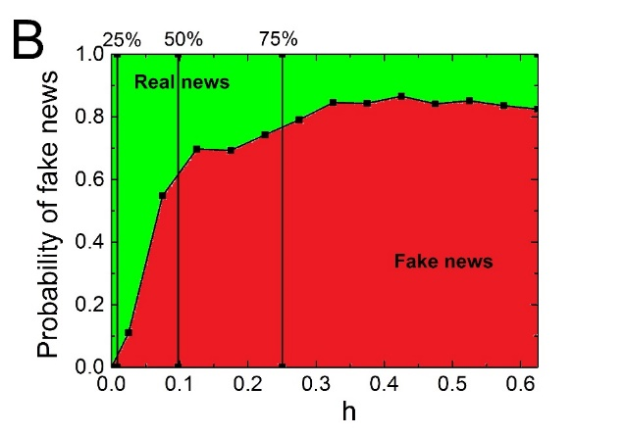

**Figure S6. Heterogeneity measure on another dataset of Weibo.** We use fake news and real news from another dataset shown in the supplementary table in this figure: (A) Probability of being fake news according to *h* at five hours. The difference significance is 0.75 (at five hours). (B) Probability of being fake news using all re-postings, in which we find the difference significance is 0.79 (for the whole lifespan).

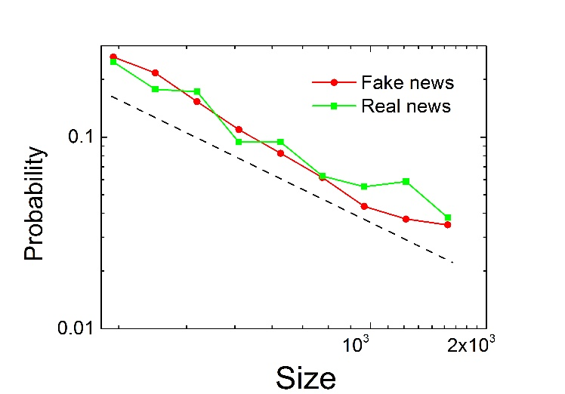

**Figure S7. The size distribution of real news and fake news network is similar in our Weibo dataset.**

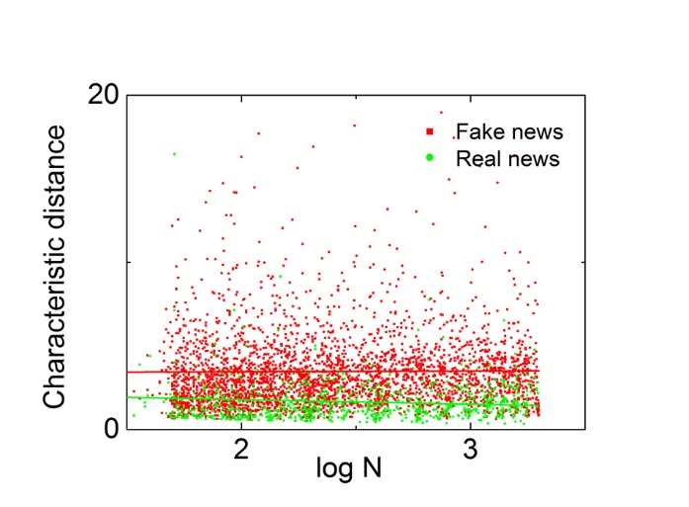

**Figure S8. Characteristic distance as a function of network size (N).** The scatter plot of characteristic distance and N shows little strong correlation in **our Weibo dataset**.

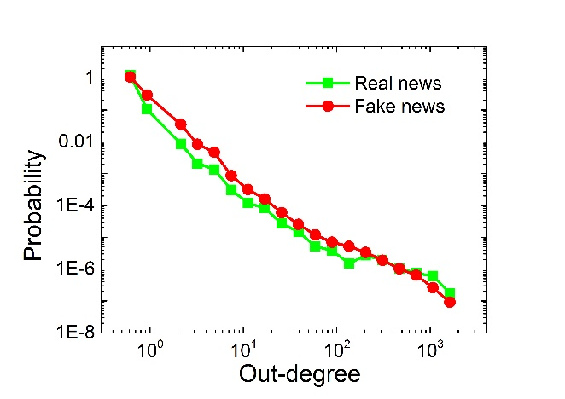

**Figure S9. Out-degree distribution of propagation network in our Weibo dataset**.

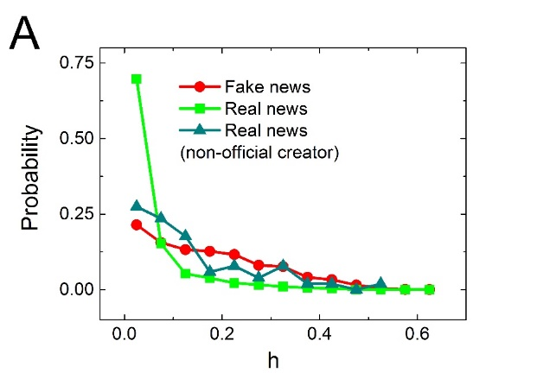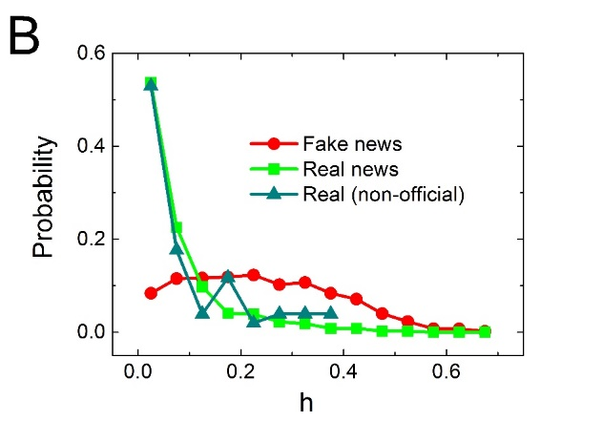

**Figure S10. Heterogeneity measure including non-official creators in Weibo.** (A) Distribution of h at five hours from the first re-posting. We also plot the distribution of h for real news with non-official creators. (B) Distribution of h for all re-postings for the whole lifespan.

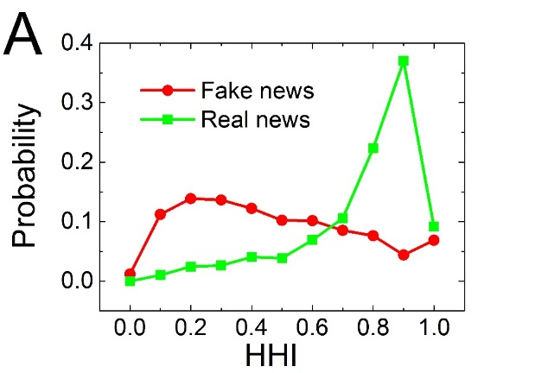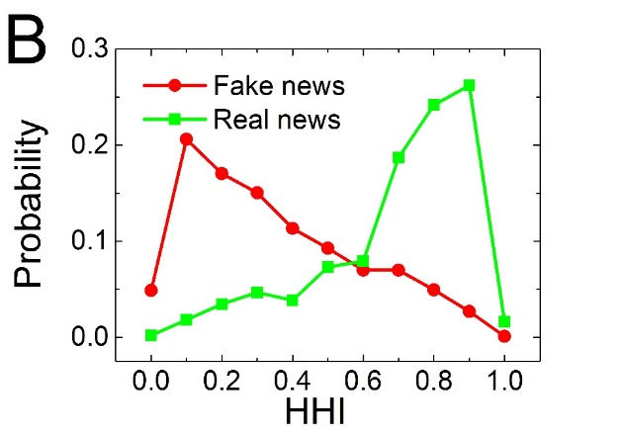

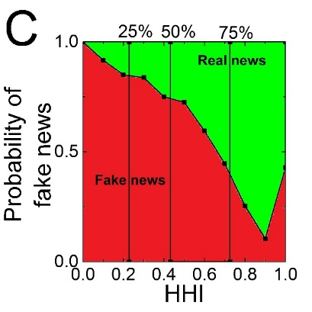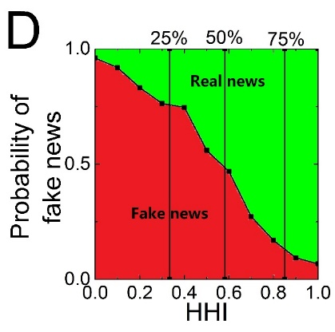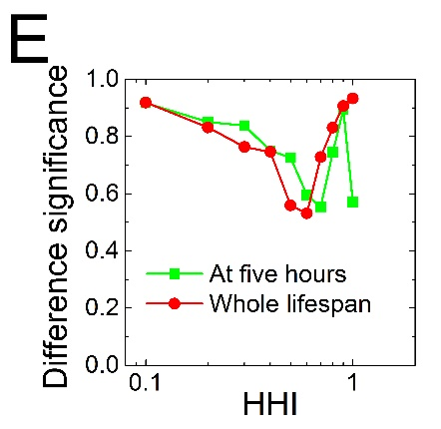

**Figure S11. Probability of being fake news according to HHI.** The HHI is defined as:

 (8)

: The number of nodes in the network

: The out-degree of the node number $j$

(A) Distribution of HHI at five hours from the first re-posting. The p-value here is below 0.01. (B) Distribution of HHI of all re-postings. The p-value is below 0.01. (C) Probability of being fake news at five hours according to HHI. (D) Probability of being fake news for the whole propagation lifespan according to HHI. (E) The difference significance is 0.755 (at five hours). And for the whole propagation lifespan, the difference significance is 0.785.

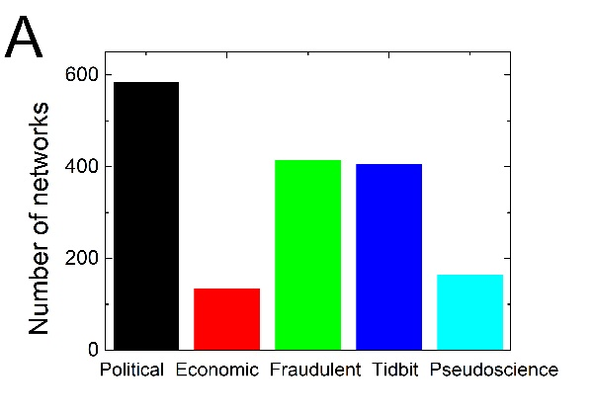 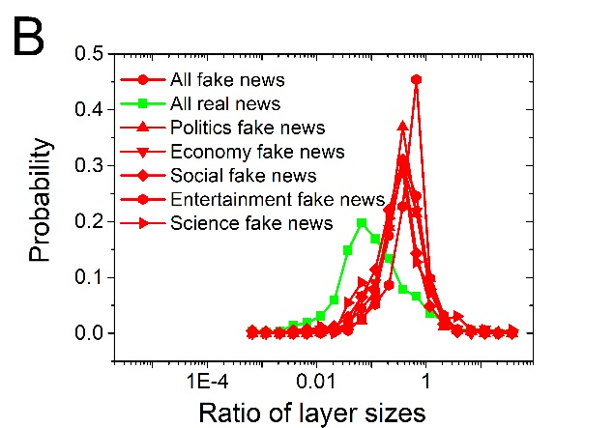

**Figure S12. Different topics of fake news in Weibo.** (A) The distribution of topics for fake news in Weibo. We analyze all 1701 fake news and divide them into five categories manually according to their topics of content: political fake news, economic fake news, fraudulent fake news, tidbits fake news, and pseudoscience fake news. (B) The ratio of layer sizes distributions for five types of fake news respectively and the distribution of real news.



Figure S13. Comparison between networks built by the mention sign “@” (circles) and retweet sign “RT @” (squares). There is little difference between the results based on both network definitions.