Supplement

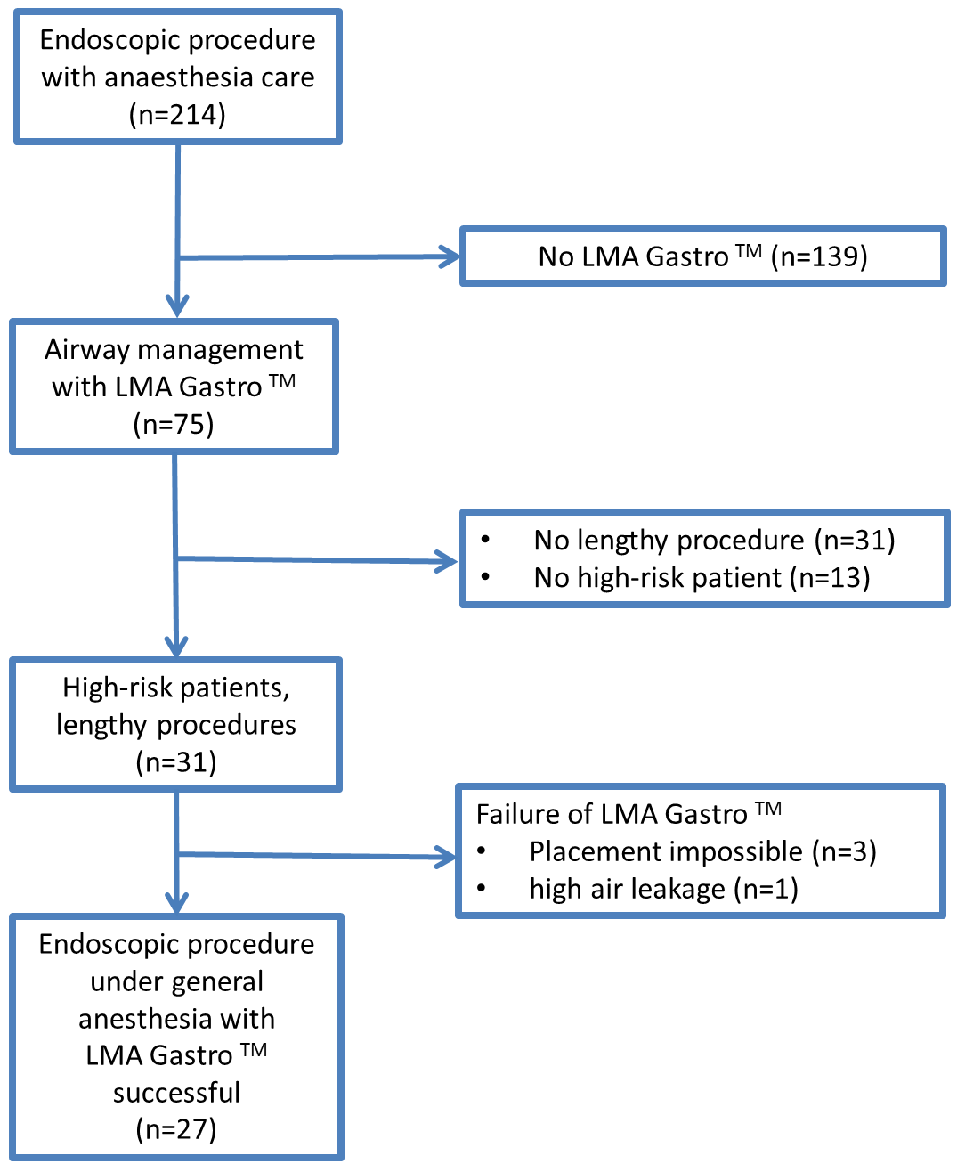
Fig S1: CONSORT flow diagram
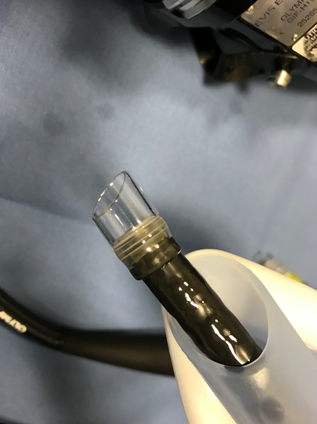
Fig S2: Gastroduodenoscope with attachment cap for peroral
endoscopic myotomy (POEM), passing through the gastric channel
of a LMA GastroTM

