Additional file 1
High frequency optogenetic activation of inputs to the lateral amygdala forms distant association with foot-shock
Fei Li¹, Chun-Hui Jia^{1#}, Jun Huang^{1#}, Guo-Qiang Bi^{1,2}* and Pak-Ming Lau¹*
*Correspondence: gqbi@ustc.edu.cn or plau@ustc.edu.cn

This file includes:
Materials and Methods
Fig. S1
Fig. S2

Materials and Methods

Animals:
All animal experiments were conducted following protocols approved by the Animal Experiment Committee at the University of Science and Technology of China. Male Sprague-Dawley rats were housed under a 12-hour light/dark cycle, with ad libitum access to food and water. The rats were about 8 weeks old when used for experiments.
Virus injection and surgery:
Rats (8 weeks old) were anesthetized with 2% pentobarbital sodium (60 mg/kg, Merck) and were mounted in a stereotaxic frame. The body temperature was kept around 37.5 °C using a heating pad during surgery and recovery from anesthesia. AAV viruses (Shanghai Taitool Bioscience) carrying hSyn-oChIEF-tdTomato or hSyn-tdTomato (vector-only, for control experiments) constructs were injected into the medial geniculate nucleus (AP: -5.1 mm and -5.7 mm; ML: 2.9 mm; DV: -5.5 to -6.5 mm) and the auditory cortex (AP: -5.7 mm; ML: 4.8 mm with a 20-degree angle; DV: -4.5 to -5.7 mm). A total of 400 nl of virus was injected for each site at a speed of 40 nl / min. A multimode optical fiber of 200 μm dimeter (NA = 0.37, Suzhou CooCore Photoelectronic Technology) was implanted above the lateral amygdala (AP: -3.3 mm; ML: 4.2 mm; DV: -7 mm with a 7-degree angle) and was secured on the skull with four screws and dental cement. Animals were used for behavioral experiments 4 weeks after viral injections, when plenty of oChIEF-tdTomato expressions were observed under a fluorescence microscope.
Behavioral assays:
Lever press training. Animals were trained for 1 week starting from 3 weeks after the surgery. The custom-made lever-pressing box (35 cm Х 35 cm Х 30 cm) was controlled by an Arduino-based custom-program. Water restricted rats (with 2 hours of free water intake daily) were allowed 5 minutes of free exploration in the behavior box before having access to the lever, and every lever press was rewarded with a drop of sucrose solution (40 μl of 10% sucrose, Sinopharm Chemical Reagent Co). The rats were given 40 minutes of lever press training every day.

Fear training. Fear training was performed about four weeks after viral injection. Rats had free access to water 24 hours before conditioning training. For optogenetic stimulation, a 473 nm laser (Shanghai Fiblaser Technology) was connected to the pre-implanted optical fiber through another 200 μm diameter multimode optical fiber to deliver light pulses to the LA. For optogenetic moderate-frequency stimuli (oMFS) paired with foot-shock, a 20-sec train of 10 Hz pulses (10-15 mW at the output of the implanted optical fiber, 2-ms pulse width) was co-terminated with the foot-shock (0.8 mA, 2 seconds) and repeated every 3 minutes for 5 times. For the unpaired group, there was an interval (60-120 s, randomly assigned) between oMFS and foot-shock. For distant association, optogenetic high-frequency stimuli (oHFS; five 1-sec trains of 100 Hz light pulses separated by a 3-min interval, 10-15 mW, 2-ms pulse width) were delivered before or after the foot-shock (0.8 mA, 3 seconds). After training, rats were allowed to rest in the box for 5 minutes before being returned to the home cage.

Fear recall test. Rats were water restricted for 24 hours before being placed in the lever-pressing box. After two minutes of stable lever press (at least 6 lever presses per minute), optogenetic test stimuli (OTS; 10 Hz for 2 minutes) were delivered through the implanted optical fiber. After light stimulation, another 2-min of post-stimulation lever press behavior was also monitored. The number of lever presses during the 2-min OTS period was counted as a measure of fear response. Rats were allowed to stay in the behavior box for 5 minutes after the fear recall test.

Histology and imaging:
After the fear recall test, rats were sacrificed and transcardially perfused with saline followed by 4% paraformaldehyde (Sigma) in PBS. The brains were kept in 4% paraformaldehyde at 4 °C for 24 hours and then 30% sucrose for 72 hours before being sliced into 40-μm coronal sections and imaged under a fluorescence microscope (Olympus MVX10).
Statistics:
All values are expressed as mean ± SEM. One-way repeated ANOVA followed by Tukey’s multiple comparison test was used for comparing lever press before and after optogenetic stimulation. Student’s t-test or one-way ANOVA followed by Tukey’s multiple comparison test were used for comparing lever press in experimental and control groups.

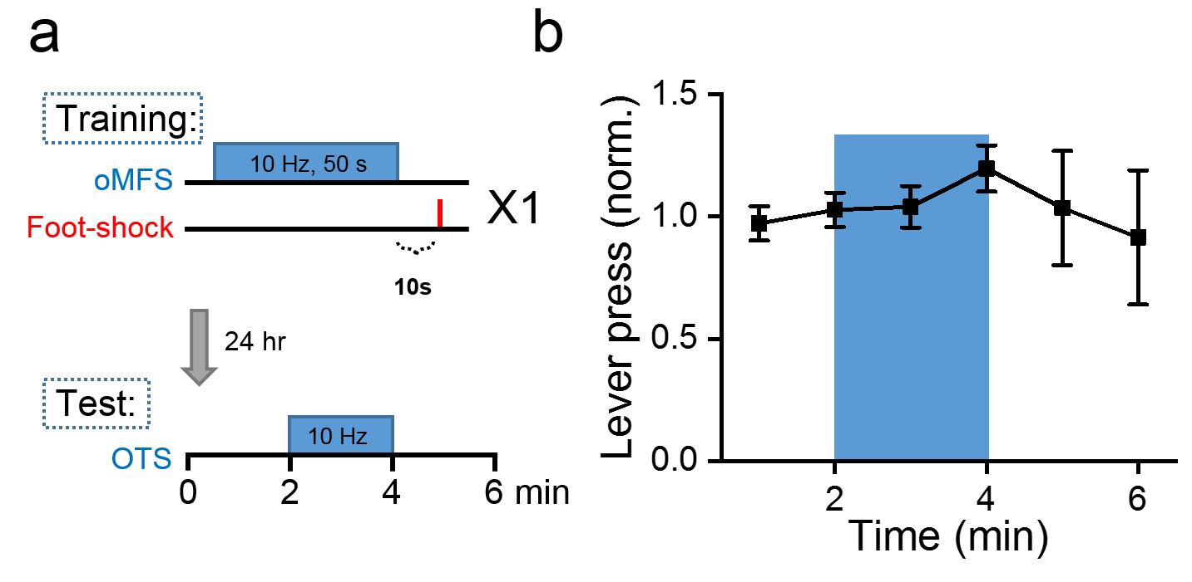
Fig. S1 Distant association could not be formed with oMFS followed by foot-shock.
a. Fear training paradigm with prolonged oMFS (10 Hz for 50 seconds) delivered to the LA 10 seconds before a 3-sec foot-shock.
b. Normalized number of lever presses 24 hours after oMFS fear training. OTS caused no significant change in lever-pressing (P = 0.91 and P = 0.20 at 3 minute and 4 minute point， respectively, n = 4; one-way repeated ANOVA followed by Tukey’s multiple comparison test).

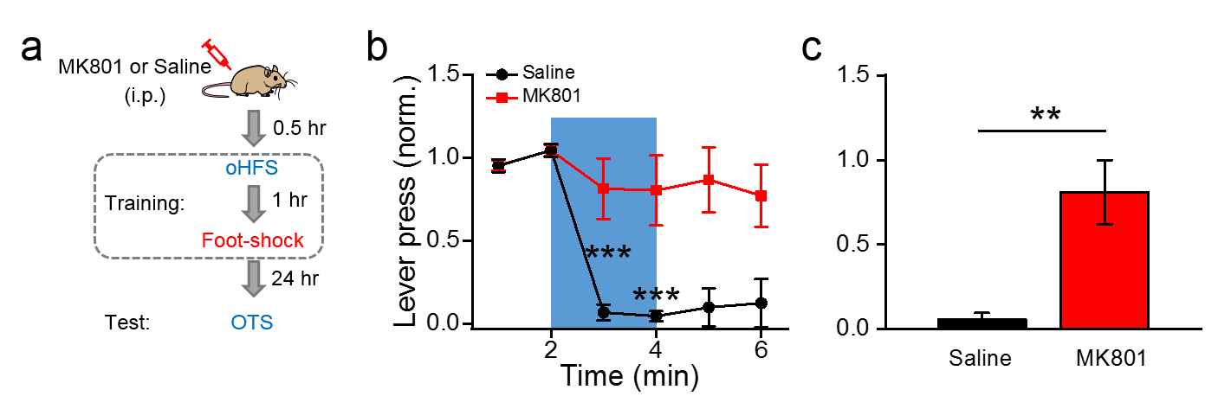
Fig. S2 Systemic administration of MK801 before fear training blocked distant association.
a. Experimental paradigm. Rats were intraperitoneally injected with MK801 (0.2 mg/kg, Sigma) or saline 0.5 hour before oHFS, which was followed by foot-shock 1 hour later.
b. Results of fear recall tests. Significant reduction in the normalized number lever presses was found in the saline group (n = 4) but not in the MK801 group (n = 6). *** indicates P < 0.001; one-way repeated ANOVA followed by Tukey’s multiple comparison test.
c. Mean normalized number of lever presses during the 2 minutes of the OTS. Significant reduction in lever pressing was found in the saline group (n = 4) compared with the MK801 group (n = 6). ** indicates P < 0.01; Student’s t-test.

