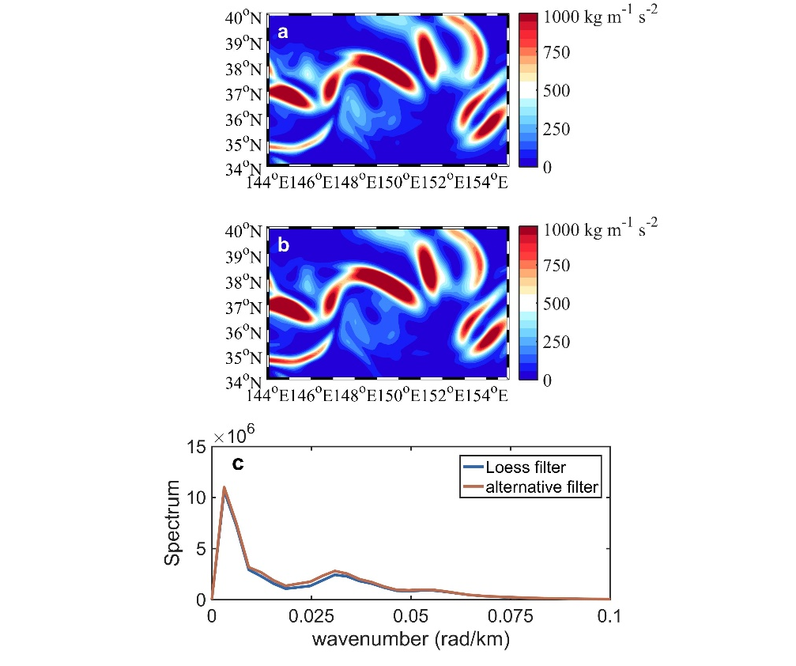
Figure S1. The isolation of mesoscale variabilities. (a) A snapshot of EKE isolated by a Loess filter with a 15° (longitude) × 5° (latitude) half width in the Kuroshio extension region (34°-40°N, 144°-155°E); (b) is similar to (a) but for the alternative filter we use in the paper. (c) The wavenumber spectrum of (a) and (b) denoted by the blue and red lines respectively.

