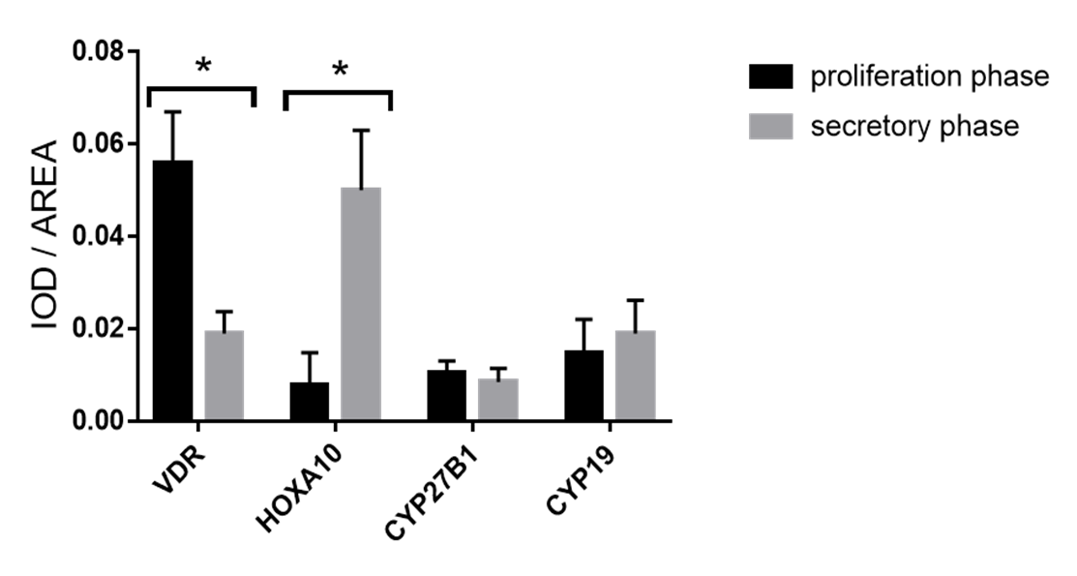
Supplementary figure
Area analysis method for immunohistochemistry for for VDR, CYP27B1, HOXA10, and CYP19 during the proliferative and secretory phases of the menstrual cycle. Summarized data are presented as the mean ± SEM of eight observations in each group, *P < 0.05.

