Additional file 10: Figure S3. Observed and expected daily trap catches for Culicoides chiopterus females for trap locations at both zoos.
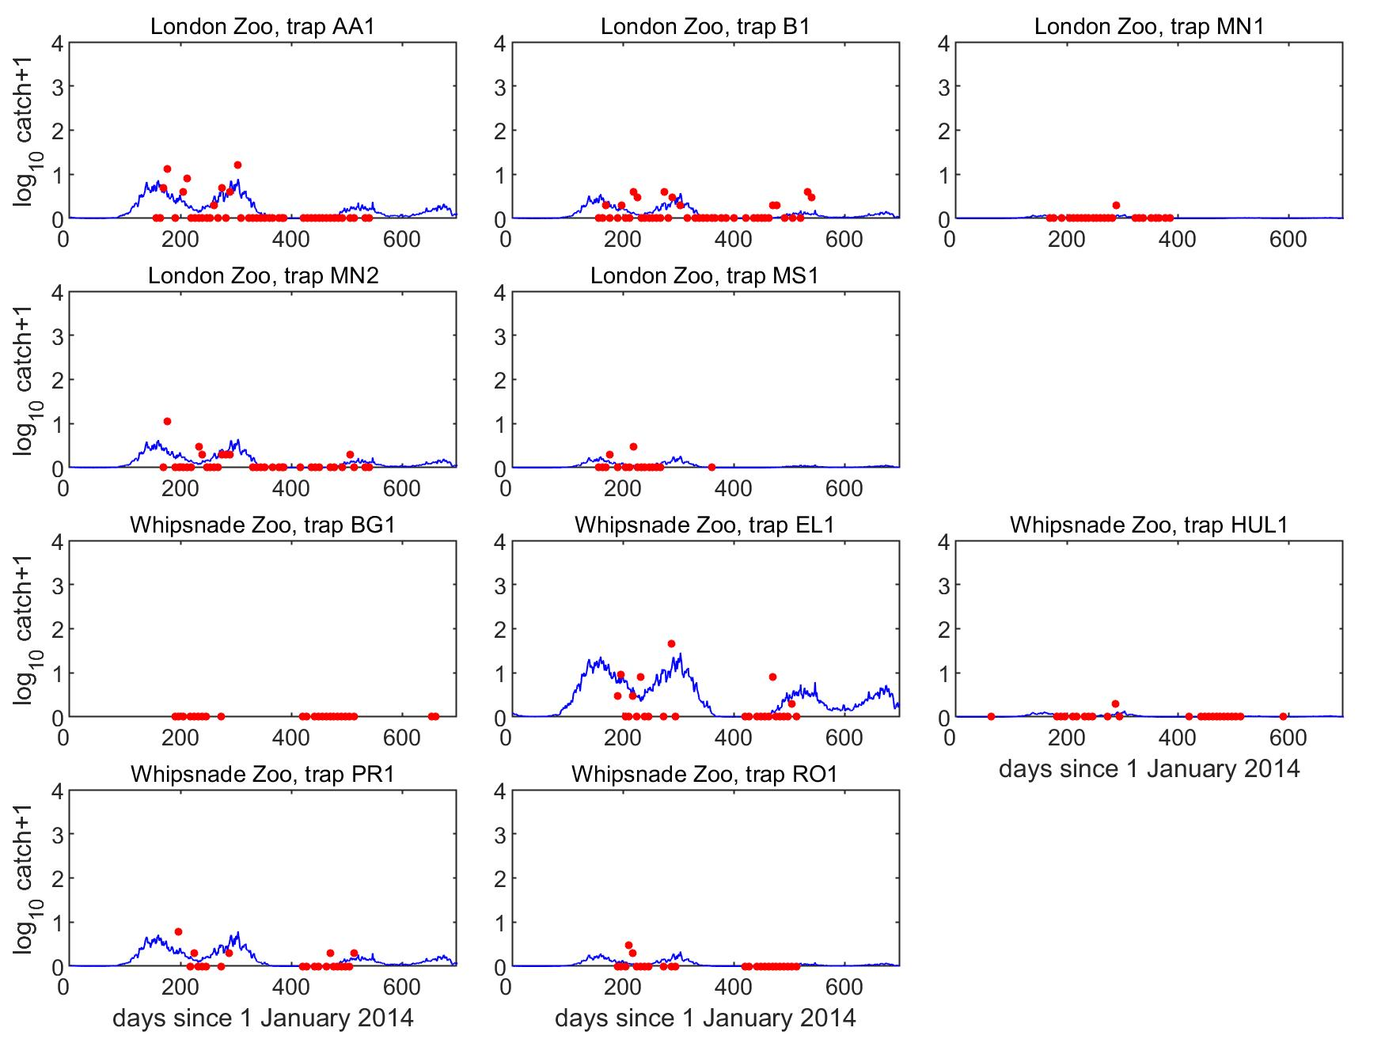

Each plot shows the expected (i.e. the fitted GLM) catch (solid line) and the observed catch (circles) for a trap location.

