**Enzymatic production of 4-*O*-methyl D-glucaric acid from hardwood xylan**

Thu V. Vuong1 and Emma R. Master1,2*

1Department of Chemical Engineering and Applied Chemistry, University of Toronto, Toronto, ON, Canada

2Department of Bioproducts and Biosystems, Aalto University; FI-00076 Aalto, Kemistintie 1, Espoo, Finland

**Figure S1.** SDS-PAGE of purified AxyAgu115A and GOOX-Y300A. Lane 1: Purified AxyAgu115A (2 μg, the theoretical molecular mass = 110 kDa); lanes 2 and 3: Different amounts of purified GOOX-Y300A (1 and 4 μg, the theoretical molecular mass = 56 kDa including a FAD cofactor).

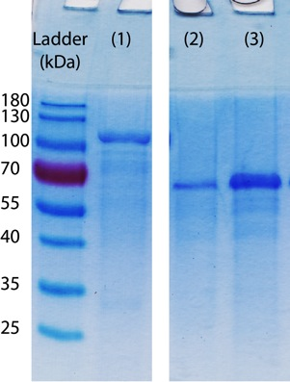

**Figure S2. HPAEC-PAD analysis of AxyAgu115A action on glucuronoxylan.** The presence of 4-*O*-methyl D-glucuronic acid (MeGlcA) was detected in a 4-h treatment of glucuronoxylan with AxyAgu115A (red line), not in the untreated glucuronoxylan sample (black line). MeGlcA at 0.25 mM (grey, dash line) was included as the standard.

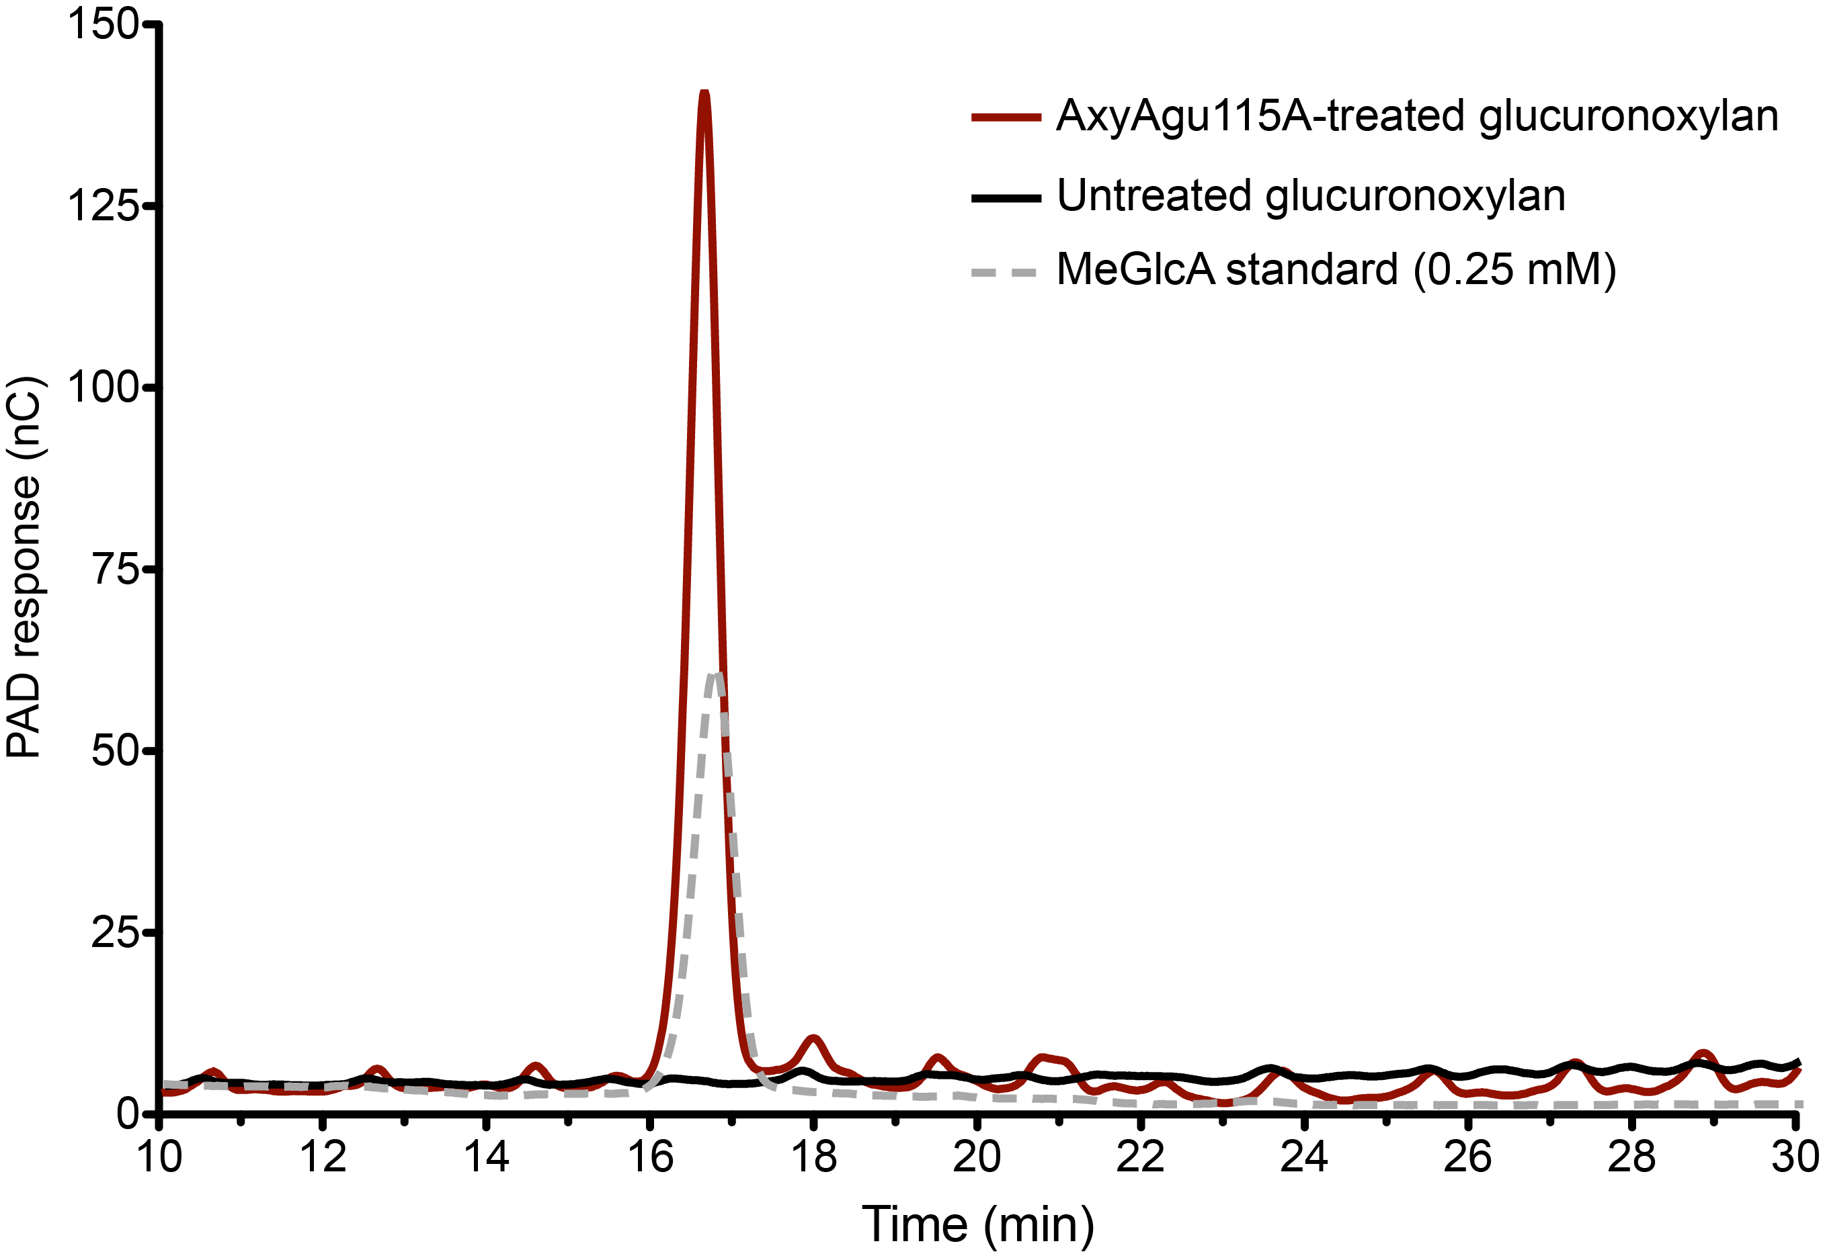

**Figure S3**. HPAEC-PAD chromatograms of 0.25 mM GlcA and 0.25 mM MeGlcA.

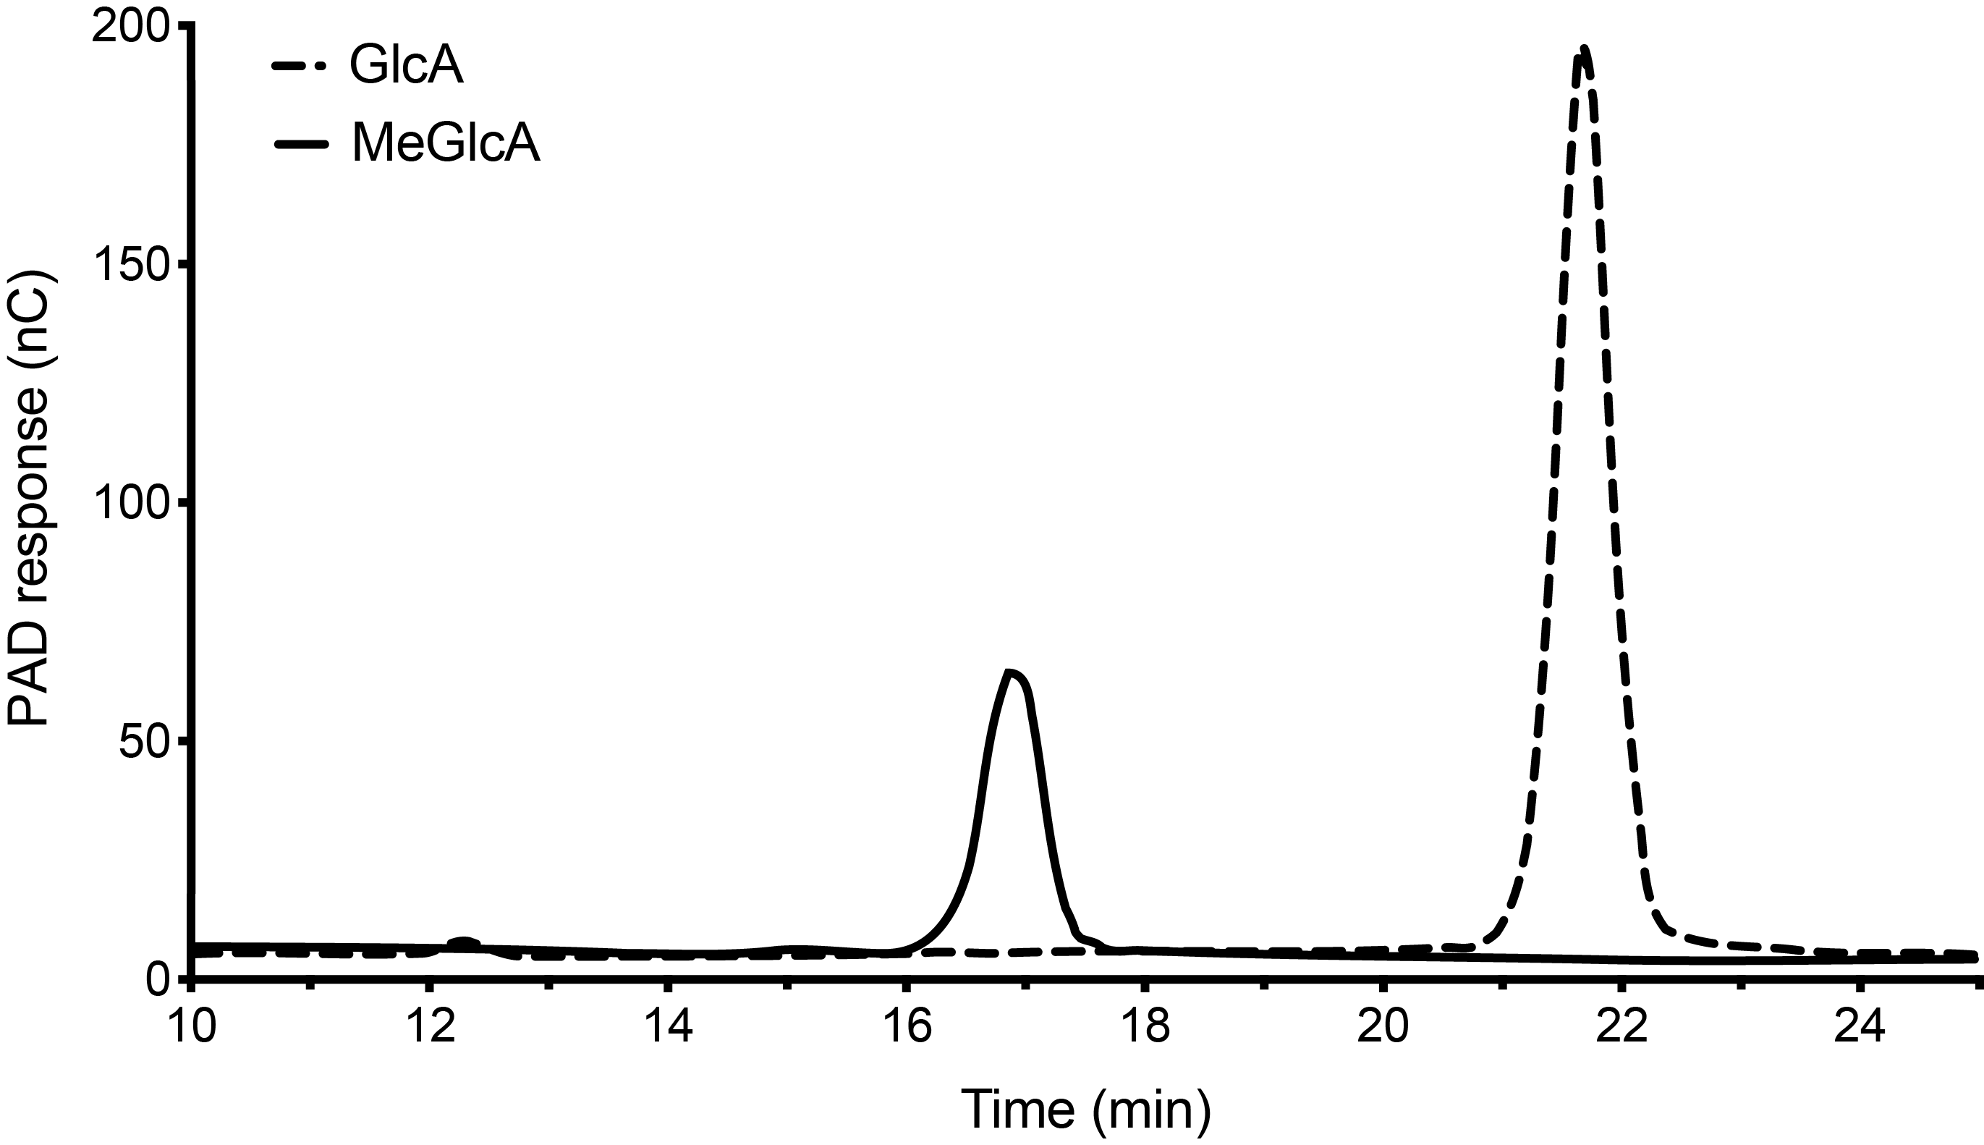

**Figure S4**. NSI-MS spectrum of released MeGlcA (208.05 g/mol) by AxyAgu115A. Samples in 50 % methanol were injected in a negative mode and the spectrum was recorded from 100 m/z to 1,000 m/z.

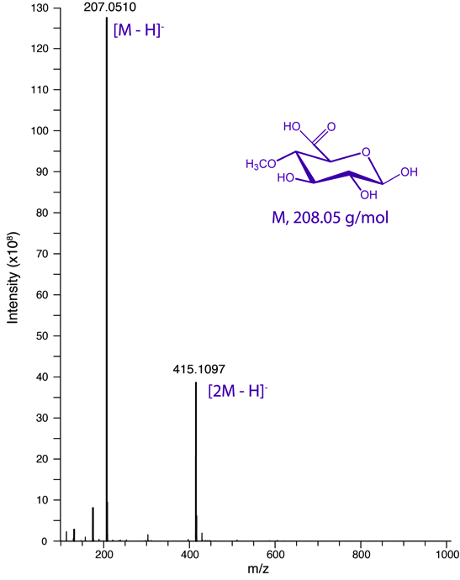­­

**Figure S5**. NSI-MS spectra of MeGlcA (208.05 g/mol) from experimental acquisition (A) and from simulation (B).



**Figure S6**. MeGlcA (0.05 mM - 1 mM) standard curve by HPAEC-PAD.

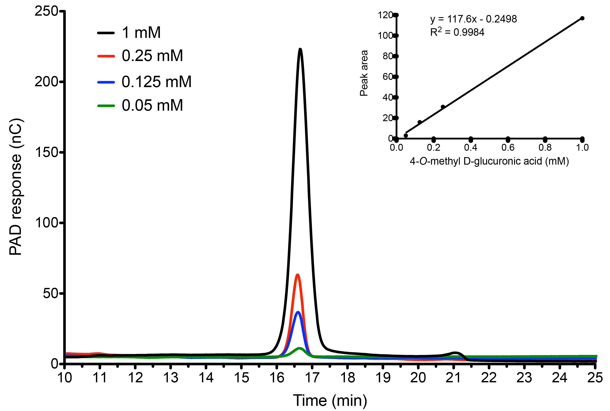

**Figure S7**. Colorimetric analysis of anion-exchange fractions resulting from AxyAgu115A digestion of glucuronoxylan. Each fraction (4 μL) was loaded on one square, numbered from 1 to 72. The silica plate was then stained with diphenylamineaniline to detect the presence of MeGlcA, which appeared when the concentration of ammonium acetate was higher than 0.5 M (from fraction 63).

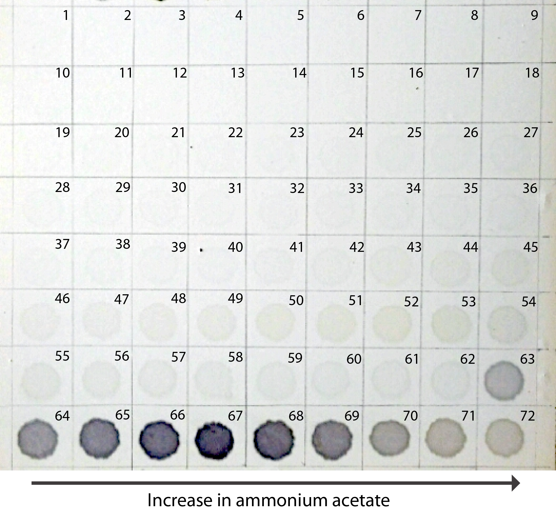

**Figure S8**. Activity screening of GOOX mutants and glucose oxidase (GO, cat. no. G2133 from Sigma) on GlcA and MeGlcA. The enzymes (16 nM) were assayed at 37 oC with 10 mM GlcA and 1 mM MeGlcA in 100 mM Tris buffer pH 8.0 (for GOOX mutants) or 50 mM sodium acetate pH 5.0 (for GO).

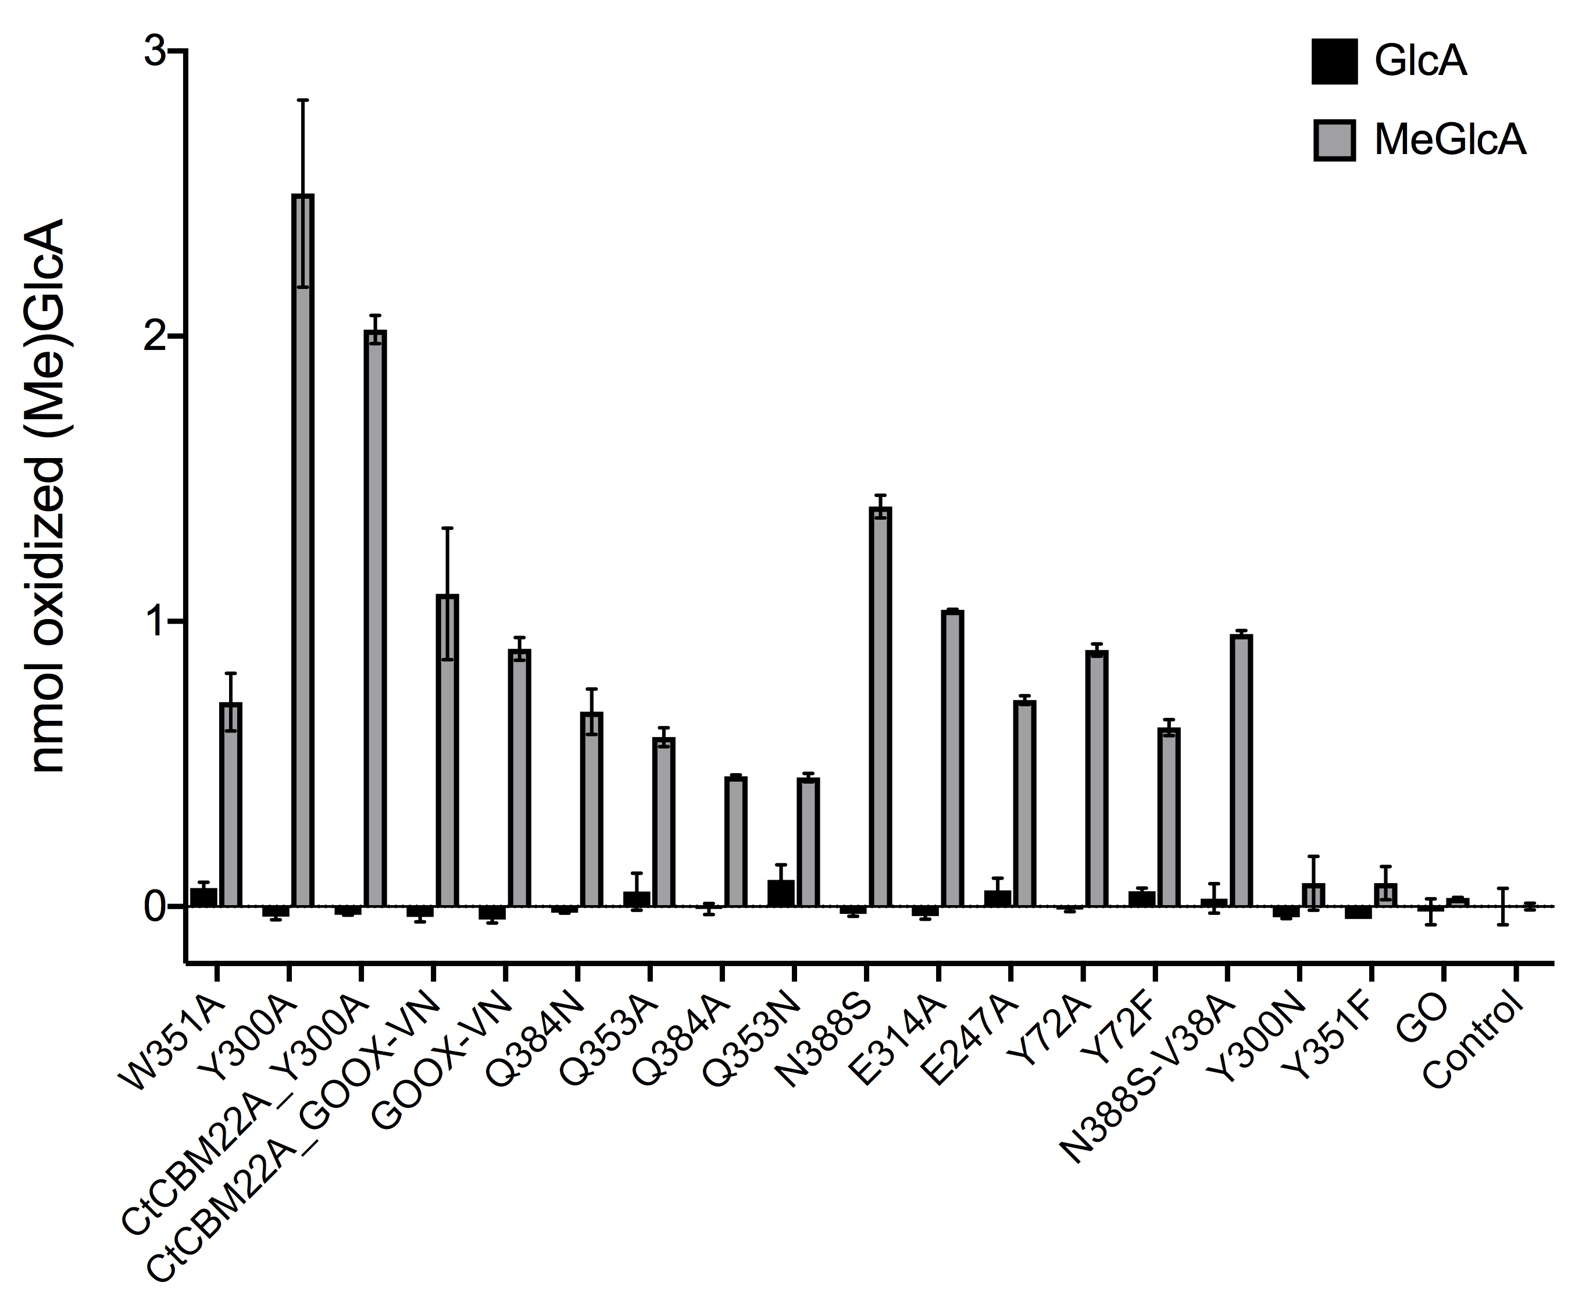

**Figure S9**. HPAEC-PAD analyses of H2O2 effects on AxyAgu115A activity and MeGlcA degradation. (A) The presence of H2O2 did not cause a loss of MeGlcA (as quantified by peak area). (B) Higher concentrations of H2O2 lowered the amount of MeGlcA released from glucuronoxylan by AxyAgu115A.



**Figure S10. Isolation of xylan after AxyAgu115A and GOOX-Y300A treatment.** Untreated glucuronoxylan remained soluble before (A) and after (C) centrifugation; however, hydrogel-like material was formed (B) in the reaction incubated with the two enzymes, and it was separated out by centrifugation (D).

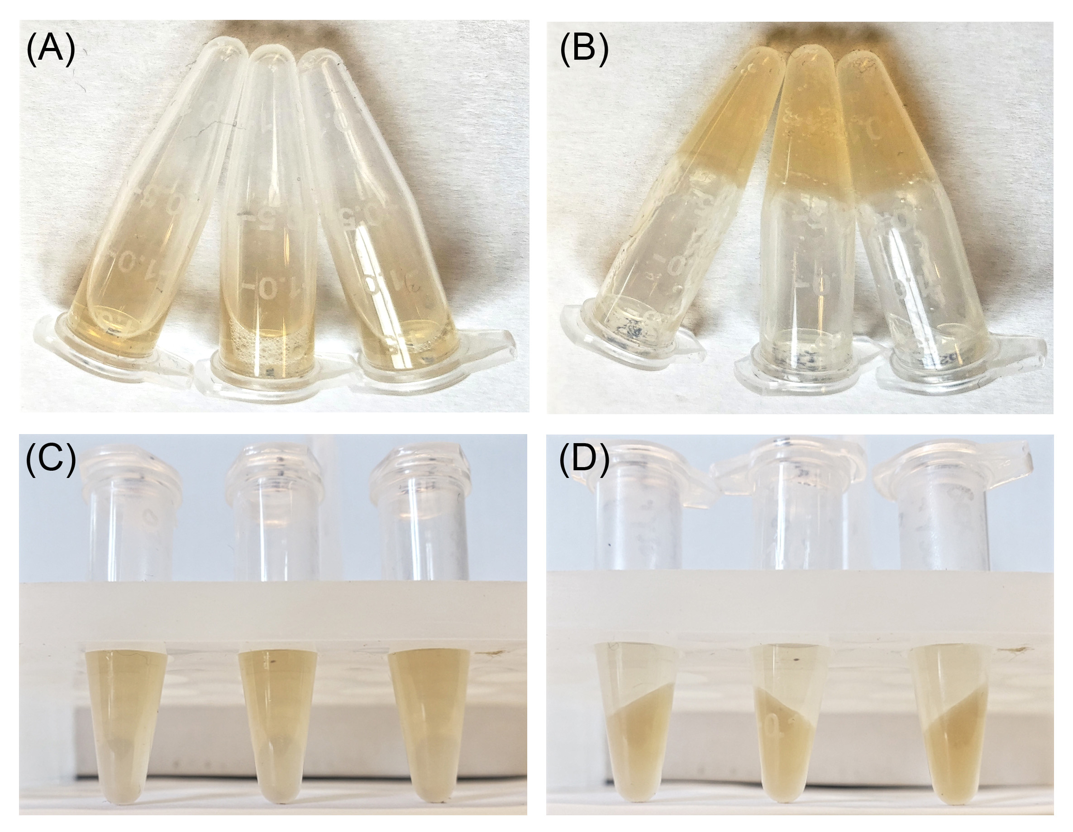

**Figure S11**. Reducing-end sugars released from glucuronoxylans before (triangle) and after (circle) AxyAgu115A and GOOX pre-treatments. After the two-enzyme incubation, the xylan fraction was harvested and water-washed by centrifugation before xylanase digestion. The amount of reducing-end sugars was measured by the PAHBAH method.

