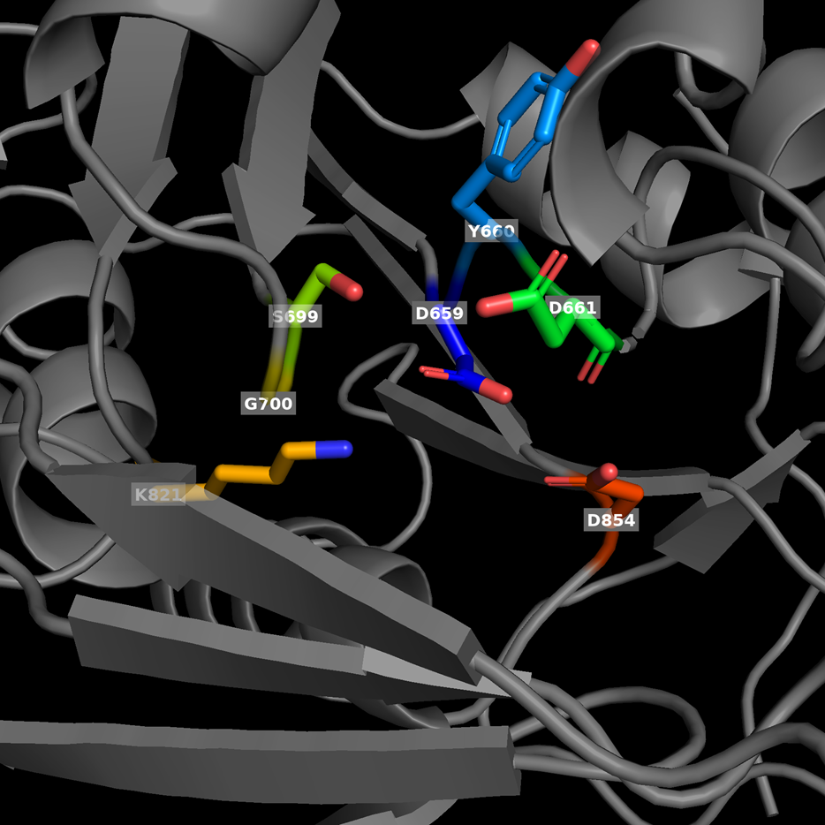
Fig. S4 Predicted binding pocket in wild-type TPP domain. The Mg²⁺ ion binding site of wild type TPS was expressed.

