Supplementary Data

The cost-effective preparation of green fluorescent carbon dots for bioimaging and enhanced intracellular drug delivery
Yuqing Sun^{a,1}, Shaohui Zheng^{a,b,1*}, Long Liuª, Ying Kongª, Aiwei Zhang^{b}, Kai Xu^{a,b*}, Cuiping Han^{a,b*}
ªSchool of Medical Imaging, Xuzhou Medical University, Xuzhou, Jiangsu,221004, PR China
^{b}Department of Radiology, Affiliated Hospital of Xuzhou Medical University, Xuzhou, Jiangsu221000, PR China
*Corresponding authors: C. Han (hancp@xzhmu.edu.cn) and K. Xu (xkpaper@163.com) S. Zheng (shaohui19910@163.com)

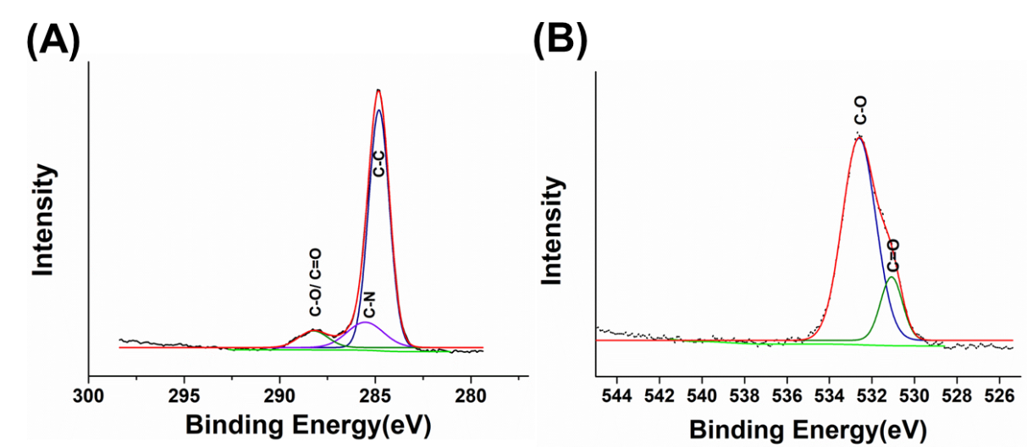
Figure. S1 XPS spectrum of DOX-CDs: (A) C_{1s} spectrum, (B) O_{1s} spectrum

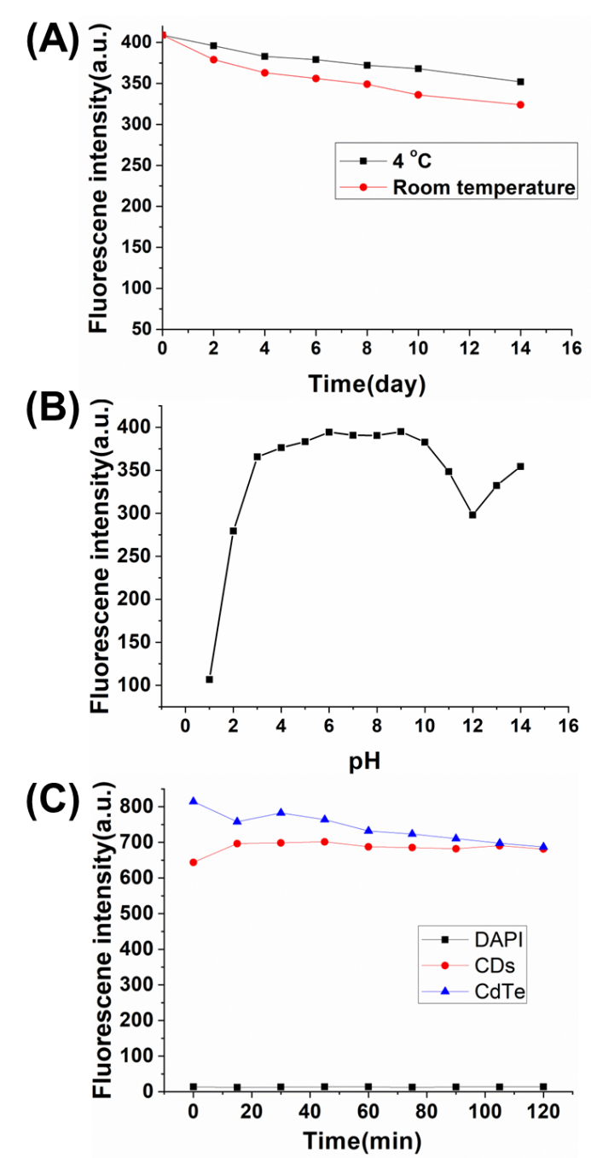

Figure. S2 Stability test of DOX-CDs at (A) Different time, (B) different pH, (C) Fluorescence anti-photobleaching test.
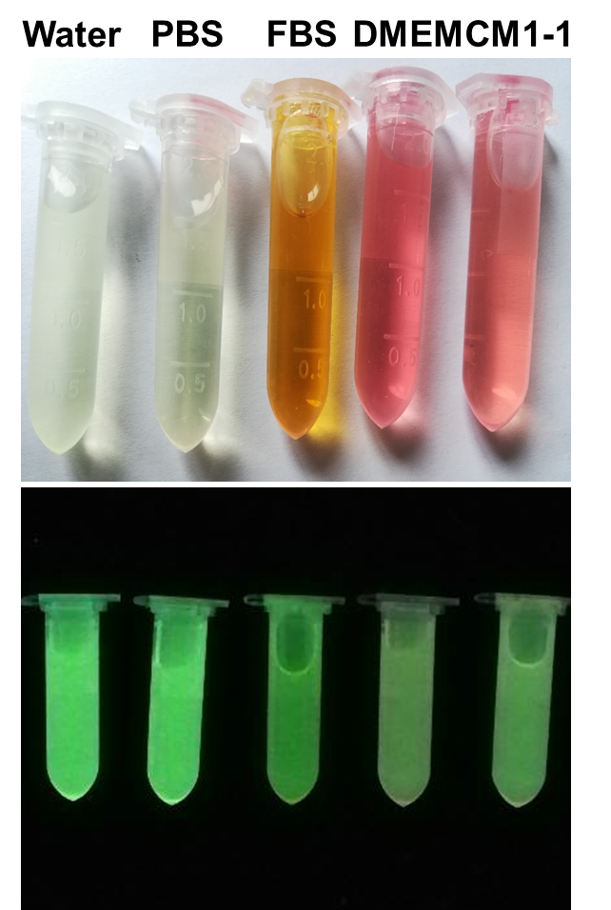

Figure. S3 Bright and fluorescent photos of DOX-CDs in various medium including DI water, PBS, FBS, DMEM and CM1-1.

Figure. S4. The zeta potential of CDs, DOX and DOX-CDs.
Figure. S5 Drug loading ability of CDs: (A) Drug encapsulation efficiency at various concentrations of DOX, (B) Drug loading efficiency at various concentrations of DOX.

