1.About the allergen extract
Reconstitute one vial of the allergen extract of Artemisia (XP61D3A2.5, Greer) in 2.5ml of double distilled water to make stock solution and then detect its concentration by BCA method as 9.386mg/ml.
Reconstitute the stock solution in PBS to make the needed concentration, such as 1:500 and 1:1000 in the article.
2.The best concentration of allergen extract in ELIFAB
The optimal antibody/allergen ratio to form complexes was found at an allergen extract concentration of 1:500.

3.The pollen data of Beijing from August 1st to September 29th of each year from 2015 to 2018.
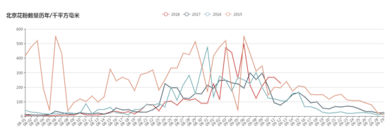
The Chinese characters “北京花粉数量历年/千平方毫米” mean that “the pollen levels of Beijing of each year/k·mm²”.

