Supplementary Information: More support for Earth’s massive microbiome

Jay T. Lennon and Kenneth J. Locey

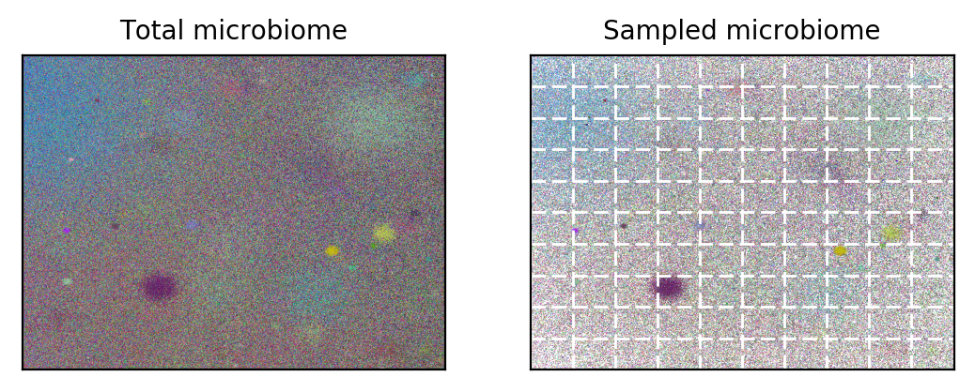

S1 Fig. Simulated 2-D landscape containing an abundant (10⁷ individuals) and diverse (10⁵ taxa) microbiome for assessing bias in richness estimators. Left panel depicts the unsampled microbiome where taxa have uneven distributions of abundance and are aggregated in space. Right panel represents the microbiome following random sampling. Source code and simulated data can be found at https://www.github.com/LennonLab/census.

