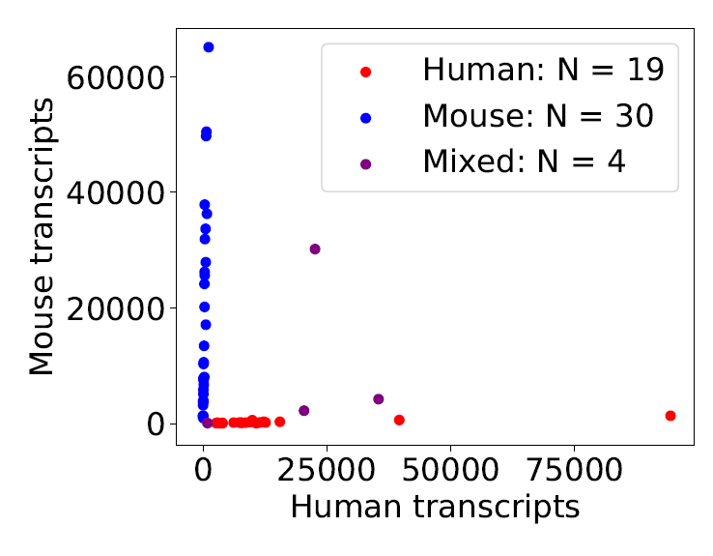
Figure S1. Deeper sequencing of a small subset of beads from a 2-cell experiment, showing beads that captured at least 1000 transcripts. Beads are classified as mixed beads if they captured 10% mouse or human transcripts, depending on the dominant transcript type.

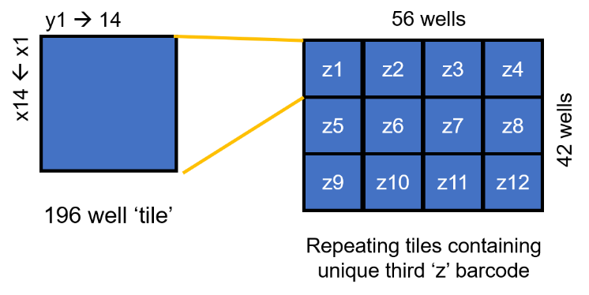
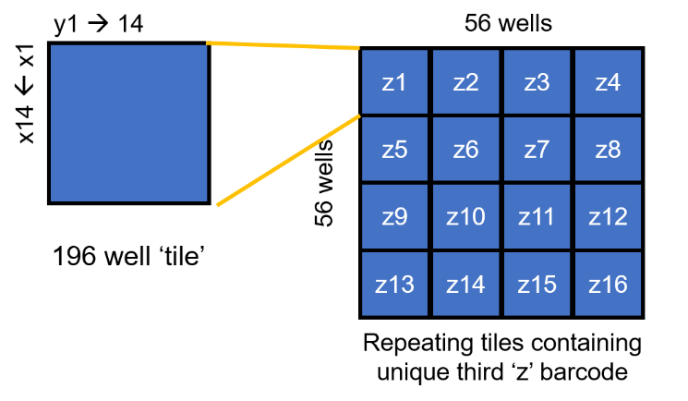
B
A

Figure S2. Well index coordinating scheme. Each well has a unique but known combination of three indexes. A 14 by 14 tile has each column and row barcoded with a unique index. This tile is repeated a total of (A) twelve or (B) sixteen times with each tile having a unique third index.

Component | Sequence
TSO_PCR Primer | AAGCAGTGGTATCAACGCAGAGTGAAT
Illumina Read2 Primer | GTCTCGTGGGCTCGGAGATGTGTATAAGAGACAG
Barcode | NNNNNNNN
PolyA (21) tail | AAAAAAAAAAAAAAAAAAAAA

Table S1: Components of coordinate oligo, in 5’ to 3’ order.

Coordinate Name | 8bp barcode
y1 | CGCCGCAA
y2 | ACCAGCCG
y3 | TACTGCGA
y4 | GTCGGCTG
y5 | CCCAGGAC
y6 | AACTGGCT
y7 | TTCGGGGC
y8 | GGCCGGTT
y9 | CACTGTAG
y10 | ATCGGTCA
y11 | TGCCGTGG
y12 | GCCAGTTA
y13 | GGCATTGT
y14 | CCCTTTTC
x1 | TGCATACG
x2 | GCCTTAGA
x3 | CACGTATG
x4 | AGCATCAC
x5 | TCCTTCCT
x6 | GACGTCGC
x7 | CTCCTCTT
x8 | ACCTTGAG
x9 | TACGTGCA
x10 | GTCCTGGG
x11 | CGCATGTA
x12 | TTCCTTCC
x13 | TCGTAGTG
x14 | GTGCATAC
z1 | GGGAAAAG
z2 | CCGTAACA
z3 | AAGGAAGG
z4 | GCGTACAT
z5 | CAGGACCC
z6 | ATGCACGT
z7 | TGGAACTC
z8 | GAGGAGAA
z9 | CGGAATCT
z10 | ACGTATGC
z11 | CGGTCAAT
z12 | ACGGCACC
z13 | TAGCCAGT
z14 | GTGACATC
z15 | CCGGCCAA
z16 | AAGCCCCG

Table S2: Lookup table of the barcode sequences of the coordinate oligos used in this study.

