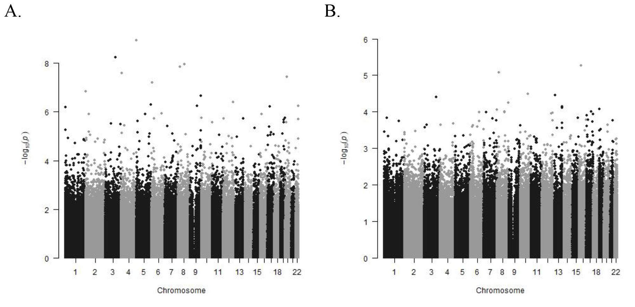

Supplementary Figure 1:
Manhattan Plots of CpG sites for differentially methylated sites from either non-diabetic vs. diabetic (Panel A) or non-obese vs obese (Panel B) models. Unadjusted p-values models without correction for covariates is presented.

