Co-expressing GroEL-GroES, Ssa1-Sis1 and Bip-PDI chaperones for enhanced intracellular production and partial-wall breaking improved stability of porcine growth hormone

Jinbo Deng¹$, Jiaoqing Li¹$, Miaopeng Ma¹, Peijing Zhao¹, Feiping Ming¹, Zhipeng Lu¹ $, Juqing Shi¹ $, Qin Fan¹, Qianyi Liang¹, Junhao Jia¹, Jiayi Li¹, Shuxia Zhang¹, Linghua Zhang^{1,2}*

1 Guangdong Provincial Key Laboratory of Protein Function and Regulation in Agricultural Organisms, College of Life Sciences, South China Agricultural University, Guangzhou, Guangdong 510642, China
2 Guangdong Laboratory for Lingnan Modern Agriculture, Guangzhou, Guangdong 510642, China

*Corresponding author. Tel.: 86-13650960875; Fax: 8620-85282180.
E-mail address: lhzhang@scau.edu.cn
Address: Zhang LingHua
Microbiological staff room, College of Life Sciences,
South China Agricultural University,
Wushan Road, Tianhe district
Guangzhou
GuangDong
China
510642
E-mail address: lhzhang@scau.edu.cn

$ These authors contributed equally to this work.

Hyg-Zeo-R (Kan- Zeo-R)
Hyg-Zeo-F (Kan- Zeo-F)
Ins1
Ins2
Ins2
Ins1
pGAPZA
Zeo
pGAPZA
Hyg (Kan)
Hyg (Kan)
Hyg (Kan)
pGAPK(H)A

Zeo: Zeocin resistance gene
Hyg: Hygromycin resistance gene
Kan: G418 resistance gene
Starting
plasmid
Chimeric
primers
Omega-PCR
Substitution mode
plasmid
First PCR
products
plasmid
Final
plasmid
Fig. S1 Substitution omega PCR for pGAPK(H)A construction
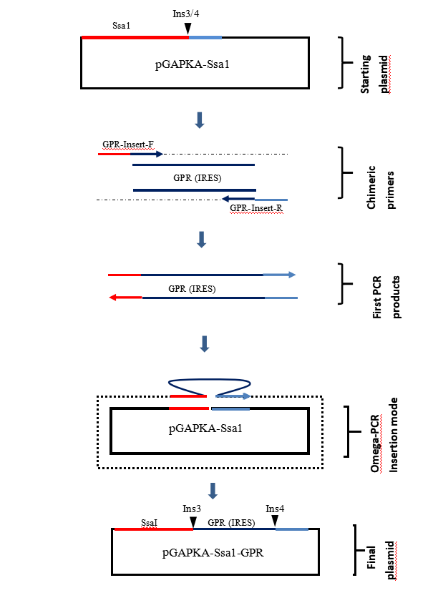
Fig. S2 Insertion omega PCR for pGAPKA-Ssa1-GPR construction

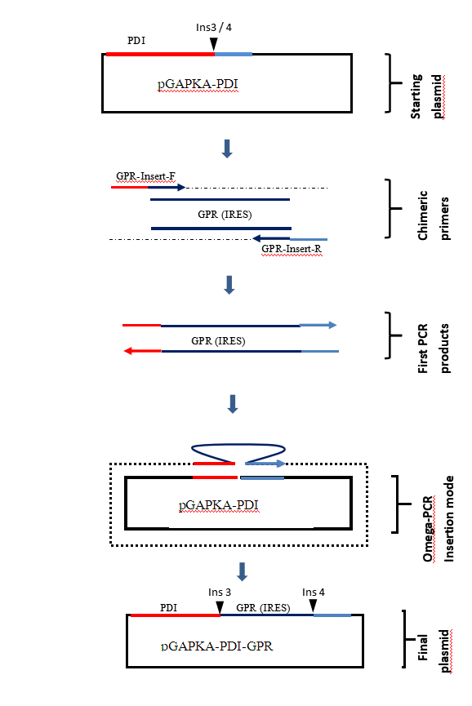

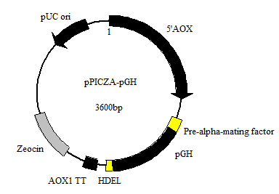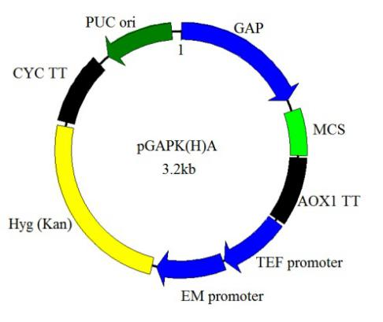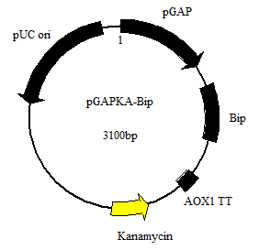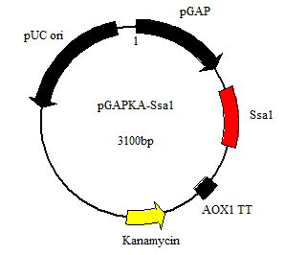
Fig. S3 Insertion omega PCR for pGAPKA-PDI-GPR construction
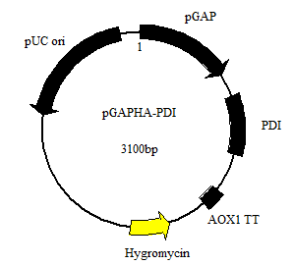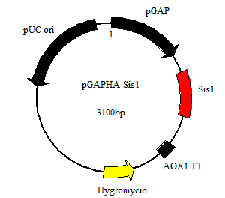

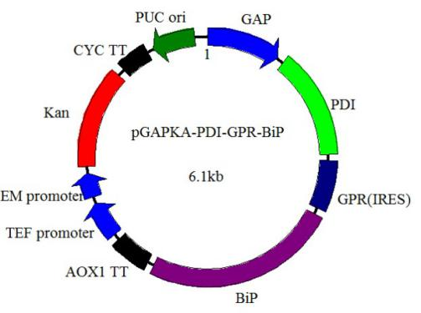
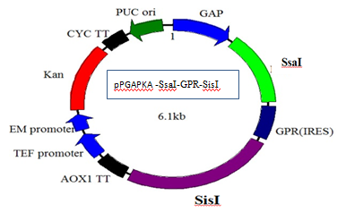
Fig. S4 The plasmids used in this study

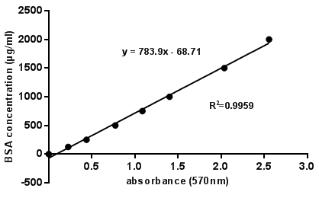

Fig. S5 Standard curve of BSA standard solution

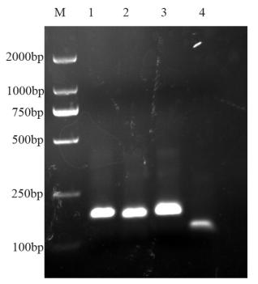

Fig. S6 PCR splicing results

Lane M was DL2000 standard molecular weight Marker, Lane 1, the result of the first group P1-P4 PCR splicing, Lane 2, the result of the second group P5-P8 PCR splicing, Lane 3, the result of the third group P9-P12 PCR splicing, and Lane 4, the result of the fourth group P13-P15 PCR splicing.

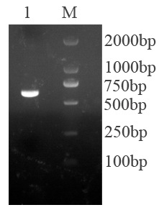

Fig. S7 PCR splicing results

Lane M, DL2000 standard molecular weight Marker, Lane 1, the result of PCR splicing of the target gene.

Table S1 Primers for PCR reactions

Primer name | Sequencea
P1 | CCGGAATTCGCCACCATGTTTCCAGCTATGCCATTGTCTTCTTTGTTTGCTAACGCTG
P2 | GTATCAGCAGCCAATTGATGCAAATGTTGGGCTCTCAAGACAGCGTTAGCAAACAAAG
P3 | CAATTGGCTGCTGATACTTACAAGGAATTTGAAAGAGCTTACATTCCAGAAGGTCAAAG
P4 | CAGAGAAACAGAAAGCAGCTTGAGCGTTCTGAATAGAGTATCTTTGACCTTCTGGAATG
P5 | CAATTGGCTGCTGATACTTACAAGGAATTTGAAAGAGCTTACATTCCAGAAGGTCAAAG
P6 | CAACAAAGAGAATCTCAACAATTCAACATCAGATCTTTGTTGAGCTTCATCCTTACC
P7 | GTTGAGATTCTCTTTGTTGTTGATTCAATCTTGGTTGGGTCCAGTTCAATTCTTGTC
P8 | CAGAAGTACCAAAGACCAAAGAGTTAGTAAAGACTCTAGACAAGAATTGAACTGGAC
P9 | GGTCTTTGGTACTTCTGATAGAGTTTACGAGAAGTTGAAGGATTTGGAAGAAGGTATTC
P10 | GCTCTTGGAGAACCATCTTCCAATTCTCTCATCAAAGCTTGAATACCTTCTTCCAAATC
P11 | GATGGTTCTCCAAGAGCTGGTCAAATCTTGAAGCAAACTTACGATAAGTTTGATAC
P12 | CCGTAGTTCTTCAACAAAGCATCATCAGATCTCAAGTTAGTATCAAACTTATCGTAAG
P13 | CTTTGTTGAAGAACTACGGTTTGTTGTCTTGCTTCAAGAAGGATTTGCATAAGGCTG
P14 | GATTCAACAAATCTTCTACACTTCATAACTCTCAAGTAAGTTTCAGCCTTATGCAAATC
P15 | GTAGAAGATTTGTTGAATCTTCTTGTGCTTTCTAATAGCTCGAGCGG
PF | CCGGAATTCGCCACCATG
PR | CCGCTCGAGCTATTAGAAAG
GroEL-F | GGAATTCACCATGGCAGCTAAAGACGTAAAATTCGGTAACG
GroEL-R | ATAAGAATGCGGCCGCTTACATCATGCCGCCCATGCCACC
GroES-F | GGAATTCACCATGAATATTCGTCCATTGC
GroES-R | ATAAGAATGCGGCCGCTTACGCTTCAACAATTGCCAG
5’AOX1 | GACTGGTTCCAATTGTTGACAAGC
3’AOX1 | GCAAATGGCATTCTGACATCC
PGAP | GTCCCTATTTCAATCAATTGAA
Hsp70-F | ATGCCAGCTGTCGGTATTGATTTAGGAAC
Hsp70-R-Xba | GCTCTAGACTAATCGACTTCCTCAACAGTTGGTCCGT
Hsp70-F-Xho  Hsp40-F | CCGCTCGAGTTCAAACAAAATGCCAGCTGTCGGTATTGATTTAGGAAC  ATGGTGAAAGAACAAGGACTATACAAT
Hsp40-F-EcoR | CGGAATTCTTCAAACAAAATGGTGAAAGAACAAGGACTATACAAT
Hsp40-R-Not | CTTGCGGCCGCTTAAAACGCTTTGGAAATGGCATC
sig-F | ATGGCTGCTGGTCCAAGAACTTCAGTTTTATTGGCTTTCGCTTTGCTTTGTTTACCTTG
sig-R | AATGGCATTGCTGGAAACATAGCTCCAACTTCTTGAGTCCAAGGTAAACAAAGCAAAGC
sig-F/EcoR I | CGGAATTCTTCAAACAAAATGGCTGCTG
F-pre- alpha | ATGAGATTTCCTTCAATTTTTACTGCTGTTTTATTCGCAG
R-pre-alpha  R-HDEL-Not1 | TAATGGCATTGCTGGAAAAGCAGCTAATGCGGAGGATGCTGCGAATAAAACAGCAGT  CTTGCGGCCGCCTATTAAAGCTCGTCGTGGAAAGCGCAAGAGGATTCGAC
F-pre-alpha-EcoR1 | CGGAATTCTTCAAACAAAATGAGATTTCCTTCAAT
（wild）pgh-F | ATGTTGGGAGCCATGCCCTT
（wild）pgh-R | CTAGAAGGCACAGCTGCTC
phg-F-EcoRI | cggaattcaccATGTTGGGAGCCATGCCCTT
pgh-R-NotI | CTTGCGGCCGCCTAATGATGATGATGATGATGGAAGGCACAGCTGCTC

Table S2 The plasmids used in this study
Plasmids | Marker
pPICZA | Zeocin
pGAPZA | Zeocin
pPICZA-pGH（optimized）-HDEL | Zeocin
pPAO | Hygromycin
pPICZαA | Zeocin
pPICZA-pGH | Zeocin
pPICZαA-pGH | Zeocin
pPICZA-pGH（optimized ） | Zeocin
pGAPZA-GroEL-GroES | Zeocin
pGAPKA-Bip | Amp，Kan
pGAPHA-PDI | Hygromycin
pGAPKA-Ssa1 | Amp，Kan
pGAPHA-Sis1 | Hygromycin

Detailed procedure:

Native pGH cloing from cDNA:

Full-length pGH gene splicing by overlapping PCR with optimized splicing primers P1-P15: using P1-P4 as the first group, P5-P8 as the second group, P9-P12 as the third group, and P13-P15 as the fourth group. These four groups were individually subjected to PCR with the following conditions:
20 μL reaction volume including 10 μL KOD-FX buffer, 0.2-0.4μL KOD-FX polymerase, 1~100 ng cDNA, 0.3 μM dNTP mix, 0.3 μM each forward and reverse primer. And the PCR cycling parameters were as follows: 94 ℃ for 2 min; 30 cycles of 98 ℃ for 10 s, 62 ℃ for 10 s, 72 ℃ for 15 s (1 kb/min) followed by a final 2 min extension.

Optimized-pGH by splicing PCR:

The four PCR products from above PCR were mixed, and primers PF/PR were used for the second round of splicing, the stitching was performed under condition as follows:
20 μL reaction volume including 10 μL KOD-FX buffer, 0.2-0.4μL KOD-FX polymerase, 1~100 ng cDNA, 0.3 μM dNTP mix, 0.3 μM each forward and reverse primer. And the PCR cycling parameters were as follows: 94 ℃ for 2 min; 30 cycles of 98 ℃ for 10 s, 53 ℃ for 10 s, 72 ℃ for 40 s (1 kb / min) followed by a final 2 min extension.
The results were shown in Fig. S6. The first to fourth groups of PCR products were added to the overlapping PCR reaction system, and splicing amplification was performed under splicing PCR conditions by primers PF/PR. The results were shown in Fig. S7.

