Three Dimensional CuO/TiO₂ Hybrid Nanorod Arrays Prepared by Electrodeposition in AAO Membranes as an Excellent Fenton-like Photocatalyst for Dye Degradation
Manisha Kondiba Date^{1,2, 3}, Li-Heng Yang^{1,2, 3}, Tzu-Yi Yang^{1,2, 3}, Kuang-ye Wang^{1,2, 3}, Teng-Yu Su^{1,2, 3}, Ding-Chou Wu^{1,2, 3}, Yu-Lun Cheuh^{1,2, 3*}
¹Department of Materials Science and Engineering& Frontier Research Center on Fundamental and Applied Sciences of Matters National Tsing Hua University, Hsinchu 30013, Taiwan
²Department of Physics, National Sun Yat-Sen University, Kaohsiung, 80424, Taiwan
³Frontier Research Center on Fundamental and Applied Sciences of Matters, National Tsing Hua University, Hsinchu 30013, Taiwan.
*Corresponding email: ylchueh@mx.nthu.edu.tw

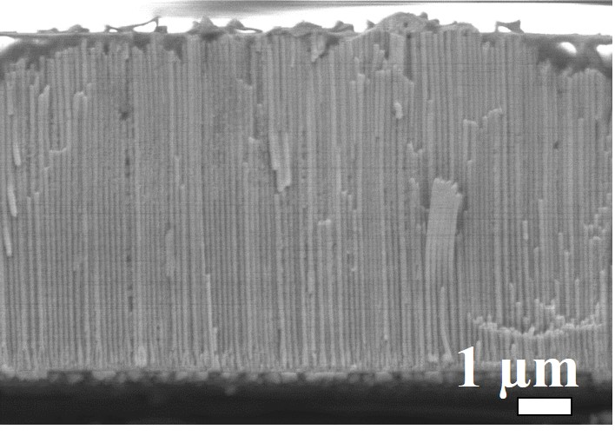
Figure S1. Cross-section SEM image of 6.53 µm long CuO NRs in AAO (scale bar: 1 µm).
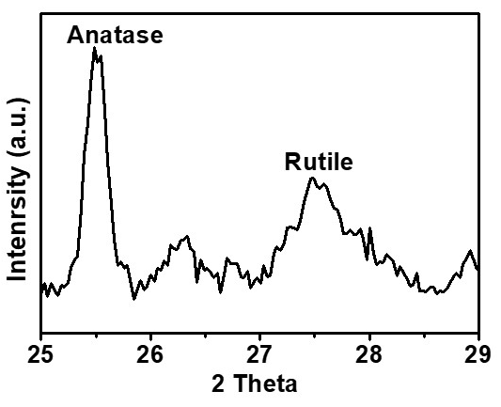
Figure S2. XRD spectrum of TiO₂ capping CuO NRs annealed at 600°C, over the 2θ ranges of 25°-29°.
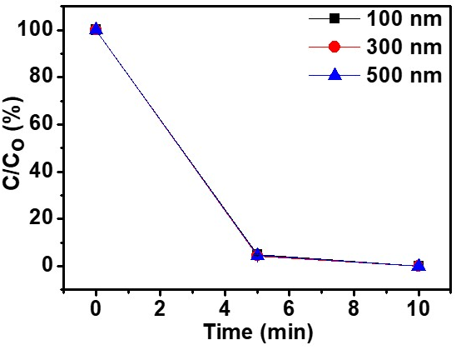
Figure S3. Degradation results of different TiO₂ thickness annealed at 500 °C capping 1.85 µm long CuO NR arrays.

