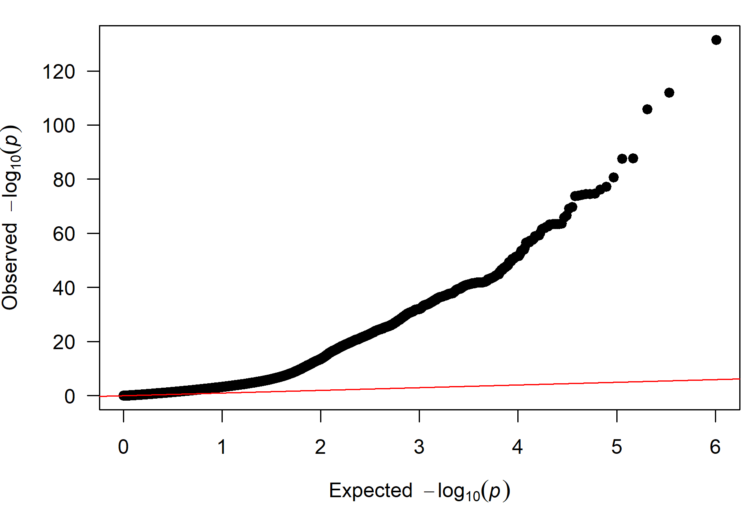
Figure S1. Quantile-quantile plot of association P-values from BOLT-LMM showing residual inflation following linkage disequilibrium score regression calibration expected under polygenicity.

