Supplemental data
Fig. S1. Inflammation and matrix remodeling markers were different in mRNA levels between sham and CLP.
Fig. S2. No significant differences were shown in circulating cytokines between two treatment groups.
Fig. S3. Cell cycle regulation, proliferation and pro-fibrosis markers were different in mRNA levels between sham and CLP.
Table. S1. Primers for quantitative polymerase chain reaction.
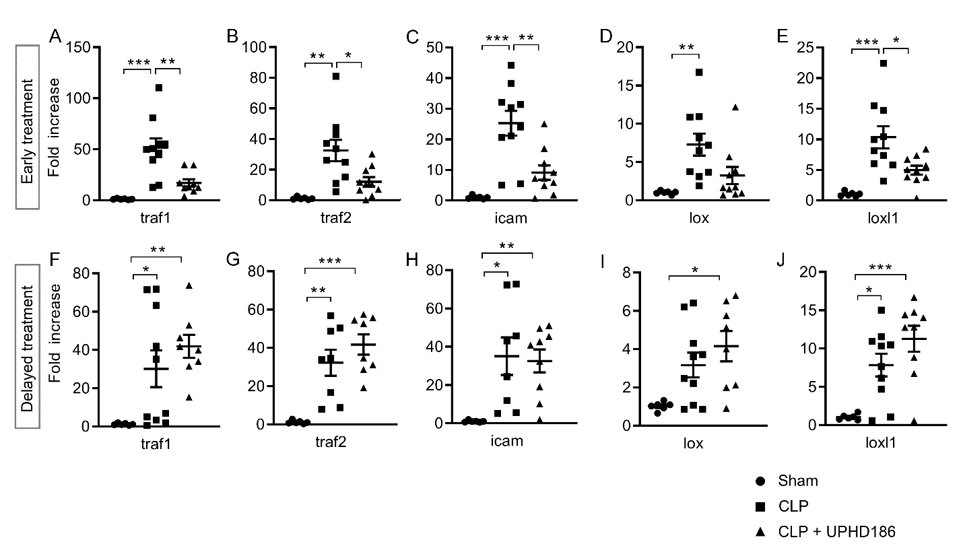
Fig. S1. Inflammation and matrix remodeling markers were different in mRNA levels between sham and CLP. Markers with statistically significant differences between sham and CLP + vehicle at treatment-day-3 are shown. Presented are dot plot figures with group mean ± SD of key mediators involved in inflammation (traf1, traf2, icam) and matrix remodeling (lox, loxl1). N = 6 ~ 8 for each group. *P < 0.05, **P < 0.01, ***P < 0.001. Abbreviations: icam, intercellular adhesion molecule; lox, lysyl oxidase; loxl1, lysyl oxidase homolog 1; traf, tumor necrosis factor receptor associated factor.
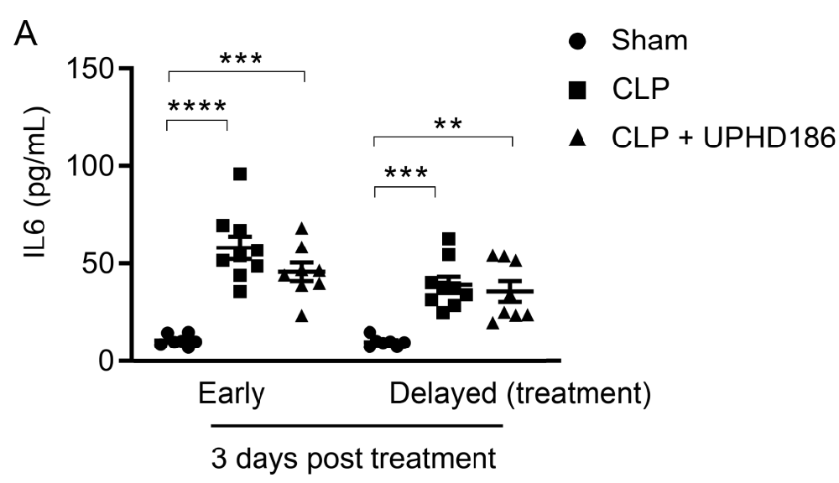

Fig. S2. No significant differences were seen in circulating cytokines between two treatment groups. A. dot plots of interleukin (IL) 6. N = 7 ~ 9 each group. **P < 0.01, ***P < 0.001, ****P < 0.0001. Abbreviation: Trt, UPHD186 treatment.
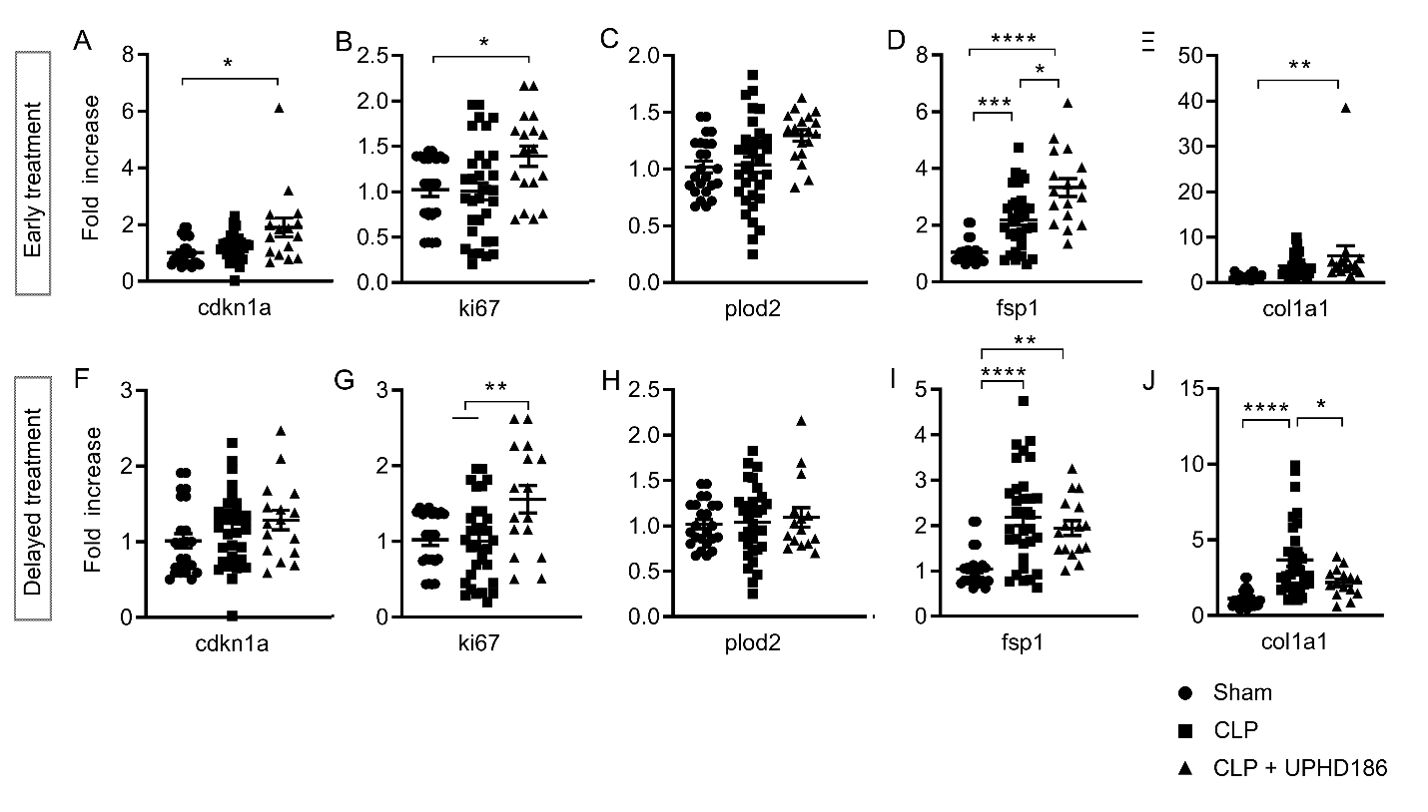
Fig. S3. Cell cycle regulation, proliferation and pro-fibrosis markers were different in mRNA levels between sham and CLP. Significant markers that had statistically significant differences between sham and CLP + vehicle at CLP-day-14 are shown. Presented are dot plot figures with group mean ± SD of key mediators involved in cell cycle arrest (cdkn1a), proliferation (ki67), and fibrosis (col1a1, plod2, fsp1). N = 9~12 for each group. *P < 0.05, **P < 0.01, ***P < 0.001, ****P < 0.0001. Abbreviations: cdkn1a, cyclin-dependent kinase inhibitor 1a; col1a1, collagen type I alpha 1 chain; fsp1, fibroblast-specific protein 1; ki67, Ki-67; plod2, procollagen-lysine, 2-oxoglutarate 5-dioxygenase 2.
Table. S1. Primers for quantitative polymerase chain reaction
Gene | Primer (5' to 3')
 | Forward | Reverse
ccl20 | GCCTCTCGTACATACAGACGC | CCAGTTCTGCTTTGGATCAGC
cdkn1a | TAGGACTCAACCGTAATATCCCGAC | AAGAGCAGCAGATCACCAGATTAAC
col1a1 | GGTATGCTTGATCTGTATCTGCCAC | CCTCGACTCCTACATCTTCTGAGTT
fsp1 | ACTTGGACAGCAACAGGGACA | GGGCTCCTTATCTGGGCAGC
gapdh | GTCAAGCTCATTTCCTGGTATGACAA | GGATAGGGCCTCTCTTGCTAGT
icam | GTGATGCTCAGGTATCCATCCA | CACAGTTCTCAAAGCACAGCG
ki67 | CTGGTTGTTACTGAAGAGCCCATAC | CTTAACTGTCCTTGGTTGGTTCCTC
kim1 | AAACCAGAGATTCCCACACG | GTCGTGGGTCTTCCTGTAGC
lox | CCACAGCATGGACGAATTCA | AGCTTGCTTTGTGGCCTTCA
loxl2 | GATCTTCAGCCCCGATGGA | CAAGGGTTGCTCTGGCTTGT
nfkb | GGAGGCATGTTCGGTAGTGG | CCCTGCGTTGGATTTCGTG
plod2 | GATGTTCGTTTCTGGTGGAAATTGG | TAAAGCAGAAAGACATGAGCTTCCC
traft1 | CACTGCCAAGTATGGTTACAAGT | GGTTGTTCTGGTCAAGTAGCAT
traft2 | TTCGGCCTTTCCAGATAACGC | ACTCCGTCAGCAGGAATGGGC

