Additional material

Appendix A

Number of pixels
 | Left-right | Caudal-cranial | Anterior-posterior
Prostate | 40 | 40 | 40
SV | 40 | 20 | 20
CTV56 | 80 | 80 | 80
Rectum | 40 | 80 | 40
Bladder | 80 | 40 | 80
R Femoral Head | 40 | 40 | 40
L Femoral Head | 40 | 40 | 40
Penile Bulb | 20 | 20 | 20
Table A1. Number of pixels used to generate population percentile surface distance projection images.
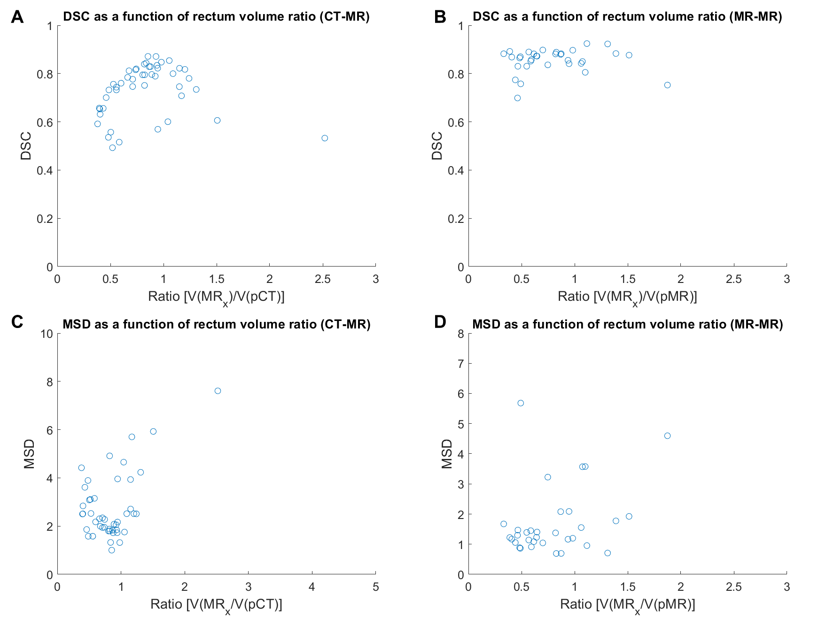
Figure A1. DSC and MSD plotted against the ratio of ground truth rectum volumes of planning images and the image of the day.

Appendix B
CTV56 projection image
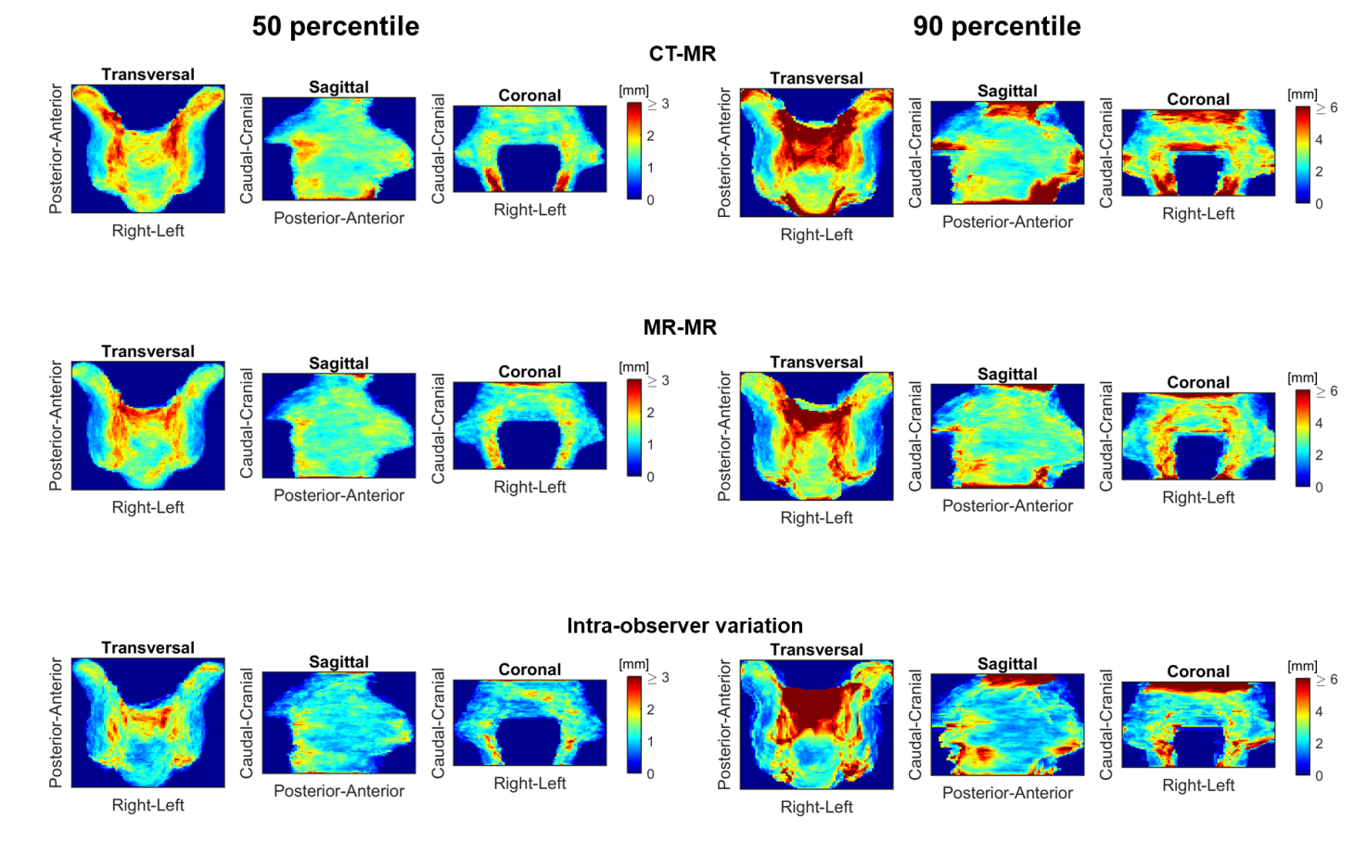
Figure B1. 50 and 90 percentile surface distance projection images for CTV56 based on CT-MR and MR-MR registrations as well as the intra-observer variation.

Seminal vesicles projection image
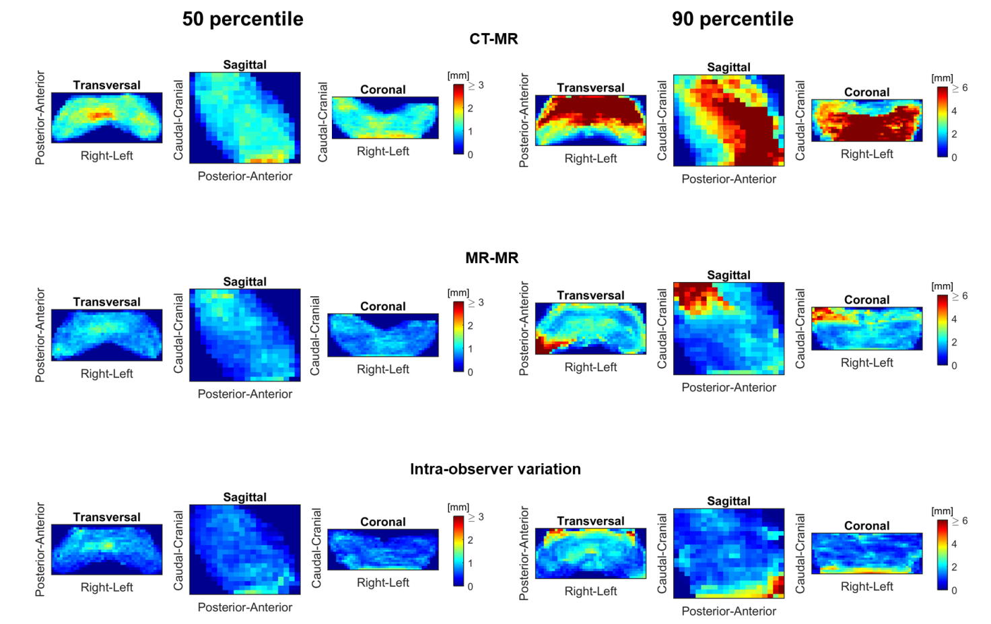
Figure B2. 50 and 90 percentile surface distance projection images for SV based on CT-MR and MR-MR registrations as well as the intra-observer variation.

Bladder projection image
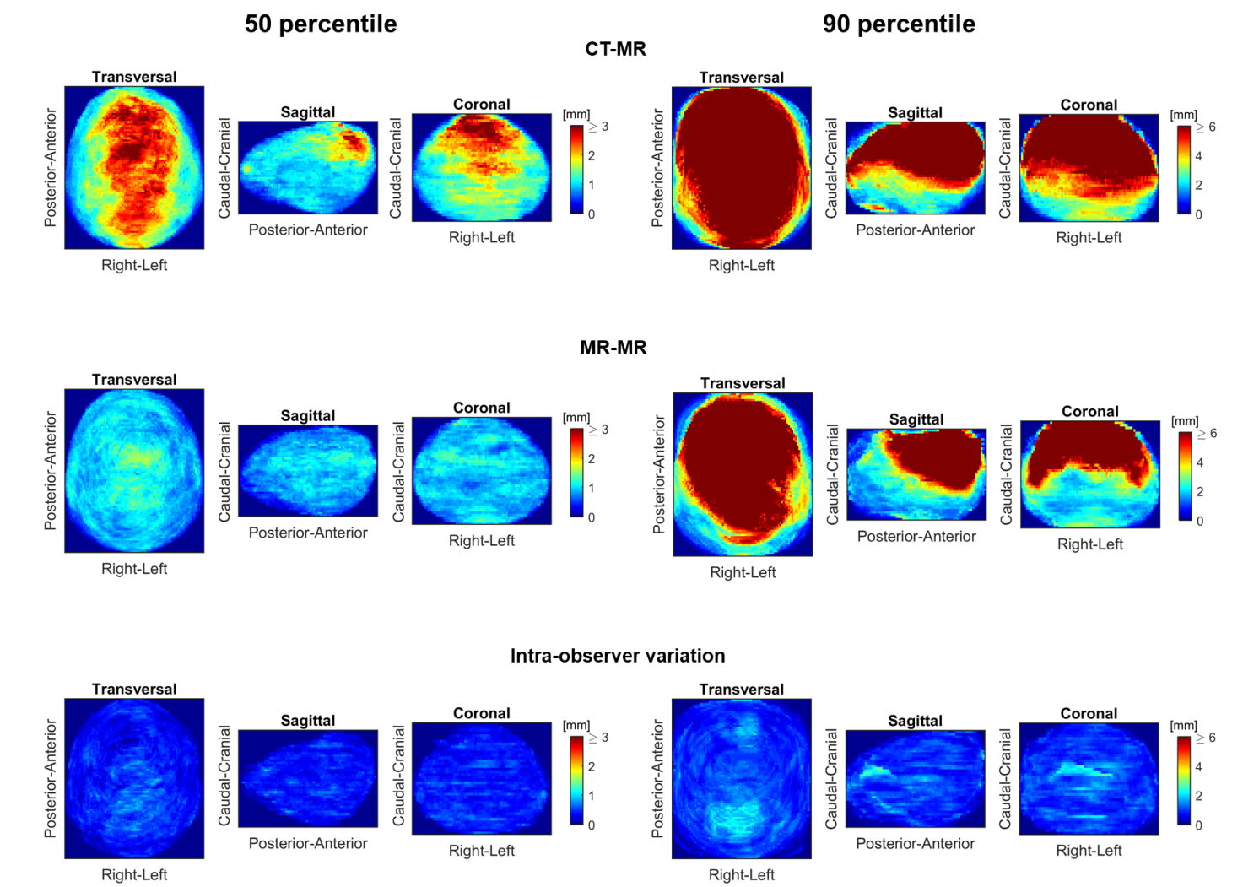
Figure B3. 50 and 90 percentile surface distance projection images for bladder based on CT-MR and MR-MR registrations as well as the intra-observer variation.

Right femoral head projection image
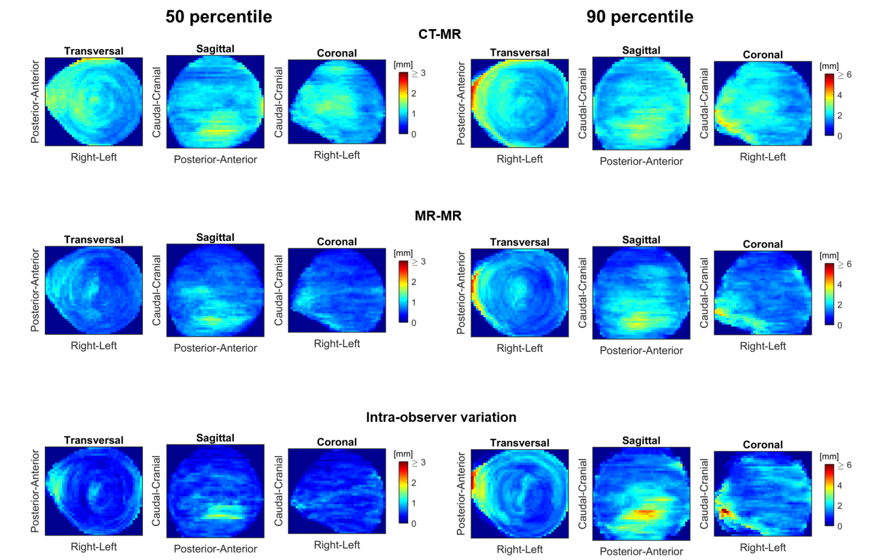
Figure B4. 50 and 90 percentile surface distance projection images for right femoral head based on CT-MR and MR-MR registrations as well as the intra-observer variation.

Left femoral head projection image
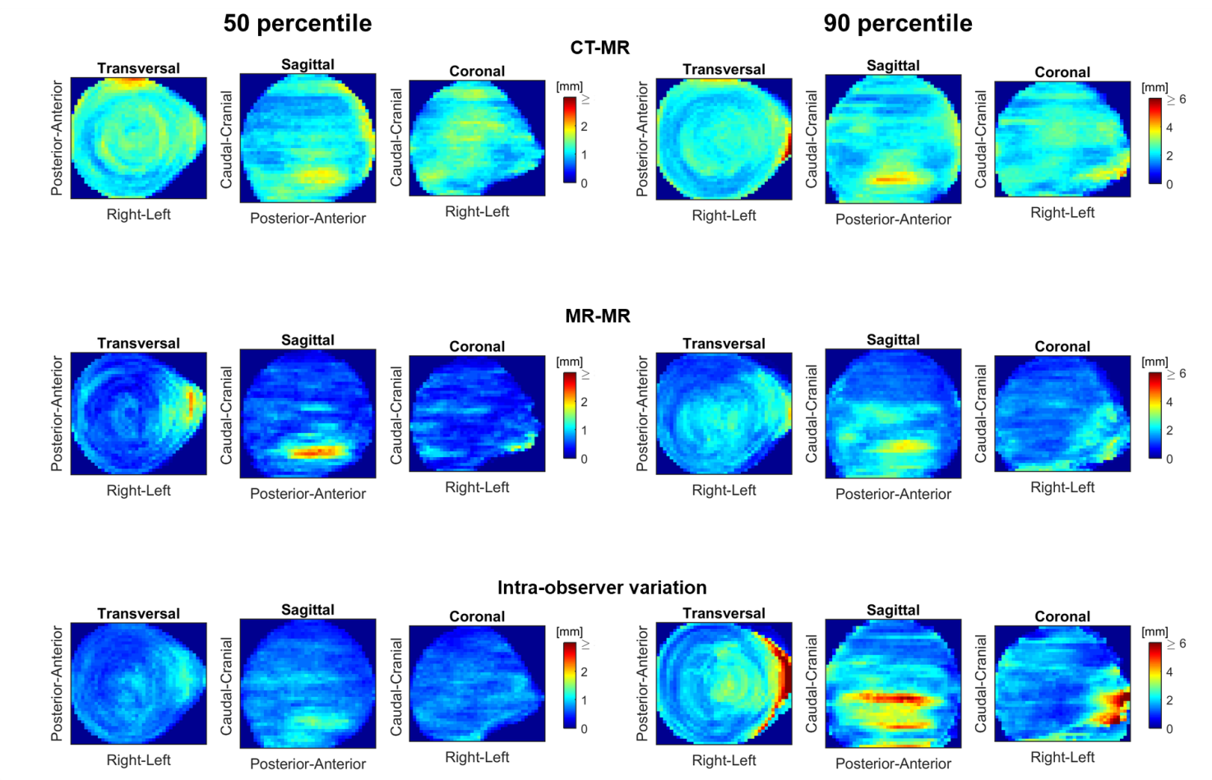
Figure B5. 50 and 90 percentile surface distance projection images for left femoral head based on CT-MR and MR-MR registrations as well as the intra-observer variation.

Penile Bulb projection image
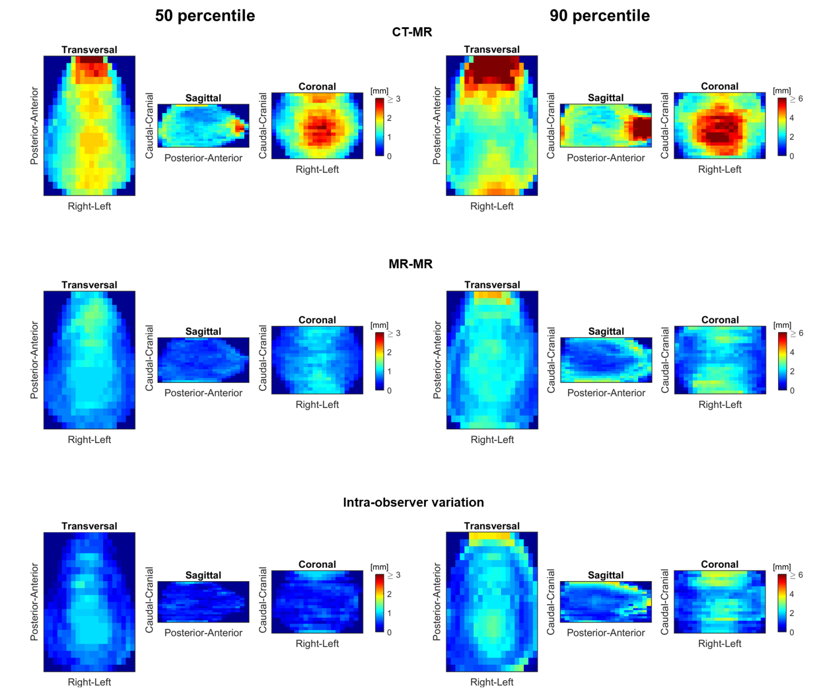
Figure B6. 50 and 90 percentile surface distance projection images for penile bulb based on CT-MR and MR-MR registrations as well as the intra-observer variation.

