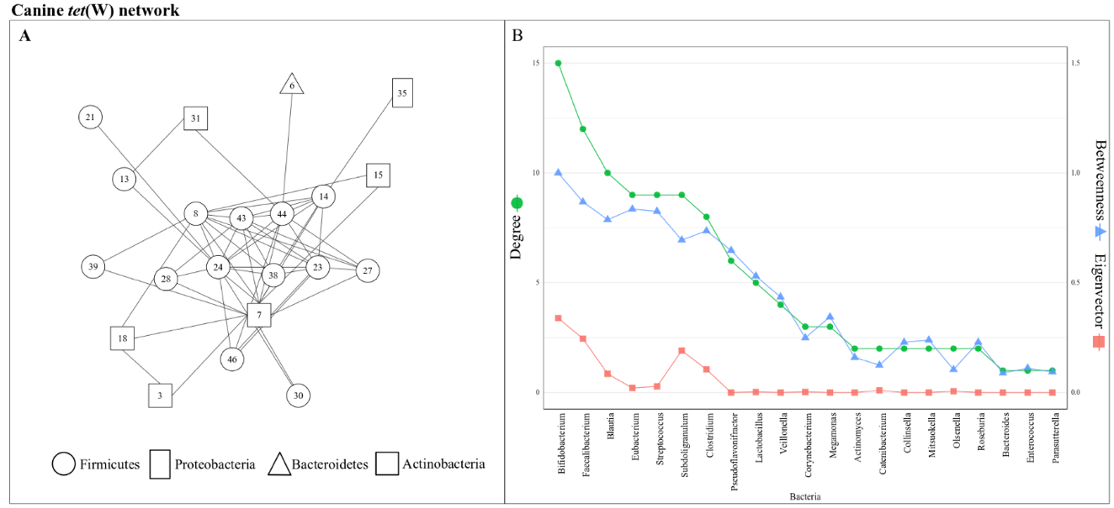
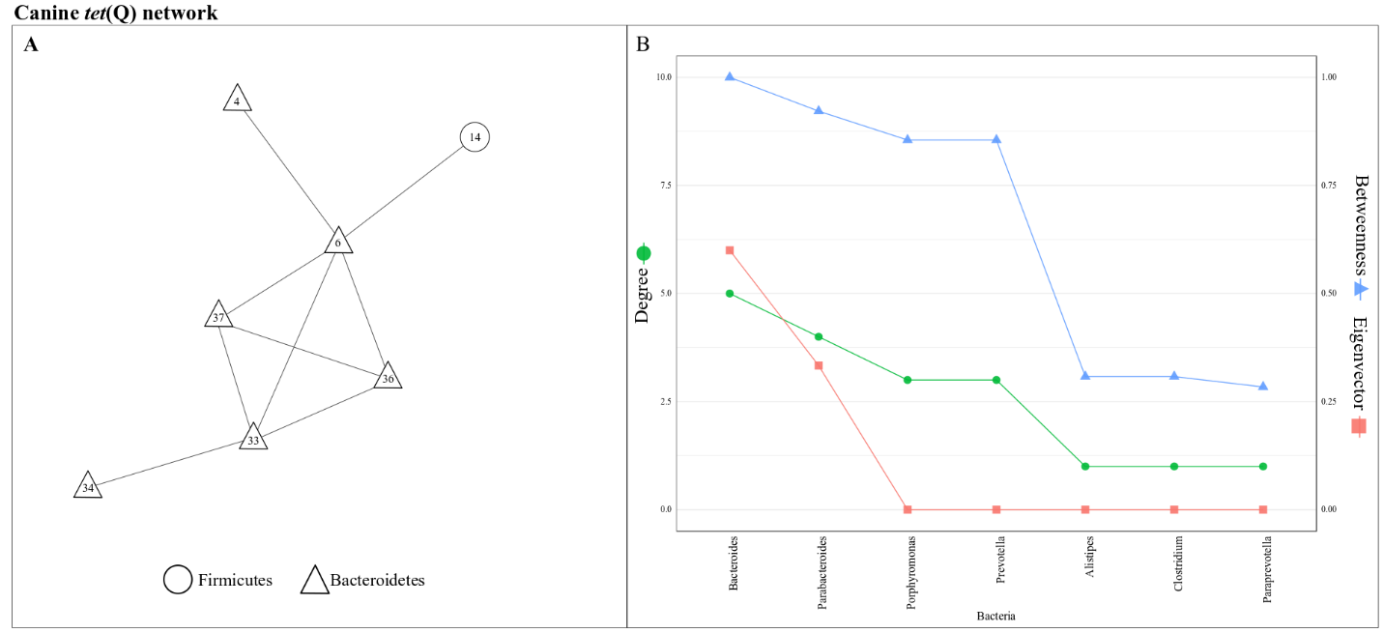
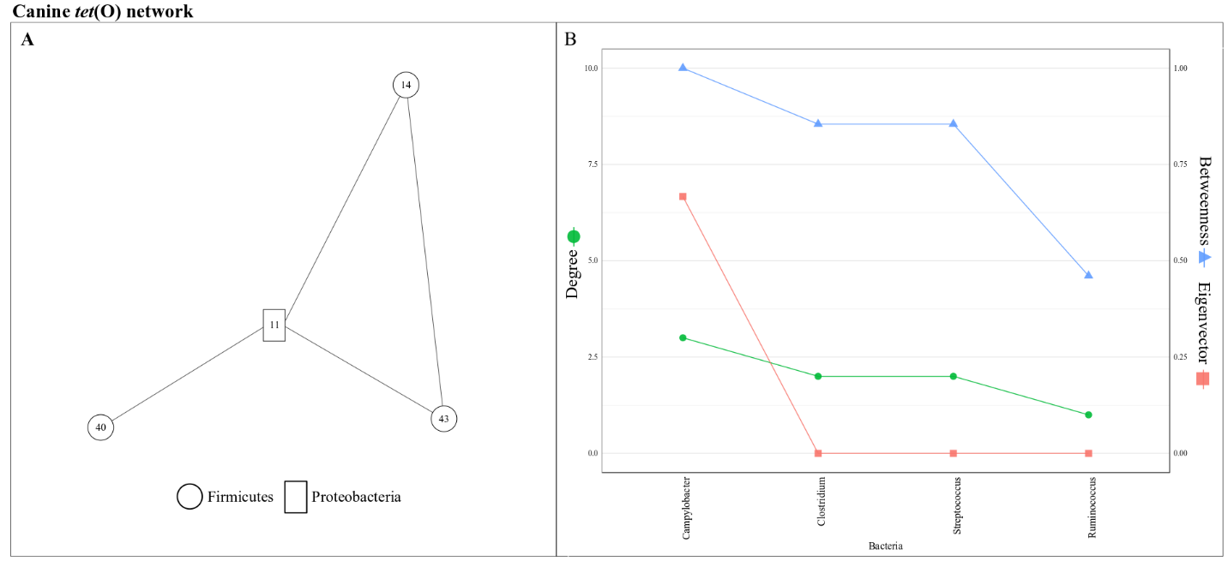
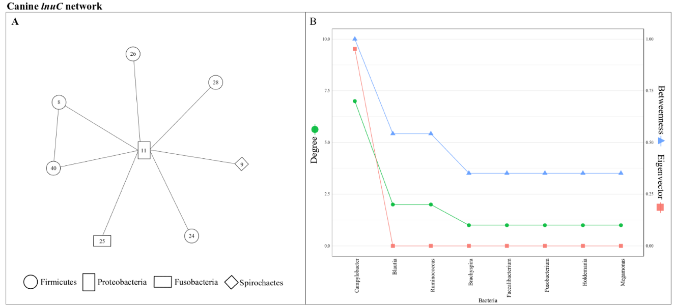
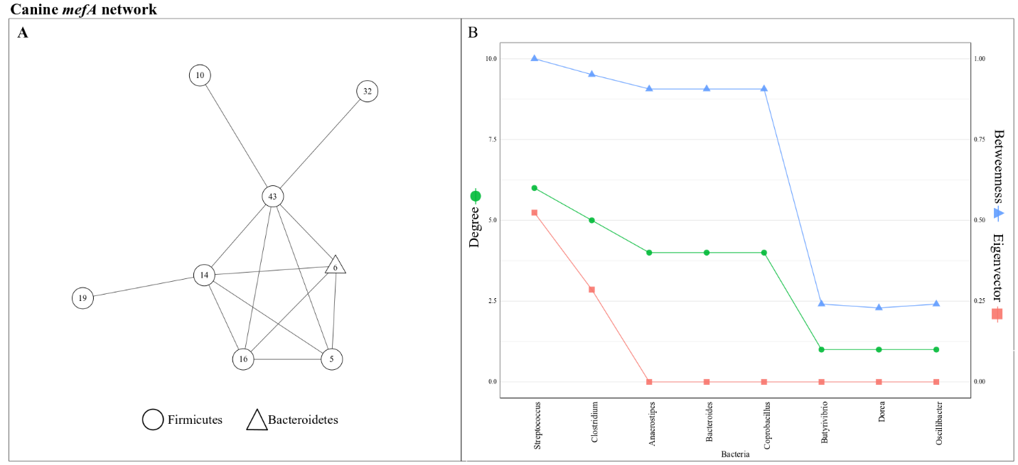
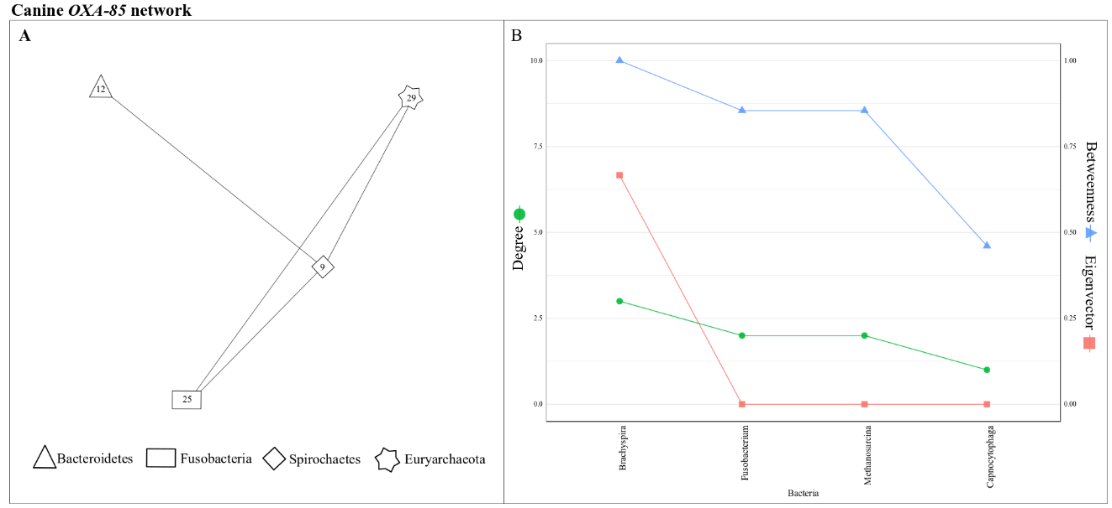
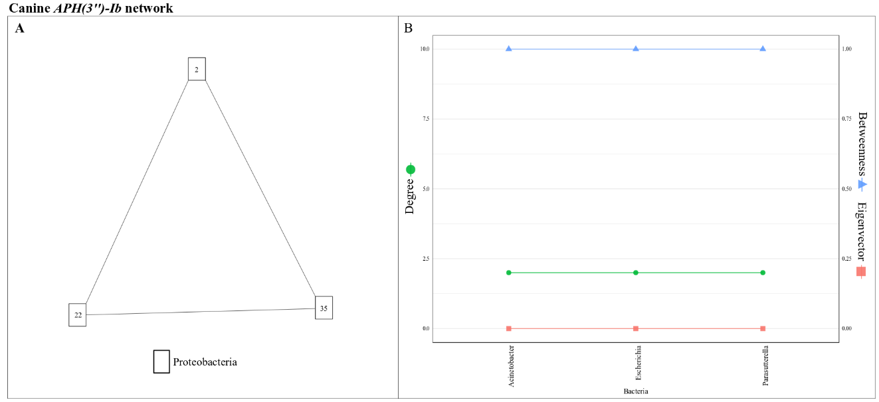
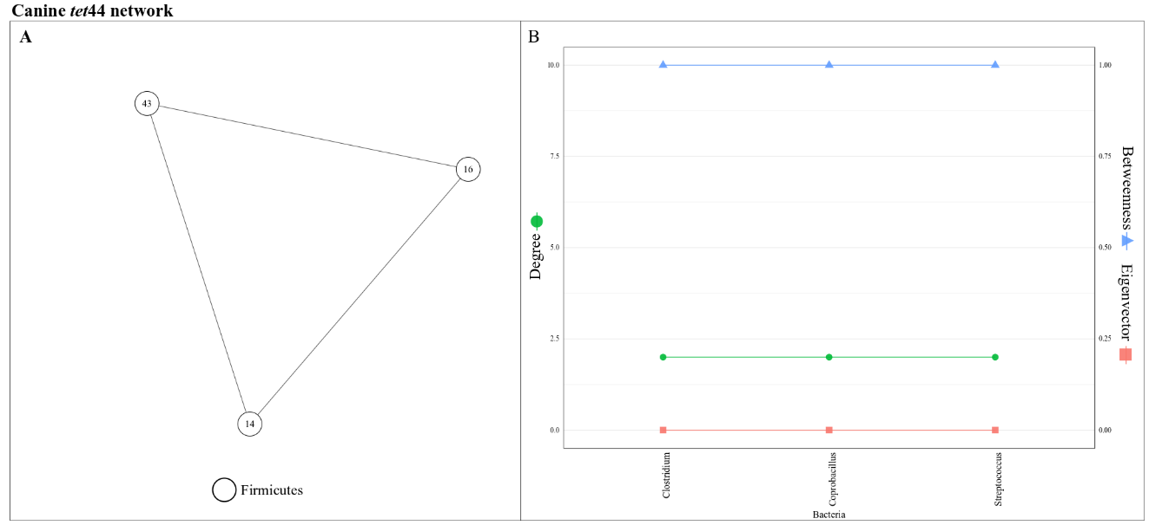
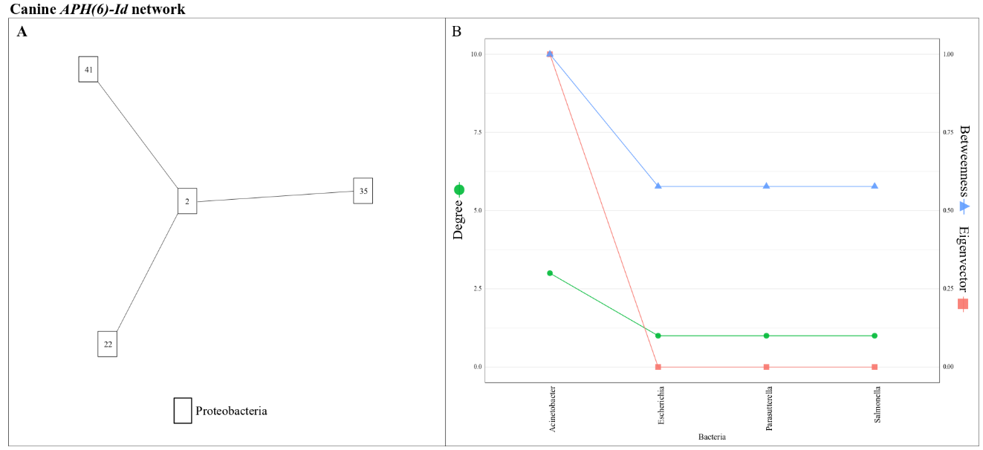
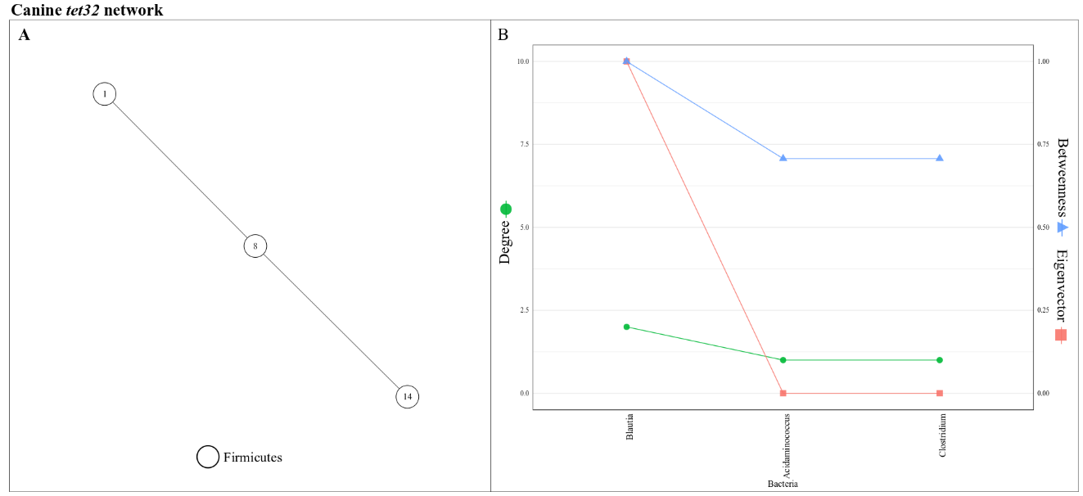
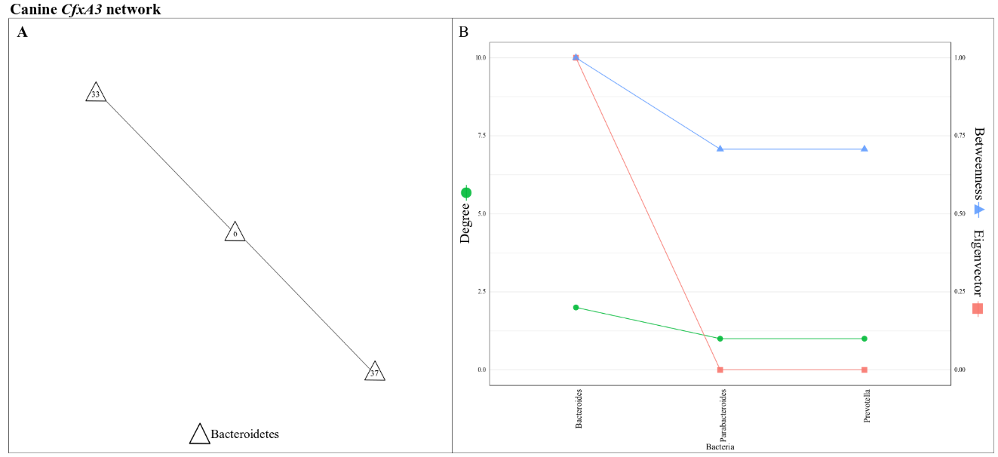
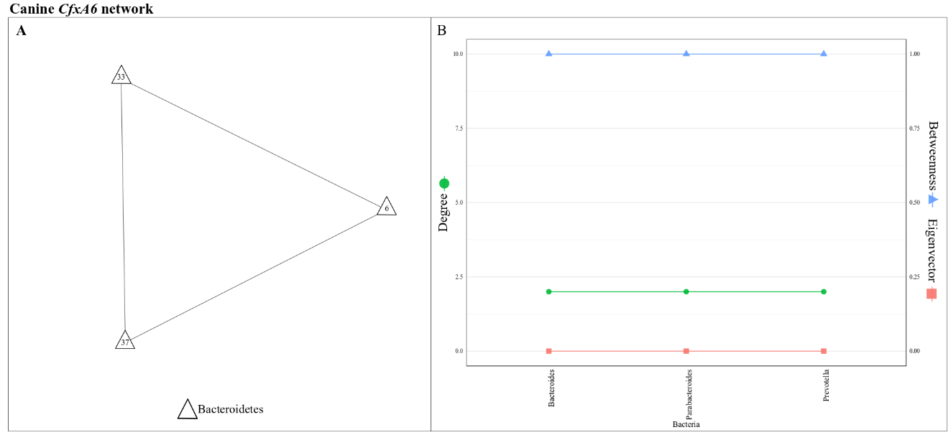

Figure S1. The ARG-specific network of the canine gut microbiota. (A) represents the network graph for a given ARG found in ≥ 50% of the samples. Nodes represented genera, with their shapes and colors representing phylum and community memberships, respectively. Two genera were connected by an edge if their contigs shared a given ARG in ≥ 1 sample. Node labels are IDs of genera (Suppl. Table 3). (B) represents centrality in the corresponding ARG-specific network. Only the ARGs shared by more than three bacterial genera are presented (See Suppl. Table 5 for those shared only by two genera).

Table S5. Antibiotic resistance genes (ARGs) shared only by two bacterial genera in the canine gut microbiota
ARG | Bacteria 1 |  | Bacteria 2
 | Genus | Phylum | Genus | Phylum
tetM | Enterococcus | Firmicutes | Streptococcus | Firmicutes
bacA | Escherichia | Proteobacteria | Salmonella | Proteobacteria
lnuA | Enterococcus | Firmicutes | Staphylococcus | Firmicutes
mdtM | Enterobacter | Proteobacteria | Escherichia | Proteobacteria
aadA2 | Acinetobacter | Proteobacteria | Escherichia | Proteobacteria
mdtO | Escherichia | Proteobacteria | Salmonella | Proteobacteria
cmeB | Campylobacter | Proteobacteria | Turicibacter | Firmicutes
AAC(6’)-Ip | Bifidobacterium | Actinobacteria | Clostridium | Firmicutes
mdtP | Escherichia | Proteobacteria | Salmonella | Proteobacteria

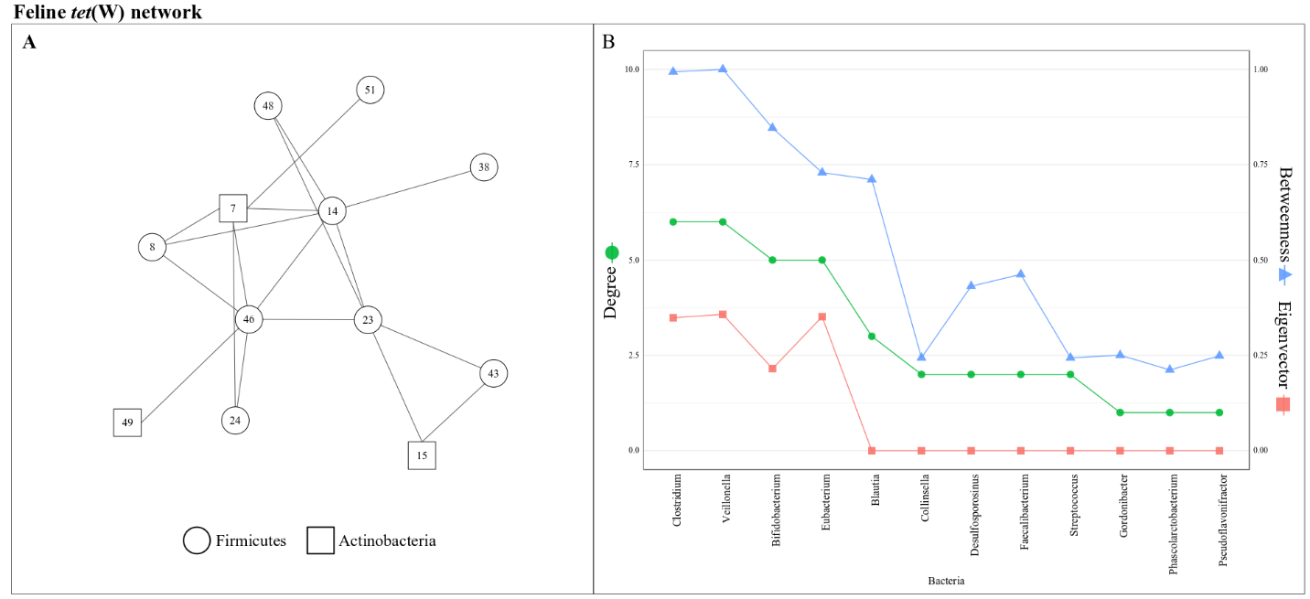
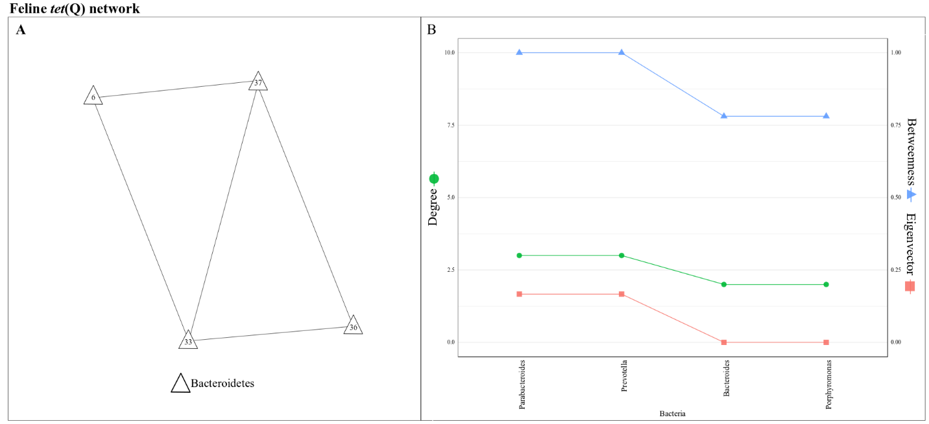
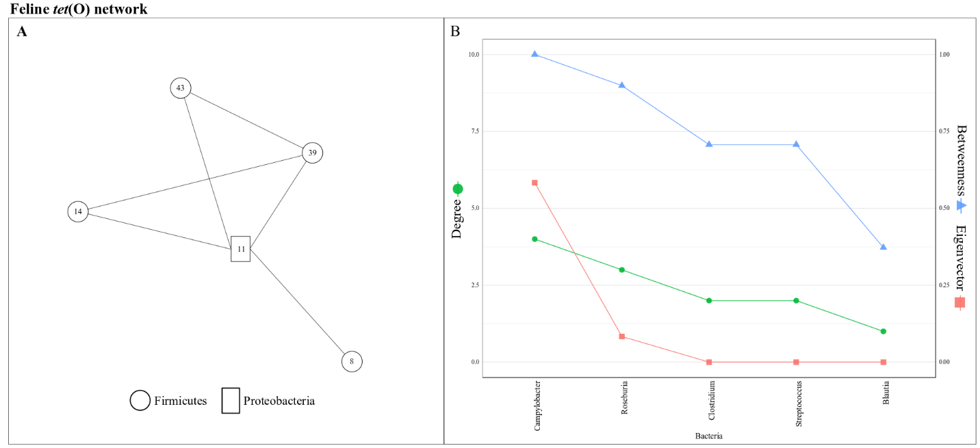
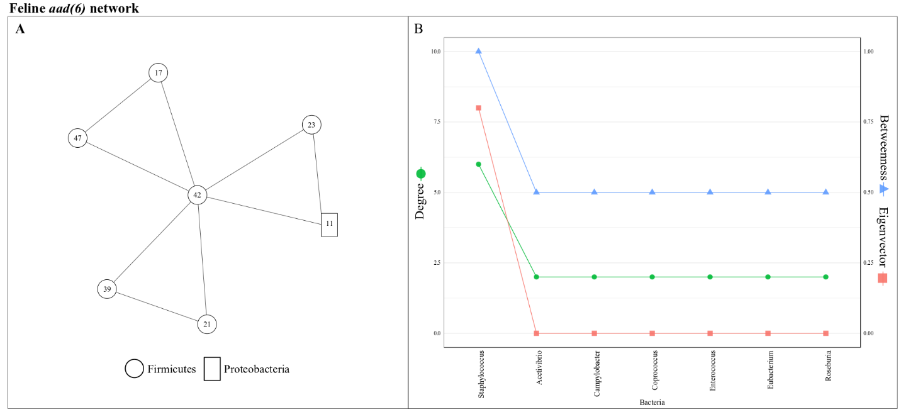
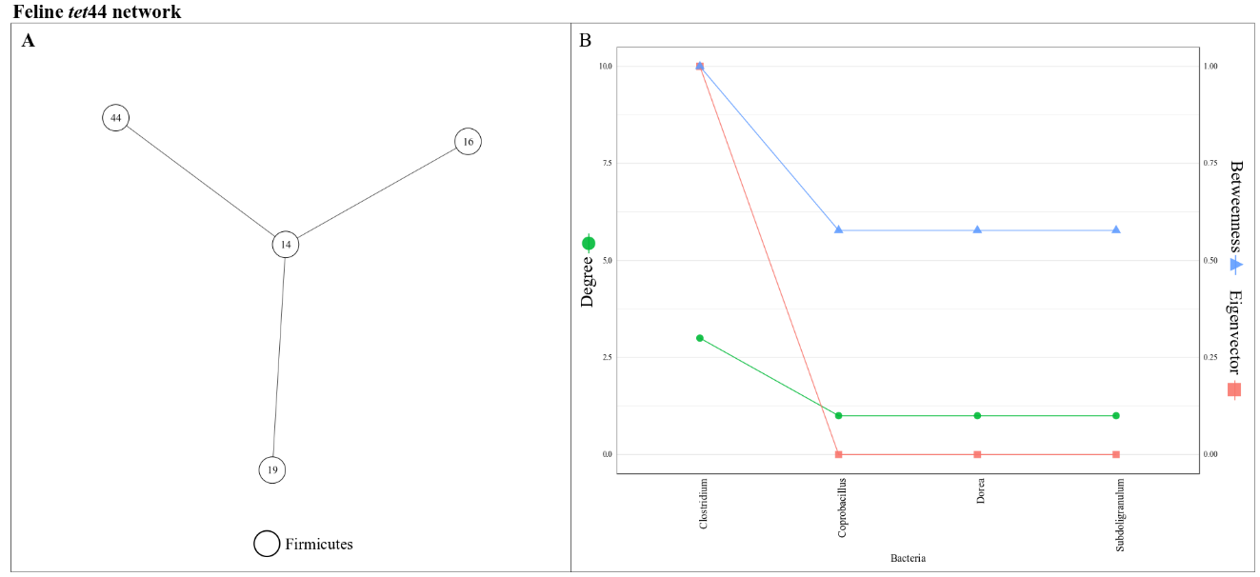
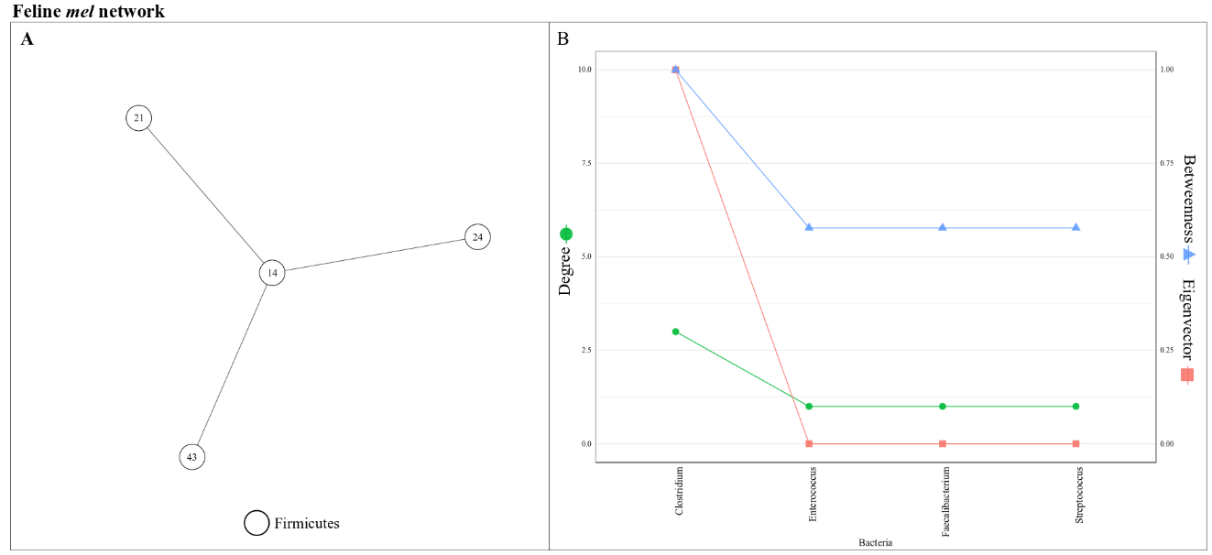
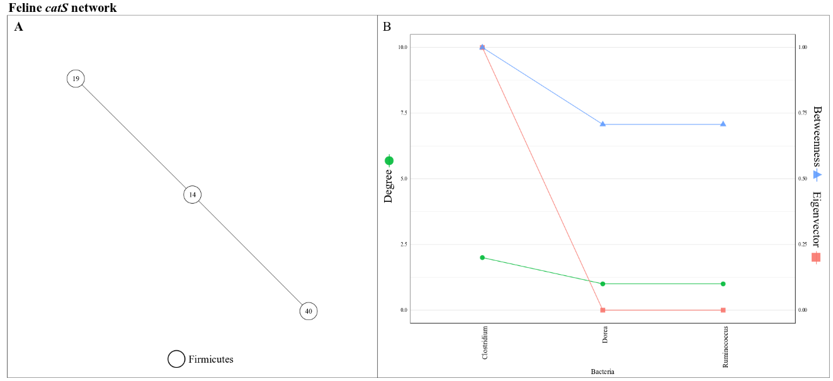
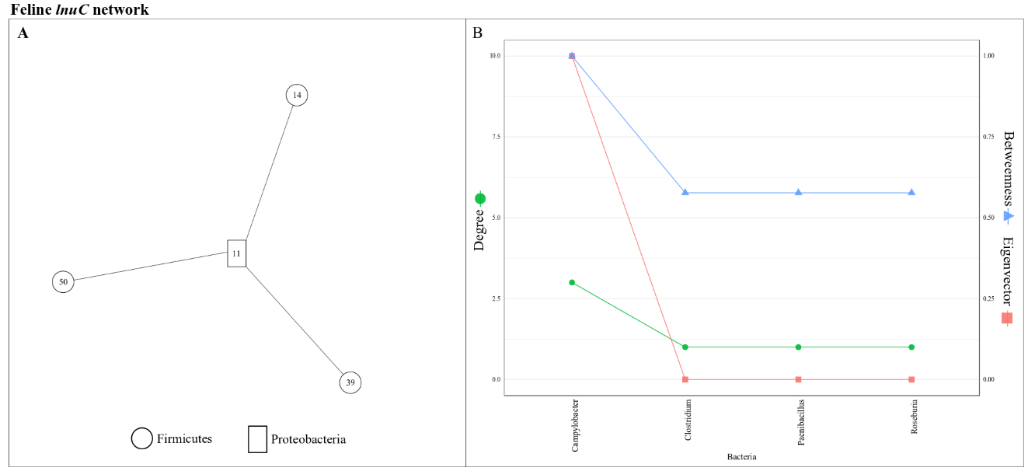
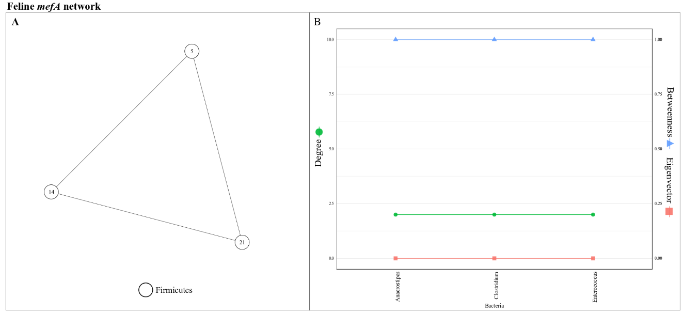
Figure S2. The ARG-specific network of the feline gut microbiota. (A) represents the network graph for a given ARG found in ≥ 50% of the samples. Nodes represented genera, with their shapes and colors representing phylum and community memberships, respectively. Two genera were connected by an edge if their contigs shared a given ARG in ≥ 1 sample. Node labels are IDs of genera (Suppl. Table 3). (B) represents centrality in the corresponding ARG-specific network. Only the ARGs shared by more than three bacterial genera are presented (See Suppl. Table 6 for those shared only by two genera).

Table S6. Antibiotic resistance genes (ARGs) shared only by two bacterial genera in the feline gut microbiota
ARG | Bacteria 1 |  | Bacteria 2
 | Genus | Phylum | Genus | Phylum
ErmB | Enterococcus | Firmicutes | Streptococcus | Firmicutes
SAT-4 | Enterococcus | Firmicutes | Staphylococcus | Firmicutes

Table S7. The number of genera by phylum membership in the canine ARG-specific networks
ARG type | Phylum |  |  |  |  |  |  | Total ª
 | Firmicutes | Bacteroidetes | Actinobacteria | Spirochaetes | Proteobacteria | Fusobacteria | Euryarchaeota
tetW | 14 | 1 | 5 | 0 | 1 | 0 | 0 | 21
mefA | 7 | 1 | 0 | 0 | 0 | 0 | 0 | 8
tetO | 3 | 0 | 0 | 0 | 1 | 0 | 0 | 4
tetQ | 1 | 6 | 0 | 0 | 0 | 0 | 0 | 7
mel | 7 | 1 | 0 | 0 | 0 | 1 | 0 | 9
lnuC | 5 | 0 | 0 | 1 | 1 | 1 | 0 | 8
OXA-85 | 0 | 1 | 0 | 1 | 0 | 1 | 1 | 4
APH(3'')-Ib | 0 | 0 | 0 | 0 | 3 | 0 | 0 | 3
tetM | 2 | 0 | 0 | 0 | 0 | 0 | 0 | 2
APH(6)-Id | 0 | 0 | 0 | 0 | 4 | 0 | 0 | 4
tet44 | 3 | 0 | 0 | 0 | 0 | 0 | 0 | 3
CfxA3 | 0 | 3 | 0 | 0 | 0 | 0 | 0 | 3
CfxA6 | 0 | 3 | 0 | 0 | 0 | 0 | 0 | 3
tet32 | 3 | 0 | 0 | 0 | 0 | 0 | 0 | 3
mdtM | 0 | 0 | 0 | 0 | 2 | 0 | 0 | 2
lnuA | 2 | 0 | 0 | 0 | 0 | 0 | 0 | 2
bacA | 0 | 0 | 0 | 0 | 2 | 0 | 0 | 2
cmeB | 1 | 0 | 0 | 0 | 1 | 0 | 0 | 2
AAC(6')-Ip | 1 | 0 | 1 | 0 | 0 | 0 | 0 | 2
aadA2 | 0 | 0 | 0 | 0 | 2 | 0 | 0 | 2
mdtO | 0 | 0 | 0 | 0 | 2 | 0 | 0 | 2
mdtP | 0 | 0 | 0 | 0 | 2 | 0 | 0 | 2
a The number of genera in each canine ARG-specific network

Table S8. The number of genera by phylum membership in the feline ARG-specific networks
ARG type | Phylum |  |  |  | Total ª
 | Firmicutes | Bacteroidetes | Actinobacteria | Proteobacteria
tetW | 9 | 0 | 3 | 0 | 12
tetQ | 0 | 4 | 0 | 0 | 4
tetO | 4 | 0 | 0 | 1 | 5
tet44 | 4 | 0 | 0 | 0 | 4
Mel | 4 | 0 | 0 | 0 | 4
Aad(6) | 6 | 0 | 0 | 1 | 7
ErmB | 2 | 0 | 0 | 0 | 2
catS | 3 | 0 | 0 | 0 | 3
lnuC | 3 | 0 | 0 | 1 | 4
mefA | 3 | 0 | 0 | 0 | 3
SAT-4 | 2 | 0 | 0 | 0 | 2
a The number of genera in each feline ARG-specific network

