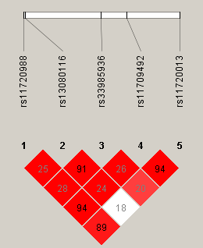
Figure S1. LD plots of SNPs of the SCN11A gene. The top horizontal bar illustrates the location of SNPs on a physical scale. Colors indicate the level of D’ (white = low D’, red = high D’), while numbers represent the r² value (no number where r² = 1). The rs11709492 SNP was genotyped as a proxy (r² > 0.9) for rs11700988 and rs117020013. The rs33985936 SNP was genotyped as a proxy (r² > 0.9) for rs13080116.

