Additional File 2
Fig. S1: Subject disposition.
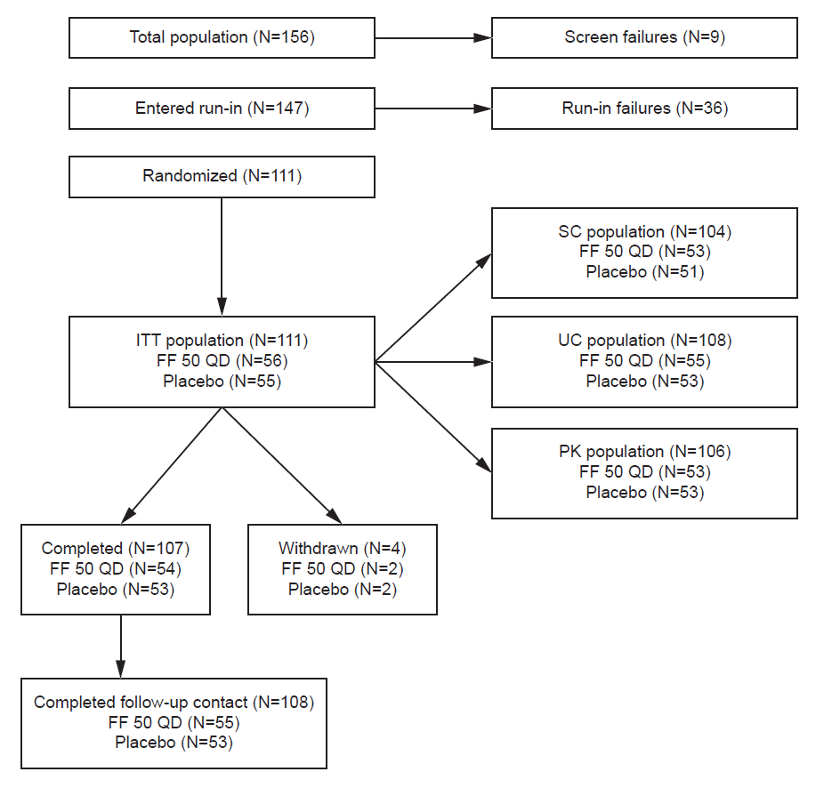
FF 50 QD, fluticasone furoate 50 µg once daily; ITT, intent-to-treat; PK, pharmacokinetic; SC; serum cortisol; UC, urinary cortisol.

