SUPPLEMENTARY FIGURES
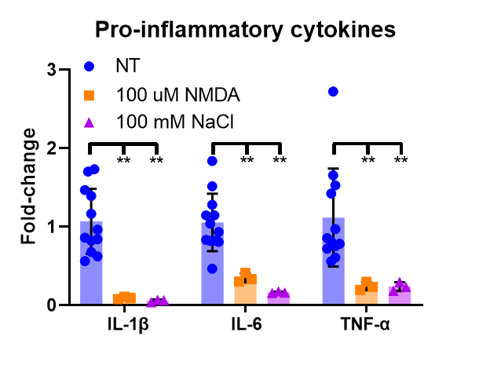
Figure S1: Fold-changes of pro-inflammatory mRNAs for NT, 100 μM NMDA, and 100 mM NaCl slices at 6h (n=3-12).
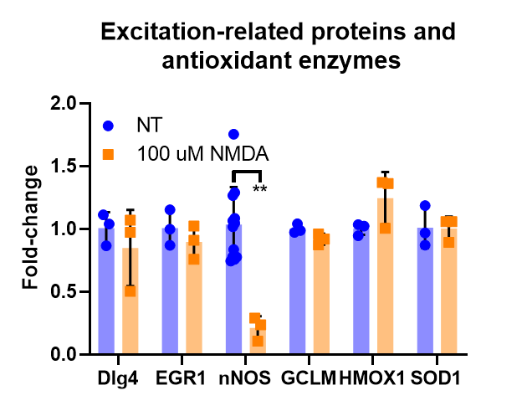
Figure S2: Fold-changes of excitation-related proteins and antioxidant enzyme mRNAs mRNAs for NT and 100 μM NMDA slices at 6h (n=3-12).
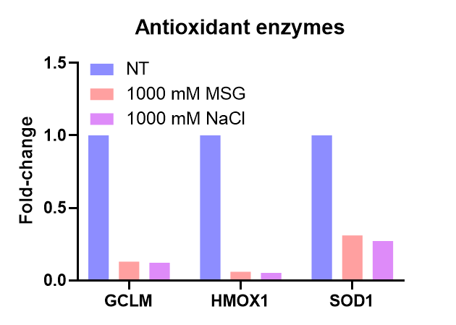
Figure S3: Fold-changes of antioxidant mRNAs for NT, 1000 mM MSG, and 1000 mM NaCl slices at 6h (n=1).

