Additional file 2 : Asthma Control Questionnaire and Copyright letter of permission.
Appendix S1 : Asthma Control Questionnaire.
E.F. JUNIPER ET AL.
ASTHMA CONTROL QUESTIONNAIRE©
Please answer questions 1±6.
Circle the number of the response that best describes how you have been during the past week

1. | On average, during the past week, how often were you woken by your asthma during the night? | 0  1 | Never  Hardly ever
 |  | 2 | A few minutes
 |  | 3 | Several times
 |  | 4 | Many times
 |  | 5 | A great many times
 |  | 6 | Unable to sleep because of asthma
2. | On average, during the past week, how bad were your asthma symptoms when you woke up in the morning? | 0  1 | No symptoms  Very mild symptoms
 |  | 2 | Mild symptoms
 |  | 3 | Moderate symptoms
 |  | 4 | Quite severe symptoms
 |  | 5 | Severe symptoms
 |  | 6 | Very severe symptoms
3. | In general, during the past week, how limited were you in your activities because of your asthma? | 0  1 | Not limited at all  Very slightly limited
 |  | 2 | Slightly limited
 |  | 3 | Moderately limited
 |  | 4 | Very limited
 |  | 5 | Extremely limited
 |  | 6 | Totally limited
4. | In general, during the past week, how much shortness of breath did you experience because of you asthma? | 0  1 | None  A very little
 |  | 2 | A little
 |  | 3 | A moderate amount
 |  | 4 | Quite a lot
 |  | 5 | A great deal
 |  | 6 | A very great deal
5. | In general, during the past week, how much of the time did you wheeze? | 0 | Not at all
 |  | 1 | Hardly any of the time
 |  | 2 | A little of the time
 |  | 3 | A moderate amount of the time
 |  | 4 | A lot of the time
 |  | 5 | Most of the time
 |  | 6 | All the time
6. | On average, during the past week, how many puffs of short-acting bronchodilator (eg. Ventolin) have you used each day? | 0  1 | None  1±2 puffs most days
 |  | 2 | 3±4 puffs most days
 |  | 3 | 5±8 puffs most days
 |  | 4 | 9±12 puffs most days
 |  | 5 | 13±16 puffs most days
 | To be completed by a member of the clinic staff | 6 | More than 16 puffs most days
7. | FEV1 pre-bronchodilator: ................................ | 0 | >95% predicted
 |  | 1 | 95±90%
 | FEV1 predicted ................................................ | 2 | 89±80%
 |  | 3 | 79±70%
 | FEV1 % predicted ...........................................  (Record actual values on the dotted lines and score the FEV1 % predicted in the next column) | 4  5  6 | 69±60%  59±50%  <50% predicted
©The Asthma Control Questionnaire is copyrighted. It may not be changed, translated or sold (paper or software) without the permission of Elizabeth Juniper.

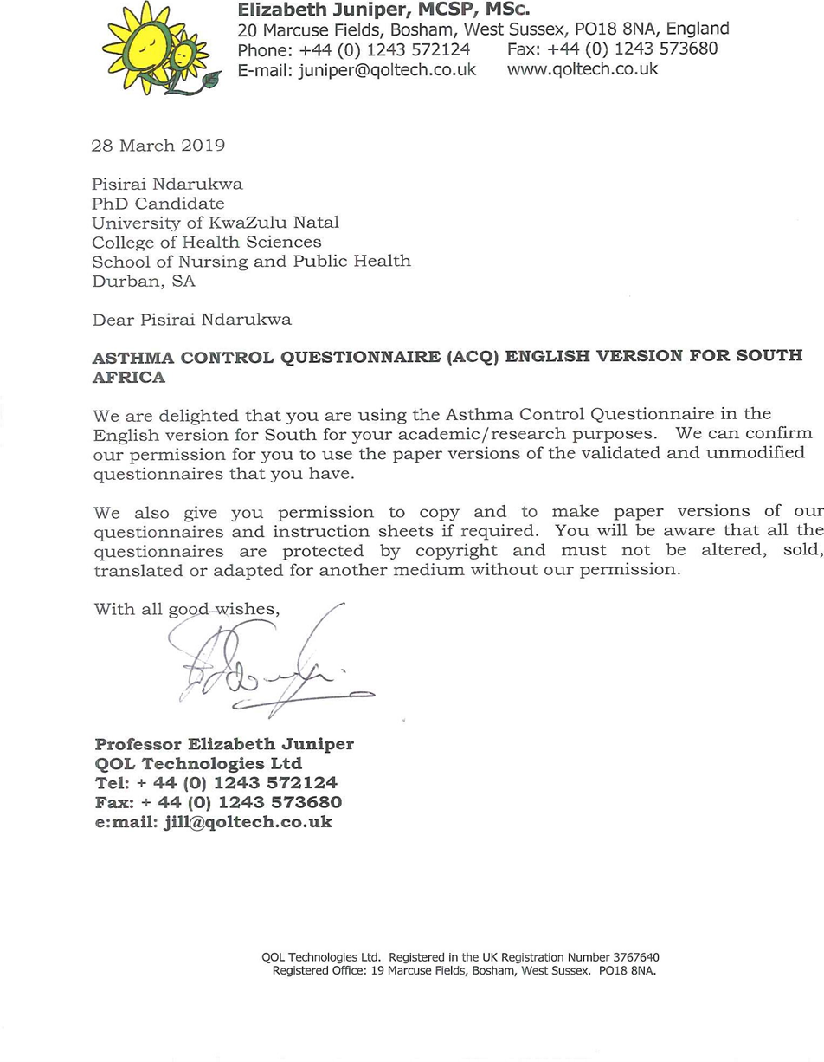
Appendix S2: ACQ letter of copyright permission.

