Additional file 1
Table S1. Photographic guide of bee-eater nestlings from hatch to fledging.
Development class (days) | Image |  | Description
1-3 |  |  | Head: Hatchlings are blind (eyes are closed), completely naked and pink. The bill is small and pink with a grey tip.  Size/behavior: Hatchlings have approximately the same size as an egg. They struggle to lift the head and belly.
4-6 | 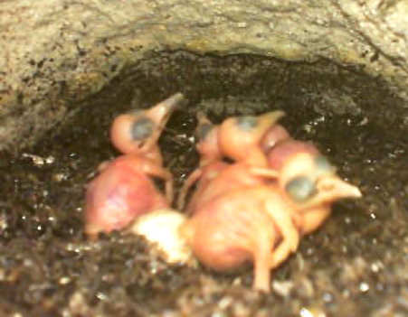 |  | Size/behavior: Nestlings are able to raise and support their head. Nestlings are now bigger, about 2x to 3x the size of an egg.
7-9 | 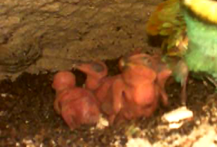 |  | Head: The eyes begin to open.  Feathers: Wings and tail area display a very light grey coloration, indicative of the subcutaneous alar pins (from where feathers will grow). Light grey coloration can also be visible in other parts of the body.
10-12 |  |  | Head: The bill is longer than the rest of skull.  Feathers: Alar pins are pressing on the skin surface: the light grey coloration on wings and tail is now dark grey. At the end of this stage, alar pins might start to emerge out of the skin.
13-15 |  |  | Head: The bill is now predominantly grey and the throat is yellowish.  Feathers: Alar pins have emerged out of skin and are clearly growing outside it. Dorsal and lateral pins also start to emerge in great number. Some feather tracts are unsheathing (colored tip at the end of some pins).
 | 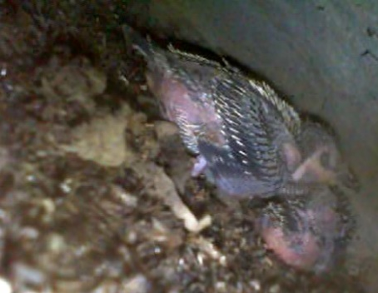
16-18 | 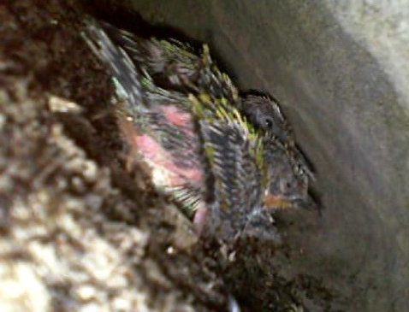 |  | Head: Eyes are fully open.  Feathers: Almost every part of the nestling is covered with pins, even the ventral area (but not around the cloaca). Many feathers are unsheathing; colors are more visible in the dorsal area and throat/chest region.
 | 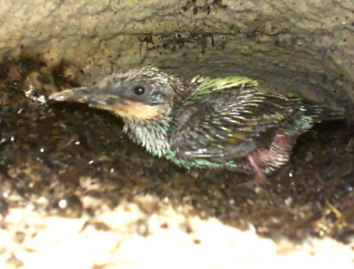
19-21 |  |  | Head: The bill becomes black and dull.  Feathers: Feathers continue to unsheathe and are now half grown (mainly the dorsal and wing coverts). Feather development in the head and ventral areas are delayed.
 | 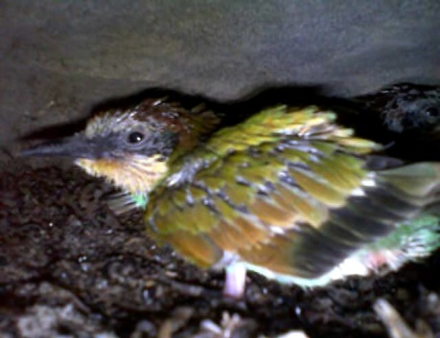
22-24 |  |  | Feathers: Fist continuous patches of feathers (not pins) between back and wings and/or in the head.
 | 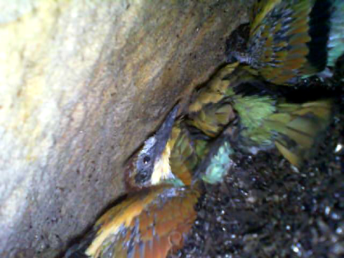
25-27 |  |  |  | Head: The bill is now shiny and the black stripe between eyes and bill is well defined.  Feathers: Almost all feathers are fully grown, with some exceptions, usually around the cloaca or below the bill. Tail feathers might not be fully unsheathed.
 |  | 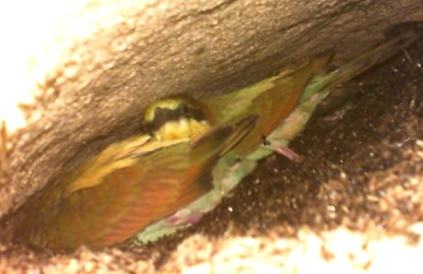
28-30 |  | 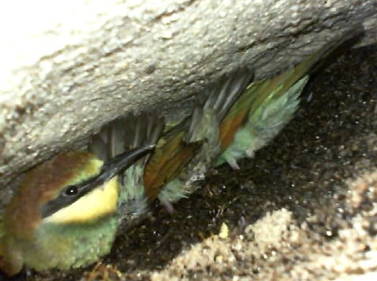 |  | Feathers: Plumage is now fully developed.

Table S2. Table illustrating the confusion matrix constructed for age class 7 as an example. Number in parenthesis exemplifies the number of displayed images categorized as: true positive (TP), true negative (TN), false positive (FP) and false negative (FN).
 |  | Actual age class (image displayed)
 |  | Focal class (class 7) | Different class (any other class)
Class assigned by observer | Assigned as the focal class (class 7) | TP - True positive (16) | FP - False Positive (4)
 | Assigned as a different class (any other class) | FN - False negative (2) | TN - True negative (158)

Table S3. Overall confusion matrix comparing assigned age classes (rows) by the observers in the test, to the actual classes (columns) confirmed by nest inspection. Correct assignments are denoted in bold.
 | 1 | 4 | 7 | 10 | 13 | 16 | 19 | 22 | 25 | 28
1 | 16 | 3 | 1 | 0 | 0 | 0 | 0 | 0 | 0 | 0
4 | 1 | 14 | 10 | 4 | 0 | 0 | 0 | 0 | 0 | 0
7 | 1 | 1 | 7 | 1 | 0 | 0 | 0 | 0 | 0 | 0
10 | 0 | 0 | 0 | 13 | 1 | 0 | 0 | 0 | 0 | 0
13 | 0 | 0 | 0 | 0 | 16 | 0 | 0 | 0 | 0 | 0
16 | 0 | 0 | 0 | 0 | 1 | 18 | 2 | 0 | 0 | 0
19 | 0 | 0 | 0 | 0 | 0 | 0 | 14 | 5 | 0 | 0
22 | 0 | 0 | 0 | 0 | 0 | 0 | 2 | 13 | 3 | 1
25 | 0 | 0 | 0 | 0 | 0 | 0 | 0 | 0 | 10 | 7
28 | 0 | 0 | 0 | 0 | 0 | 0 | 0 | 0 | 5 | 10

Table S4. Ranking of candidate models explaining the ability to predict bee-eater nestling age. AICc = Akaike information criterion for small sample size; ∆AICc = difference between AICc of the best model and reduced model; AICcw = Akaike model weights; loglik = log-likelihood; k = number of model parameters. Models with the lowest ∆AICc are shown in bold.
Model | AICc | ∆AICc | AICcw | loglik | k
1 Class + (1|observer) | 206.54 | 0.00 | 0.690 | -91.48 | 4
2. Class + Trial + (1|observer) | 208.22 | 1.68 | 0.300 | -90.01 | 5
3. (1|observer) | 216.77 | 10.23 | 0.004 | -106.35 | 3
4. Trial + (1|observer) | 218.23 | 11.69 | 0.002 | -105.00 | 4

Table S5. Pairwise comparisons between trials following GLMM of the second top-ranked model: Class + Trial + (1|observer). Estimated differences (± SE) in the probability of a given observer providing a correct identification of age classes between trials for each pairwise comparison (row – column) are reported. No significant differences were found between trials.
 | Trial 2 | Trial 3
Trial 1 | -0.08 (±0.08) | -0.13 (±0.08)
Trial 2 |  | -0.05 (±0.07)

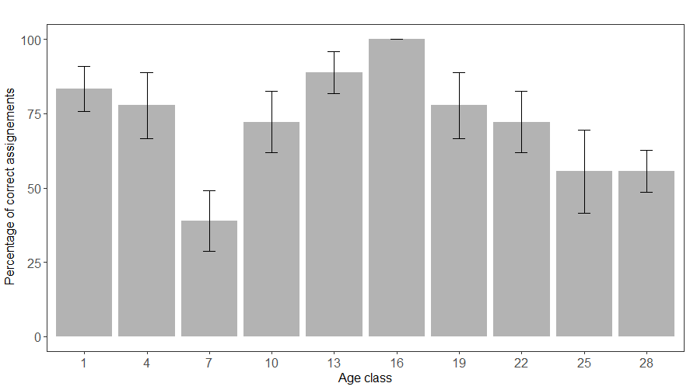
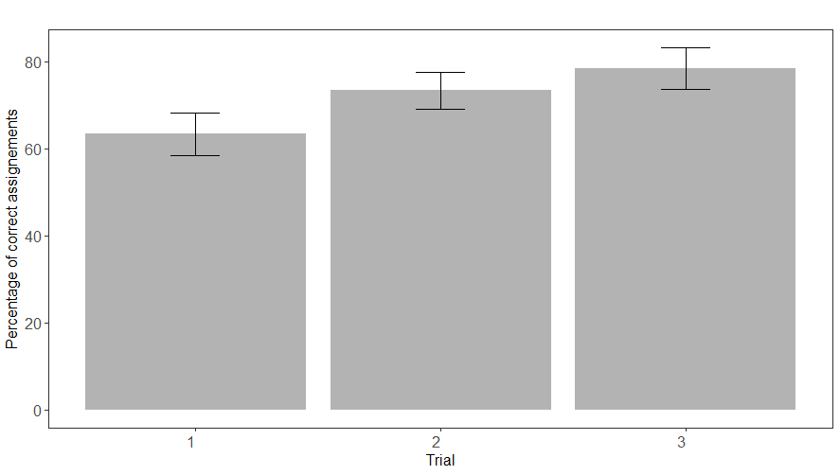
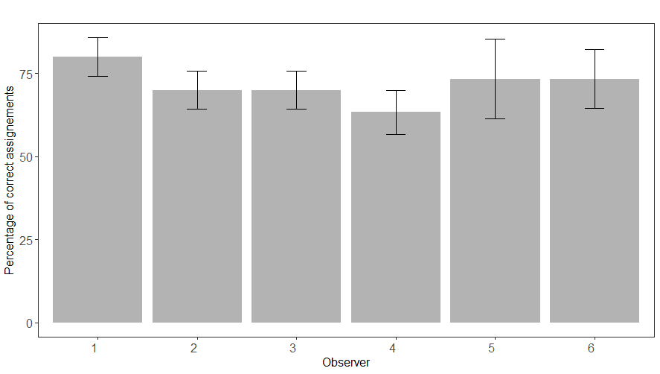
Figure S1. Variation on the mean percentage (±se) of correctly assigned estimates for age class (A, n=18), observer (B, n=30) and trial (C, n=10).
A
C
B

