Supplementary Data

pH- and acoustic-responsive platforms based on perfluoropentane loaded protein nanoparticles for ovarian tumor targeted ultrasound imaging and therapy
Jianping Li^{1†}, Hong Ji^{1†}, Yong Jing², Shiguang Wang²*

¹ Department of Geriatric Medicine, Sichuan Academy of Medical Sciences & Sichuan Provincial People’s Hospital, Chengdu, Sichuan 610041, China
² Department of Imaging, Eastern Hospital of Sichuan Academy of Medical Sciences & Sichuan Provincial People’s Hospital, Chengdu, Sichuan 610000, China

*Corresponding author: Shiguang Wang
Email: wangsg_im@hotmail.com
Telephone: + 86-13684006886
Address: No. 585 Honghe North Road, Longquanyi District, Chengdu, Sichuan 610000, China
† These authors contribute equally to this work.

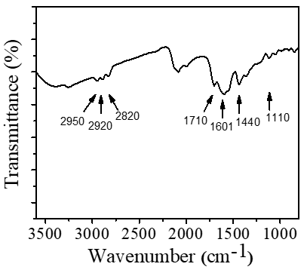
Figure S1. The FT-IR spectrum of FA-FRT.

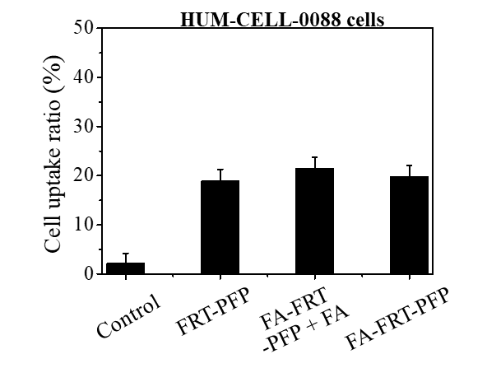

Figure S2. The statistical data of FITC fluorescence signal inside HUM-CELL-0088 cells treated with free FITC and FITC labeled FRT-PFP, FA-FRT-PFP + FA and FA-FRT-PFP.

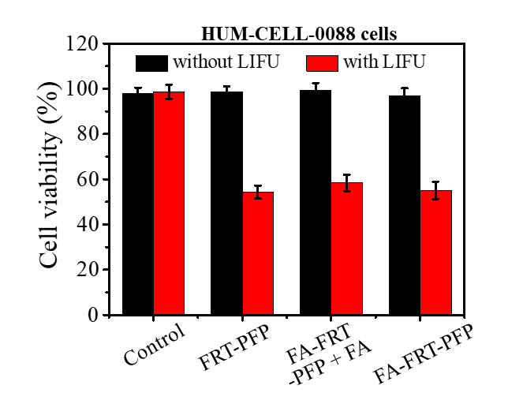

Figure S3. Cell viabilities of HUM-CELL-0088 cells treated with 40 μg/ml of PBS (control), FRT-PFP, FA-FRT-PFP + FA and FA-FRT-PFP combined with or without LIFU irradiation (2.0 W/cm², 4 min) and further 21 h incubation.

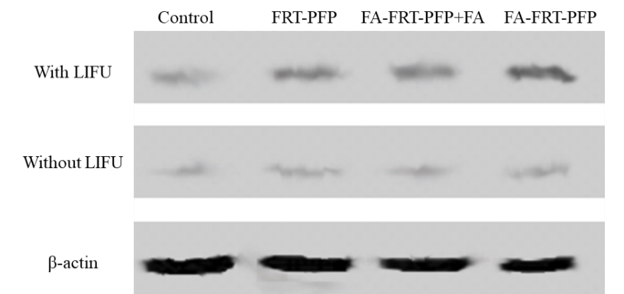
Figure S4. The TNF protein expression level of cells treated with 40 μg/mL of PBS (control), FRT-PFP, FA-FRT-PFP + FA and FA-FRT-PFP combined with or without LIFU irradiation (2.0 W/cm², 4 min) and further 21 h incubation.

