Additional File 1
Elevated methylation levels, reduced expression levels, and frequent contractions in a clinical cohort of C9orf72 expansion carriers
Jazmyne L. Jackson¹, NiCole A. Finch¹, Matthew C. Baker¹, Jennifer M. Kachergus², Mariely DeJesus-Hernandez¹, Kimberly Pereira¹, Elizabeth Christopher¹, Mercedes Prudencio¹, Michael G. Heckman³, E. Aubrey Thompson², Dennis W. Dickson¹, Jaimin Shah⁴, Björn Oskarsson⁴, Leonard Petrucelli¹, Rosa Rademakers¹, and Marka van Blitterswijk¹
Affiliations:
- Department of Neuroscience, Mayo Clinic, Jacksonville, Florida, USA
- Department of Cancer Biology, Mayo Clinic, Jacksonville, Florida, USA
- Division of Biomedical Statistics and Informatics, Mayo Clinic, Jacksonville, Florida, USA
- Department of Neurology, Mayo Clinic, Jacksonville, Florida, USA
Contents:
Table S1. Characteristics of overall cohort
Table S2. Characteristics of expression cohort
Figure S1. Comparison blood and brain
Figure S2. Southern blot examples

Table S1. Characteristics of overall cohort

Variable | C9Plus (n=108)ª | C9Minus (n=37)ª | Control (n=50)ª
Sex, No. (% female) | 59 (54.63) | 17 (45.95) | 30 (60.00)
Site of Onset, No. (% bulbar) | 16 (14.81) | 6 (16.22) | NA
Age at Collection, median (IQR), y | 58.53 (48.39–64.83) | 61.25 (56.75–65.36) | 47.35 (36.09–62.64)
Age at Onset, median (IQR), y | 59.25 (53.25–63.95) | 59.58 (55.10–63.42) | NA
Survival after Onset^{b}, median (IQR), y | 1.98 (1.44–3.13) | 1.96 (1.10–3.18) | NA
Methylation, median (IQR), % | 3.05 (1.10–15.12) | 0.23 (0.11–0.31) | 0.22 (0.09–0.60)
Expression, median (IQR), % | 74.11 (66.30–83.77) | 110.62 (94.41–135.67) | 100.00 (89.72–110.48)
Repeat Length, median (IQR), kb | 18.17 (11.16–24.51) | NA | NA
C9Plus: individuals carrying an expanded C9orf72 repeat; C9Minus: patients without this expansion; Control: control subjects without a neurodegenerative disease; IQR: interquartile range; NA: not applicable.
ªOf the family members included in this cohort (n=67), 33 carry a C9orf72 repeat expansion and are added to the C9Plus group (n=108). Four of the family members without a C9orf72 repeat expansion are affected by a neurodegenerative disease (dementia) and/or represent a phenocopy; those individuals are added to the C9Minus group (n=37). The remaining 30 family members are unaffected and added to the Control group (n=50).

^{b}In total, 27 of our 84 affected C9orf72 expansion carriers are currently alive (32%). Of the 33 patients without this expansion, 20 are alive (61%).

Table S2. Characteristics of expression cohort

Variable | C9Plus (n=34) | C9Minus (n=33) | Control (n=20)
Sex, No. (% female) | 16 (47.06) | 15 (45.45) | 10 (50.00)
Site of Onset, No. (% bulbar) | 6 (17.65) | 6 (18.18) | NA
Age at Collection, median (IQR), y | 60.52 (56.98–63.07) | 61.25 (56.58–65.05) | 60.05 (52.05–65.26)
Age at Onset, median (IQR), y | 59.25 (54.90–61.73) | 60.08 (55.08–63.42) | NA
Survival after Onsetª, median (IQR), y | 2.16 (1.59–4.05) | 1.99 (1.12–3.19) | NA
Methylation, median (IQR), % | 3.04 (1.09–14.16) | 0.24 (0.15–0.33) | 0.46 (0.14–0.75)
Expression, median (IQR), % | 73.32 (65.96–86.20) | 110.70 (93.68–132.88) | 100.00 (87.48–111.27)
Repeat Length, median (IQR), kb | 19.26 (15.54–24.93) | NA | NA
C9Plus: patients with a C9orf72 repeat expansion; C9Minus: patients without this expansion; Control: control subjects without a neurodegenerative disease; IQR; interquartile range; NA: not applicable.
ªIn total, 8 of our 34 affected C9orf72 expansion carriers are currently alive (24%). Of the 33 patients without this expansion, 20 are alive (61%).

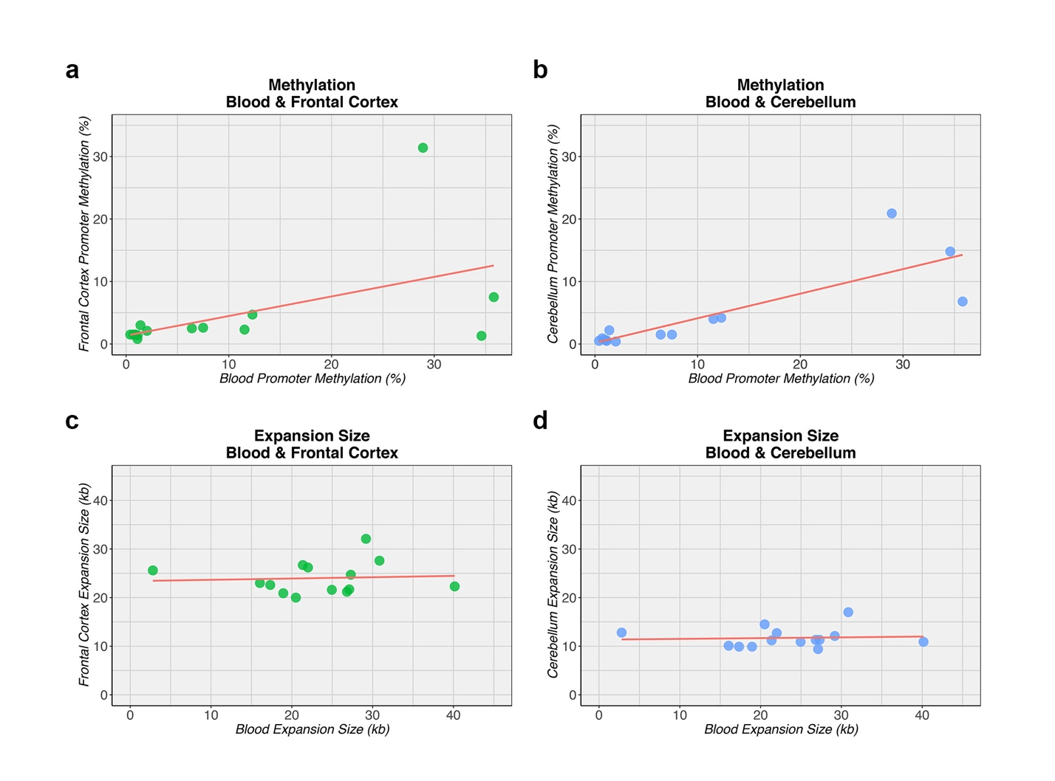
Figure S1. Comparison blood and brain

a-b Higher C9orf72 promoter methylation levels in blood are correlated with higher methylation levels in the frontal cortex (left) and cerebellum (right). c-d There is no correlation between the C9orf72 expansion size in blood and the frontal cortex (left) or cerebellum (right). In these plots, the solid red line is the linear regression line. Each solid circle represents a sample from the frontal cortex (green) or cerebellum (blue).

Figure S2. Southern blot examples
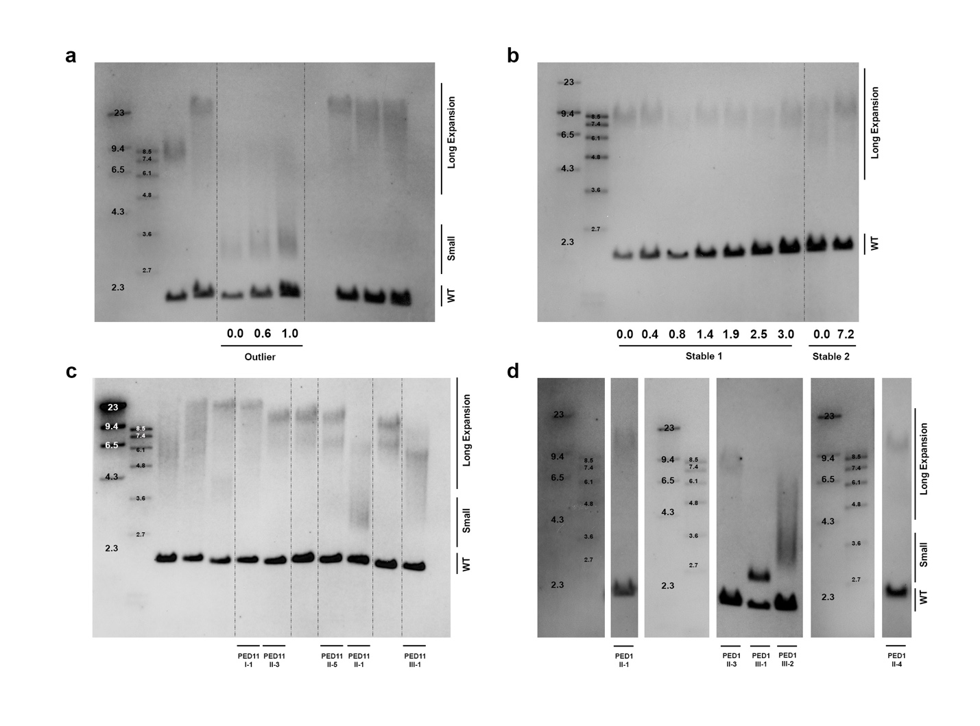

a The first panel displays the outlier described in our main text with high C9orf72 expression levels (>200%). In addition to the wild-type allele (WT), two bands are shown for time-points that span a period of 1 year: one weak band of 7.9 kb and a strong band of 3.4 kb. b In the second panel, two representative examples are shared of subjects with relatively long expansions that are stable over time (up to 7.2 years). c The third panel contains several members of a large family; for simplicity, only individuals from one branch (PED11; Figure 5a) are specified. Multiple bands are present and parent-offspring transmissions result in contractions. d In the last panel, members of another family (PED1; Figure 3d) are displayed, including the proband, his siblings, and his children. In this family, contractions are also encountered in parent-to-child transmissions. Of note, in these panels, dashed lines are added as visual aids. In general, Southern blot estimates are based on the most abundant expansion size (peak), as determined by densitometry. When multiple bands are detected in a single individual, the repeat length of the highest band (longest expansion) is used in statistical analyses.

