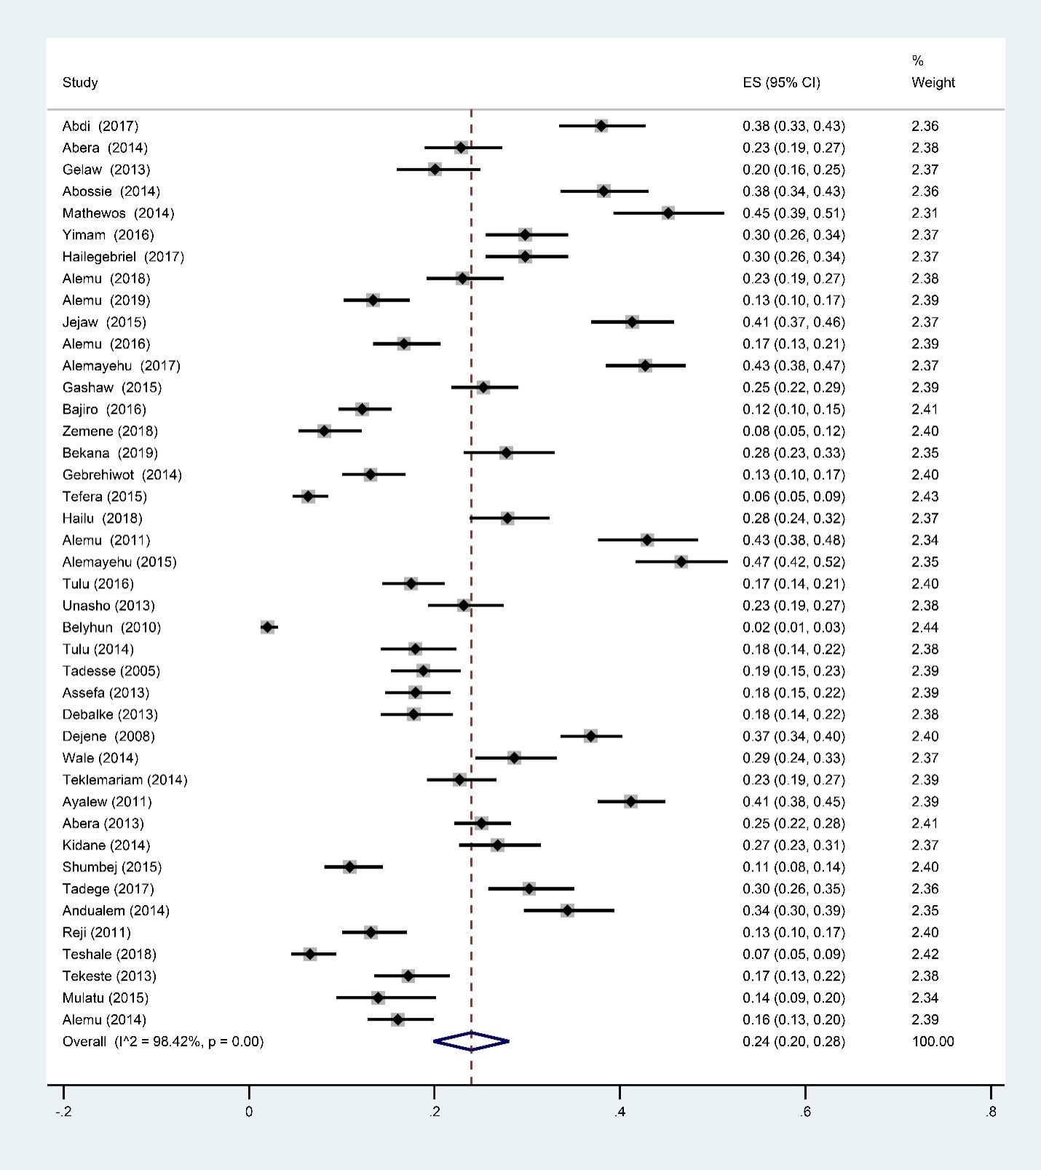
Additional file 3. Forest plot showing prevalence of intestinal parasite infections among male Ethiopian children

