Fig. S1. GO classification analysis of all DEGs. GO functions are shown in X axis. The Y axis shows the numbers of genes which have the GO function.

Fig. S2. Validation of selected genes using real-time PCR during sex reversal. (A) hibadh, (B) dhrs11, (C) dhrs12, (D) p5cdh, (E) cyp3a40, (F) dhrs13.

Fig. S3. Validation of zbtb genes using RT-PCR. (A) zbtb1, (B) zbtb22, (C) zbtb40, (D) zbtb44.

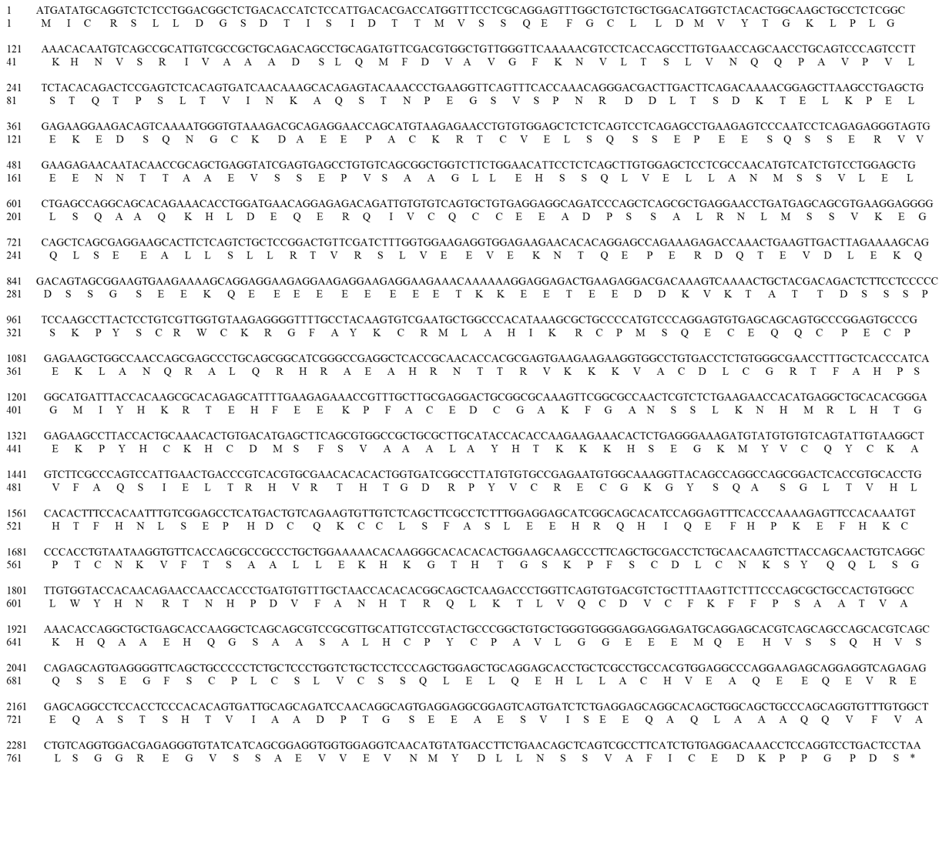
Fig. S4. The nucleotide sequences and deduced amino acid sequences of zbtb40. The stop codon was denoted by an asterisk. Nucleotide and amino acid were numbered on the left.

