Supplemental Information
HIV-1 CRF01_AE subtype and HIV-1 DNA level among patients with chronic HIV-1 infection: a correlation study
Tingxia Lyu¹, Yongsong Yue¹, Hsieh Evelyn^{1,2}, Yang Han¹, Ting Zhu¹, Xiaojing Song¹, Wei Cao¹, Wei Lyu¹, Jianhua Wang^{3,4}, Taisheng Li^{1,5,6,7}

Supplemental tables
Table S1. Predicted co-receptor usage based on V3 loop sequence (n=76).
Supplemental figures
Fig. S1. HIV-1 DNA dynamics stratified by ART therapy and subtype.

Table S1. Predicted co-receptor usage based on V3 loop sequence.

Subtype | R5 | R5/X4 | X4
CRF01_AE (n=32) | 12 (37.5%) | 12 (37.5%) | 8 (25%)
non-CRF01_AE (n=44) | 39 (88.6%) | 3 (6.8%) | 2 (4.5%)

Fig. S1.
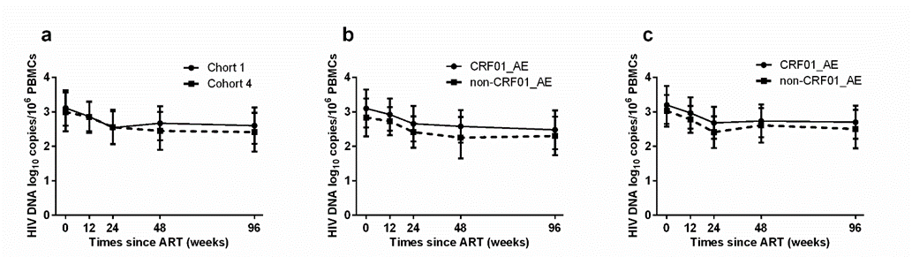
Fig. S1. HIV-1 DNA dynamics stratified by ART therapy and subtype. (a). The HIV-1 DNA dynamics in patients with baseline CD4 ≤ 350 cells/μL of cohort 1 and cohort 4. (b & c). The HIV-1 DNA dynamics of CRF01_AE and non-CRF01_AE group in cohort 1(b) and cohort 4 (c).

