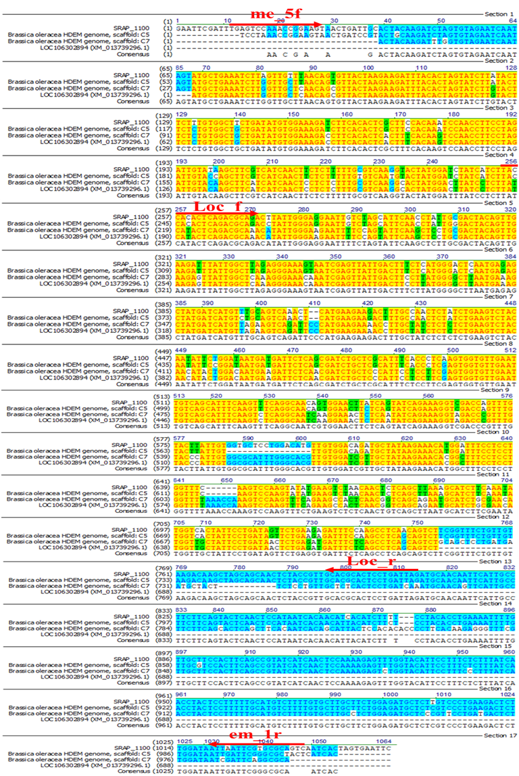

Fig. S2 BLAST and alignment results of the 1100 bp fragment. The identity and consensus positions of sequence B. oleracea HDEM genome scaffold C5 (LR031877.1), B. oleracea HDEM genome scaffold C7 (LR031876.1) and LOC101602894 (XP_013594750.1) are labeled in yellow and blue text background respectively. Primer location including SRAP (me5f and em1r) and LOC101602894 (Loc_f and Loc_r) was also highlighted in red-color arrows.

