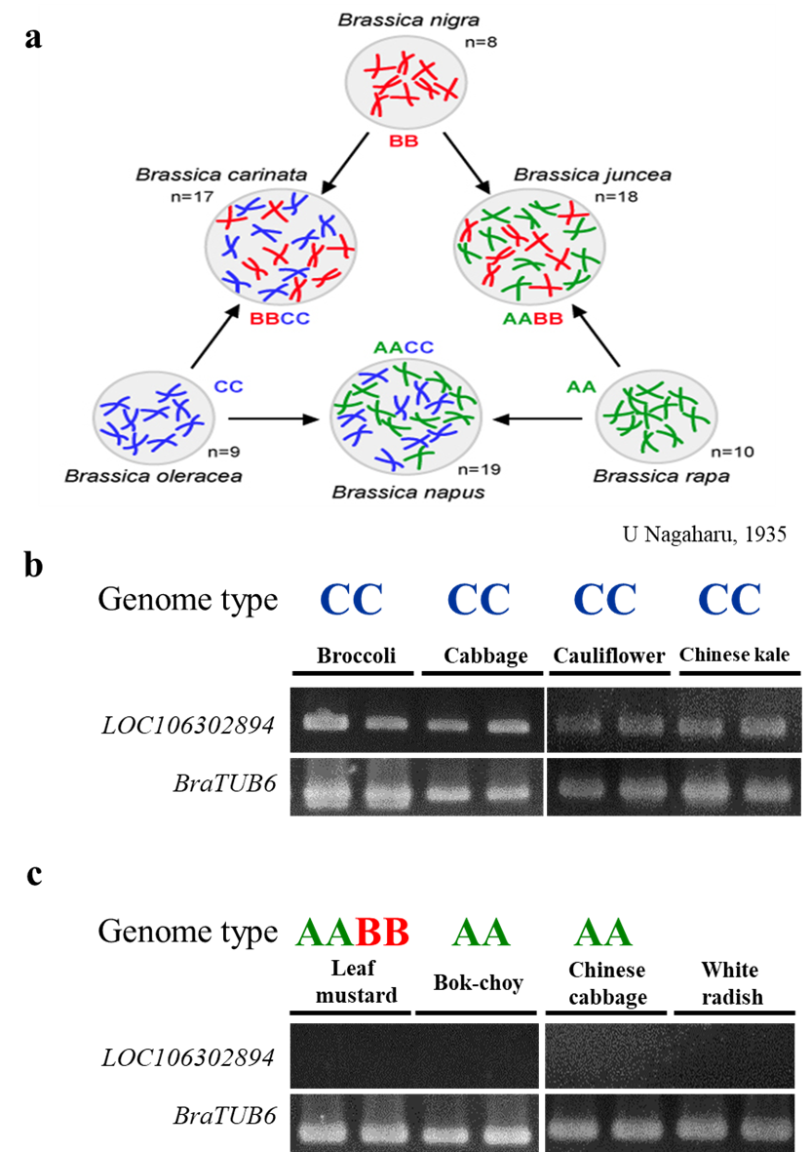

Fig. S1. Screening the LOC106302894 among common Brassicaceae vegetables in Taiwan. (a) Theory of ‘Triangle of U’ in Brassica species (U 1935). (b) and (c) PCR amplification results using LOC106302894 and BraTUB6 primer. Banding patterns were separated in 1.8% agarose gel. Genomic DNA of classic CC genome species Brassica oleracea such as broccoli (B. oleracea var. italica), cabbage (B. oleracea var. capitata), cauliflower (B. oleracea var. botrytis), and Chinese kale (B. oleracea var. alboglabra) were analyzed. Other Brassicaceae relatives including one AABB genome species leaf mustard (B. juncea (L.) Czern.), two AA genome species bok-choy (B. rapa var. Chinensis) and Chinese cabbage (B. rapa var. pekinensis), and white radish (Raphanus sativus var. Longipinnatus) were also investigated.

