**a**

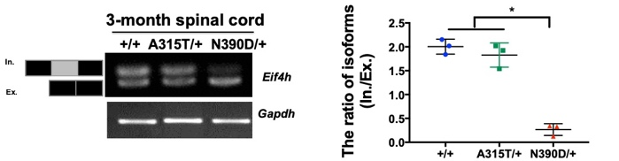**b**

**c**

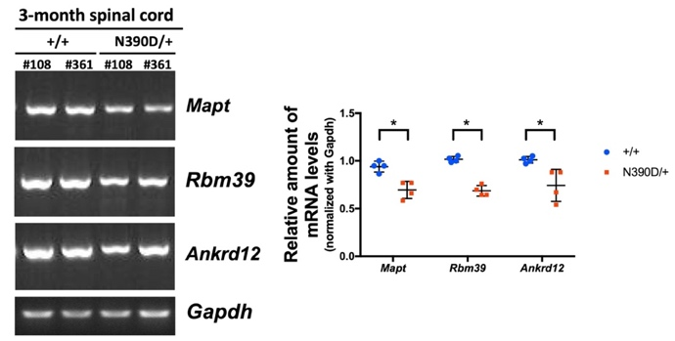

**Figure S7. Expression change of *Bcl-2* and other TDP-43 target genes in the spinal cord of N390D/+ male mice in comparison to the +/+male mice.**

**(a)** RT-PCR detection and statistical analysis of the levels of *Bcl-2* mRNA are shown in the left panels. Western blotting and statistical analysis of the levels of Bcl-2 protein are shown in right panels. N=3 (randomly chosen from lines #108 and/or #361) per age group. *p<0.05. **(b)** RT-PCR analysis of *eif4h* showing the alternative splicing patterns in the spinal cord of 3-month old N390D/+ and +/+ male mice, with the higher bands on gel representing the inclusive form and the lower gel bands representing the exclusive form. N=3 (randomly chosen from lines #108 and/or #361) per age group.*p<0.05. **(c)** RT-PCR data showing the decreases of the mRNA levels of the ALS-associated genes*, Mapt, Rbm39,* and *Ankrd12,* in the spinal cord of 3-month old N390D/+ male mice in comparison to the +/+male mice. N=4 (2 from #108 and 2 from #316) per group. *p<0.05.