a
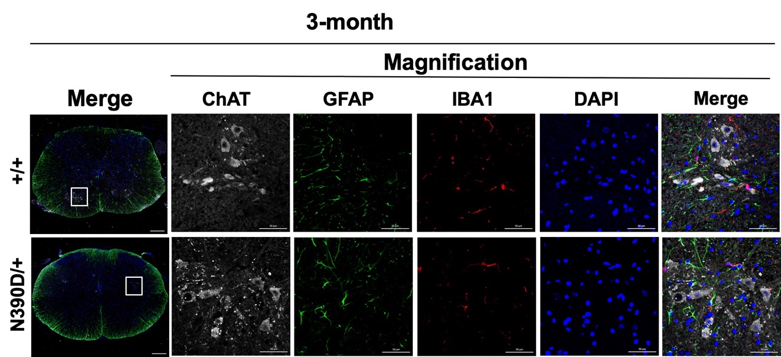

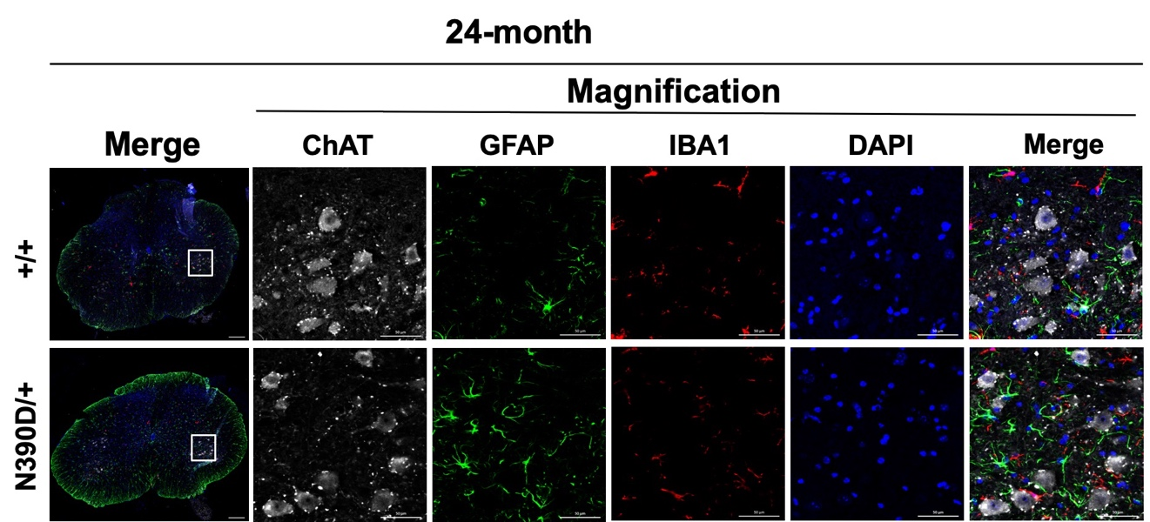

b c
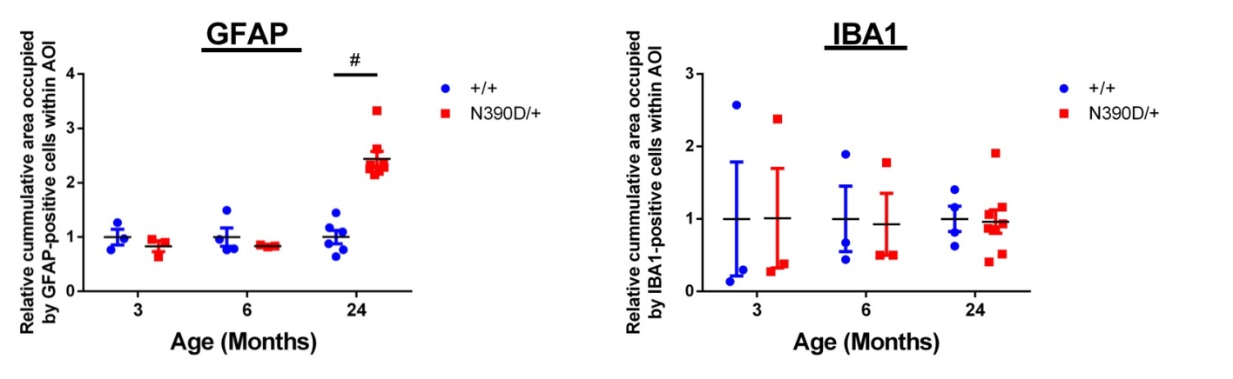

Figure S5. (a) Immunofluorescence co-staining of spinal cord sections from 3-month and 24-month old N390D/+ and +/+ male mice using anti-GFAP (green), anti-IBA1 (red) and anti-ChAT (gray). DAPI (blue) indicates the locations of the nuclei. The white line boxes mark the magnified regions from ventral horn of the spinal cord. The relative cumulative areas occupied by astrocytes (b) and microglia (c) are presented by the scatter dot plots. Only representative images of the 3-month and 24-month samples are shown. Note the increased signals of GFAP (green) in the spinal cord of 24-month old N390D/+ male mice in comparison to the age-matched +/+ male mice. N=3 (randomly chosen from each of the two independent lines) per group. The scale bars are 50 μm. #p<0.001.

