a
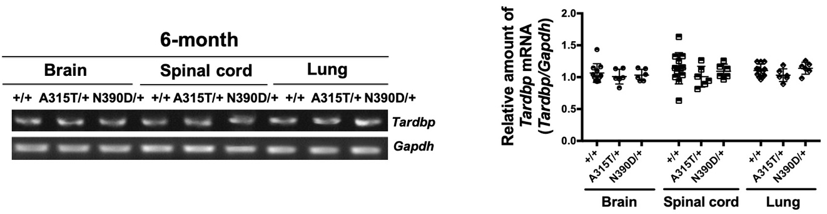

b
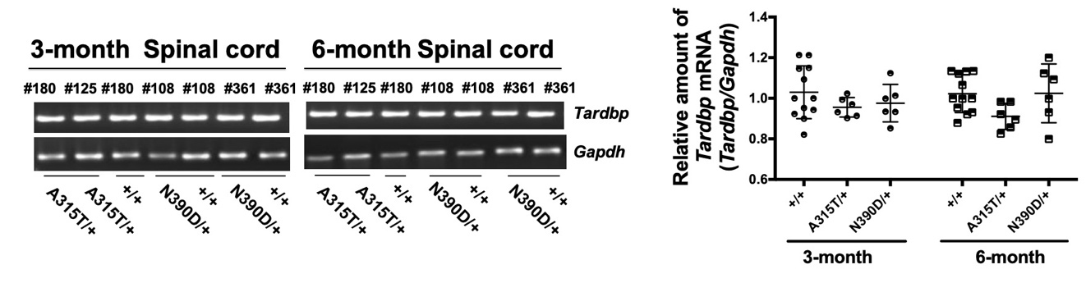
c
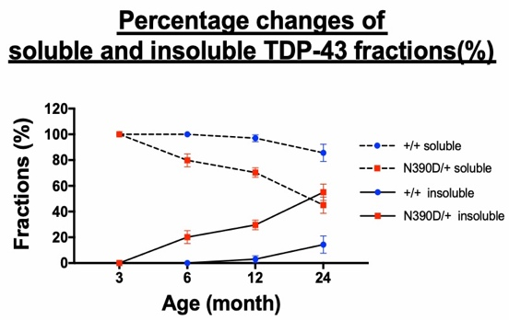

Figure S3. Similar levels of Tardbp mRNA expression in different tissues of +/+, A315T/+ and N390D/+ male mice.
(a) The RT-PCR patterns of Tardbp mRNAs in the brain, spinal cord and lung of 6-month old mice. (b) The RT-PCR patterns of Tardbp mRNAs in the spinal cord from 3-month and 6-month old mice. The corresponding comparisons of the relative levels of Tardbp mRNAs by qRT-PCR are shown in the two dot plots on the right side (mean± SD). The number of mice of each group and their line origins are as follows: N=12 for +/+ (3 from each of the independent lines); N=6 (3 from each of the two independent lines) per genotype group. (c) The connecting-line plot deduced from Figure2b presents the changes of the fractions (%) of the soluble and insoluble TDP-43 in the spinal cord of N390D/+ and +/+ male mice, respectively. Mean± SD and *p<0.05, **p<0.01.

