a
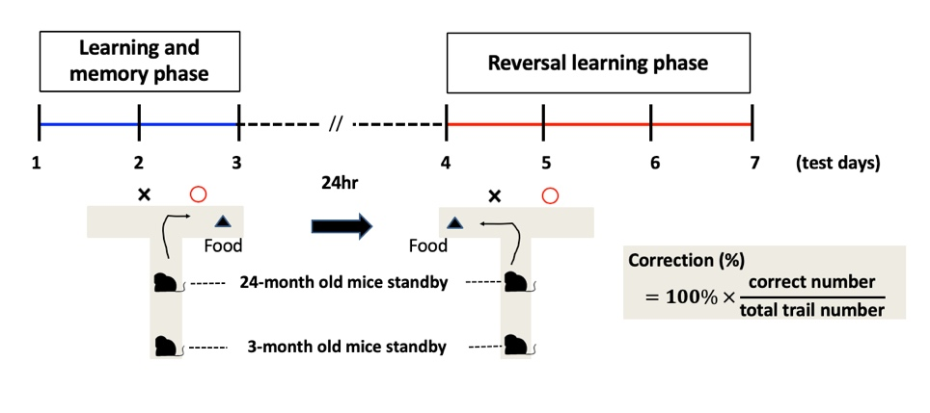

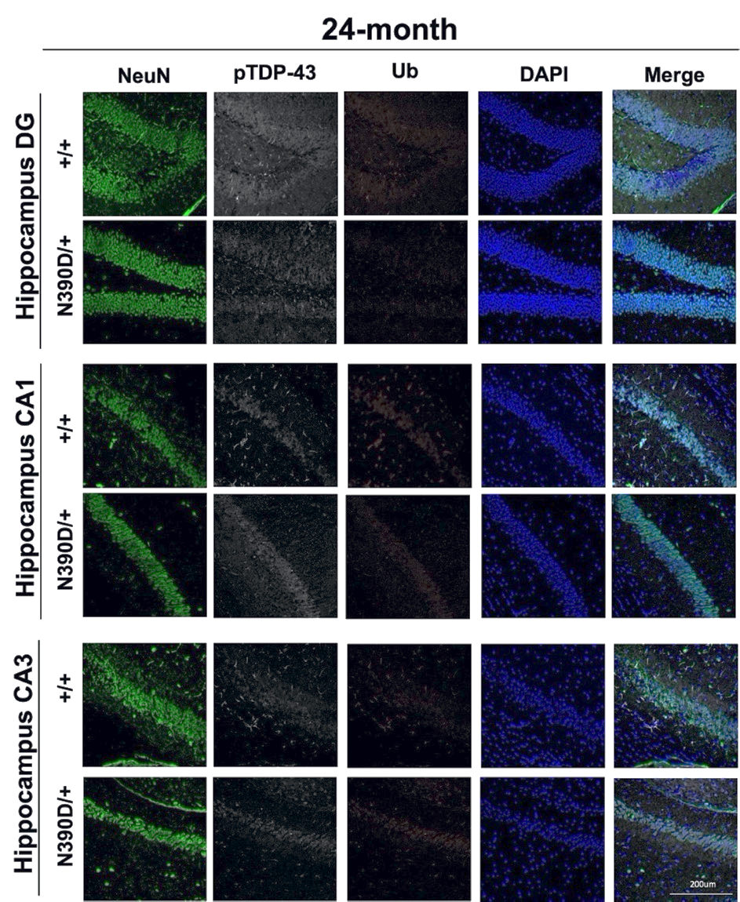
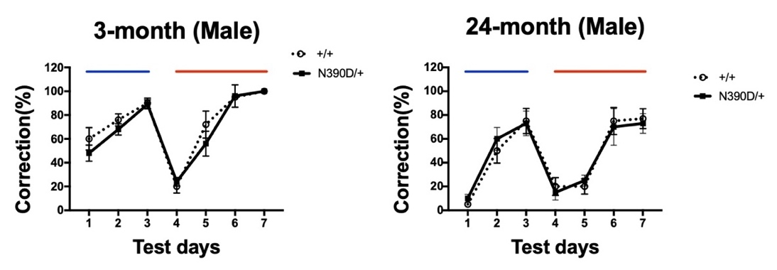
b

c
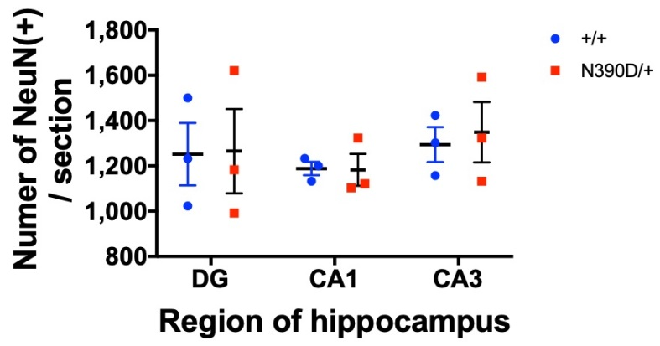

Figure S2. Cognition analysis of N390D/+ male mice.
(a) Flow chart of T-maze test. The mice learned and memorized the position of food during day1 to day3 (blue line). The position of food was changed on day 4 to observe the reversal learning ability of the mice (red line). The marks O and X were used for strengthening the spatial memory of hippocampus. The standby site of the young mice was 30-35 cm from the intersection. The site of 24-month old mice was closer (10 cm) from the intersection because of their dyskinesia. For more details, see Methods. T-maze test results are presented in the lower two panels. Note the similar cognitive function of the N390D/+ male mice as the +/+ male mice at both the ages of 3 months and 24 months (mean ± SEM). N=9 (>3 each from lines #108 and #361) per group. (b) Immunofluorescence co-staining analysis of the hippocampus of 24-month old mice using anti-NeuN (green, a neuron marker), anti- pTDP-43 (gray) and anti-ubiquitin (Ub, red). DAPI (blue) indicates the locations of the nuclei. The scale bar is 200 μm. (c) Statistical comparison of the average numbers of the neurons per brain section in the hippocampal dentate gyrus (DG), CA1, and CA3 regions of N390D/+ and +/+ male mice (mean ± SEM), respectively. At least 2 discontinuous forebrain sections were counted for each mouse. N=3 (randomly chosen from lines #108 and/or #361) per group.

