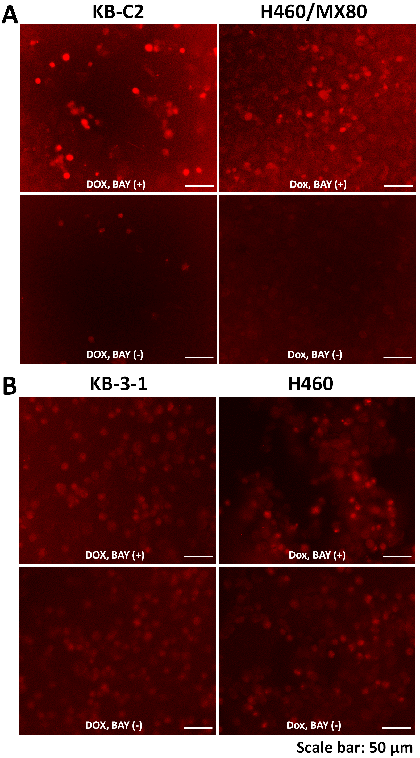
Figure S3 Long-term influence of BAY-1082439 on the accumulation of doxorubicin within the MDR and drug-sensitive cell lines. (A) BAY-1082439 induced higher ratios of MDR KB-C2 and H460/MX80 cells with a weakened ability to efflux doxorubicin (DOX) during 72 h of drug treatment. The red fluorescence showed distribution and intensity of DOX accumulated within cells. The cells were seeded at 3× 10³ cells per well, cultured for 8 h. Then DOX was used at 1 µM to provide drug pressure for these MDR cells and support typical cell viability. BAY-1082439 for reversal of MDR was used at 10 µM prior to application of DOX. Three repeats of this experiment were performed. (B) BAY-1082439 showed no obvious function in increasing drug internalization by the parental drug-sensitive cells KB-3-1 and H460. The red fluorescence showed distribution and intensity of DOX accumulated within cells. The cells were seeded at 3× 10³ cells per well, cultured for 8 h. Then DOX was used at 0.1 µM to provide drug pressure for these drug-sensitive cells and keep typical cell viability. BAY-1082439 was used at 10 µM. Three repeats of this experiment were performed independently.

