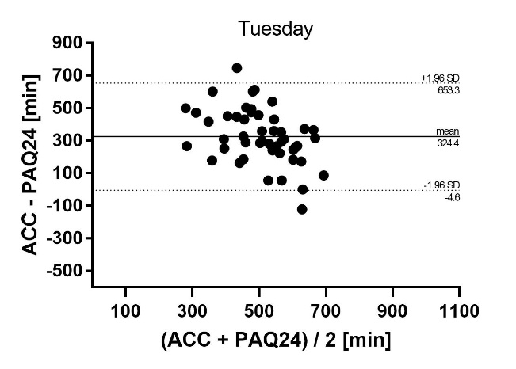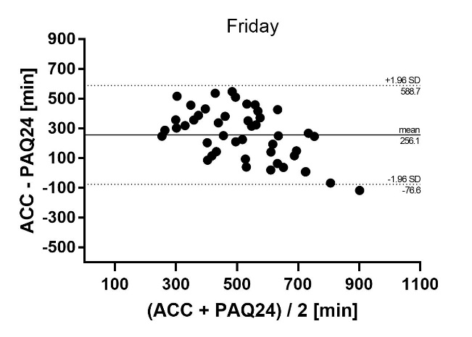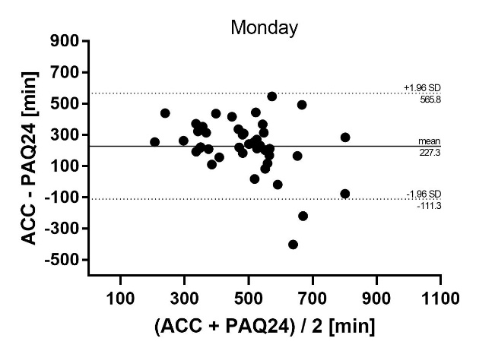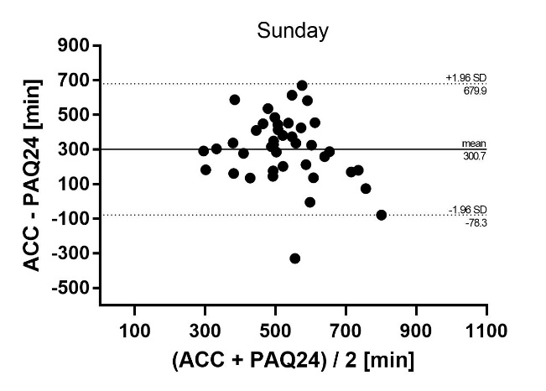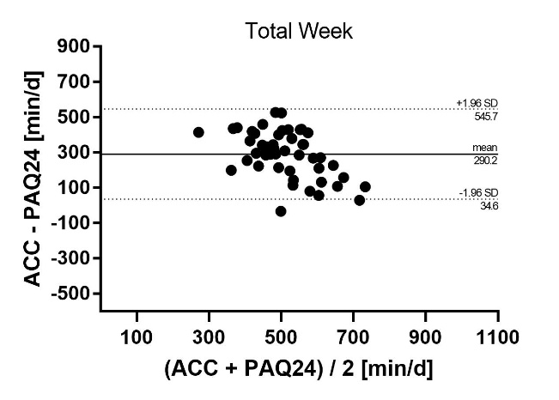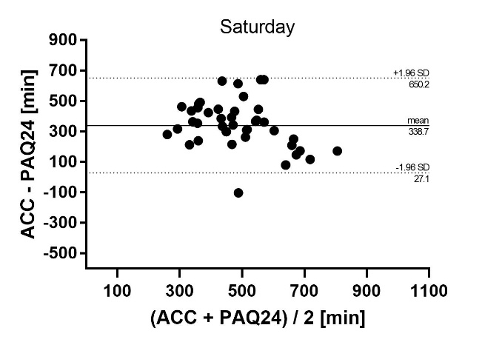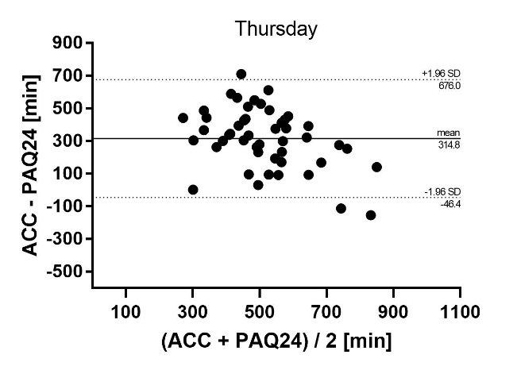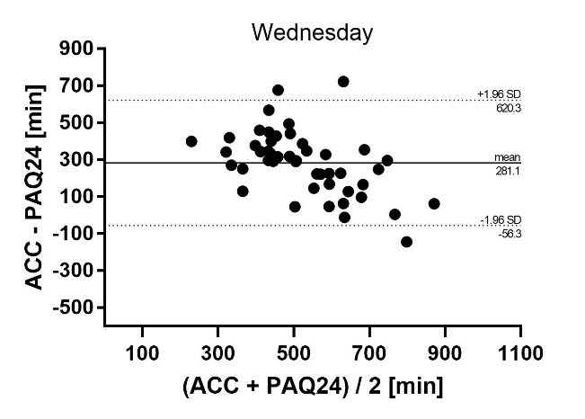

**Additional file 4** Absolute agreement of daily and weekly ST between PAQ24 and accelerometer. Bland-Altman plots for each day showing difference versus average of the values measured by the two methods with 95% limits of agreement. *ACC* accelerometer, *PAQ24* Physical Activity Questionnaire for 24 h, *ST* sedentary time