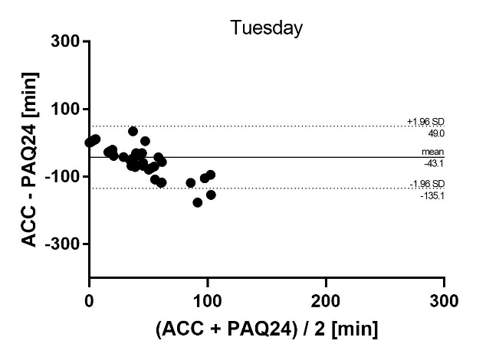
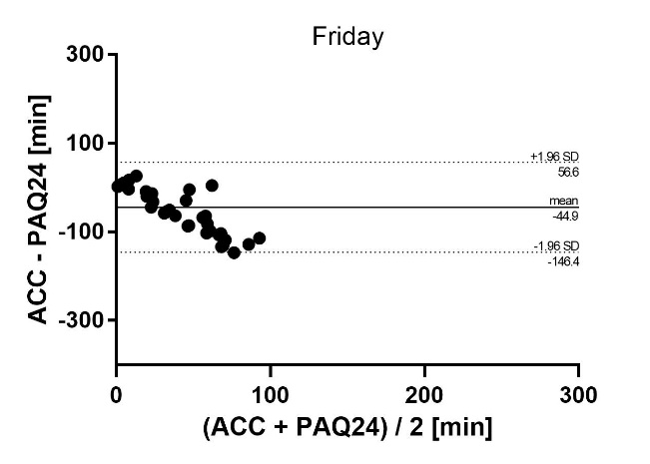
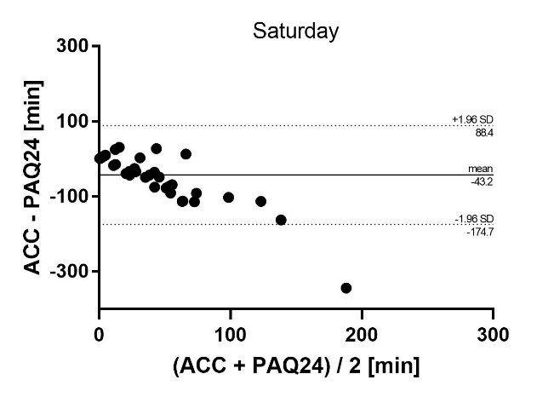
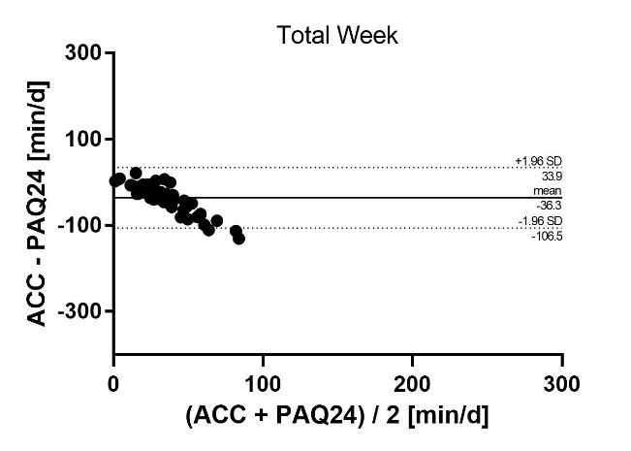
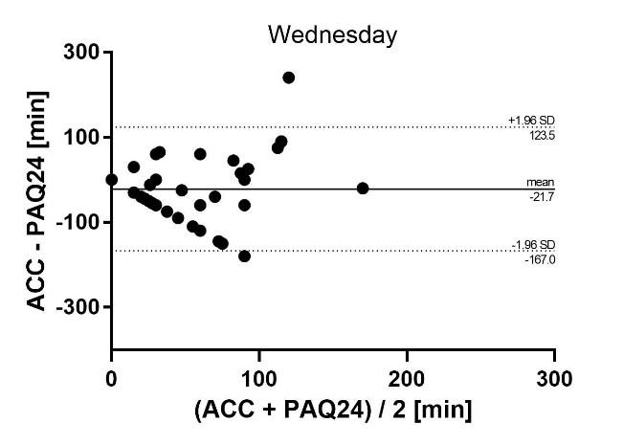
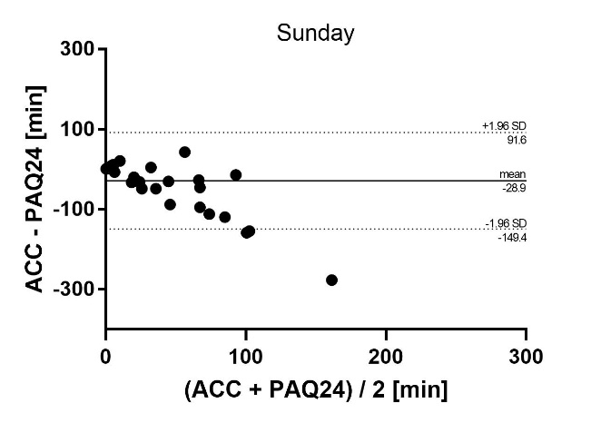
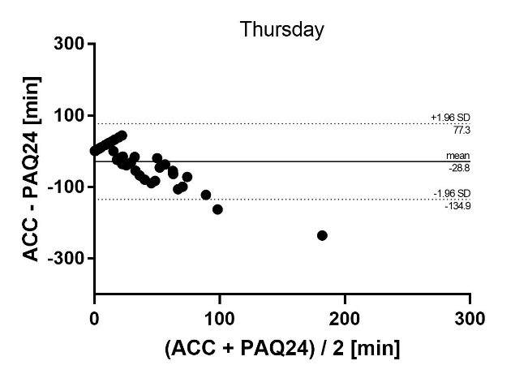
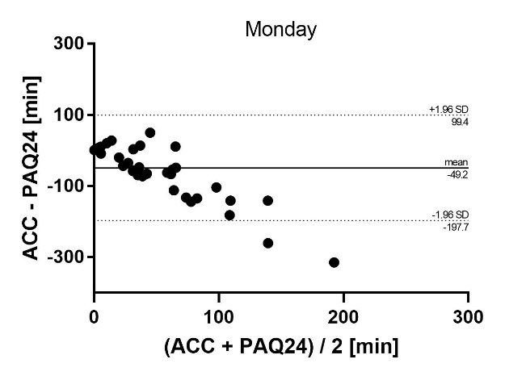

Additional file 3 Absolute agreement of daily and weekly VPA between PAQ24 and accelerometer. Bland-Altman plots for each day showing difference versus average of the values measured by the two methods with 95% limits of agreement. ACC accelerometer, PAQ24 Physical Activity Questionnaire for 24 h, VPA vigorous physical activity

