Figure S1: Receiver Operating Characteristic (ROC) curves for the Nordic prediction model to predict functional disability. A) Original model, B) Fine-tuned model
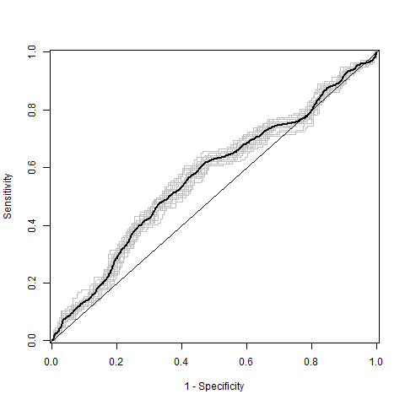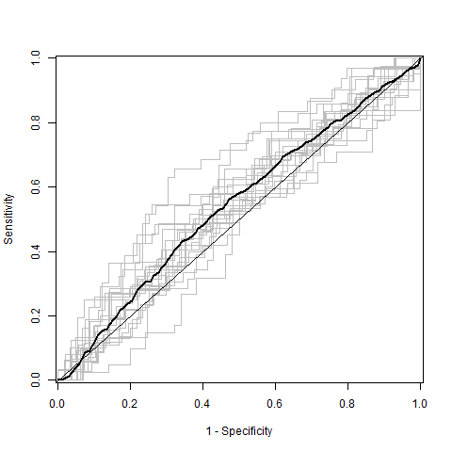
B
C-index = 0.51
C-index = 0.57
A

