Additional file 1

Figure S1
Figure S1: PTEN expression of healthy, lesional, non lesional and peri-lesional skin (n=10). The microarray data were obtained from GSE65127 in GEO.

Figure S2
Figure S2: Primary melanocytes cocultured with MSCs for 0 hours, 4 hours, 8 hours or 12 hours and analyzed by immunoblotting for Mitf. The quantification of bands was performed with Image-Pro Plus, and the results were normalized to those for the control GAPDH.

Figure S3
Figure S3: Primary melanocytes cocultured with MSCs for 48 hours and the cellular melanin was extracted by using melanin extraction buffer (1M NaOH containing 10% DMSO) at 100°C for 30 min.

Figure S4
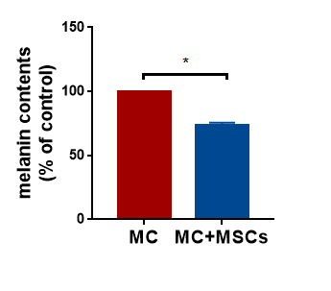
Figure S4: The cellular melanin content were determined by measuring the absorbance at 450 nm using the spectrophotometer reader. SPSS 20.0 was used to perform the Student’s t-test, P < 0.05 were considered statistical significance. * represents P value<0.05.

