Additional material
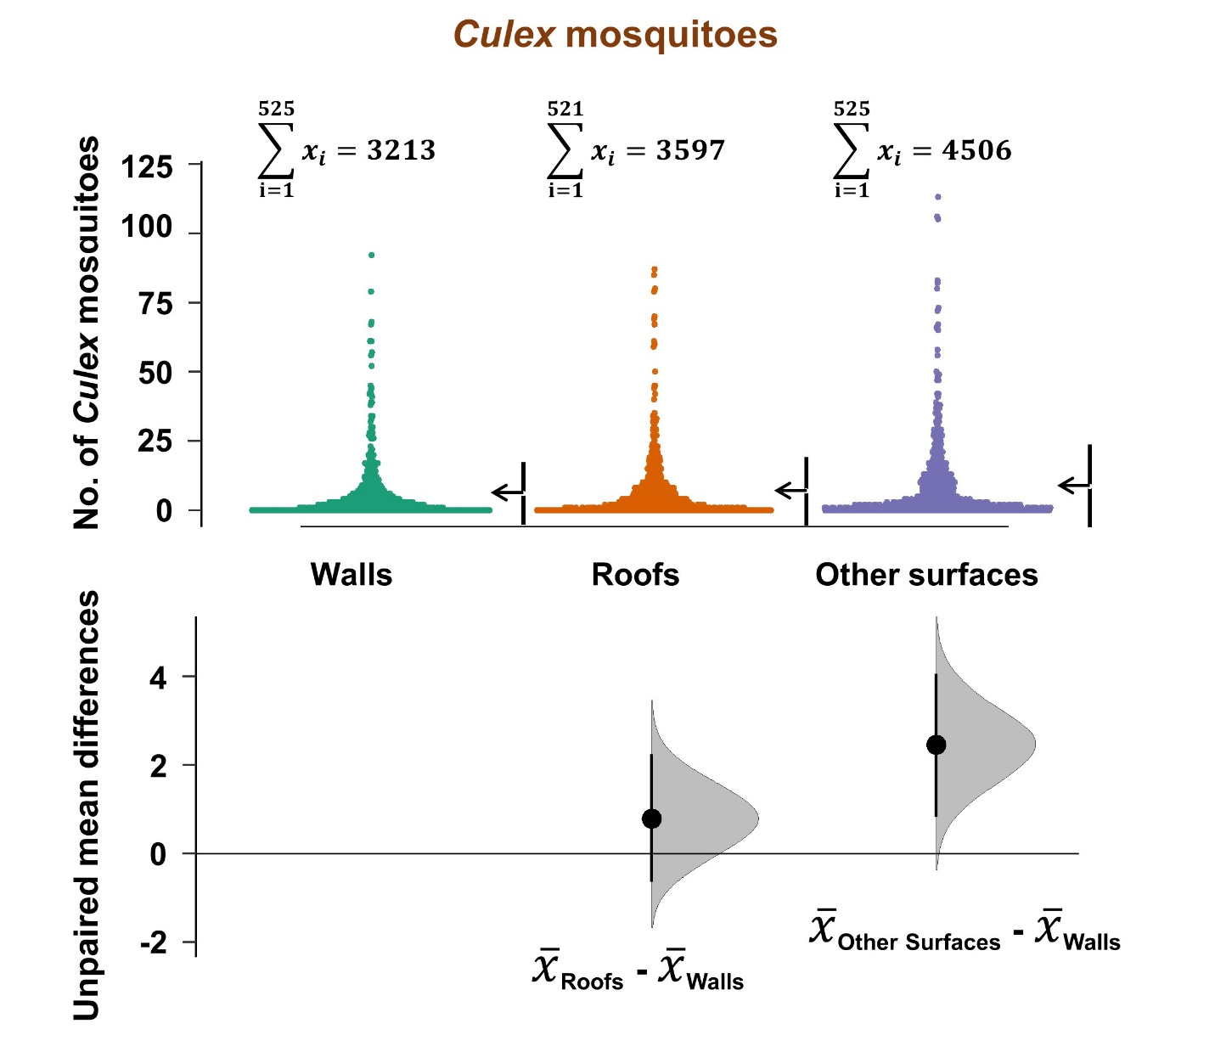
Figure S1. Overall densities of Culex mosquitoes, from different resting surfaces in houses. This data is aggregated for all house types in the study area. Estimation plots are provided to depict distribution of residuals between collections from roofs or other surfaces, and the collections on walls. The number of mosquitoes resting on either roofs or other surfaces are considered significantly higher or lower based on how far the means of the residuals are above or below the reference line.

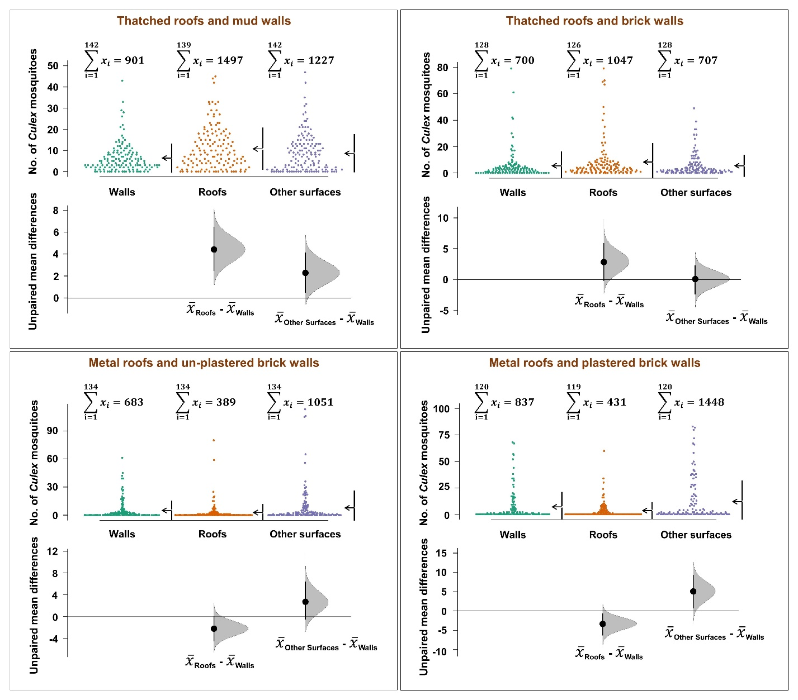
Figure S2. Comparison of densities of Culex mosquitoes, from different resting surfaces in different house types. Estimation plots are provided to depict distribution of residuals between collections from roofs or other surfaces, and the collections on walls. The number of mosquitoes resting on either roofs or other surfaces are considered significantly higher or lower based on how far the means of the residuals are above or below the reference line.
Table S1. Summary statistics of interactions between mosquitoes of different species collected from different resting surfaces (walls, roofs and other surfaces) and time
 | An. funestus |  |  | An. gambiae |  |  | Culex mosquitoes
 | RR (95% CI) | p value |  | RR (95% CI) | p value |  | RR (95% CI) | p value
Walls | 1 |  |  | 1 |  |  | 1
Roofs | 1.06 (0.77-1.46) | 0.728 |  | 1.81 (0.92-3.57) | 0.087 |  | 1.60 (1.17-2.19) | 0.003
Other surfaces | 1.64 (1.20-2.23) | 0.002 |  | 1.95 (0.99-3.81) | 0.053 |  | 1.61 (1.18-2.20) | 0.003
Morning (6a.m. and 9a.m.) | 0.52 (0.20-1.41) | 0.201 |  | 0.73 (0.13-4.10) | 0.716 |  | 0.67 (0.30-1.50) | 0.330
Morning (9a.m. and 12p.m.) | 0.57 (0.21-1.58) | 0.281 |  | 0.43 (0.08-2.46) | 0.342 |  | 0.57 (0.25-1.30) | 0.183
Evening (6p.m. and 8p.m.) | 0.74 (0.53-1.05) | 0.093 |  | 2.57 (1.29-5.13) | 0.007 |  | 1.25 (0.89-1.76) | 0.203
Night (6p.m. and 8p.m.) | 1.21 (0.88-1.65) | 0.242 |  | 1.62 (0.80-3.27) | 0.177 |  | 1.19 (0.86-1.64) | 0.306
Roofs * Morning (6a.m. and 9a.m.) | 1.07 (0.69-1.64) | 0.769 |  | 1.06 (0.45-2.51) | 0.898 |  | 0.79 (0.54-1.15) | 0.213
Other surfaces * Morning (6a.m. and 9a.m.) | 0.96 (0.63-1.45) | 0.837 |  | 1.54 (0.66-3.63) | 0.321 |  | 0.82 (0.56-1.19) | 0.292
Roofs * Morning (9a.m. and 12p.m.) | 0.77 (0.44-1.35) | 0.369 |  | 1.49 (0.52-4.25) | 0.461 |  | 0.65 (0.42-1.00) | 0.051
Other surfaces * Morning (9a.m. and 12p.m.) | 0.89 (0.53-1.52) | 0.679 |  | 1.11 (0.38-3.25) | 0.846 |  | 0.95(0.62-1.46) | 0.828
Roofs * Evening (6p.m. and 8p.m.) | 1.72 (1.09-2.72) | 0.020 |  | 0.96 (0.40-2.31) | 0.931 |  | 0.76 (0.48-1.19) | 0.227
Other surfaces * Evening (6p.m. and 8p.m.) | 0.92 (0.58-1.46) | 0.730 |  | 0.86 (0.36-2.07) | 0.744 |  | 0.90 (0.57-1.42) | 0.655
Roofs * Night (6p.m. and 8p.m.) | 1.07 (0.69-1.66) | 0.759 |  | 1.01 (0.41-2.53) | 0.975 |  | 0.76 (0.49-1.18) | 0.223
Other surfaces * Night (6p.m. and 8p.m.) | 0.91 (0.59-1.39) | 0.650 |  | 1.36 (0.56-3.35) | 0.498 |  | 0.95 (0.61-1.47) | 0.806

